Test Results

I have been having problems sending my files by email  
  
This project is available here in GitHub:  
<https://github.com/nic0michael/NicosCode>

This project was developed using Test Driven Development(TDD)  
My goal was to not violate the SOLID Principles

**In order not to violate the Law of Demeter** I made 3 classes each Extending the super-class Vehicle with all the behavior needed and so **exposed one public method doEverything()**

**I decided to name these classes:**

1. DemetersSmallCar
2. DemetersElectricCar
3. DemetersLargeCar

**I decided not to put a main method but rather to write Junit unit tests (TDD) instead.**

As this is a Maven project you can run : mvn clean install  
and see all the tests passing in the terminal

Unit Test 1: DemetersSmallCarTest  
Results:

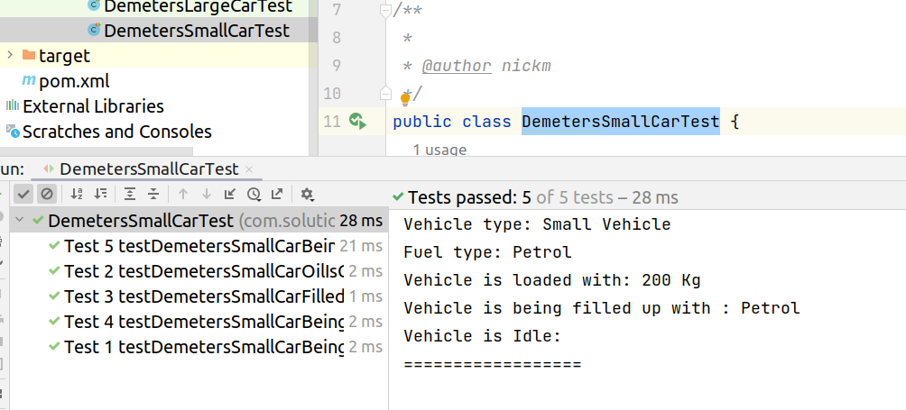

Unit Test 2: DemetersElectriclCarTest

Results :

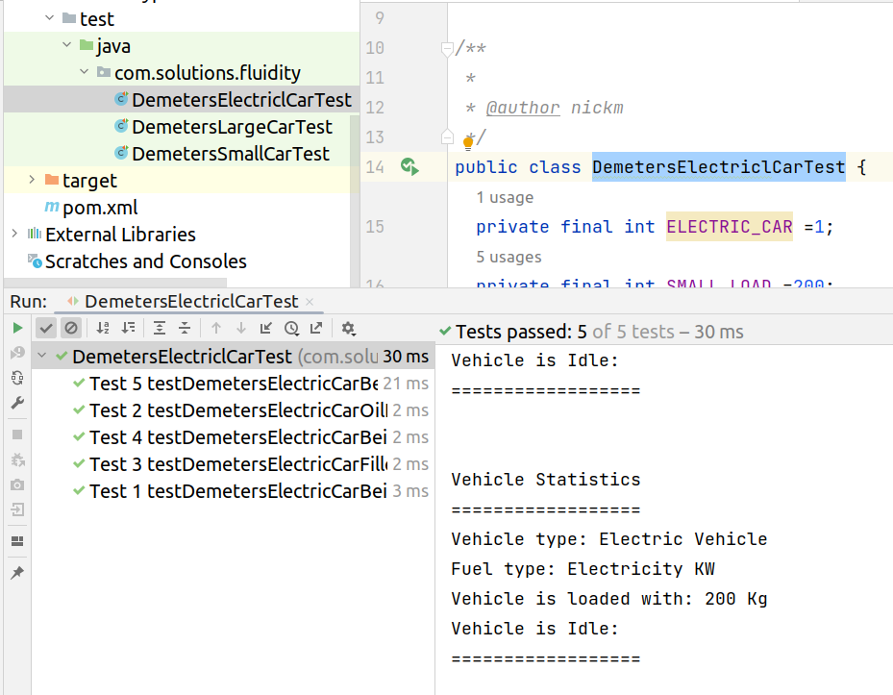

Unit Test 3: DemetersElectriclCarTest

Results :

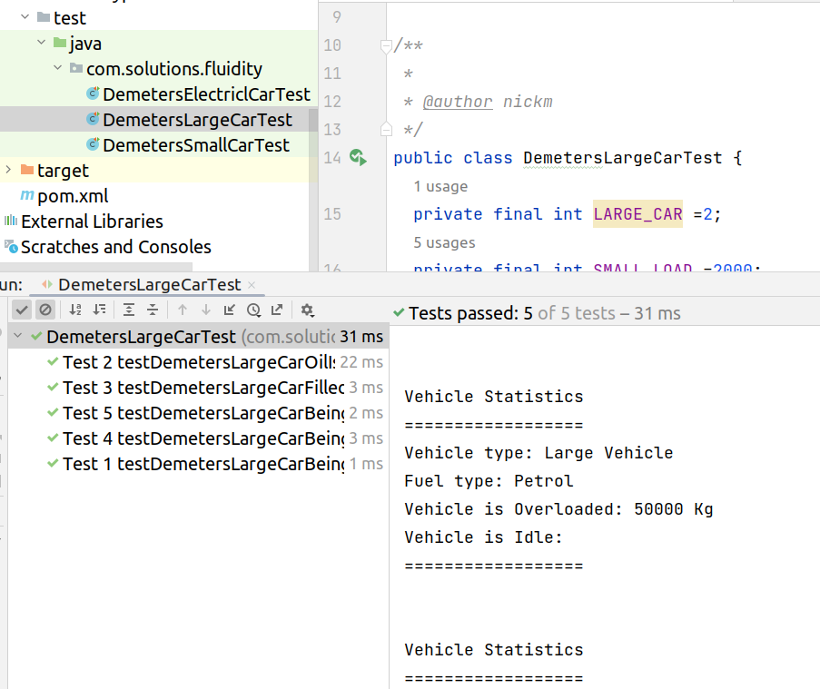

I have two projects that I published in GitHub that may be of interest :

1. This project UI used to teach Test Driven Development  
As well as software Quality Testing using SonarQube  
[GitHub - nic0michael/RabbitMQProducerMicroservice](https://github.com/nic0michael/RabbitMQProducerMicroservice)

2. This project is a functional Spring Boot Microservice for a Coffee shop  
I used Thymeleaf for my Javascript  
[GitHub - nic0michael/business-dashboard-microservice](https://github.com/nic0michael/business-dashboard-microservice)