The Nano VNA Jig
In order to measure Common Mode Rejection with a NanoVNA we made this jig

3. Measuring the Current Chokes

3.1 The Jig used for making measurements
In order to test these solutions I made a small jig to connect to my NanoVNA (Vector Network Analyzer)
I used a Strip-Line transmission line between two SMA connectors with two crocodile clips to connect to the DUT (Device under test). This works up to 1GHz and provides a stable and repeatable measurement setup for HF measurements. The ground plane is at the rear of the PCB, ensuring consistent reference conditions.
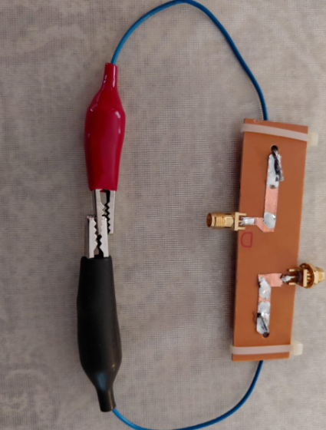
The Ground plane is at the rear of the PCB
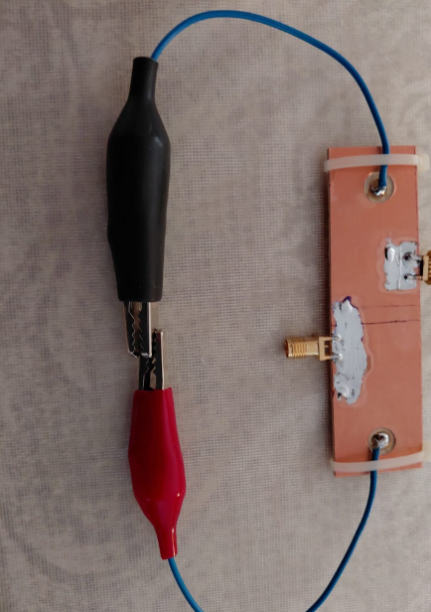
This also uses the Island Board technique, which simplifies construction and improves measurement reliability.
We made two Islands for connections to the SMA center pins
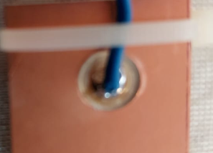

Modification made for HF Transformer testing
We added a Green Crocodile Clip connected to the ground. This allows quick connection and testing of various components without soldering, making experimentation faster and more flexible.
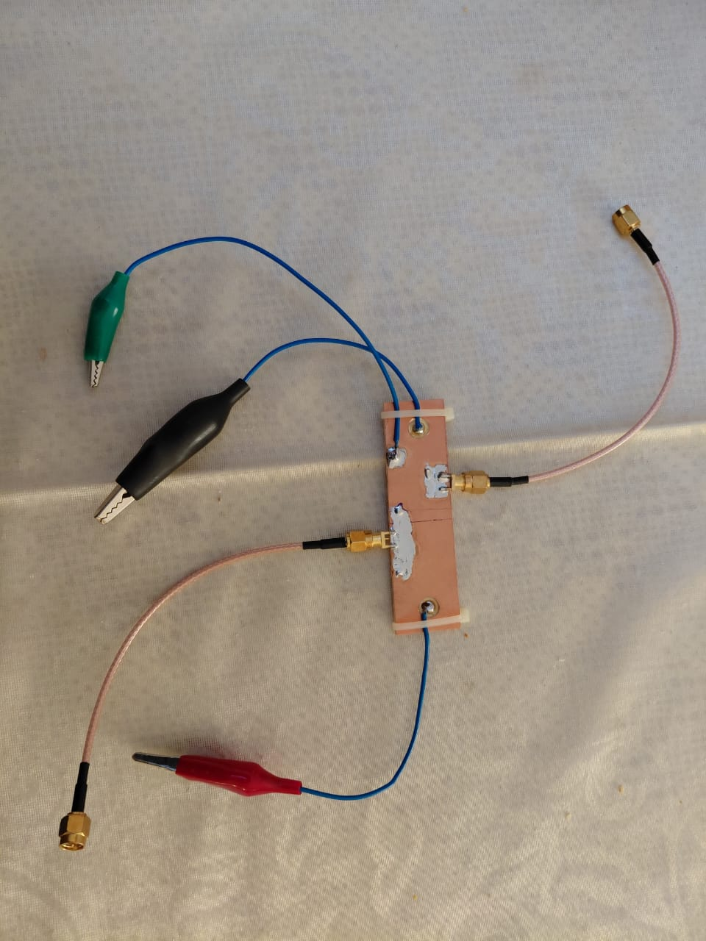

3.2 The NanoVNA Vector Network Analyzer
The NanoVNA is a compact and affordable instrument used to measure RF characteristics such as impedance, SWR, and insertion loss. It is ideal for hobbyists and professionals alike, allowing accurate testing of the Baluns and chokes across a wide frequency range 1MHz to 30MHz.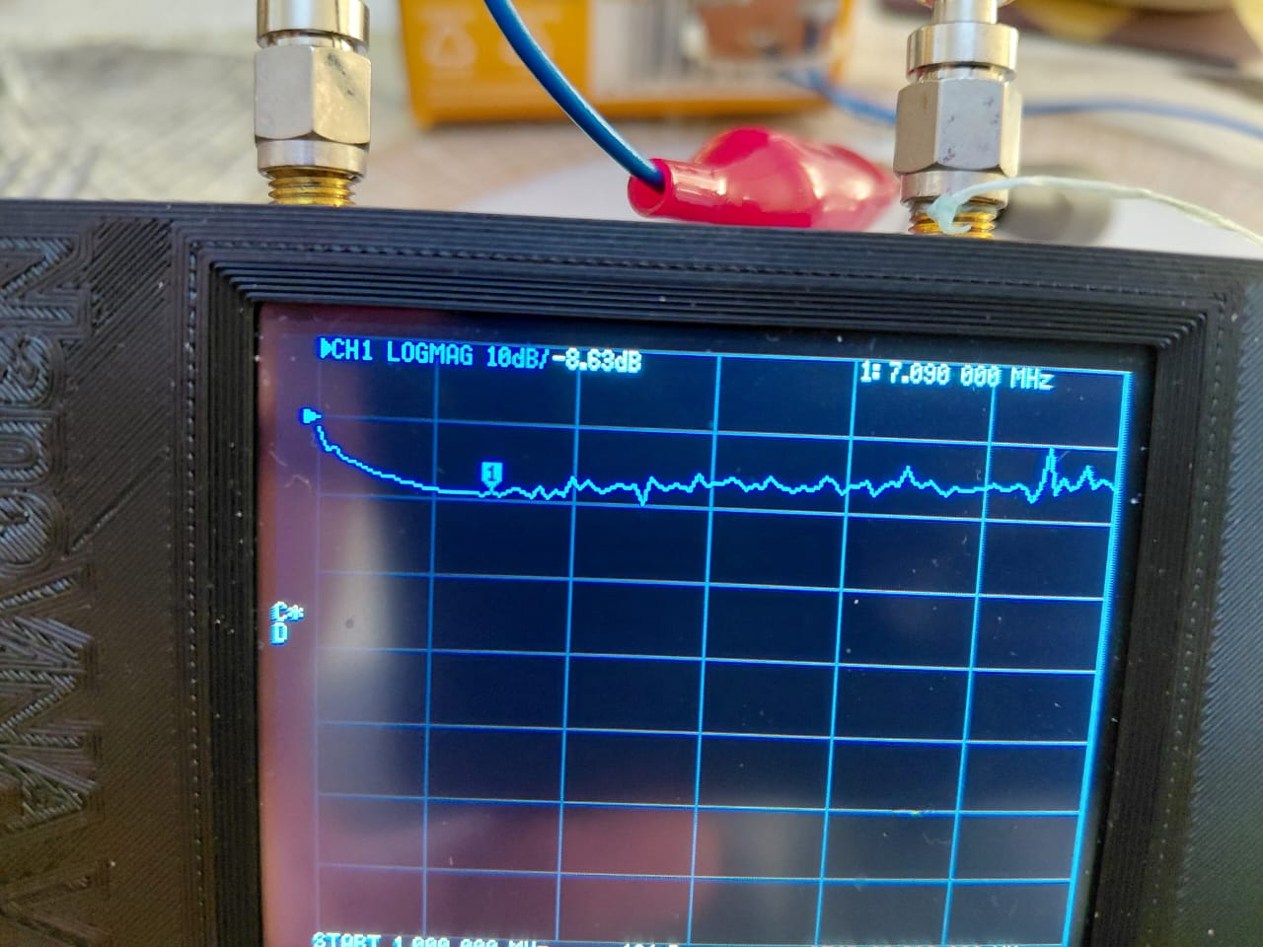

3.2.1 The Common mode Measurements
We tested a 2 turn single Toroid Common Mode Choke
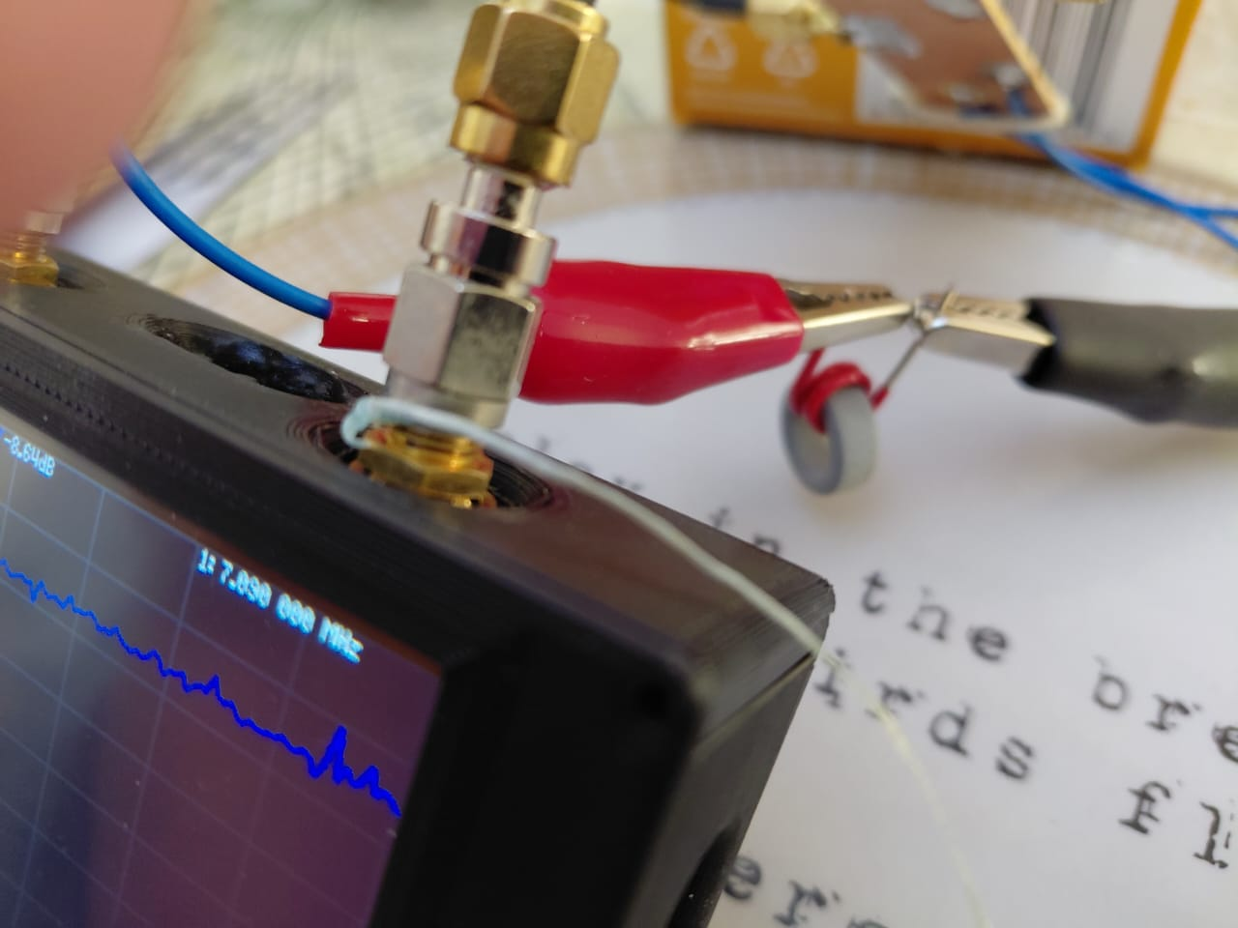
We measured -8.63dB Common Mode Rejection at 7MHz
We did something better using two toroids
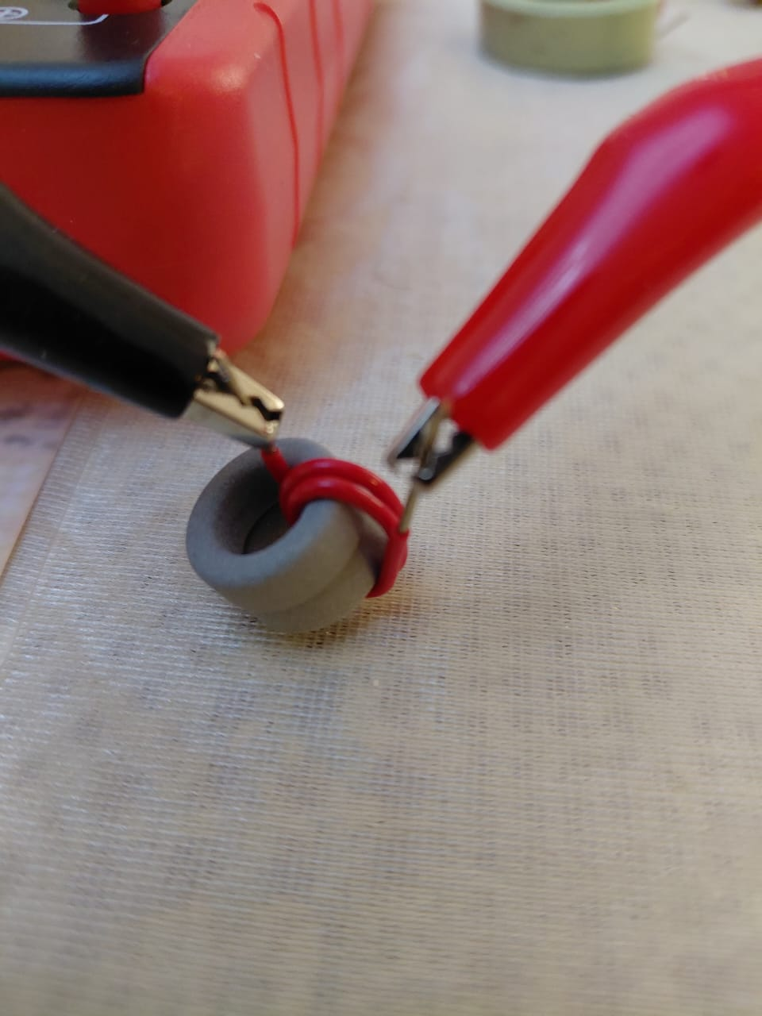
We measured -12.7dB Common Mode Rejection , showing that simply adding cores without proper design does not always improve performance.
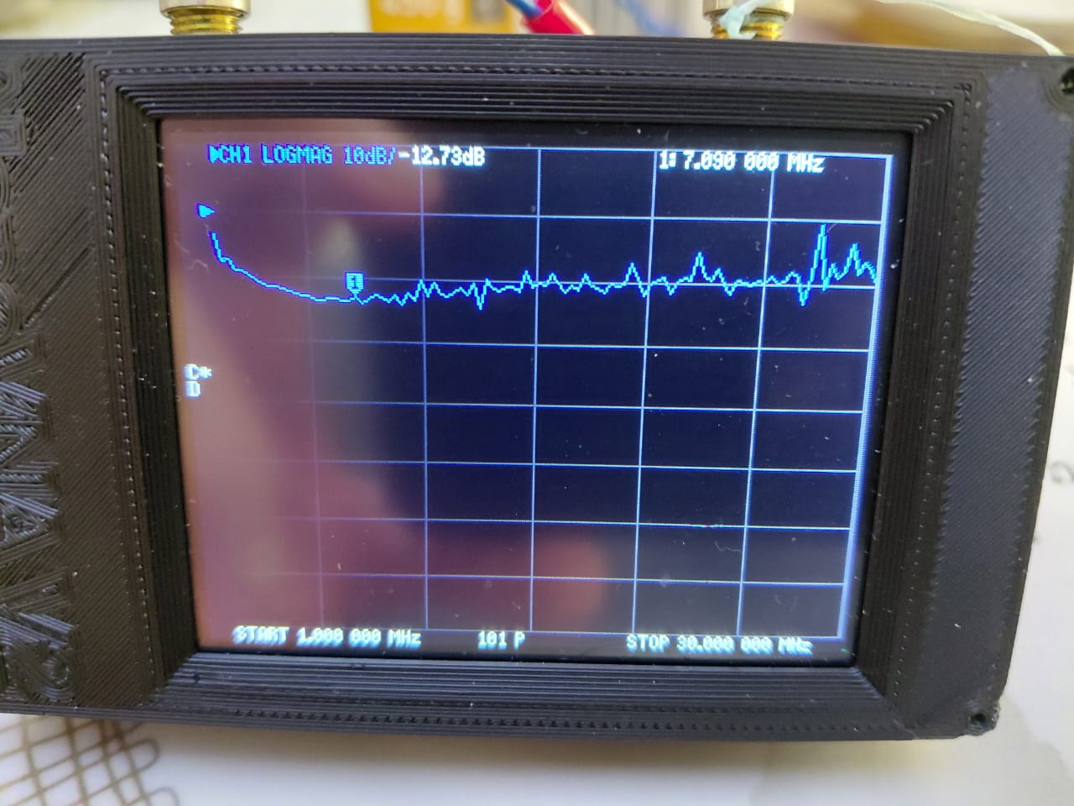
Now we tested the what the professionals make
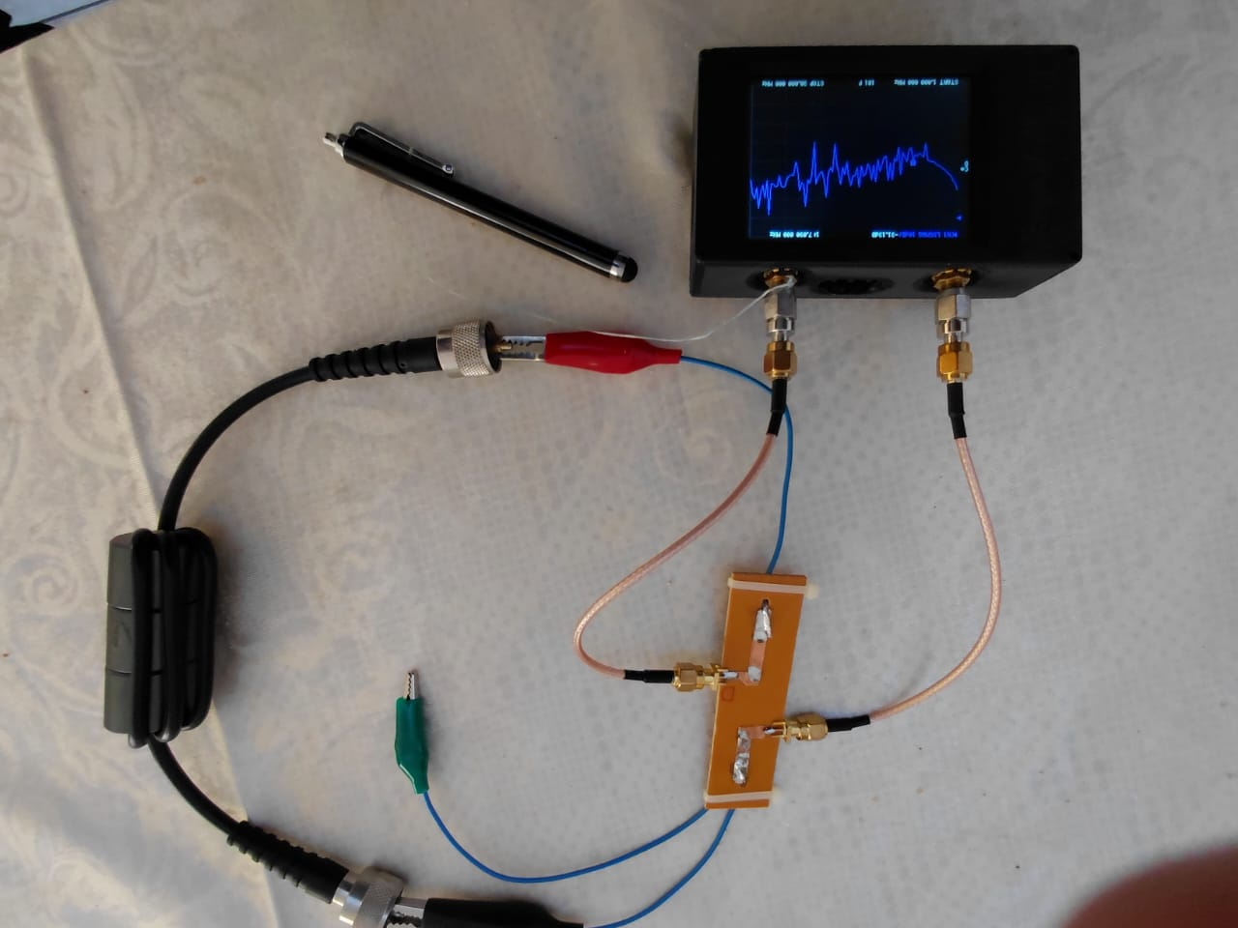
We measured -31.15dB Common Mode Rejection at 7MHz
This clearly demonstrates the importance of proper design, material selection, and construction techniques when building effective current chokes.
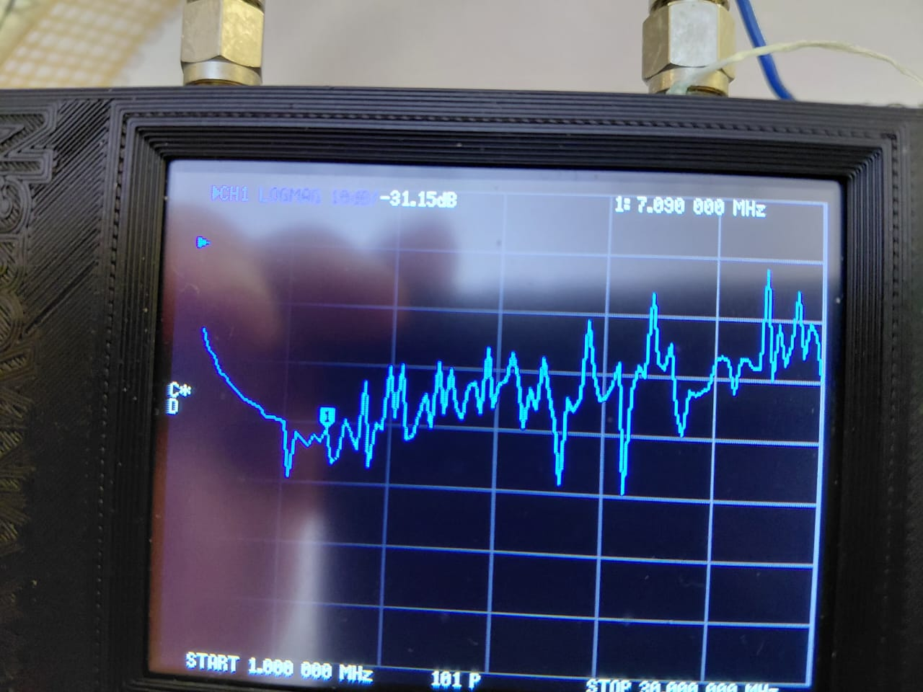

3.2.1 The Bifilar HF Transformer Measurements
We wanted to use the same jig for testing Baluns and HF Transformers using all three Crocodile clips.
Testing a Bifilar Wound Ferrite Transformer
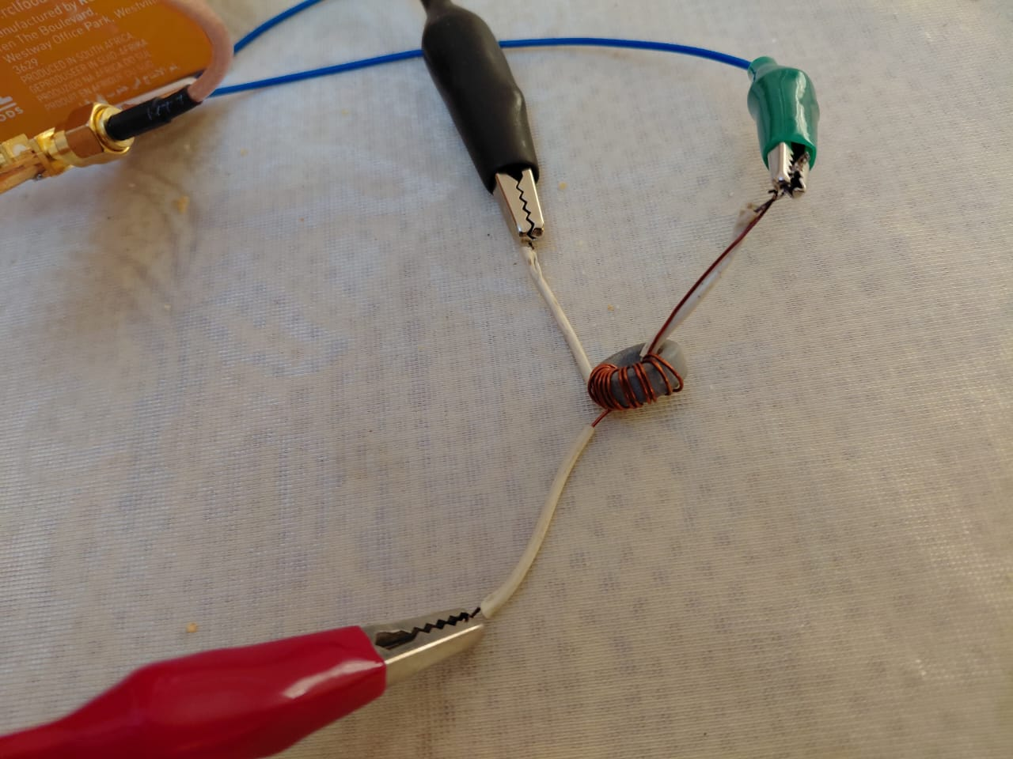
Result 1.3dB loss at 7MHz its flat up to 30MHz
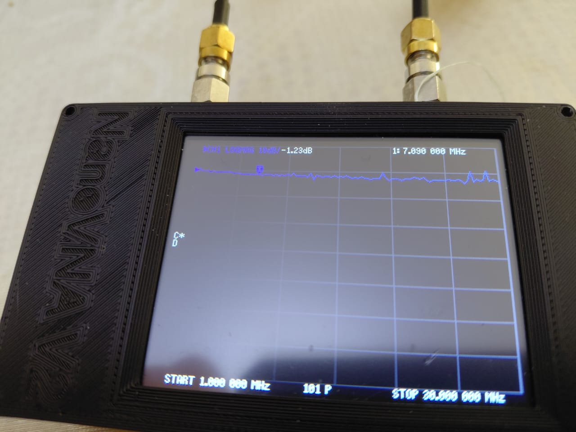

Testing a larger Bifilar Wound Ferrite Transformer
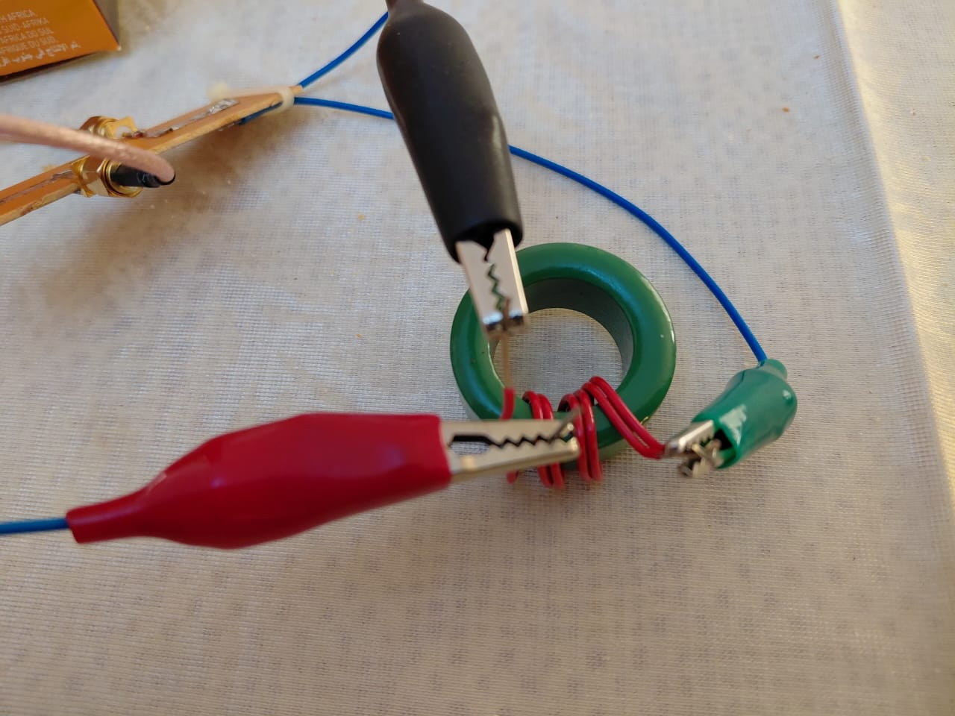
Result 1.24dB loss at 7MHz its flat up to 30MHz handles more Power
These results show that bifilar transformers can provide low loss and wideband performance, making them suitable for many HF applications where efficiency is important.
