BiQuad Antenna

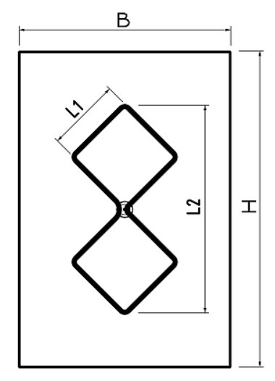
https://www.changpuak.ch/electronics/bi_quad_antenna_designer.php

Note: D is the Distance from the Dipole to the Reflector.

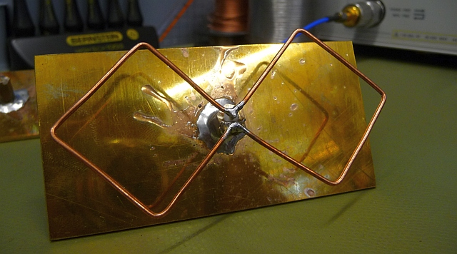

146 MHz 2m
L1 498.3 mm
L2 1395.2 mm
H 2054.8 mm
D 256.875 mm
Copper tube Diameter 11.13 mm
Copper tube length 4249.4 mm

438 MHz 70cm
L1 166.1 mm
L2 465.1 mm
H 684.9 mm
D 85.625 mm
Wire Diameter 4.62 mm
Wire length 1427.9 mm

1270 MHz 23CM
L1 57.3 mm
L2 160.4 mm
H 236.2 mm
D 29.5 mm
Wire Diameter 1.97 mm
Wire length 497.2 mm

2450 MHz WIFI
L1 29.7 mm
L2 83.1 mm
H 122.5 mm
D 15.25 mm
Wire Diameter 1.17 mm
Wire length 259.6 mm

