The ZS6BVR Island Board
an alternative to the Dirty Board

At the AGM a member asked about my alternative to the Dirty Board so I decided to publish this in Watts I also wanted to make this relevant for Higher frequencies, so I added a section on how I created Strip Lines for working at microwave frequencies.
The idea of making a board that you can solder your components without printing a PC Board and
without drilling holes for the components is not new.

The Dirty Board
Here you sacrifice a piece of PB Board and cut it into squares and glue them on top of the PC Board so that the PC board becomes the Ground plane and the components are soldered between the Ground plane and the blocks glued to the board
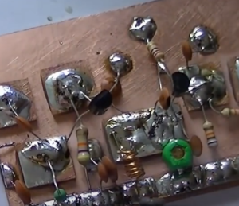
One of the disadvantages of the Dirty Board is that you have to sacrifice another PC Board to make the blocks you glue onto the board these blocks can break off.

Another Type of Dirty Board
An evolution of the dirty Board is to cut out the blocks with a Stanley Knife Now you are not sacrificing a board to make blocks.
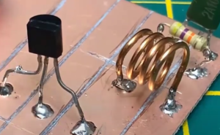
The problem with this approach is the effort it takes to cut the tracks and it does not look good to the eye.

Introducing the ZS6BVR Island Board
Here we use a range of Diamond Tipped Circular drill bits to cut Islands on the board.
These are much neater and if you use a Drill press you can position the holes accurately on the board.
For making prototype boards I use SRBP (synthetic resin bonded paper) PC Boards these are cheap and easy to work with.
The following picture is a closeup showing the Islands
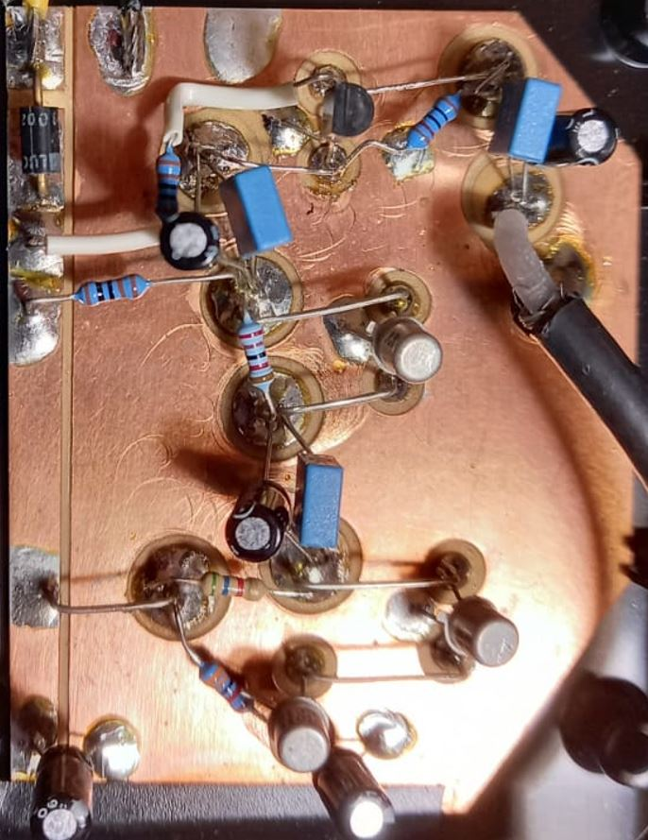

Examples of project prototype made using the ZS6BVR Island Board
The Logic Probe prototype
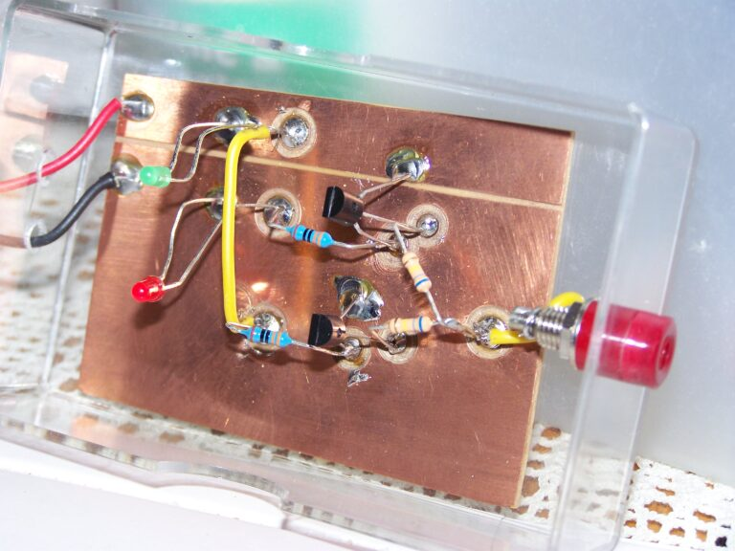
The High Frequency Noise Generator
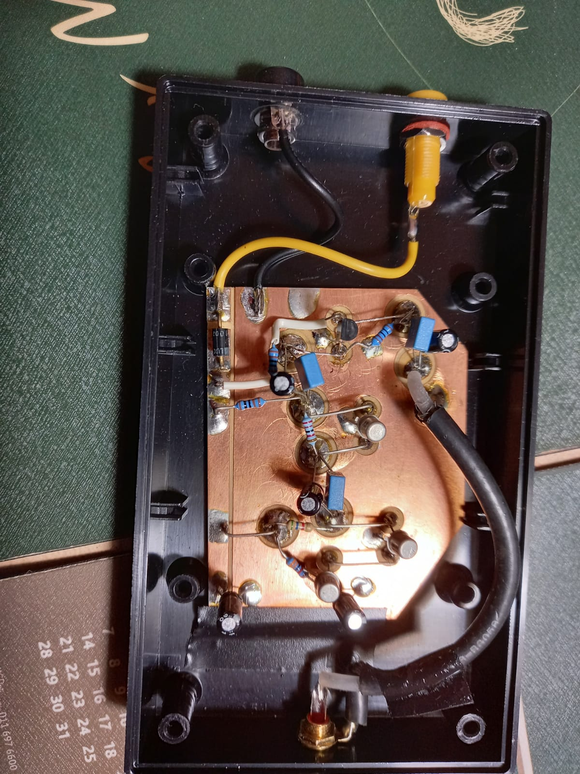

How to make ZS6BVR Island Boards
You will notice I have used a Hacksaw and placed the PB Board in a miter box to cut a neat horizontal line on the PCB.
This is done to provide a positive power rail with a series diode for polarity protection.
The PC Board is placed in a Mitre Box and then you proceed to saw a straight line on the side of the PCB to provide a power rail. I then also make a gentle cut or drill an island to be able to put a diode in series with the power rail.
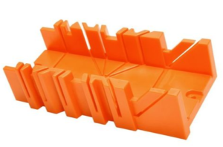
I use 6mm, 8mm, and 10mm Toark Craft Diamond core Drill Bits
I did find the 6mm s bit small should replace it with a 12mm drill bit.
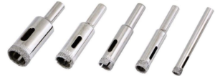

Microwave Boards
The ZS6BVR Island Board is fine for frequencies up to VHF.
But for Higher frequencies up to 1GHz I started making Strip Line Transmission lines
I found that for 50 Ohms Impedance you need 3mm Strip Lines.
What you do is stick a length of Copper tape on the back of the PCB and use a VNA(Vector Network Analyzer) to measure the impedance of the transmission line terminated in a prescision50 Termination plugged into the SMA Connector.
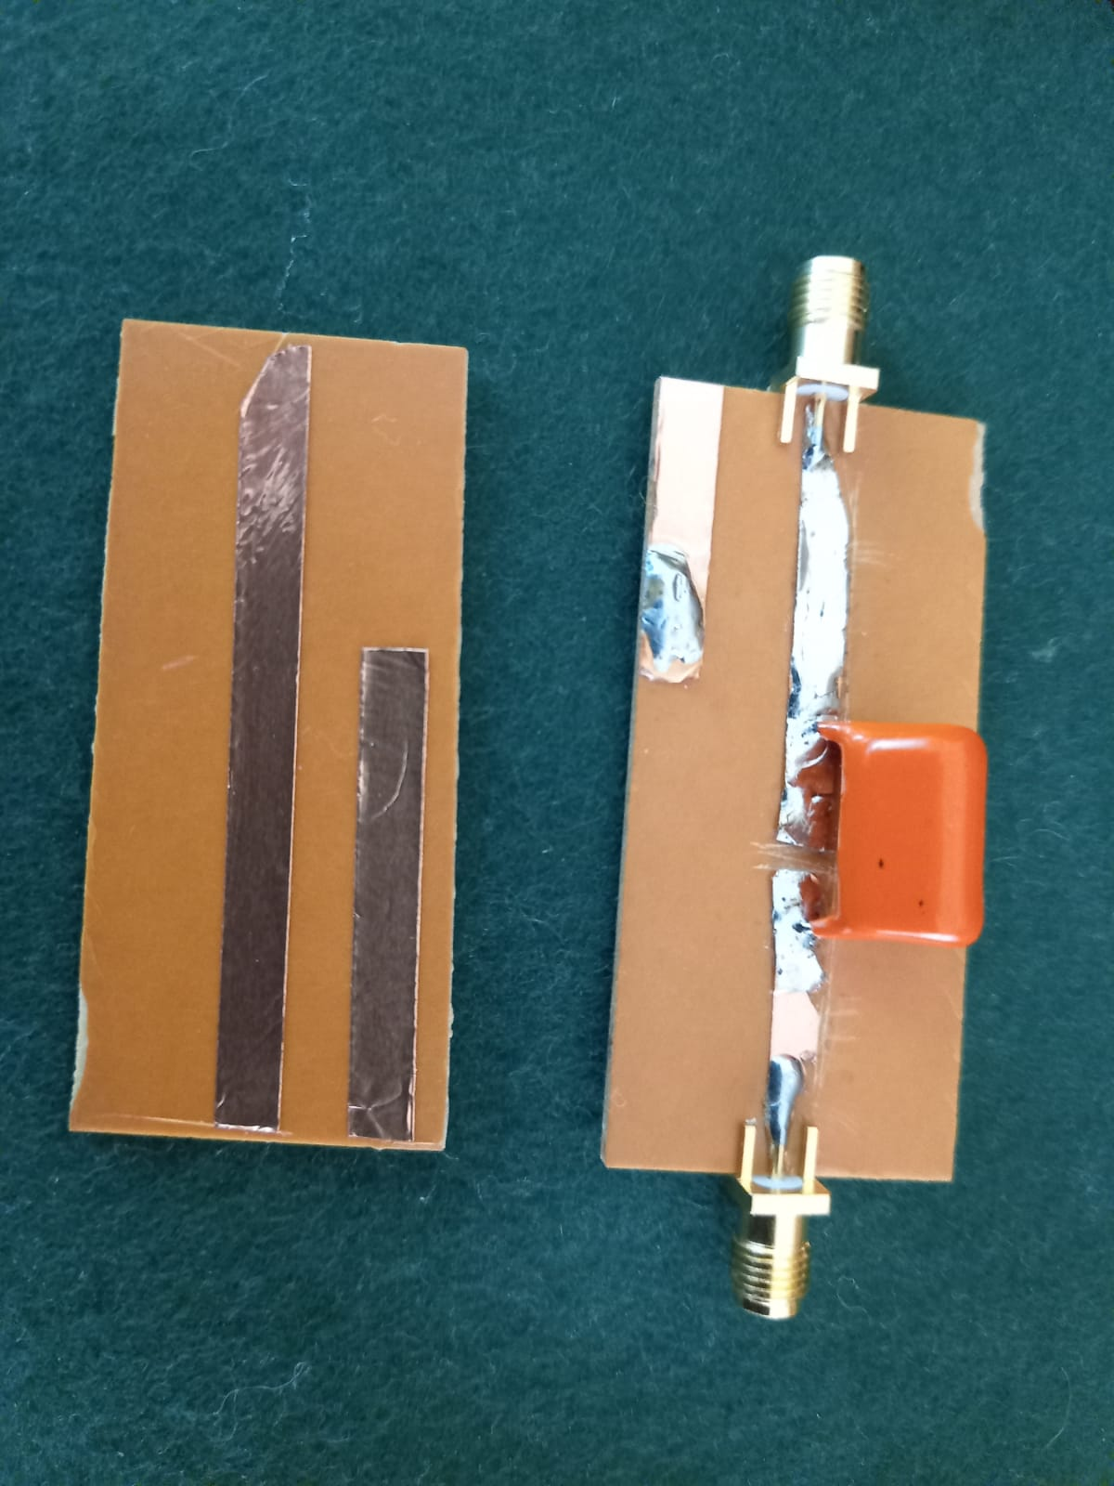
Unfortunately I could only get 5mm Coper Tape from Communica so I started cutting a few half millimetres till I got a dot in the centre of the Smith Chart or the smallest arc.

Tapering the board to get a better impedance match
I did also taper the as seen below and a VSWR of 1.01 all the way up to 1 GHz
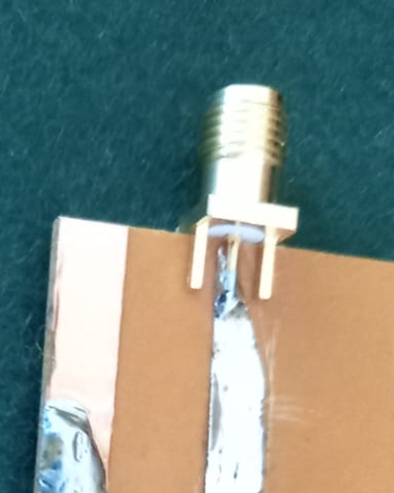

Making a DC Block for the NANO VNA and the Tiny SA
Inserting a 100Nano Farad Capacitor in the transmission line
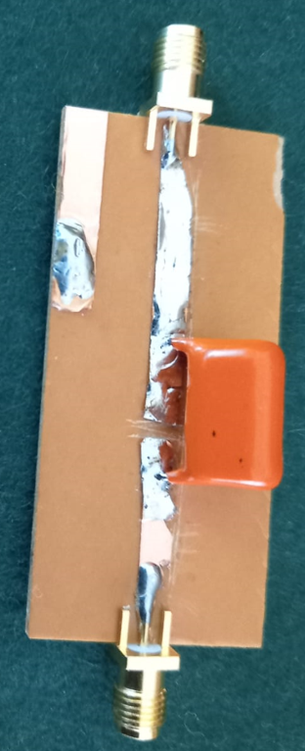
I got a VSWR 1.38 at 828MHz on the yellow line (the component leads start becoming Inductive)
This will work from 180M to 70cm
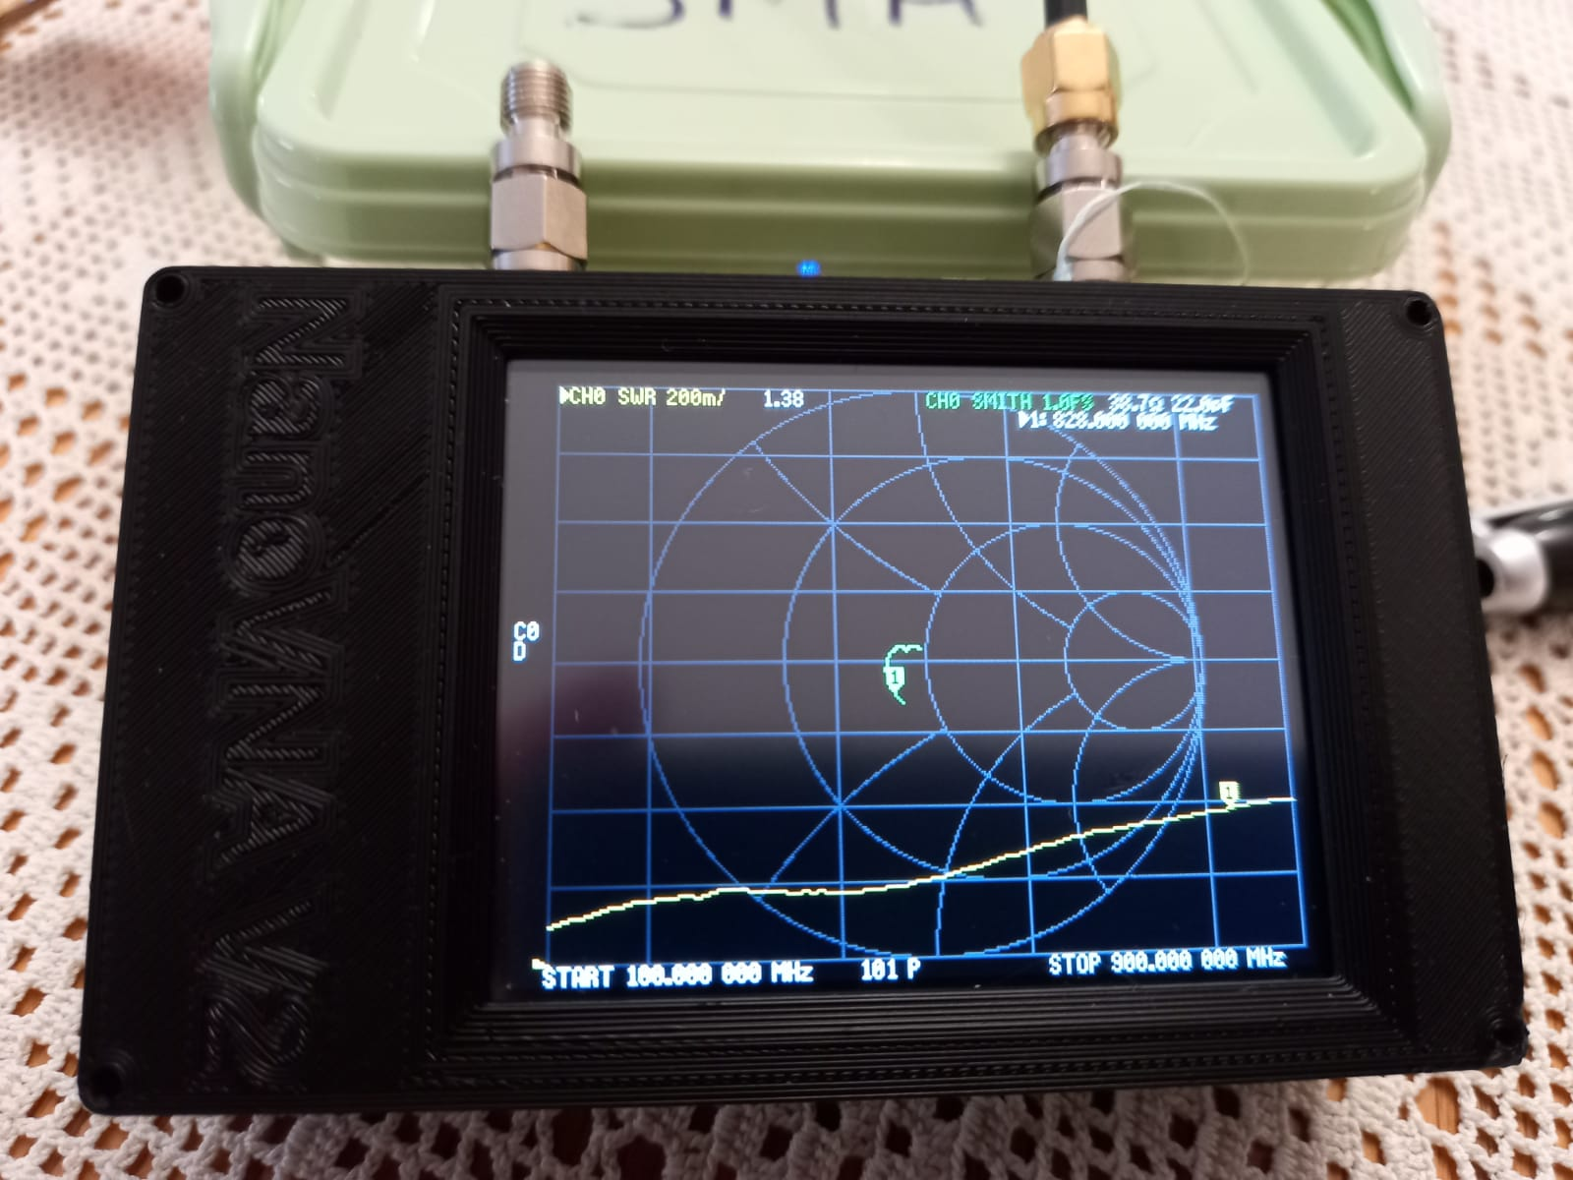

Making this measurement on the Nano VNA
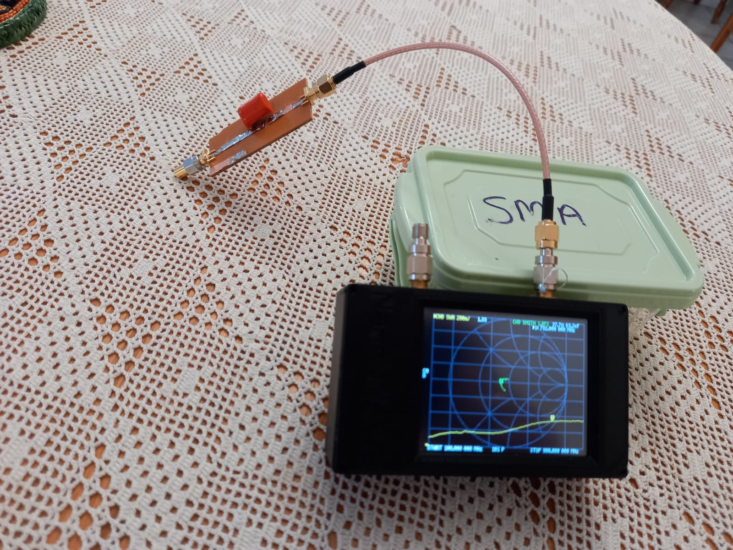

Please Visit the ZS6BVR Web site for more articles like this one
https://zs6bvr.wordpress.com/
If someone has 3mm Copper tape I would love to have a meter or that.
73 de Nico
ZS6BVR

