ZS6BVR Field Strength Meter
Here we have a very simple project that you could build in an hour
This Field Strength Meter uses Schottky diodes instead of Germanium diodes.
With this design we extend the frequency range to the UHF (and even SHF bands if you use a strip line PCB and an SMA connector and surface mount components).
By fitting a BNC Female Connector we can also use this instrument to measure relative power
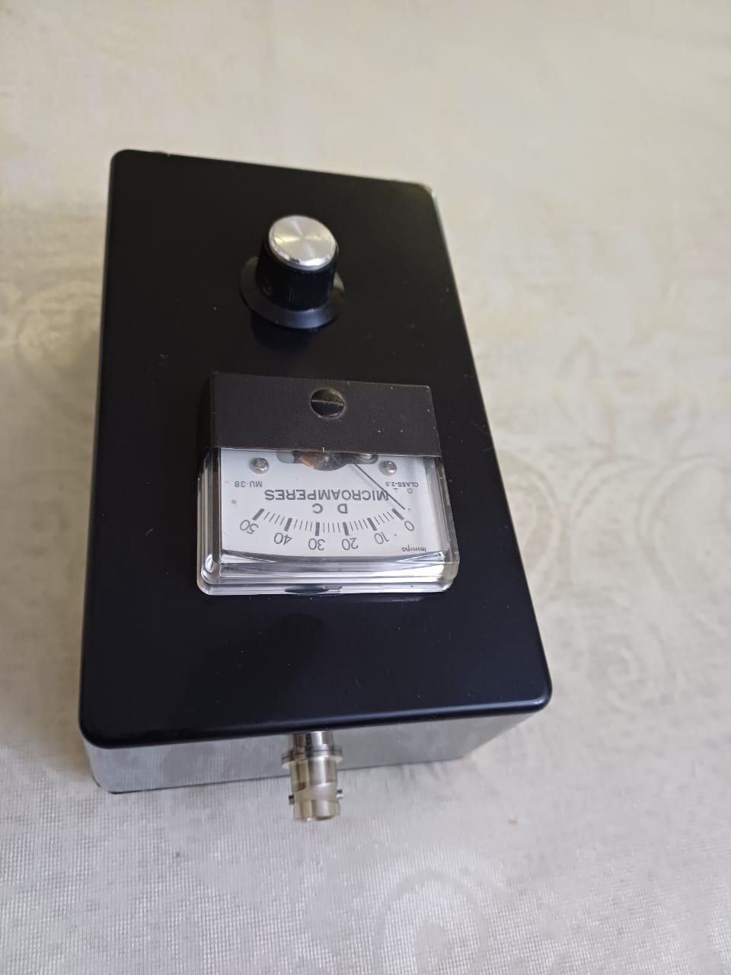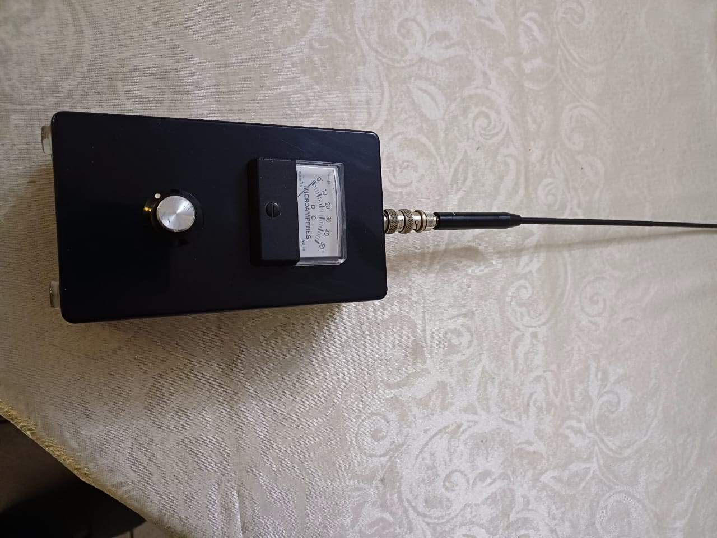
Here are two pictures of the completed instrument.

Uses
1. First as a Relative Field strength Meter
2. You could also compare a known signal level from your signal generator with the output of an oscillator by adjusting the known signal and comparing with the unknown.
Construction
Use a circular saw attachment on you Drill and slowly drill the hole for the pannel meter.
Then use a step drill bit to drill the hole for your BNC Socket
Design
This circuit diagram shows the design of the Field Strength meter
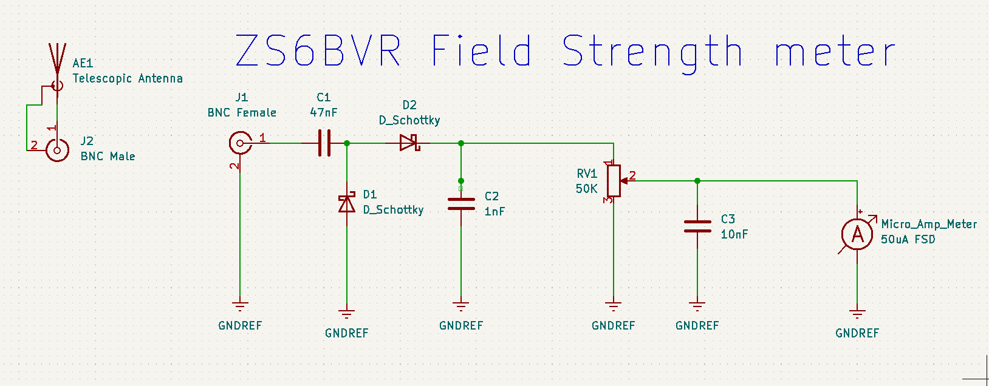

Description of circuit
Capacitors C1 and C2 together with the two Schottky signal diodes provide a voltage doubling RF detector with a DC output with C3 as a Smoothing Capacitor. One uses the Potentiometer to set the needle of the 50uA meter to either the center or full scale for comparing radiated power from antennas being compared. It can also be used to indicate that you transmitter is working
Component list
J1 Chassis mounted BNC Female Connector
D1,D2 BAT85 or equivalent Schottky signal diodes
C1 47nF
C2 470pf or 1nF
C3 10nF
VR1 50K Linear Potentiometer
Meter 50uA FSD Micro Amp Meter

