Beginners Documentation

Contents

Chapter1 : Logging in to CMS 2

Chapter 2 The Process to creating and populating an Article 4

Chapter 3 Creating a new Article 5

3.1 Capture the details about the article 5

3.1.1 Press the Article Manager button 5

Chapter 4 Creating Content for the new Article 8

4.1 Capturing Content for the Article 8

4.1.1 Typing the content for the article 9

4.1.2 to add a link on the page : 10

4.1.3 To add an image to the page 11

# Chapter1 : Logging in to CMS

Step 1 On the website click on the Homepage button

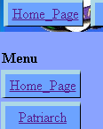

Step 2 click on the login link

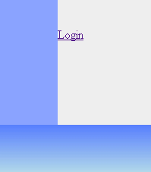

Step 3 type your Logon ID and Password and Number on the page the press the Login button

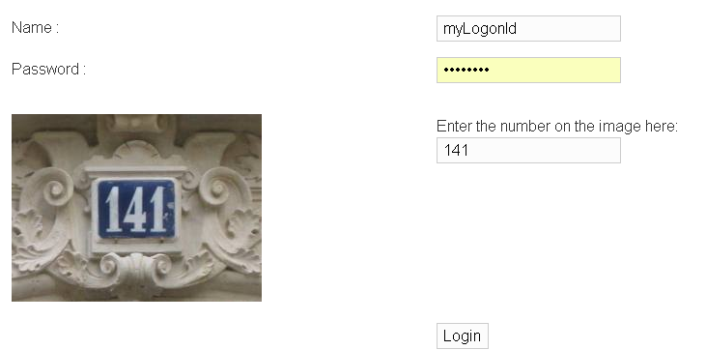

You have successfully logged in if you see this:

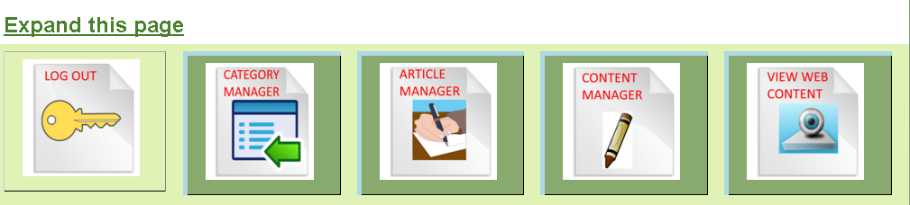

You are now in the Administration Home Page

# Chapter 2 The Process to creating and populating an Article

In order to create a web page there are two steps that have to be taken

1. Use the Article Manager to capture the Meta Data (Descriptive information) of the Article
2. After capturing the Meta Data you use the Content Manager to populate the text and image Content associated to the Article
3. The Editor can now choose where to link your Article and its Content to the Menu of the website. As a beginner user this step is out of your scope

Although you start as a beginner you do have full control of every facet of the CMS administration

It is recommended you take baby steps to learn how to use the CMS if you are new to the Content Managed Server concept after mastering these steps you can read the Editors Manual.

# Chapter 3 Creating a new Article

## 3.1 Capture the details about the article

### 3.1.1 Press the Article Manager button

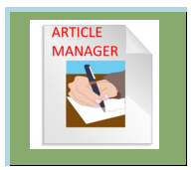

You will get this screen

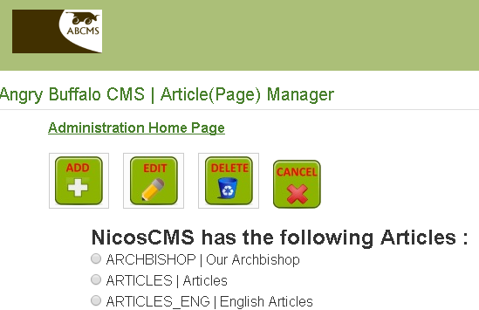

#### 3.2.1.1 press the Add button

You will get this form to fill in all the details about the article:  
  
The Short Name must not have spaces  
The PageURL must not have spaces  
The page access is Visitor if you want everyone to read this article  
Choose the template for your web site   
Choose a category for the article if categories were defined

Press the Submit button below

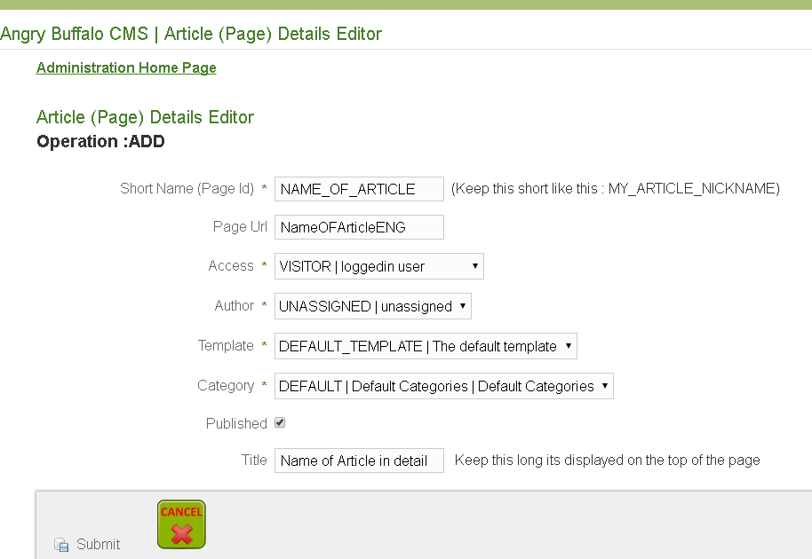

Now you have defined an Article with its details  
  
You can edit your article details by clocking on the radio button next to the article and pressing the Edit Button  
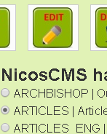

Click on the Administration Home Page Link at the top of the page to return

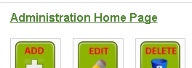

You are back at the Administration Home Page



# Chapter 4 Creating Content for the new Article

At the Administration Home Page Click on the Content Manager Button

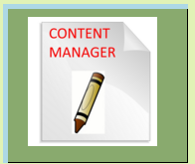

## 4.1 Capturing Content for the Article

On the Text content Manager2 screen press the Add button

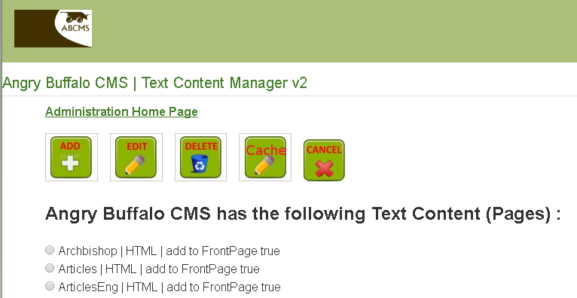

### 4.1.1 Typing the content for the article

Before you type the text there are a few details to be captured  
First select the article  
Type the Short Name for the Article  
Select the type of content (HTML) for web pages  
Select f this article must appear on the Front Page  
Specify the order on the top and side menu

Now you are ready to type text

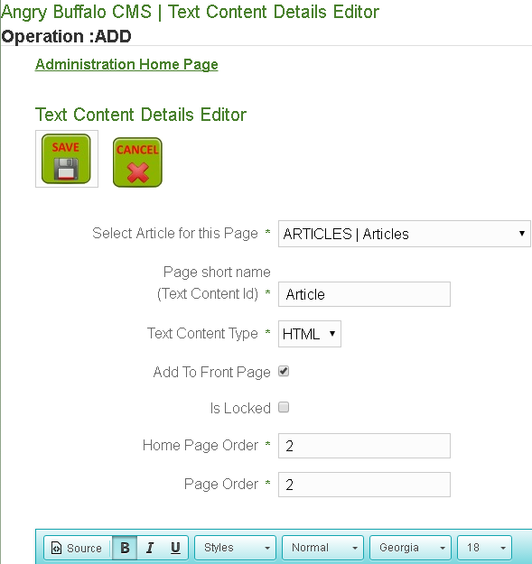

In the Editor you can type your text in it like a word processor

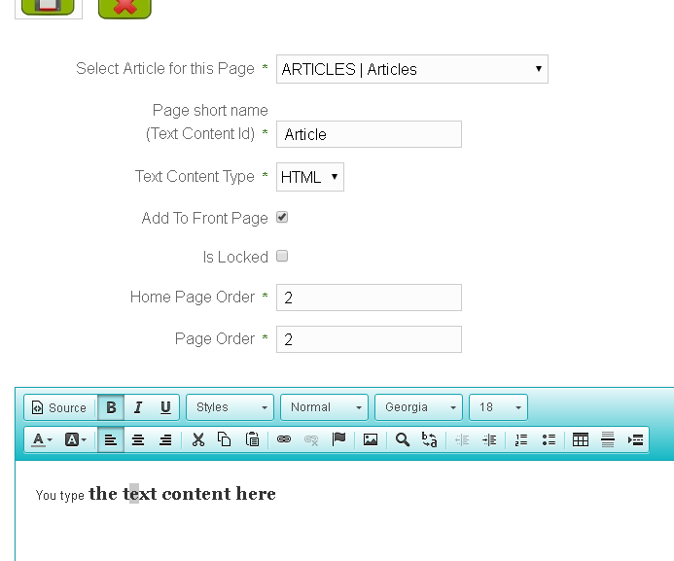

### 4.1.2 to add a link on the page :

First type the test for the link

www.google.co.za

Select this text and Click on the click icon



Now type the details of the Link (URL)

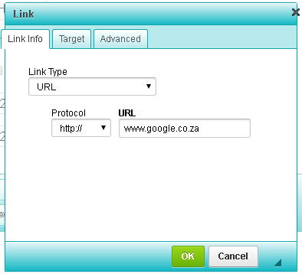

### 4.1.3 To add an image to the page

Click on the picture Icon



Now type the details of the picture (its URL to where its located on this or other server)

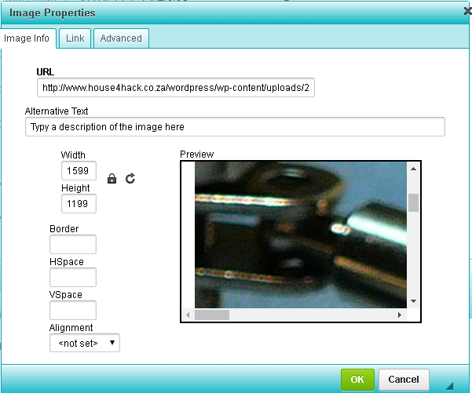

When you are finished creating your first Article press the save button on the top of the page

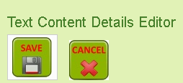

And that all you need to create articles

The webmaster (who has advanced knowledge) will link your article to the menus on the website