The Editors Manual

Contents

Chapter 1 : After learning the Basics , what’s next ? 2

Chapter 2 The Life Cycle of the published and linked Articles 3

2.1 The Category Manager 4

2.2 The Article Manager 4

2.3 Content Manager 4

2.4 Menu Manager 5

2.5 Cache Content 5

Chapter 3 Advanced CMS Functions : Making your Templates 6

3.1 Image Manager 7

3.2 Banner Manager 8

3.3 The Template Manager 9

Chapter 4 Managing the Home Page 10

4.1 Front Page Manager 10

4.1.1 Associate/Change the Template that delivers the Home Page 10

4.1.2 Add or remove the Article Contents to the Home Page 11

# Chapter 1 : After learning the Basics , what’s next ?

In the beginners documentation we were taught how to login and the minimum functionality the Beginner is exposed to :

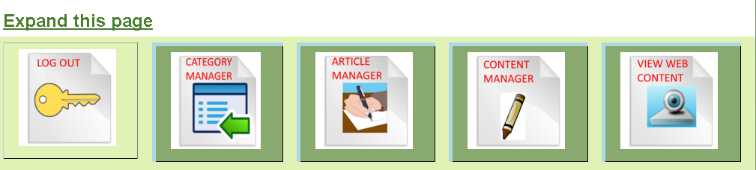

You are now in the Administration Home Page

The Editor will be exposed to a larger scope of management.  
The management of all the aspects of the website.

If you click on the above link “Expand this page” you will get this screen:

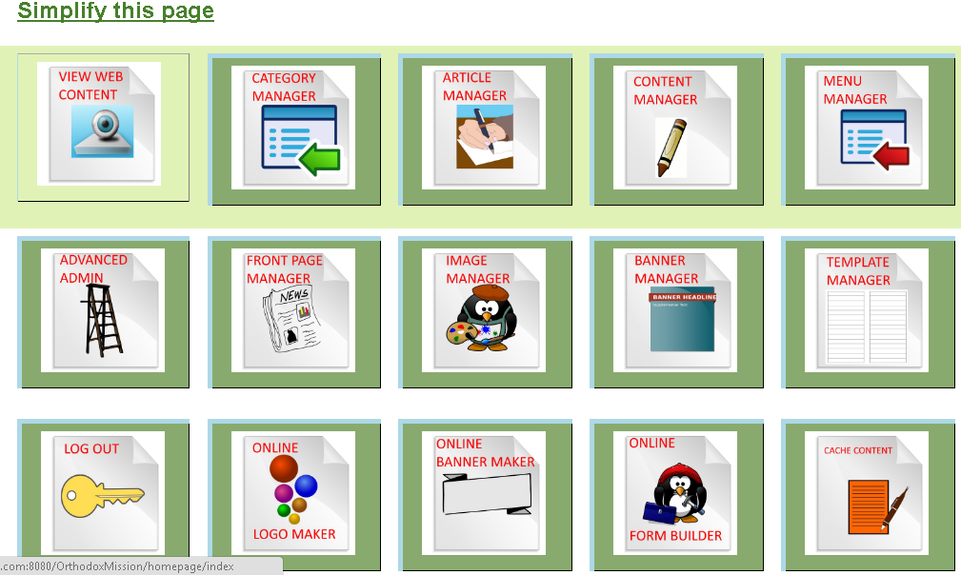

# Chapter 2 The Life Cycle of the published and linked Articles

In order to create a web page there are two steps that have to be taken

1. The Category Manager allows us create different Categories to associate Articles to
2. Use the Article Manager to capture the Meta Data (Descriptive information) of the Article
3. After capturing the Meta Data you use the Content Manager to populate the text and image Content associated to the Article
4. The Menu Manager allows the Editor to add links to the Top and Side of the web pages  
   and to link Articles with their Content to these links
5. The Cache Content Button will make all new Articles and Menu links to become visible by publishing the contents and caching it to the servers hard disk making all new content visible. This way the Editor can also edit and verify all content and control what gets cached and displayed on the website

## 2.1 The Category Manager

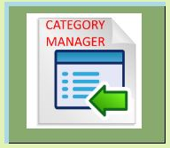 This is used to create Categories to associate Articles to

After pressing the Add button you get this screen:

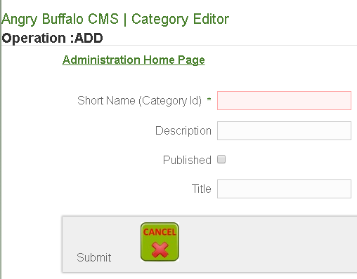

Here you create or edit a category and make it available

## 2.2 The Article Manager

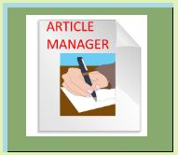Please read the Beginners Documentation for more information

## 2.3 Content Manager

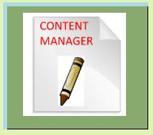 Please read the Beginners Documentation for more information

## 2.4 Menu Manager

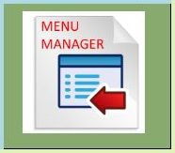This is used to associating Articles and their Content to links on the top and  
 side of the web pages  
After pressing the Add button you get this screen:  
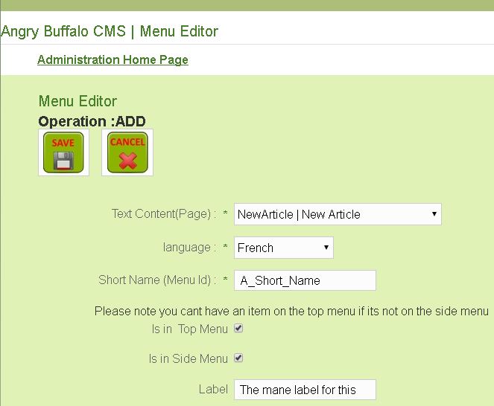

Here you select the Article, the Language, a short database name  
and the text for the Menu Label. You select whether o display on the top and bottom menu’s

## 2.5 Cache Content

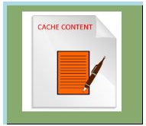Pressing this button will save all content on the servers hard disk  
 making all content visible on the web site and being cached there   
 is a significant speed improvement (25X) for delivering content

# Chapter 3 Advanced CMS Functions : Making your Templates

Most Content Management Systems require very advanced web development skills to create   
Templates. With angry Buffalo CMS our philosophy is very different we created reusable Template Outlay Component that we provided to enable the making of templates a very simple process.

What you do is:

1. Add an Image to the CMS
2. Select and define the Banner Images you want for your template
3. Associate a Template Outlay Component template outlay

## 3.1 Image Manager

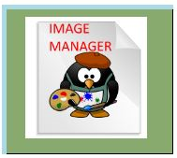We have provided many banner images for your website:  
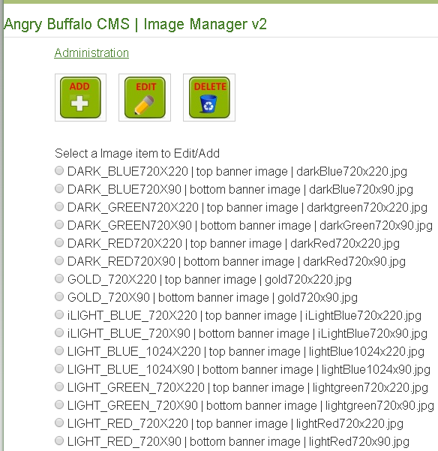

Adding a new Banner Image : Press the Add Button :   
The assumption is that you copied your image to the folder:  
………/content/images/banners/

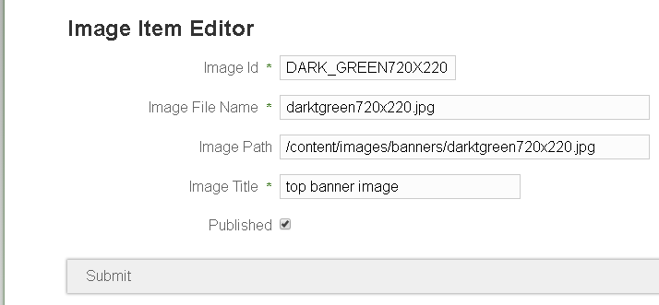

## 3.2 Banner Manager

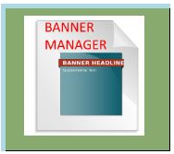Although there are many banner images available for our use only 3 of them  
 are available for the Templates to use:

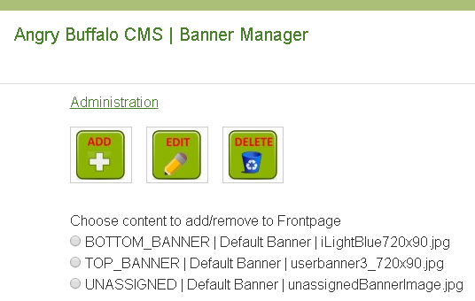  
Pressing the Add button allows us to make more banners available:

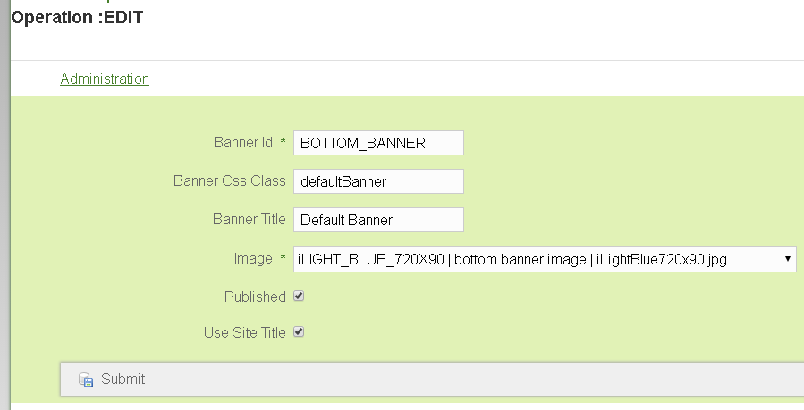  
Here you select a banner image and assign it to be available as a Banner

## 3.3 The Template Manager

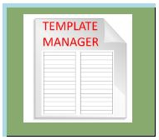Creating Templates made simple with our philosophy

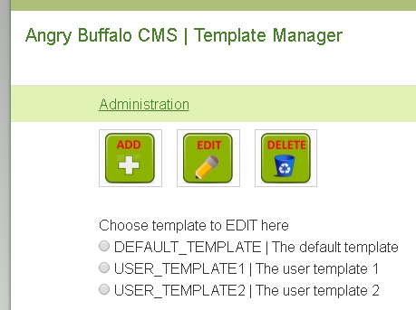  
We have defined 3 templates but by pressing the add button you can define your own templates

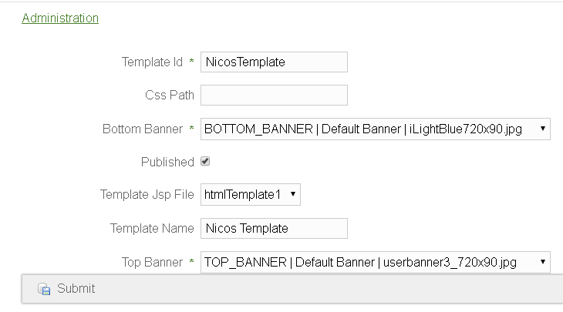

# Chapter 4 Managing the Home Page

## 4.1 Front Page Manager

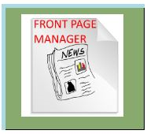You add Articles to the Home Page

This Manager has two Sections for the following aspects:

1. Associate/Change the Template that delivers the Home Page
2. Add or remove the Article Contents to the Home Page

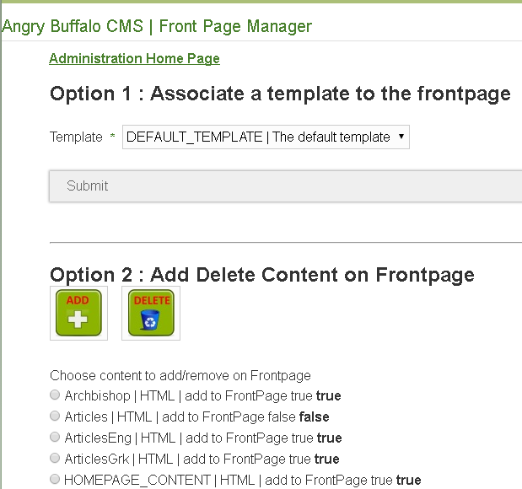

### 4.1.1 Associate/Change the Template that delivers the Home Page

Select the template here:

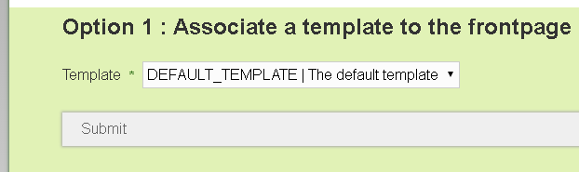

### 4.1.2 Add or remove the Article Contents to the Home Page

Click on the Article then

click the Add (or Delete) button to make that articles to appear in the Home Page.

