**Proxmox and Docker Bible**

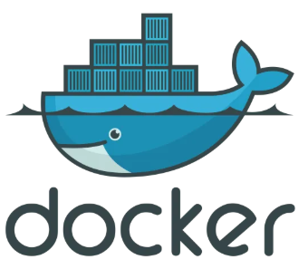

Table of Contents

1 Introduction 2

Chapter 1: What is Proxmox? 3

Chapter 2: Virtual Machines vs. Proxmox LXC Containers 3

Virtual Machines (VMs) 3

LXC Containers 3

Chapter 3: What is Docker? 4

Chapter 4: Installing the Proxmox server 5

Chapter 5: Creating an LXC container in Proxmox 7

Chapter 6: Install Docker in the LXC Container 13

Chapter 7: Docker Training 16

7.2 Using a docker compose file to create the same container 18

Chapter 8: Adding Dockge to Docker 20

8.1 Installing Dockge **You can watch this video to see how we did this** 20

Chapter 9: Our Best Docker Containers for 2025 22

9.1 NextCloud 22

9.2 Homarr 22

9.3 Dockge 22

9.4 Portainer 22

9.5 SmokePing 22

9.7 Droppy 23

Chapter 10: Docker Cheat Sheet 24

Final Thoughts 25

# 1 Introduction

If you are reading this document the you are either interested in setting up your own **Home-lab**  
or you are wanting to replace your **VMware ESXi** server with the best **Open-source**   
**Type 1 Hypervisor VM Server** featuring **LXC Containers** apart from Virtual Machines.  
  
This document is going to explain some of the concepts regarding creating a Docker installation in Proxmox using “Best Practices”

**Installation**   
We will also provide detailed procedures for doing the three installations needed to get Docker to work optimally in Proxmox.   
Firstly we will Install Proxmox then create an LXC container and then we will show you how to install Docker there, and finally we will provide the Best Docker Applications to install.

**Docker Tutorial**  
We will also provide a Docker Tutorial so that you can make use of the Docker installation   
  
**Docker Cheat-Sheet**  
Finally we will provide you with a Docker Cheat-Sheet

And lots of additional Chapters with Interesting things for you

# Chapter 1: What is Proxmox?



Proxmox is an open-source server virtualization platform. It allows users to run and manage virtual machines (VMs) and containers from a central web-based interface. Proxmox combines two virtualization technologies: KVM (Kernel-based Virtual Machine) for full virtualization and LXC (Linux Containers) for lightweight container-based virtualization.

Proxmox VE (Virtual Environment) is popular in homelabs and enterprise environments due to its powerful features, user-friendly interface, and zero licensing cost. It includes built-in tools for backup, snapshots, live migration, clustering, and high availability.

# Chapter 2: Virtual Machines vs. Proxmox LXC Containers

## Virtual Machines (VMs)

* VMs emulate entire hardware environments.
* Each VM runs a full operating system, including its own kernel.
* VMs are isolated and resource-intensive.
* Better for running different operating systems (e.g., Windows on Linux).

## LXC Containers

* LXC containers share the host's Linux kernel.
* They are more lightweight and efficient.
* Faster to start and consume fewer resources.
* Suitable for running Linux-based applications with lower overhead.

In Proxmox, VMs are best for heavy or diverse OS workloads, while LXC containers are ideal for Linux services that benefit from lower resource use and faster performance.

# Chapter 3: What is Docker?



Docker is a platform for developing, shipping, and running applications inside containers. Containers are lightweight, portable, and run the same regardless of the underlying infrastructure.

Unlike traditional virtual machines, Docker containers package only the application and its dependencies, sharing the host operating system's kernel. This makes them more efficient and faster to start.

Docker simplifies application deployment, scaling, and updates. It is widely used in modern DevOps workflows and microservices architecture. With Docker, developers can ensure their applications run the same in development, testing, and production.

# Chapter 4: Installing the Proxmox server



You need to Download the latest ISO file here :   
<https://www.proxmox.com/en/downloads>

We selected this file:  
<https://enterprise.proxmox.com/iso/proxmox-ve_8.4-1.iso>

**Step 1 Create a Bootable Thumbdrive**

You would use balenaEtcher to create the bootable ThumbDrive: <https://etcher.balena.io/>

**Step 2 you need to define the Network Parameters for your server:**

# Hostname(FQDN) :

rhino.loseyourip.com

# IP Address (CIDR) :

10.154.2.188

# Gateway :

10.165.2.3

# DNS Server

8.8.8.8

If you need a DNS name for your Server you can use DynuDNS : <https://www.dynu.com/en-US>

**Step 3 Boot the server from the installation Media**You have 2 choices depending on your hardware :   
1. Install from a bootable USB Thumbdrive  
2. Install from a DVD

Insert the installation media ans start your server  
# Use the Installation media and retart the server hardware

wait for installation software to start

# Choose : Install using Graphical Interface GUI

-> Install using Graphical Interface GUI

# Accept the End User Licence Agreement (EULA)

-> Click Next Button

# Select Country

-> United States

-> New York

# keyboard

-> US

-> Click Next Button

# Enter Password and Email

-> Click Next Button

# Enter FQDN Details (See above) You need to type these values

rhino.loseyourip.com

10.154.2.188

10.154.2.3

8.8.8.8

-> Click Next Button

# You will have a summary ensure this is correct

-> Click Next Button Now watch this video <https://youtu.be/ThyZhVWKiZ4>

# Chapter 5: Creating an LXC container in Proxmox

**We now Install a LXC Container in Proxmox**  
We Open our Proxmox server in the browser:  
<https://upupa.loseyourip.com:8006/>



Step 1: Click on Create Container Button

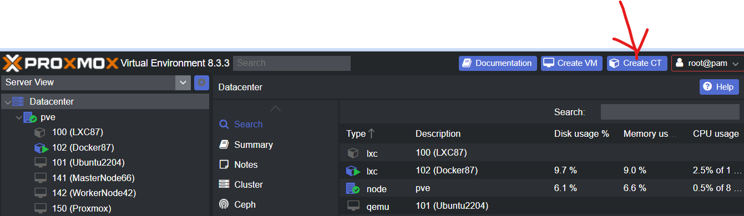

Step 2: Enter Server Name, Password and confirm password then press Next

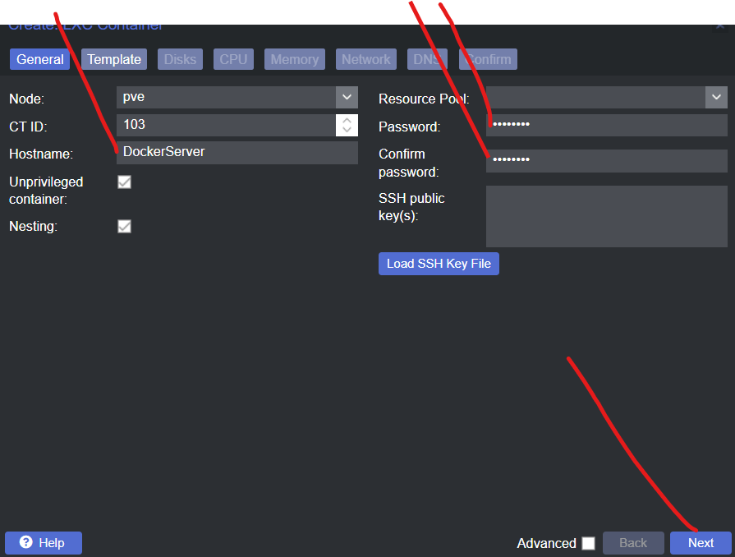

Step 3: Click Template (Dropdown) and select Ubuntu-22-04  
  
Now Click on Next

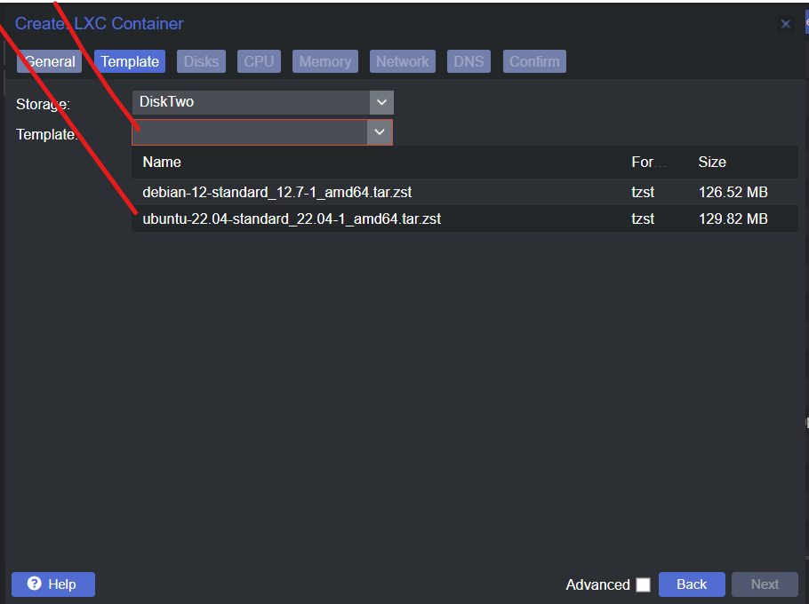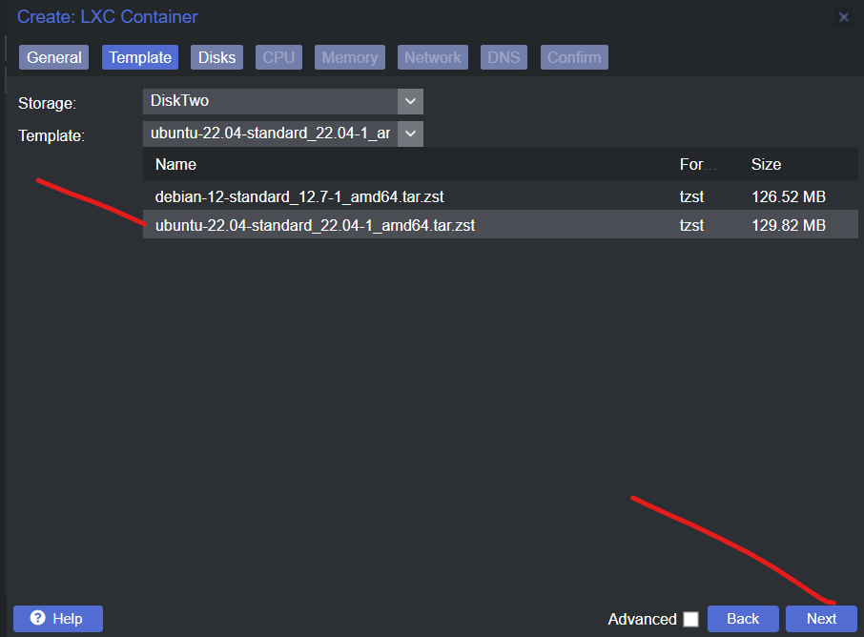

Step 4: Specify Storage 100GB and press Next  
  
Step 5: Unless you CPU has more then one core click Next

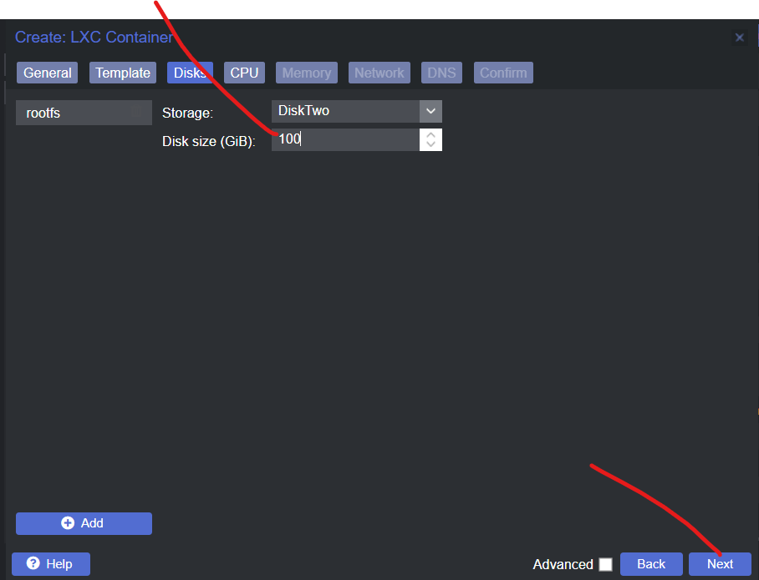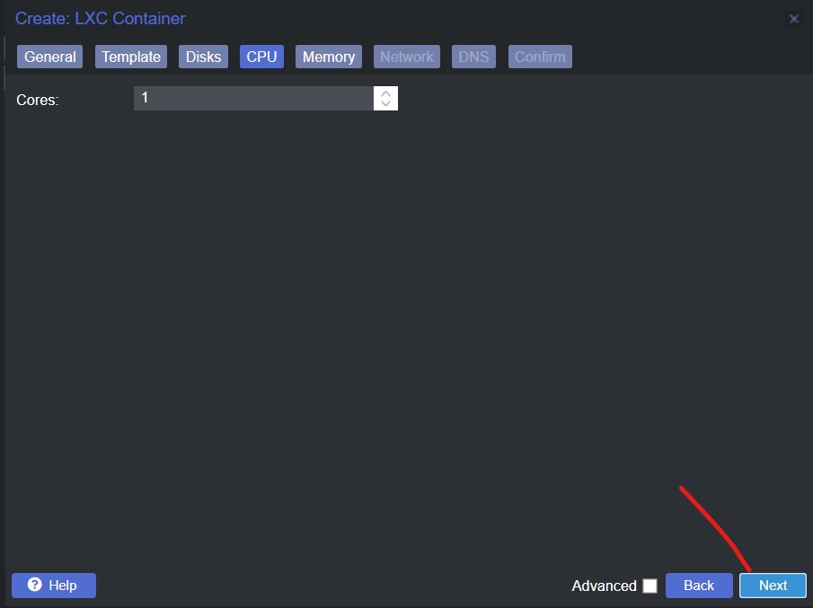

Step 6: Set memory to 8192GB also SWAP to 8192GB and Click Next  
  
Step 7: Enter IP Address followed by /12 and Gateway click on Next

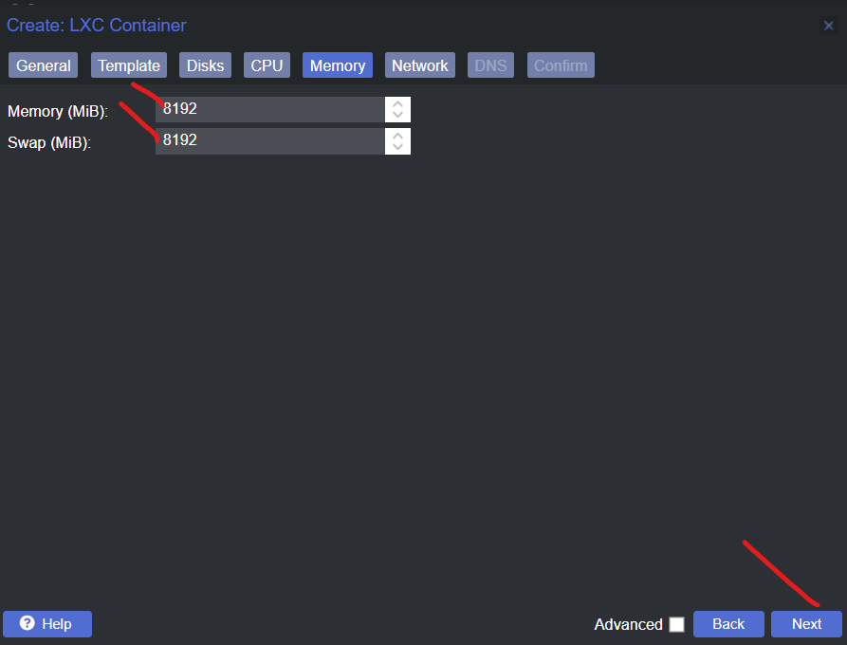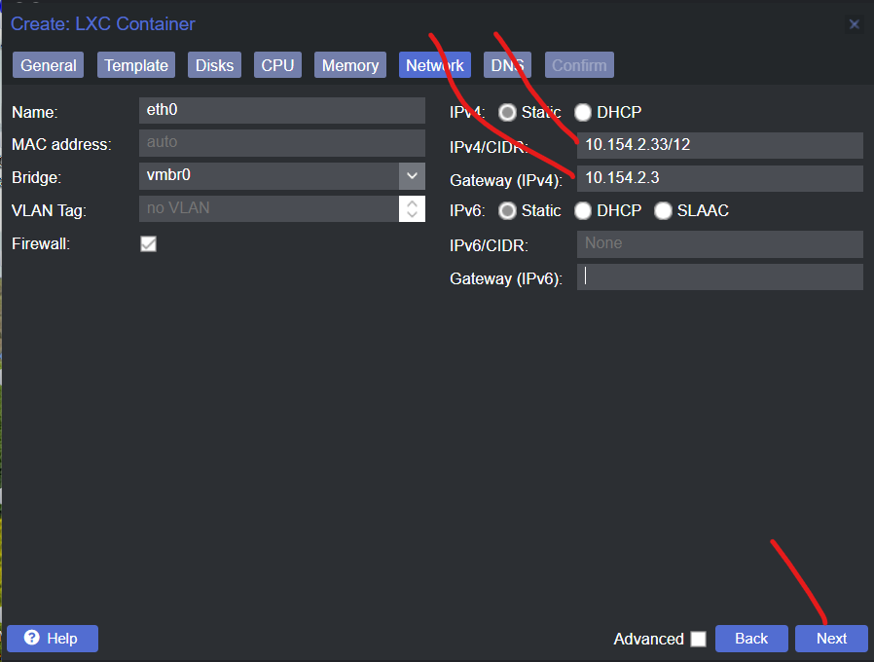

Step 8: Click on Next  
  
Step 9: If you are satisfied with the Server settings Click on Next  
  
Step 10: Click on the LXC server Id 101 the click on Start then click on Console  
  
**Congratulations we now have created an LXC Container in Proxmox**

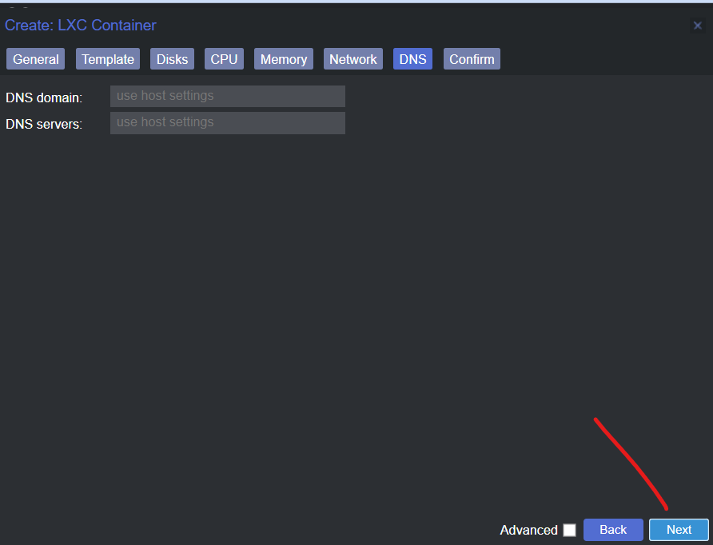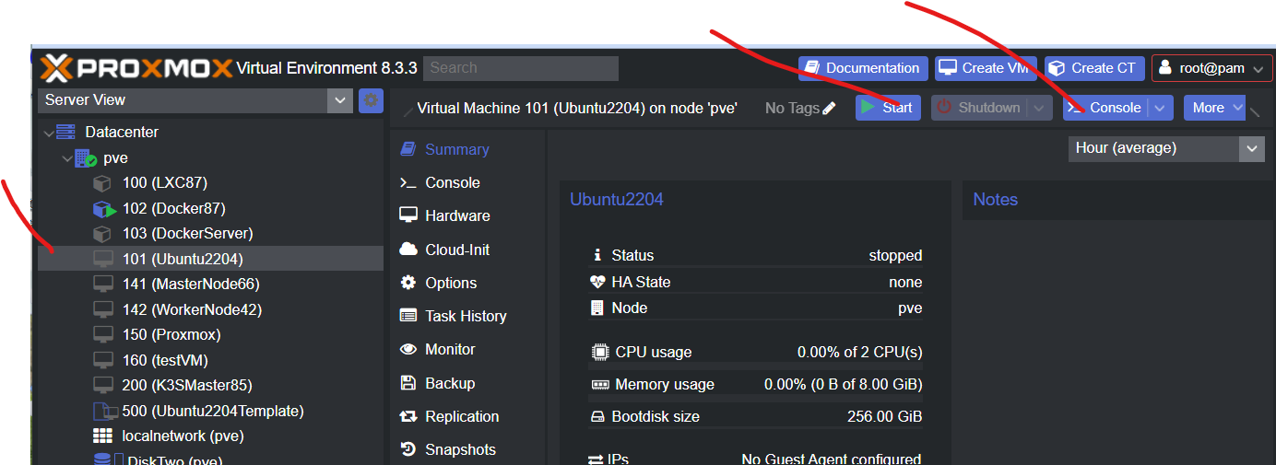

# Chapter 6: Install Docker in the LXC Container

**We now install Docker in our Proxmox LXC Container**



**Start the LXC Containe**r  
Step 1: Click on the LXC server Id 101 the click on Start then click on Console  
  
We now have created the LXC Container



In the Console type these commands:  
sudo apt update -y  
  
sudo apt install apt-transport-https ca-certificates curl software-properties-common -y  
  
curl -fsSL https://download.docker.com/linux/ubuntu/gpg | sudo apt-key add –

sudo add-apt-repository "deb [arch=amd64] https://download.docker.com/linux/ubuntu focal stable"

apt-cache policy docker-ce

sudo apt update -y

sudo systemctl enable docker

sudo systemctl start docker

**Verify the Docker Service has started**

Run this command:  
sudo systemctl status docker  
  
You should get:

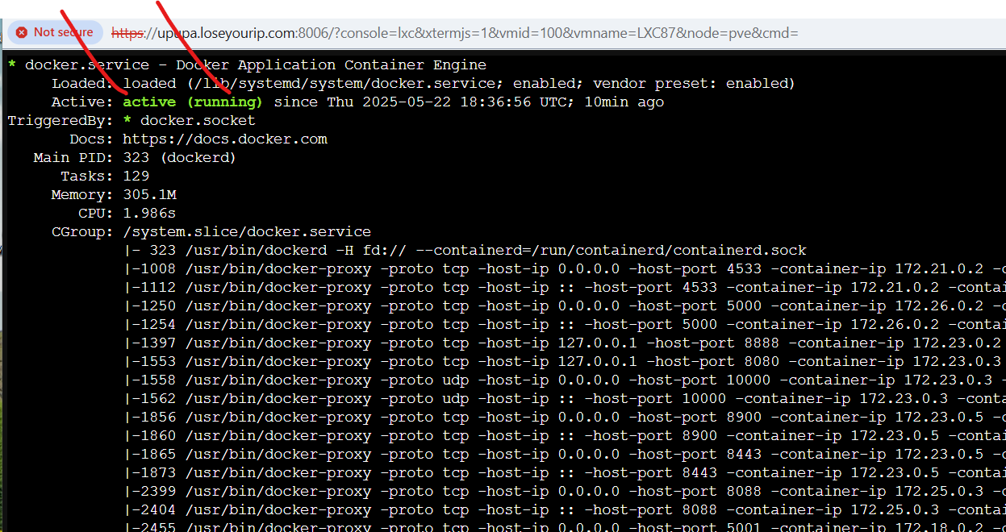

**Test docker is installed properly**

Run this command:  
docker version  
  
You should get:  
  
  
**Congratulations you have now installed Docker.**

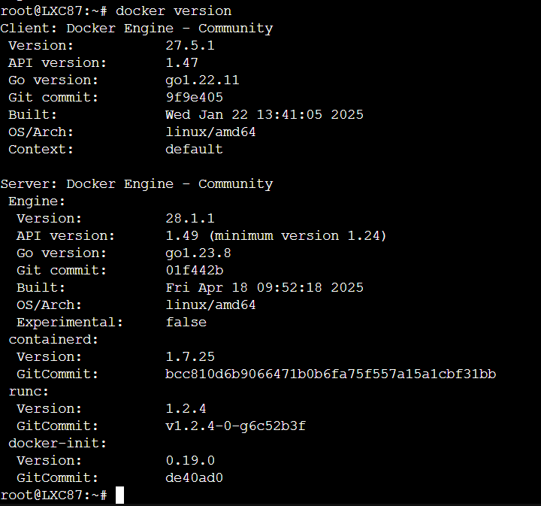

# Chapter 7: Docker Training

Open the LXC Container where you installed Docker:  
Step 1 Select the LXC Container then click on Start then click on Console  
  
  
Step 2: In the console run these commands after logging in



udo su -

mkdir DockerTraining -p

cd DockerTraining

7.1 Creating a simple Ubuntu server using Docker

** 1.1 Created from Docker Commands**

1. Pull the Ubuntu Image:

docker pull ubuntu:latest  
docker image ls

2. Run a Container with Bash Terminal:

# Windows users run :   
winpty docker run -it ubuntu:latest bash  
  
# Mac and Linux users run this command:   
docker run -it ubuntu:latest bash

3. Running commands in the container :

ls -la /home

apt update

apt install curl

4. Deleting the image

ocker ps -a

docker container rm <CONTAINER ID>

docker image ls

docker image rm <IMAGE ID>

docker image ls

## 7.2 Using a docker compose file to create the same container

Run these commands:

mkdir ubuntu -p

cd ubuntu

nano compose.yaml

Put this in the file: (dont add extra spacesthis is a yaml file)

version: '3.9'  
services:  
 ubuntu-server:  
 image: ubuntu:latest  
 container_name: ubuntu_server  
 volumes:  
 - ./data:/opt/data  
 stdin_open: true # Keeps the container interactive  
 tty: true # Allocates a pseudo-TTY

Run the following commands:

# pull the Docker images

docker compose pull

# Start the conatiner in detached mode

docker compose up -d

# To access the container, Windows users run :

winpty docker exec -it ubuntu_server bash

# To access the container, Mac and Linux users run this command:

docker exec -it ubuntu_server bash

# Now Inside the container run these commands:

ls -la /home

ls -la /opt

cd /opt/data

touch test1.txt

docker compose down

If you want to keep this server running then instead of running this command:  
docker compose up  
You run this in detached mode like this:

If you want to watch the video where we did this lesson here is the link:

# Chapter 8: Adding Dockge to Docker



We provide instructions to install one of the finest Graphical User Interface for Docker

## 8.1 Installing Dockge [**You can watch our video to see how we did this click here**](https://youtu.be/YvPpjSEvHQg)

Open the LXC Container where you installed Docker:  
**Step 1 Select the LXC Container then click on Start then click on Console**



**Step 2: Run these commands**

# Create directories that store your stacks and stores Dockge's stack

mkdir -p /opt/stacks /opt/dockge

cd /opt/dockge

# Download the compose.yaml

curl https://raw.githubusercontent.com/louislam/dockge/master/compose.yaml --output compose.yaml

# should you wish to customize this docker compose file

nano compose.yaml (however it is good)

# Start the server

docker compose up -d

Congratulations you have installed the most valuable program in Proxmox

**Step 3: Open Dockge in the browser:**

http://your-lxc-containers-ip-address:5001/

In our LXC server it is:

http://10.154.2.87:5001/

# Chapter 9: Our Best Docker Containers for 2025

## 9.1 NextCloud

By self-hosting Nextcloud, ONLYOFFICE in Proxmox, say goodbye to Microsoft Office 365  
(We used this to replace our Office 365 by self-hosting this)  
We have two videos showing two ways to install this   
(Watch both as we show different features there)  
[**Watch this video 1**](https://youtu.be/f2j1e1ftpUI)  
  
[**Watch this video 2**](https://youtu.be/4FeD1i1MOYQ)

## 9.2 Homarr

Install Homarr one of the most popular Dashboards in Proxmox   
(We us this to provide links and a dashboard to our infrastructure)  
[**Watch this video**](https://youtu.be/eo5TAIKK6D8)

## 9.3 Dockge

One of the Best Graphical User Interfaces for Docker  
(We use it for testing all the Docker containers before we publish videos)

[**Watch this video**](https://youtu.be/YvPpjSEvHQg)

## 9.4 Portainer

One of the Best Graphical User Interfaces for Docker  
(We use this together with Dockge for managing our Docker infrastructure)

[**Watch this video**](https://youtu.be/Jd8OkutJGr0)

## 9.5 SmokePing

An Excellent Network Availability Tools test you local and International Bandwidth and Latency

[**Watch this video**](https://youtu.be/Jd8OkutJGr0)

9.6 Beszel  
A lightweight, self-hosted server monitoring platform   
(We use it to monitor our Docker containers)

[**Watch this video**](https://youtu.be/FAO0Gr9SVsg)

## 9.7 Droppy

A self-hosted file storage server with a web interface to replace OneDrive.   
(We use this to share files and collaborate)

[**Watch this video**](https://youtu.be/ixpQjccC9qI)

# Chapter 10: Docker Cheat Sheet

**Manipulation Commands**

docker image ls (This lists all the docker images)

docker image rm IMAGE-ID (this deletes a docker image)

docker ps (This lists all docker instances that are running)

docker ps -a (This lists all the docker images even those that are note running)

docker container ls (this lists all docker containers)

docker container stop CONTAINER-ID

docker container rm CONTAINER-ID

docker container stop CONTAINER-NAME

docker container start CONTAINER-NAME

**Creation commands**

docker build -t IMAGE_NAME:version (this builds a Docker image from a Dockerfile)

docker build -t stubservice:latest .

docker compose up (This starts a docker container)

docker compose up -d (This starts a docker container in DETACHED MODE)

docker compose stop

docker compose start (This starts a docker container after it was stopped)

docker compose down (this stops the container and deletes the image)

**Connect to the Containing servers of Docker containers**

docker run -it ubuntu:latest bash | create container from image and connect to its containing server

docker exec -it ubuntu_server bash | connect to containing server of existing and running container

**Accessing the Logs**

docker logs CONTAINER-ID

# Final Thoughts

Thank you for your interest in our video and downloading this document.  
Please visit our YouTube Channel and subscribe and watch our videos from start to end as we have not met our target for hours viewed.  
  
Please leave us a comment on one of our YouTube videos after watching it.  
  
Our YouTube Channel<https://www.youtube.com/@dvp7388>