CprE 381, Computer Organization and

Assembly Level Programming

Lab 1 Report

Student Name _________Nicaela Rose___________

Submit a typeset pdf version of this on Canvas by the due date. Refer to the highlighted language in the lab document for the context of the following questions.

[Part 1.c] Think of three more cases and record them in your lab report.

Case 1: Setting the Associated Weight Load Control Signal iLdW to 10 for there to be a change in weight.
- With setting the weight data initialization to 3 and the Activation input to 6 and the partial sum input to 9. The weight iLdW is set to 10 causing a change in the weight data initialization.
- I expect the Weight Data to be changed to 13 = 3 + 10 after setting the weight data initialization to 10. This would cause the partial sum output to be a bigger value since we are using the value of iLdW rather than just the value of iW.

Case 2: Perform a MAC operation that will have the partial sum output equal to 200 by the summation of both the partial sum output and the partial sum input.
- Set the weight by setting iLdW = 1 and setting iW = 2. The activation input iX will be set to 50 and then the partial sum iY will be set to 10
- I expect that, after two positive edges of the clock, the activation output, oX, will be 2 and the partial sum output, oY will be 2*50+10=110.
- The next operation will use the partial sum output oY, the partial sum input iY=110, and the activation input iX=45
- I expect that, after two positive edges of the clock the activation output oX will be equal to 45 and the partial sum output will be 2*24+110=200.

Case 3: Perform one MAC operation that has the partial sum output equal to my birthday.
- I expect that, after two positive edges of the clock, the partial sum output oY will be equal to the same day of my birth which is 22499 = 100*220+499
- Initialize the weight register by setting iLdW to 1 and iW with the value of 220. Then set the activation input iX to 90, and the partial sum input iY to 25.

[Part 1.e] For labels 9, 20, 32, and 33, specify where (VHDL file and line number) these values are located – some will be found in more than one place. Also attempt to explain the functionality of each label as it occurs in the code

- Label 9 – oQ
  - From looking at the code, oQ is an output integer in both the Reg and RegLd components in the TPU_MV_Element.vhd. I assume that the label output oQ then will be s_W, s_X1, s_Y1, and s_WxW or becomes connected somehow.
- Label 20 – iD
  - Alike from label 9, iD is also in both the Reg and RegLd components however instead of an output, it is an input integer. iD is then connected to iX and s_X1 as internal signals.
- Label 32 – g_Add1
  - The component g_Add1 has the functionality implemented in Adder.vhd. This label has two integer inputs iA and iB and the integer output of oC. The functionality based on the code if the rising_edge f iCLK is true then the output oC would equal the summation of both iA and iB.

- Label 33 – TPU_MV_Element
  - The TPU_MV_Element label is the entity in the code with a total of 7 ports. These ports include inputs iCLK, iX, iW, iLdW, and iY. It also has outputs of oY and oX. The functionality is the overall implementation of a processing element for the systolic matrix-vector multiplication array.

[Part 1.g.v] In your lab report, include a screenshot of the waveform. Describe, in plain English, any differences between what you expected and what the simulation showed.

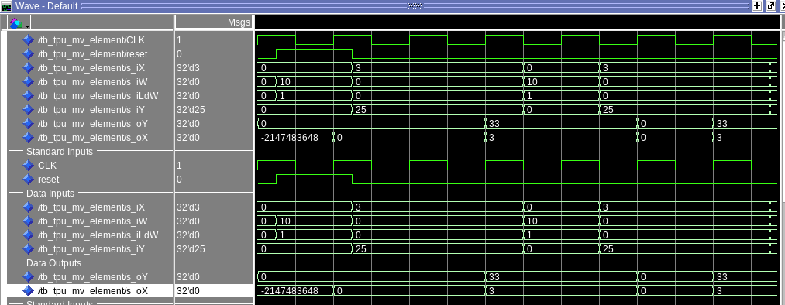

I expected the Partial Sum Output oY to be 55. Instead, in this screen shot I am getting the value of 33.

[Part 1.h] In your lab report, include a screenshot of the waveform. Describe, in plain English, how your waveform matches the expected result (e.g., reference the specific cycles and times). In your submission zip file, provide the completed TPU_MV_Element.vhd file in a folder called ‘MAC’.

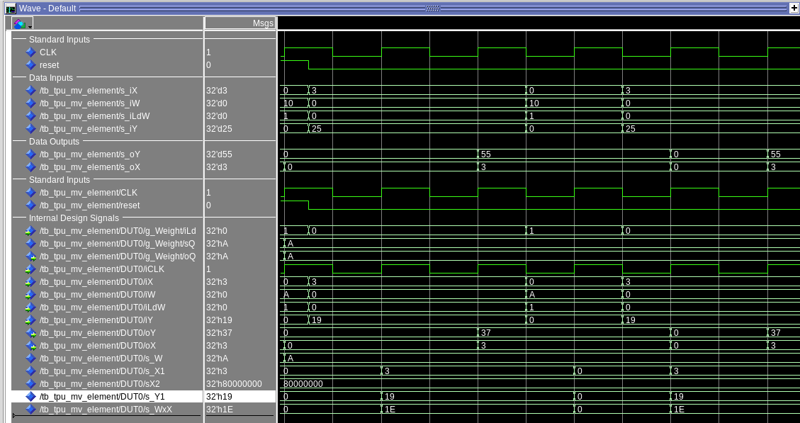
The screen shot of the wave form I have attached matches the expected result because the Partial Sum Output oY is now 55 instead of the previous output of 33. This shows after initializing the Weight to 10, the Activation input to 3, and the Partial Sum input to 25, after two positive edges of the clock/2 cycles, we get the output oX = 3 and oY = 55. The Partial Sum output is calculated after multiplying the Weight by the Activation input and then adding the Partial Sum Input ((10 * 3) + 25).

[Part 3.a] Draw the truth table, Boolean equation, and Boolean circuit equivalent (using only two-input gates) that implements a 2:1 mux. Include this in your lab report.
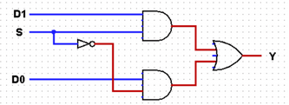
i_S i_D1 i_D0 | o_O
0 0 0 | 0
0 0 1 | 1
0 1 0 | 0
0 1 1 | 1
1 0 0 | 0
1 0 1 | 0
1 1 0 | 1
1 1 1 | 1
o_O = ((i_D1)(~i_S) + (i_D0)(i_S))

[Part 3.d] In your lab report, include a screenshot of the waveform. Make sure to label the screenshot with which module it is testing.

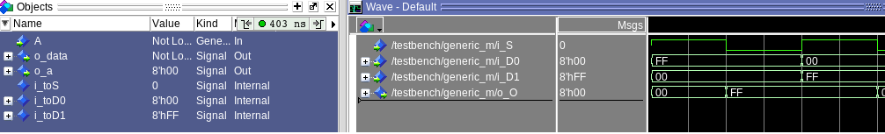

[Part 3.e] Again, in your lab report, include a labeled screenshot of the waveform showing the dataflow mux implementation working.

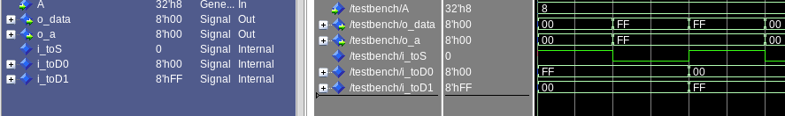

[Part 4] Include a waveform screenshot and corresponding description demonstrating it is working correctly.

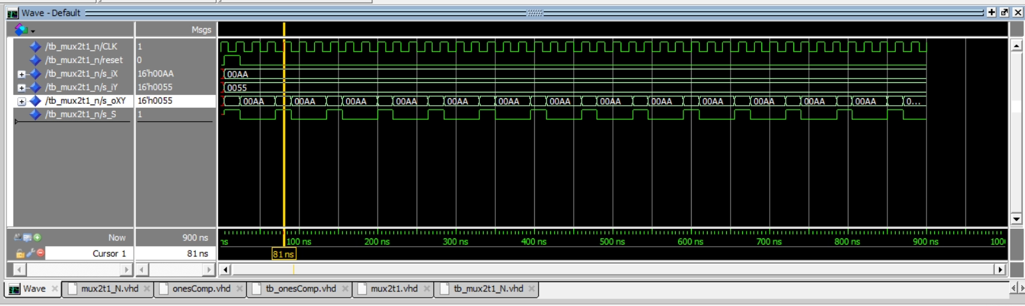

By switching between 2 different inputs from bit 0 to 1, the s_S bit goes to 1 in the screenshotted waveform. Here, the output s_oXY changes from 0x00AA to 0x0055

[Part 5.b] Include a waveform screenshot and description in your lab report.

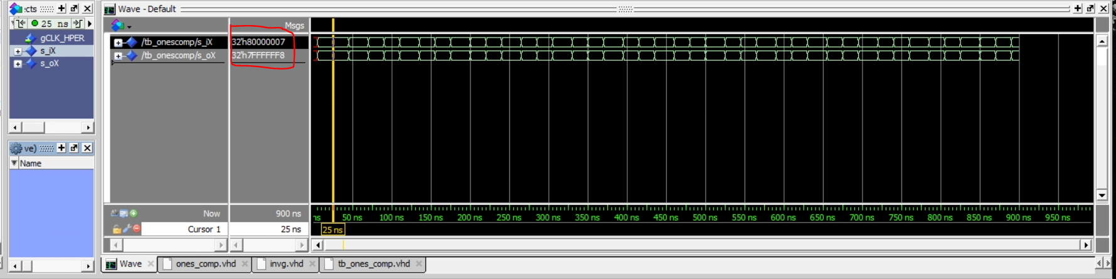

Here, s_iX was 32’h800000000007 and now it is 32’h7FFFFFFFFFF8

[Part 6.a] A full adder takes three single-bit inputs and produces two single-bit outputs – a sum and carry for the addition of the three input bits. Draw the truth table, Boolean equation, and Boolean circuit equivalent (using only two-input gates) that implements a 1-bit full adder. Include this in your report.
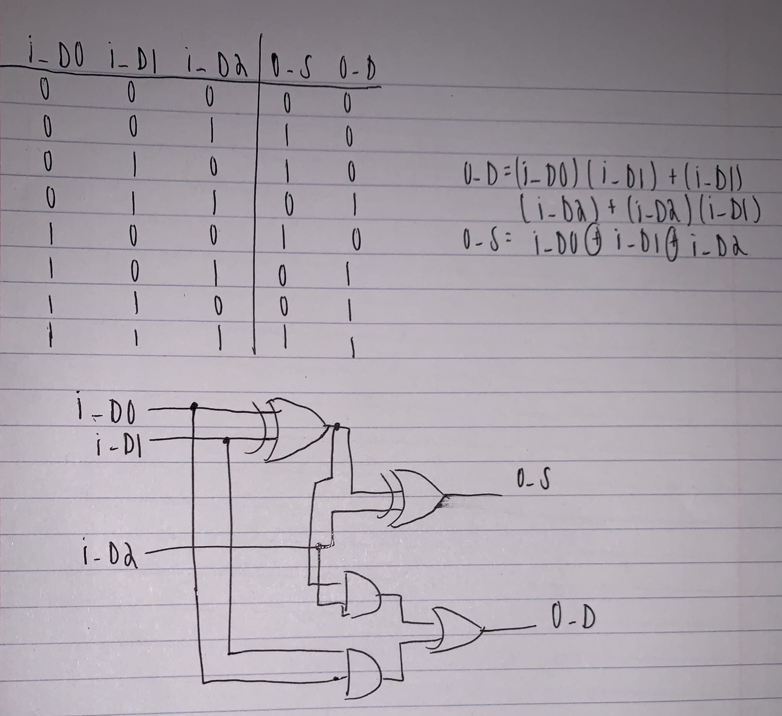

[Part 6.c] Then draw a schematic of the intended design, including inputs and outputs and at least the 0, 1, N-2, and N-1 stages. Include this in your report.

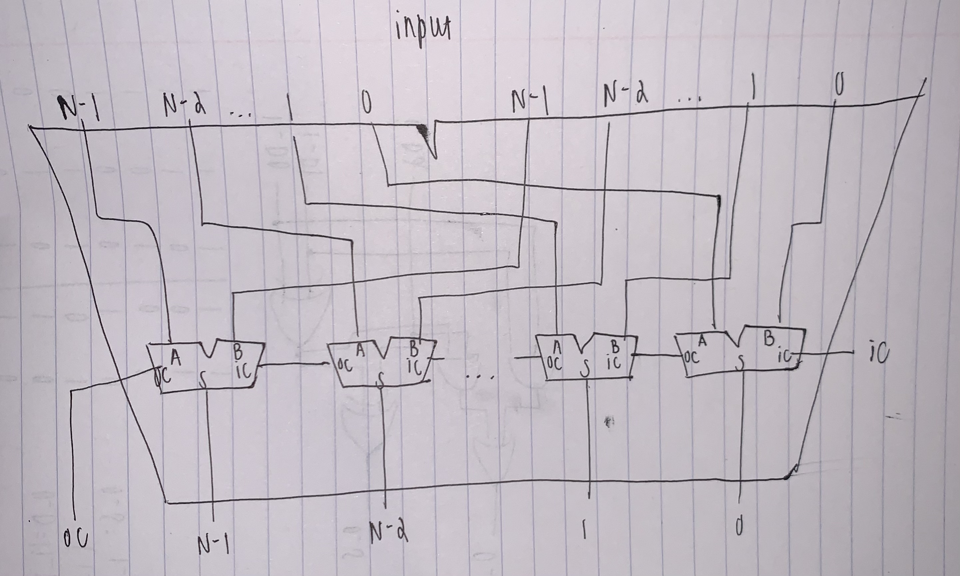

[Part 6.d] Include an annotated waveform screenshot in your write-up.

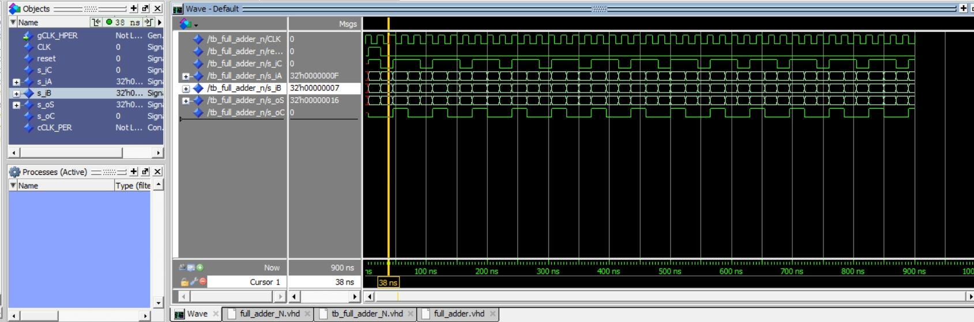

[Part 7.a] Draw a schematic (don’t use a schematic capture tool) showing how an N-bit adder/subtractor with control can be implemented using only the three main components designed in earlier parts of this lab (i.e., the N-bit inverter, N-bit 2:1 mux, and N-bit adder). How is the ‘nAdd_Sub’ bit used? Include this in your report.

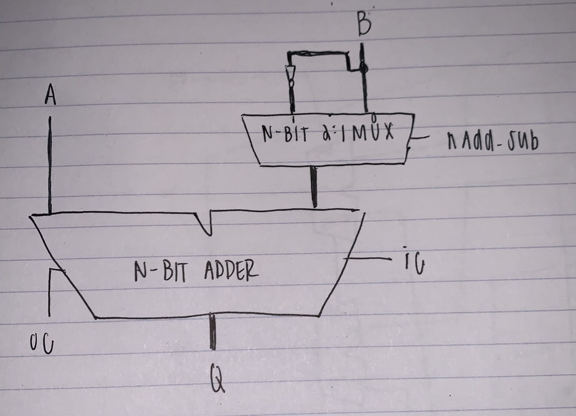

[Part 7.c] Provide multiple waveform screenshots in your write-up to confirm that this component is working correctly. What test-cases did you include and why?

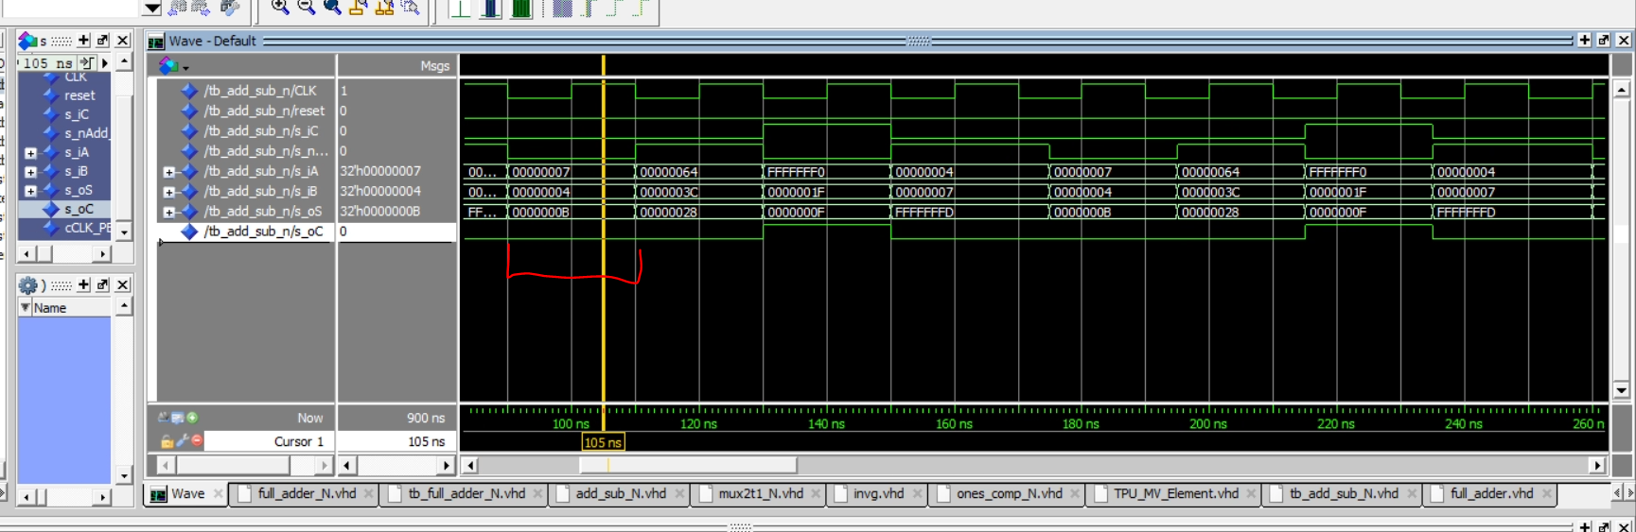

Test case: Addition. 0X7 + 0x4. Outputs: o_S = 0xB and o_C = 0. This successfully shows a simple addition problem

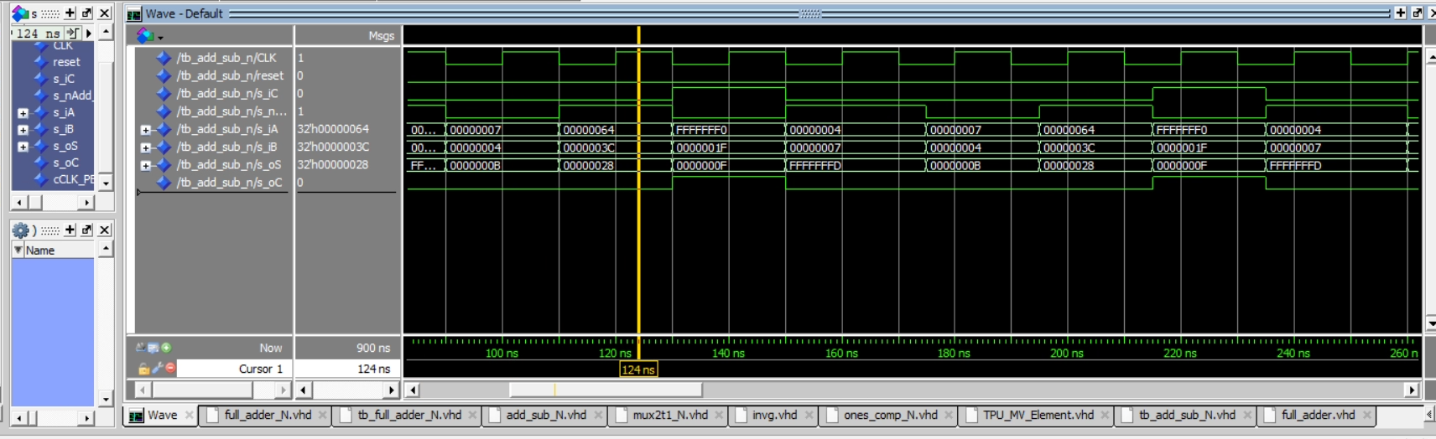

Test case: Subtraction. 0X64 – 0x3C. Outputs: o_S = 0x40. This successfully shows a simple subtraction problem.

