Mobile Develpoment Process Spiral
Ann Nosseir¹, Derek Flood², Rachel Harrison³, Osman Ibrahim¹
British University in Egypt¹ Dundalk Institute of Technology²
Oxford Brookes University³
ann.nosseir@bue.edu.eg; derek.flood@dkit.ie; rachel.harrison@brookes.ac.uk; osman.ibrahim@bue.edu.eg

Abstract—Recent advances in mobile technology have led to ever-increasing demands for specialized software for these devices. Furthermore, the need for mobility has introduced unique constraints such as context, connectivity, size, different display resolution, and data entry methods that impact on the apps’ usability. These constraints can create usability errors that could increase the risk levels especially in contexts like finance, health, or road navigation. the desire of Enterprises to embed their mobile apps’ development into their business cycle increases the need to have a specialized software development process. Although many agile methods have been introduced over the last decade, none of methods has focused on reducing usability errors. This paper proposes a novel Mobile Development Process Spiral which is a Usability-Driven-Model. The process is designed to integrate usability into existing application development process and recommends usability techniques to assess mobile apps.

Keywords; mobile software development, spiral model, user center design, usability

Introduction:

Recent advances in technology have increased the capability of mobile devices while simultaneously reducing the amount of space necessary for such devices, allowing them to be used while on the move [1]. There is a rapid growth of the number of the customers. There are 5.3 billion mobile subscribers i.e., 77 percent of the world population [2]. In 2010, Mobile devices’ sales rose with a strong growth in sales of smart phones.The main functionality of smart phones is to be reached and reach others wherever users are. Broadband and wifi Internet access has increased mobile Internet usage as it allows mobility, quick responses, time management and communication [2]. Adding more features such as GPS, Camera, and Bluetooth allowed more mobile apps to be developed in the domains like gaming, entertainment, banking, finance, sports, music, travel, health, and personal care.

Enterprises started to see the potential of using mobile apps in their business cycle. For example, “Pizza Hut CIO, Baron Concors confirmed that Pizza Hut foresees the mobile experience as an extension of the brand. payment capability over the mobile phone (via web-based payment gateways or Near-Field Communications (NFC)), location-based messaging, and mobile chat features round-up the other three major elements of a mobile retail platform strategy[2].”

ABI Research recently released a report which predicts that the sports and health mobile app market is on pace to hit $400 million in revenues by 2016[2]. Realising the advantages of mobile apps, more resources are allocated to improve the company’s standards.

This progress has pushed the software application market to boom and more specialized mobile software companies are evolving. To comply with the market pace and competition, these companies apply a rapid software development process cycle such as agile software development. However this approach usually does not allow detailed evaluation to minimize mobile apps problems and errors.

Although the processing power of mobile applications has greatly increased in the last few years, the features of the mobile device (such as size) have introduced many usability constrains. One of the most common tasks for tourists while on holidays is navigation around an unknown location. Through the use of GPS (Global Positioning Satellite) technology, users can use mobile devices to find their current location, plan a route to their destination or to find points of interest. The limited screen size of these devices however can make it difficult for users to read on-screen maps.

As well as navigation, mobile devices can also be used for searching the Web. The small screen size coupled with the limited interaction methods and poor connectivity however, affect the users’ ability to successfully search for specific pages and to find the information they require on these pages.

The examples presented above are just some of the unique constraints imposed by mobile devices that impact on the usability of these applications. Zhang and Adipat [3] detailed a number of these challenges.

- Mobile Context: When considering mobile applications the user is not tied to a single location. This also includes interaction with nearby people, objects and environmental elements which may distract the users’ attention.
- Connectivity: With mobile devices connectivity is often slow and unreliable and therefore will impact the performance of mobile applications which utilise these features.
- Small Screen Size: In order to provide portability mobile devices contain very limited screen size meaning that the amount of information that can be displayed is drastically reduced.
- Different Display Resolution: The resolution of mobile devices is reduced from that of desktop computers resulting in a lower quality images.
- Data Entry Methods: The input methods available for mobile devices are difficult and require a certain level of proficiency. This problem increased the likelihood of erroneous input and decreases the rate of data entry.

These challenges could increase the risk levels especially in contexts like finance, health or road navigation. For example, mobile apps such as spreadsheet applications are frequently used in calculating company budget, class marks, etc. Implications of a data-entry error in exam scores or company budget sheets increase the risk of public embarrassment, loss of confidence, or loss of financial control. Similarly, elderly patients who use mobile apps to remind them of their medication timetable and quantity may find the limited screen size a challenge. This also applies to navigation apps and maps..

To reduce the risk, detailed and profound usability tests and evaluation are needed. Evaluating the apps at several levels, while developing apps, may minimise usability errors. This paper describes a Mobile Development Process Spiral which is a Usability-Driven-Model. The process is designed to integrate usability into existing application development processes.

Section 1 lists the current suggested mobile development processes and addresses the reasons and the future needs for a spiral process. Section2 defines the main usability principles in the context of mobile application usage. Section 3 presents the usability main steps and describes how to incorporate these steps into the suggested spiral process. Section 4 suggests usability techniques to use to evaluate mobile apps. The Final section discusses the implementations of this idea and presents the concluding remarks.

We use the spiral development model as the base model for incorporating usability assessment. The Spiral Model of software development [4] is a refinement of the classical Waterfall model. The spiral model has the advantage of combining the approach of iterative development of several prototypes with the systematic and controlled aspects of the waterfall model. Therefore, it is based on continuous refinement of requirements followed by design, and implementation. It is reported in [4] that the spiral model is ranked the second among four other models when it comes into integrating usability to the regular practiced development process.

a mobile spiral development model

The current mobile development processes suggested such as D-Mobile [5], a software engineering process model [6]for mobile applications and hybrid methodology design process [7]are optimized for a team of less than ten developers working in a co-located office space. App developers are usually Small to Medium Enterprises (SME), aiming at delivering a fully functional mobile application in a short time. They usually apply agile methods and have a set of different iterations or phases [5][6]&[7].
For example, the D-mobile [5] is based on day iterative development and has five phases. These phases are: set-up, core, core2, stabilize, and wrap-up. Each phase consists of three different types of development days: Planning Day, Working Day, and Release Day. If multiple teams are concurrently developing different parts of the same product, an Integration Day is added.

Software engineering process model [6] for mobile applications has three iterative phases which are Phase1: Feasibility and economic efficiency analysis, phase2: Software product Realisation and phase 3: Distribution phase. The hybrid process [7] starts from the an abstract level and the scope encompasses the whole lifecycle, as design progresses to lower levels of abstraction, priority is gradually shifted to requirements with finer-grained aspects. The model descries four iterations levels to reach this granulate.

The advancement of mobile technology and widespread usage of mobile apps has led to the use of mobile applications in contexts such as large corporations, where apps may be used to access corporate databases, exchange information, and conferencing, etc. Apps can be used to manage large systems in the industrial sector and in the financial sector to access or alter data. In that respect, the risk of usability failure could have critical consequences. In a recent study [8] we catalogued usability errors which occurred when subjects used spreadsheet apps. These errors may have led to catastrophic problems like overestimation of annual budgets or sever usability errors such as failure to view or alter a spreadsheet because the functions are not clear[9] or users’ frustrations that could lead to abandonment of the applications. Obviously, to meet usability requirements the development process goes through several cycles of developing a prototype and evaluating it. With our spiral process the software development will go through several iterations to improve the software quality and reduce the usability errors. The app will have alpha and beta versions to test usability problems (see Figure 1).

Our process model is most appropriate for large, expensive, and complicated projects as it is intended to be a risk reduction model. Our model is a user-centered iterative process model that is based on the premise that users should be involved throughout the design life cycle. The process is highly iterative; so that the design can be evaluated with users to make sure it meets the users’ requirements.

The spiral model has several iterations each producing prototypes that will help the user evaluation. In order to ensure implementing a user center design, we need to identify the main usability attributes and the right approach to assess mobile applications. The following section lists the usability attributes, sets the steps to develop and use usability metrics, incorporates these steps into our spiral model, and recommends techniques to guarantee minimizing usability errors.

Usability Attributes

ISO (ISO/IEC 1998) [10]specifies a standard for usability and identifies three attributes to assess usability: Effectiveness (the ability of a user to complete a task in a specified context), Efficiency (the ability of the user to complete their task with speed and accuracy), and Satisfaction (the perceived level of comfort and pleasantness afforded to the user through the use of the software.)
In an earlier theory on usability presented by Nielsen [11], he adds three additional attributes of usability, which are learnability, memorability, and errors. Learnability is the ease with which a user can gain proficiency with an application; Memorability is the ability of a user to retain how to use an application effectively; and Errors reflects the user ability to finish the task with fewer errors. The context for mobile applications is particularly important as the same application can be used in many different contexts, and so it must achieve a reasonable level of usability in all these. For example, a user may be using a stereo while simultaneously driving a car. In this scenario, it is important that the cognitive load required by the mobile application does not detract greatly from the primary task. In that respect, the context emphasises the need to consider the Cognitive load, which refers to the amount of cognitive processing required by the user to use the application. These seven attributes i.e., effectiveness, efficiency, satisfaction, learnability, memorability, error, and cognitive load can be used to assess the usability of mobile applications. Furthermore, Ju et al added predictability, structure principle, consistency, familiarity, recognition, visibility, simplicity, subsitutivity, feedback, error indication, synthesizability, responsiveness, recoverability, flexibility user control, customizability, and effort. These attributes are grouped into five categories1.Cognition support, 2.Information support, 3.Interaction support, 4. User support, 5. Performance support (i, Y. G. Park, J. H. Lee, C. Yun, M. H..) . Although this category is comprehensive, it misses adding users’ satisfaction and cognitive load. In that respect, we add satisfaction to user support category and cognitive load to Cognition support category.

The process of developing the usability metrics

Using the previous attributes to define mobile application usability allows mobile application developers to define the usability criteria the app must meet. Additionally we can define a set of measurements to evaluate the extent to which these criteria have been met in the final app.

The process is comprised of the following steps:

- Identify all users, tasks and contexts in which the application will be used;
- Define a metric to measure each usability attribute
- Prioritise the attributes of usability;
- Specify an ideal and acceptable values for the metrics;
- measure the actual value;
- Calculate the rating of each attribute;
- Compare the rating with the previous phase
The first step is to identify the users, tasks and contexts in which the mobile application will be used. In terms of usability, the combination of each of these factors will produce a different set of acceptable usability criteria. For example an acceptable level of efficiency while walking will be different than an acceptable level of efficiency while stationary. As well as this, the performance of a novice user will be different than that of an experienced user.

If an excessive number of profiles are created, it may be possible to group some of these profiles together when considering the usability of the application.
When considering mobile applications, there are many contexts in which the system may be used. For example a user may send a text message while stationary, i.e. sitting at a desk or while standing at a bus stop; or they may be moving, i.e. walking or driving. In these contexts the acceptable levels of usability may vary.

The next step is to prioritize the attributes of usability in terms of the application under development. Some attributes may not be as important as others and it is therefore necessary to identify which attributes are most important for the app. For example if a system is designed to be used infrequently, Learnability and Memorability will be very important, where as if a system is to be used regularly effectiveness and efficiency may be most important.
For each of the attributes, a metric is needed to measure each of the attributes. These metrics will be used to quantify how well the app performs in terms of each of the attributes of usability. For example, the efficiency of the app could be measured using the time taken by users to complete the task.

A set of usability criteria will then be specified for each user, performing each task in each context. Therefore if two user groups are identified, each performing two tasks, in two unique contexts then 8 unique sets of attributes will need to be defined. It may be found that some combinations of user/task/context will produce the same set of usability criteria. This will need to be determined in the context of the application under development.

Usability Mobile Development Process Spiral

The complexity of the human side in human computer interaction makes it almost impossible to create a mobile app with few usability problems at the first trial. Combining the spiral model development process [12] and the steps to assess the development is a novel approach which may reduce the number of usability problems in mobile apps. Each iteration of the spiral model has four parts namely requirements definition and analysis, design, implementation and testing and planning the next iteration.

With the progress in this spiral, more usability details will appear. Usability assessments, in the spiral model, are iterative and use a reference in time to compare the results and amend and improve the metrics. In the following sections, we present the spiral mobile development process and the main activities in each phase incorporating the usability metric development and assessment.

The steps of developing the metrics and assessments are integrated as follows:

First iteration:
    - Determine requirements: The phase starts by collecting system requirements and identifying all users, tasks and contexts in which the application will be used. Then, defining and prioritising the attributes of usability and identifying a metric to measure each attribute; specifying an ideal and acceptable value for each metric;
    - Design: The first iteration of the design will be at the level of developing and sketching a low fidelity prototype of the app interface;
    - Test: Upon development of the prototype, the developers will use different usability techniques to measure the actual value of each attribute and calculate the rating of each attribute;
    - Plan next iteration

Second iteration:
    - Determine requirements: in this phase, the developing team will have a better idea of what the usability requirements are for the system although the design requirements will not be complete. In that respect, step 1 will be repeated and the developers will collect more data and app requirements and explore whether there are more potential users, tasks and contexts in which the application will be used. Then, the attributes of usability are redefined and prioritised. As a result, developers alter the metrics to accommodate the added requirements and specify an ideal and acceptable value for each metric;
    - Design: at that level, developers start to develop a high fidelity prototype focusing on the interface.
    - Test: Upon development of the prototype, using the usability techniques the actual value of each attribute will be measured and the rating of each attribute will be calculated and compared with the previous iteration results.
    - Plan next iteration

Third iteration:
    - Determine requirements: In this iteration, most of the design requirements are becoming more clear and by using the earlier iteration results, developers can identify and prioritise the attributes of usability, define a metric to measure each attribute and specify an ideal and acceptable value for each metric;
    - Design: here the whole system is developed and the alpha version is realized.
    - Test: Upon development of the alpha version, the developing team use usability techniques and measure the actual value of each attribute, calculate the rating of each attribute and compare rating with the previous iteration.
    - Plan next iteration
Fourth iteration:
    - Determine requirements: In this phase, the results of the previous iteration are used to identify and prioritise the attributes of usability and define a metric to measure each attribute and specify an ideal and acceptable value for each metric;
    - Design: with the results, the Beta version is developed and released to be evaluated
    - Test: Again using the usability techniques we measure the actual value of each attribute, calculate the rating of each attribute and compare the rating with the previous iteration.
    - Plan next iteration

Fifth iteration:

- Determine requirements: the results of the previous iteration are used to identify and prioritise the attributes of usability and define a metric to measure each attribute and specify an ideal and acceptable value for each metric;
- Design: final product is developed
- Test: a usability assessment is done using the measure of the actual value of each attribute, calculate the rating of each attribute and compare the rating with the previous phase. An alteration to the final product is done based on the results and released to the product
- Plan a final report of the results is issued
Our novel spiral mobile development process makes an expensive use of usability techniques. Therefore, the following section lists the most commonly used and recommends a few of them. The Usability literature offers numerous techniques to be used for different project characteristics and for different usability purposes. However, we have chosen the ones that can be applied with moderate usability training and the choice will be based on the application and the context of use. Table 1 summarizes these techniques and structures them according to the Usable Spiral Mobile Development Process iterations and phases and where they can be applied.

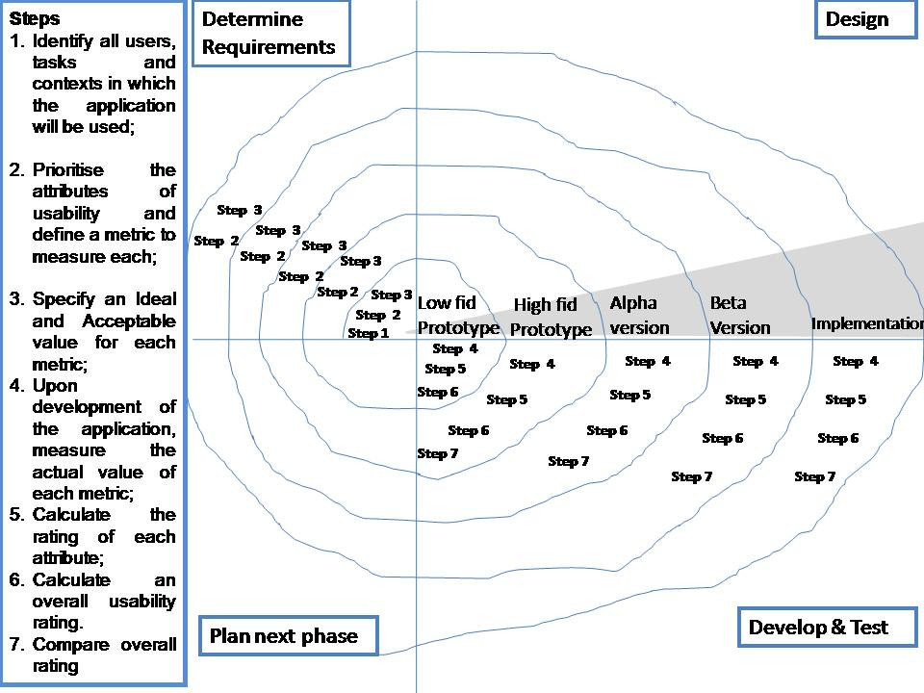

- Mobile Development Process Spiral .Phase 1: Determine Requirements
In the first iteration, to determine the Usability Specifications that includes definitions of all users, tasks and contexts and usability metrics to measure each attribute the following techniques can be used. The activity of application scope definition will be highly dependent on the kind of application to be built [13].

In the case of the development of innovative application the set of techniques known as Holistic Design [14] can yield an adequate definition of what the system will do and what it will be like and the “Product Vision” can be set [15]. For applications built from scratch, but not necessarily innovatively, Needs Analysis [16] would be sufficient. User Analysis can be performed for in-site developments or tailored systems by means of site visits, being a variant of them the Contextual Design approach [17]. For commercial products, with a broad range of users Market Analysis is more appropriate [18]. To help make the whole development process user centered, the technique of "personas" can be employed [19]. In the case of large development team involvement, Operational Models [16] can be used to represent how an organization can operate across process, organization, technology domains in order to deliver value defined by the organization in scope. In general, to determine the requirements, Data Collection Techniques such as observations, ethnography, and interviews are used to collect data about users, context, and tasks. Furthermore, Detailed Use Cases [19] for most systems would be useful to determine the system requirements. Finally, Usability Specifications are developed using the usability attributes and the usability metrics to investigate the performance of particular aspects of a working system.
In the second iteration, in order to clarify and refine the details of the usability specifications, i.e., definitions of all users, tasks and contexts in and usability metric to measure each usability attribute, there is a need to collect more requirements. The selection of the technique will be based on the nature of the interface and the system requirements. Generally, Data Collection techniques such as Ethnography, Observation, Interview, and Scenario [14], [16],[19] and [20] are helpful to collect more details. To have a deep understanding of user interaction a Contextual Inquiry [19] could be used. In that respect, the researcher watches the user do their normal activities and discusses what they see with the user. Post-It Notes or Card Sorting [19] can be used to attain a better understanding of users’ expectations and terminology how they group and label topics. Brainstorming supports a group to find a solution for a specific problem by gathering a list of ideas spontaneously contributed by its members. In the following iterations, the Usability Specifications are developed from the feedback from the elevation phase to be considered in the interface design and implementations.

Phase 2: Design
In all the iterations, the same techniques will be used to specify tasks, perform tasks and consider the information gathered by the previous activities. Techniques such as BNF Grammars, Menu-Selection and dialogue box tree, Context navigation map, Interface transition diagrams, Cognitive Task Analysis (GOMS), Hierarchal Task Analysis (HTA) and state charts [16, and[19]are used to clarify the tasks and the design of the interface.

Phase 3: Develop and Test
To allow better assessment of the system, different versions of the system are developed, in each iteration. In the first iteration, Low fidelity and Wizard of Oz techniques [19] are used to develop an initial design of the interface. Evaluation techniques such as Usability Testing, JAD [19], Cognitive walkthroughs, Pluralistic walkthroughs, Observation, and Retrospectives help developers to spot usability problems and measure the actual value of the usability attributes. In the second iteration, a high fidelity technique such as a semi-automation of the interface is created. That enables a broad use of more elaborate techniques, so beside the listed techniques above, developers can use Heuristic Evaluation, Collaborative Usability Inspection, Formative Evaluation, and Usability Testing techniques [14], [16],[19] and [20] to evaluate the design. The same techniques can be used in the third and fourth iterations for Alpha and Beta versions. The final iteration, a complete implementation of the application is finished and a Usability Test will be conducted to make the final changes.

Phase 4: Plan next iteration

In all iterations, Usability Evaluation [14], [16],[19] and [20] in the previous phase adjusts usability metrics and gives Design tips for Visual and Interaction Design and a set of Design Guidelines for the following iteration.

Case study
In this section, we describe an undergraduate project that developed an interactive museum mobile Apps to give an example of implementing our mobile development process spiral. The interactive tour mobile App system allows the museum visitors to read information about each item in the museum and allows them to express as well as share their opinion with other visitors about each exhibit. This system helps the museum staff to collect feedback information directly from their visitors. This gives a better insight into the visitors’ opinions about the exhibits and how they are organized and described.

In the first phase, determining requirements step, the context of use, the tasks and work system are the museum. The App is accessed by a wide variety of users with different age groups, nationalities and computer experiences to allow users to comment on each exhibit at the museum using a smart phone. Consequently, we have used observations, ethnography, questionnaire and interviews to collect detailed data about the museum visitors, the museum and exhibits, and consequently to identify the main tasks of the system. In that respect, the following functional items are identified: enable changing language, selecting tour, displaying map with tour route, displaying item information, displaying comments, and adding comment. We selected five usability attributes to be our focus for their relevance in this context and prioritized them as follows: 1.error indication 2. Simplicity 3. Feedback, 4. Control and 5. Consistency.

In the design step, we have done a storyboard to obtain the main skeleton of the application (see Figure 2). In the develop and test step, a low fidelity technique was used to design the screens (See Figure 3).
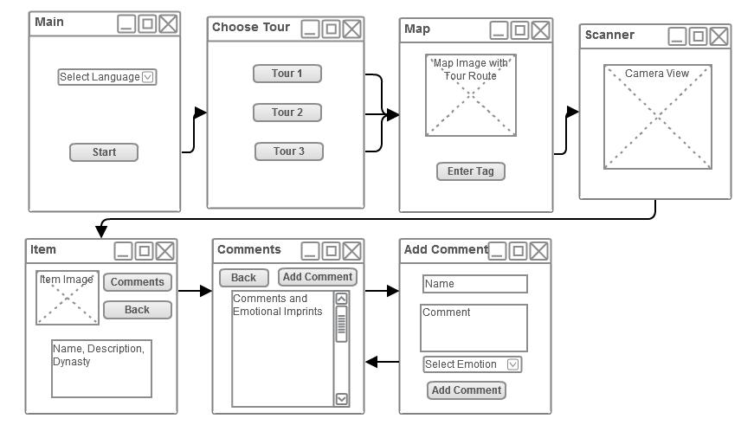
Figure 2 storyboard of the museum mobile Apps .

In the evaluation step, we generated a question for each attribute and used 5 point on Likert scale. The range was from poor with value 1 to excellent with value 5. Here are the five questions used
- Were there errors and mistakes made while using the system?
- When using the system how easy was it to use?
- How good was the feedback to your actions in the system?
- How in control did you feel while using the system?
- How consistent was the functions and design?
We have collected the responses from five real users at the museum site. Figure 4 shows the result.
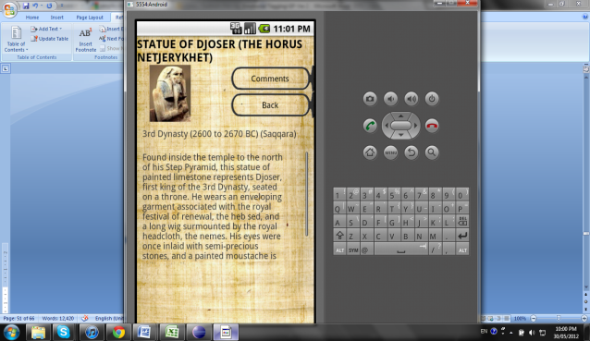
Figure 3. Example of One of the Low Fidelity) Screens
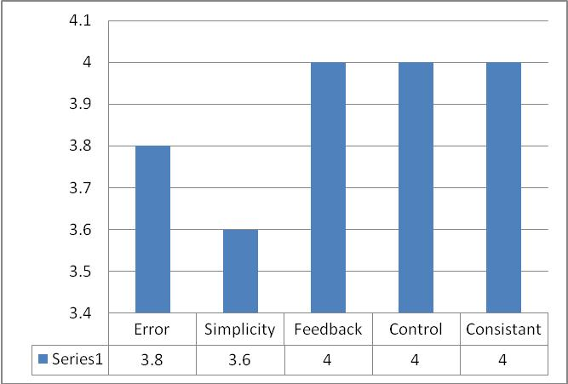

Figure 4. Result of the study
As we can see from the above figure, feedback, control, consistent attributes have higher values than error and simplicity. One problem we have observed that could be the reason for this result is some users had difficulties in entering the comments. Hence, in the plan step, we need to conduct an observation study to identify the causes of this result, adjust some of the mobile apps features, and run other studies to collect quantitative and qualitative data to figure out other usability problems

In the second phase (iteration), in the determining requirements step, the same usability attributes are used and we added more attributes such as effectiveness, efficiency, and customizability. In the design step, we used interface transition diagrams, menu-selection, and dialogue-box-tree techniques to recognize the navigation. In the develop and test step, we are currently adjusting the interface according to previous study results and will consider the same metric used in the previous phase. We are planning to use more rigorous analysis techniques such as cognitive walkthroughs, observation besides the usability testing in order to collect more quantitative and qualitative data. In the plan step, the results and conclusions will highlight the main issues to be considered in the following steps.
In the following phases (iterations), we will follow the same steps discussed above. More specifically, in the evaluation step we will use the same attributes to assess and compare across the following iterations. The results and the final conclusions will be reported in a subsequent publication.

Conclusions
Our novel proposed method, the Mobile Development Process Spiral, is a usability- driven approach, highly influenced by the spiral model. It focuses on reducing the high risks introduced by the mobile devices constrains. The five iterations of the app development process ensure that the requirements are properly addressed and validated against the requirements. To reduce usability errors, our spiral approach uses metrics to assess the development of mobile apps in a number of iterations. The proposed method identifies a set of usability techniques and incorporates these techniques into each iteration to assess the mobile apps. In the future, we will test this method in Industry.

References
- Aberdeen Group, “Mobile Retail is a Reality: The Increasing Mobility of Consumers has Retailers Engaged ,Aberdeen’s Insights”2010. http://www.mobilemarketer.com/cms/lib/9806.pdf
- ABI Research, Technology Market Intelligence, One Billion Mobile Broadband Subscriptions in 2011 http://www.abiresearch.com/press/3607-One+Billion+Mobile+Broadband+Subscriptions+in+2011:+a+Rosy+Picture+Ahead+for+Mobile+Network+Operators accessed in November 2011.
- D. Zhang, and B. Adipat, "Challenges, methodologies, and issues in the usability testing of mobile applications." International Journal of Human-Computer Interaction 18th ed, vol. 3, 2005, 293 – 308
- K. Nebe, and V. Paelke, key requirements for integrating usability engineering and software engineering , in Springer-Verlag, HCII 2011 Orlando, Florida, USA,Vol. 6761, P.114-120, 2011
- P. Abrahamsson, A. Hanhineva, H. Hulkko, T. Ihme, J. Jäälinoja, M. Korkala, J. Koskela, P. Kyllönen, and O. Salo, "Mobile-D: an agile approach for mobile application development," in ACM, 19th Annual ACM Conference on Object-Oriented Programming, Systems, Languages, and Applications (OOPSLA) Vancouver, Canada, October 2004.
- B. Morris, M. Bortenschlager, C. Luo, M. Sommerville, and J. Lansdell “An Introduction to Bada: A Developer's Guide” WILEY, West Sussex: UK, 2010
- V. Rahimian,and R. Ramsin, “Designing an agile methodology for mobile software development: a hybrid method engineering approach” in IEEE , 2nd International Conference on Research Challenges in Information Science (RCIS)Annual Conf. Marrakech, Morocco, pp. 337-342, June 2008.
- D. Flood, R., Harrison, and A. Nosseir, “Useful but tedious: an evaluation of mobile spread sheets”, in Psychology of Programming Interest Group Annual Conference (PPIG), University of York, York, UK, Septermer 2011 .
- EUSPRING organization http://www.eusprig.org/horror-stories.htm, Acessed in November 2011.
- ISO 9241: Ergonomic requirements for office work with visual display terminals (VDT)s - Part 11 Guidance on Usability.
- J. Nielsen, “Usability Engineering” Morgan Kaufmann Publishers Inc. San Francisco, CA: USA, 1993.
- B., Boehm, "A Spiral model of software development and enhancement", in ACM SIGSOFT Software Engineering Notes",Vol. 11, No.4(August), 1986, pp.14-24.
- X., Ferré, “Incorporating usability into an object oriented development” in 2nd INTERACT , Tokyo, Japan, July 9-13, 2001
- J. Preece, Y. Rogers, H. Sharp, D. Benyon, S. Holland, T. Carey. Human-Computer Interaction. Addison Wesley, 1994.
- J., Anderson, F.,.Fleek, K., Garrity, and F., Drake. “Integrating Usability Techniques into Software Development”. IEEE Software, vol.18, no.1. January/February 2001. pp. 46-53.
- D., Hix, and H., Hartson. “Developing User Interfaces: Ensuring Usability Through Product and Process.” John Wiley and Sons, NY, US, 1993.
- H. Beyer, K. Holtzblatt. Contextual Design: A Customer-Centered Approach to Systems Design. Morgan Kaufmann Publishers, 1997.
- A. M. Wychansky, C. N. Abernethy, M. E. Kotsonis; D. C. Antonelli; P. P. Mitchell. Selling Ease of use: Human Factors Partnerships with Marketing. Proc. Human Factors Society 32nd Annual Meeting, 1988, pp. 598-602.
- D., Benyon, P., Turner, and S., Turner “Designing Interactive Systems: People, Activities, Contexts, Technologies,”Pearson Education Limited, Edinburg,UK. 2005.
- B. Shneiderman. Designing the User Interface: Strategies for Effective Human-Computer Interaction. Addison-Wesley, Reading, MA, 1998

