* + - **Project Description** [5 pts]:

The name of the term project and a short description of what it will be.

Name: SimpliCity Multiplayer

A simplified multiplayer gameplay of the city building game, SimCity.

In the multiplayer gameplay, players will challenge one another to build the most prosperous city and their decisions would affect one another. For example, if a player’s city is more prosperous than your city and some of the population are unemployed, they would move over the player’s city for better opportunities.

* + - **Competitive Analysis** [5 pts]: A 1-2 paragraph analysis of similar projects you've seen online, and how your project will be similar or different to those.

Many of the existing games in the genre do not feature a competitive multiplayer mode. In the original SimCity franchise, the interaction between different players is confined to the exporting/importing of certain goods/utilities and the construction of a road to connect the cities. Hence, it appears that the gameplay between different players is not the main part of the game/ does not influence much of the gameplay and hence players usually prefer playing solo.

By injecting a multiplayer challenge mode that allows for interaction between the players, this changes the dynamics of the game and it is important for players to be strategic in their gameplay. Therefore, this shows that my project is different in a valuable way.

* + - **Structural Plan** [5 pts]: A structural plan for how the finalized project will be organized in different functions, files and/or objects.

Split code into multiple files (number of files depends on the number of classes required):

- classes of objects (1 file for each class, eg. Map, Residential Buildings, Commercial Buildings etc)

- gameplay and user interface (core Tkinter code) [1 file]

* + - **Algorithmic Plan** [5 pts]: A detailed algorithmic plan for how you will approach the trickiest part of the project.

The trickiest part of the project is currently the determination of “desirability” in the game. Desirability has considerations of many factors – pollution; availability of jobs; salaries; entertainment; healthcare; recreation etc…

The following is a simplified model of the decision tree, that shows the sequential factors that will be checked to determine if a person would move into the city.

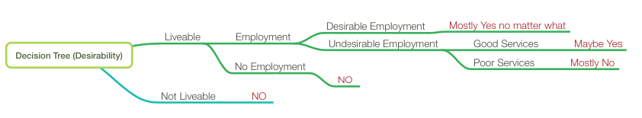

As I am unfamiliar with the concept of the decision tree, this is subject to revision for future implementation.

* + - **Timeline Plan** [5 pts]: A timeline for when you intend to complete the major features of the project.

TP0-TP1: simple single player mode (partial interface)

TP1-TP2: single player mode (just like the youtube video)

TP2-TP3: multiplayer mode

* + - **Version Control Plan** [3 pts]: A short description and image demonstrating how you are using version control to back up your code. **You must back up your code somehow!!!**

I will be using Github to track the different revisions of my code. I will “commit” to Github to save changes once I am finished coding a specific feature.

(image below)

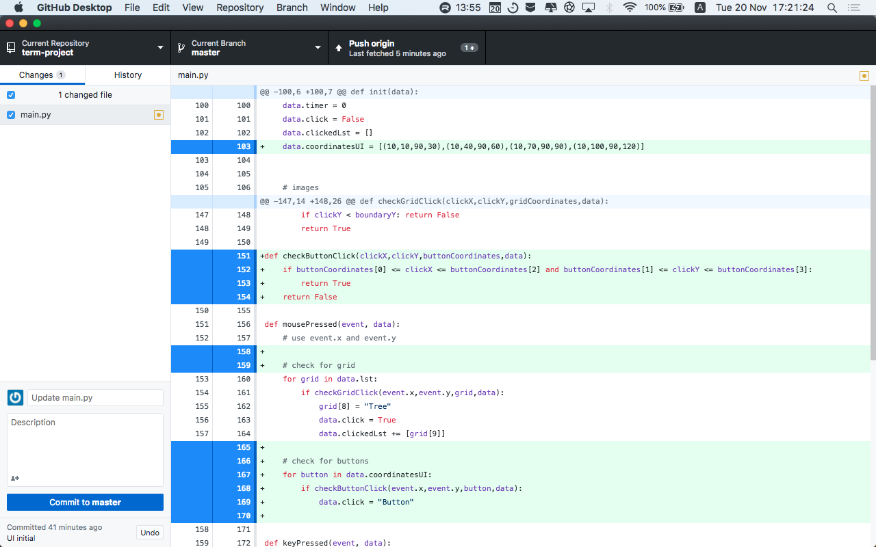

* + - **Module List** [2 pts]: A list of all external modules/hardware/technologies you are planning to use in your project. Note that any such modules must be approved by a tech demo. If you are not planning to use any additional modules, that's okay, just say so!

I will be using sockets for the multiplayer component.

But as advised by my mentor, this will be for the later stage for the project – for implementation upon completing the core components of the game.