Transport Panel
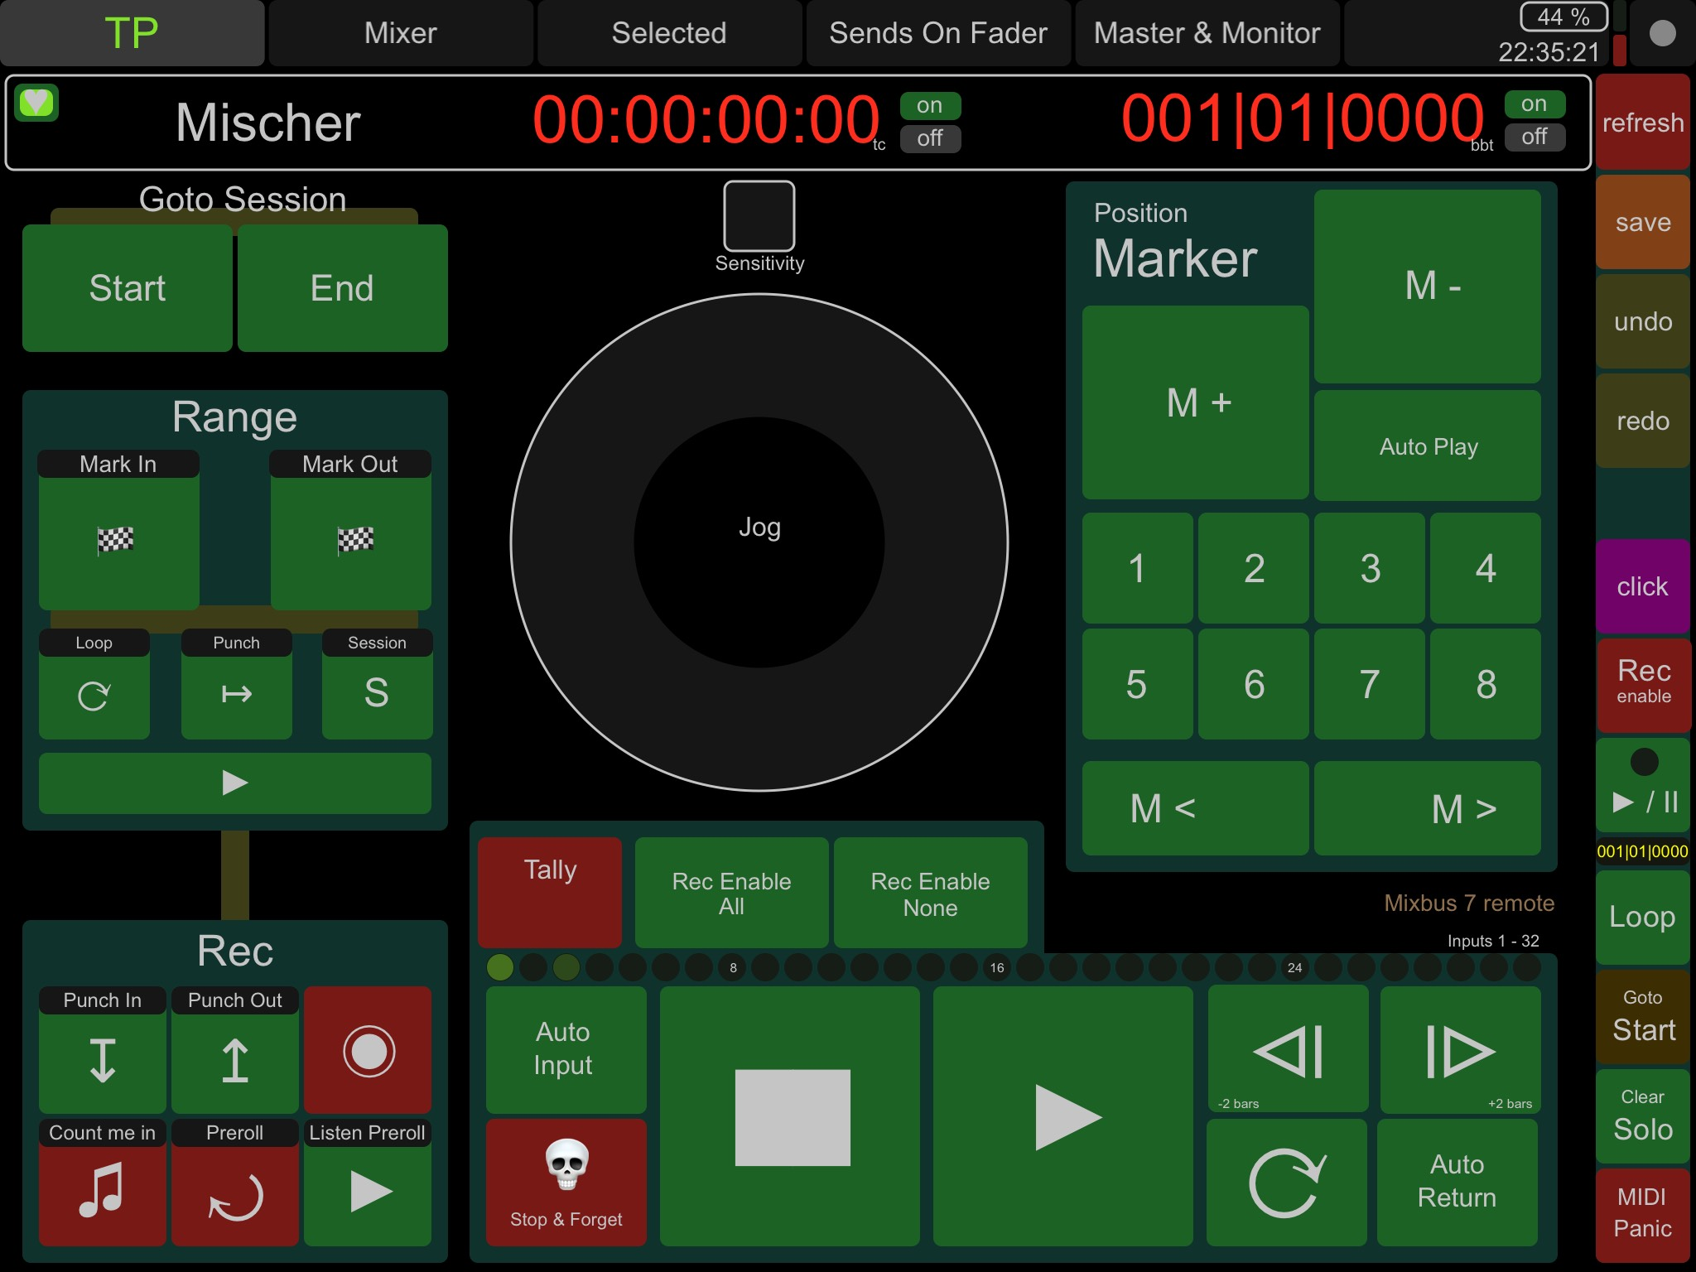
The first of 5 panels unites functions
to locate positions and control playback
Intuitively set range markers to mark a loop or a punch area,
recording controls include count in and preroll recordings,
jog wheel lets you easily relocate song position on the fly,
keep track of your recording by managing position markers.
All panels share a control field including refresh, save, metronome toggle, playback and more.

The panel switch area
lets you switch the different panels – transport, mixer, selected, sends on fader, master and monitor
On the right side there‘s a charge level indicator to show your tablet‘s charging level and the current time

Info Pane
Left of the session name there‘s a heartbeat indicator. It flashes at second intervals when there is a connection to Mixbus.
Right of session name there are 2 position indicators:
current point in time in timecode format and as bars and beats.

Main jump targets
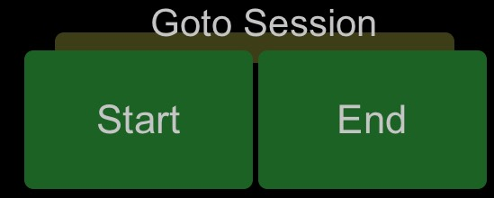
Go to session start or end

Range functions
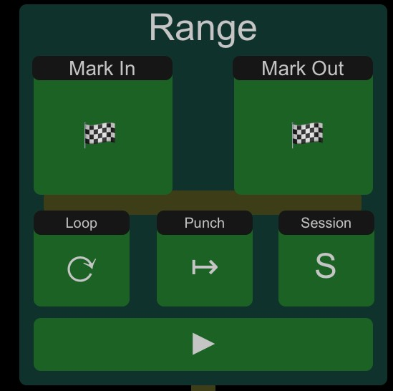

Range markers to define a range that can be looped and/or used as a punch range for recording.
By pressing „Mark In“ and „Mark Out“ while rolling you can mark a range, with „Loop“ you create a loop range, by pressing „Punch“ you get a punch range, „S“ stands for session – to set session boundaries from range markers.
Listen range by pressing the play symbol at the bottom.

Record controls
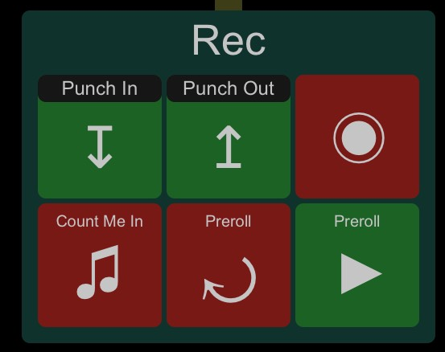

Record controls let you activate recording options.
Punch recording is enabled by „Punch In“ and „Punch Out“.
To get a count in before actual recording starts, push „Count Me In“.
Use a preroll instead push „Preroll“ (both lengths can be set in preferences of Mixbus)
Optional you might just listen to the preroll period by using the play button labeled „Preroll“.
Top right you find „Record Enable“ unlabeled to start recording after pressing the main play button in the playback control section. (see Control Pane)
Controls at the bottom start either function immediately.

Jog Wheel
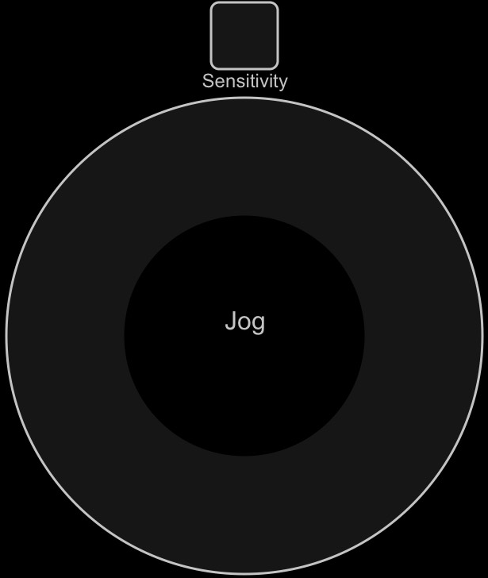

Jog wheel functionality in Mixbus is not yet complete but to get access to what makes sense right now this jog wheel lets you skip back and forth in two different scales. Available scales are „Jog“ and „Nudge“:
„Jog“ means playhead is moved 0.2s forward or backwards,
„Nudge“ means playhead is moved by the amount of the nudge clock, you can edit in preferences of Mixbus.

Playback Controls
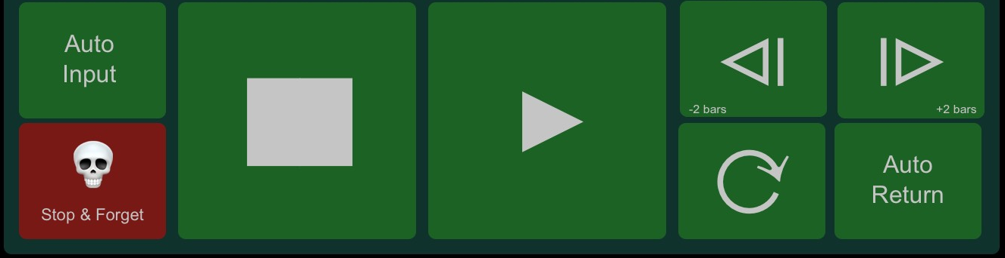

Main playback control elements and more:
„Auto Input“ toggles the state of monitoring the input channels. Refer to the Mixbus Manual to set up your monitoring options.
„Stop & Forget“ is an easy way to stop and delete your last recording.
Controls for stop, play, loop-play are self-explanatory.
Skip 2 bars forward and backwards by using the skip buttons at the top right.
„Auto Return“ toggles the behaviour of the stop button.

Track Meter
Above playback buttons there’s a meter row to show signal levels for the first 32 input channels. The brighter the louder.

Global Track Control & Tally Light
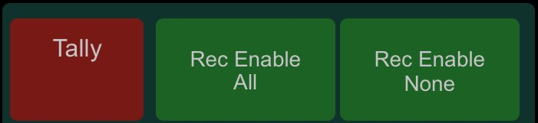
Above the meter there’s a tally indicator which flashes up when any recording is enabled anywhere in Mixbus.
To enable record on all input tracks push „Rec Enable All“. To disable record enable on all input tracks push „Rec Enable None“.

Position Marker
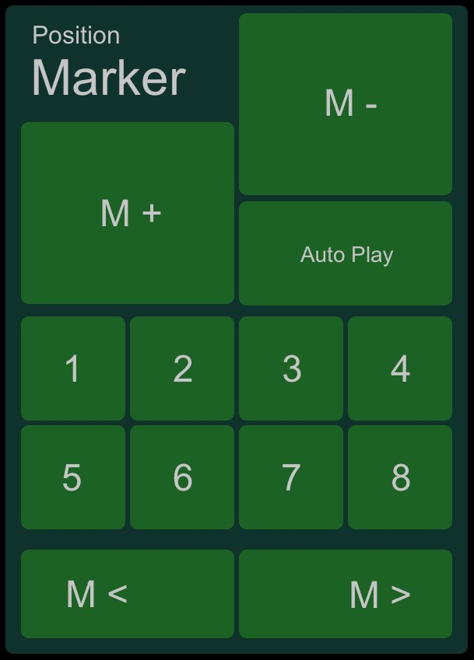

In this area position markers can be set.
Add a new marker at song position with „M+“, „M-“ deletes it.
Arbitrary number of markers are possible, the first 8 of them are quickly accessable by numbered buttons.
„M<“ and „M>“ skip to previous or next marker.
„AutoPlay“ starts playback at marker position immediately.
Control Pane
On the right side of the panel there’s an area which is nearly the same for all panels. Although the control pane at transport panel differs slightly from the others:
If the panel has not been updated properly, „refresh“ may help. Unlike initializing the panel, „refresh“ only refreshes feedback values sent from Mixbus. If transport panel has not been connected, you have to switch to another panel and switch back to transport panel, because initialization takes place when you select a panel.
„save“, „undo“ and „redo“ trigger the corresponding actions in Mixbus.
Metronome is enable/disabled by „click“,
another record enable button is located below, followed by a start/stop button. If you are rolling, the LED turns on.
Next the position is displayed in bars and beats.
„Loop“ starts looped playback if there is a loop set,
„Clear Solo“ turns solo mode off on any channel.
„MIDI Panic“ sends note-off commands to all MIDI capable receivers which only is relevant if you use MIDI.

Mixer Panel
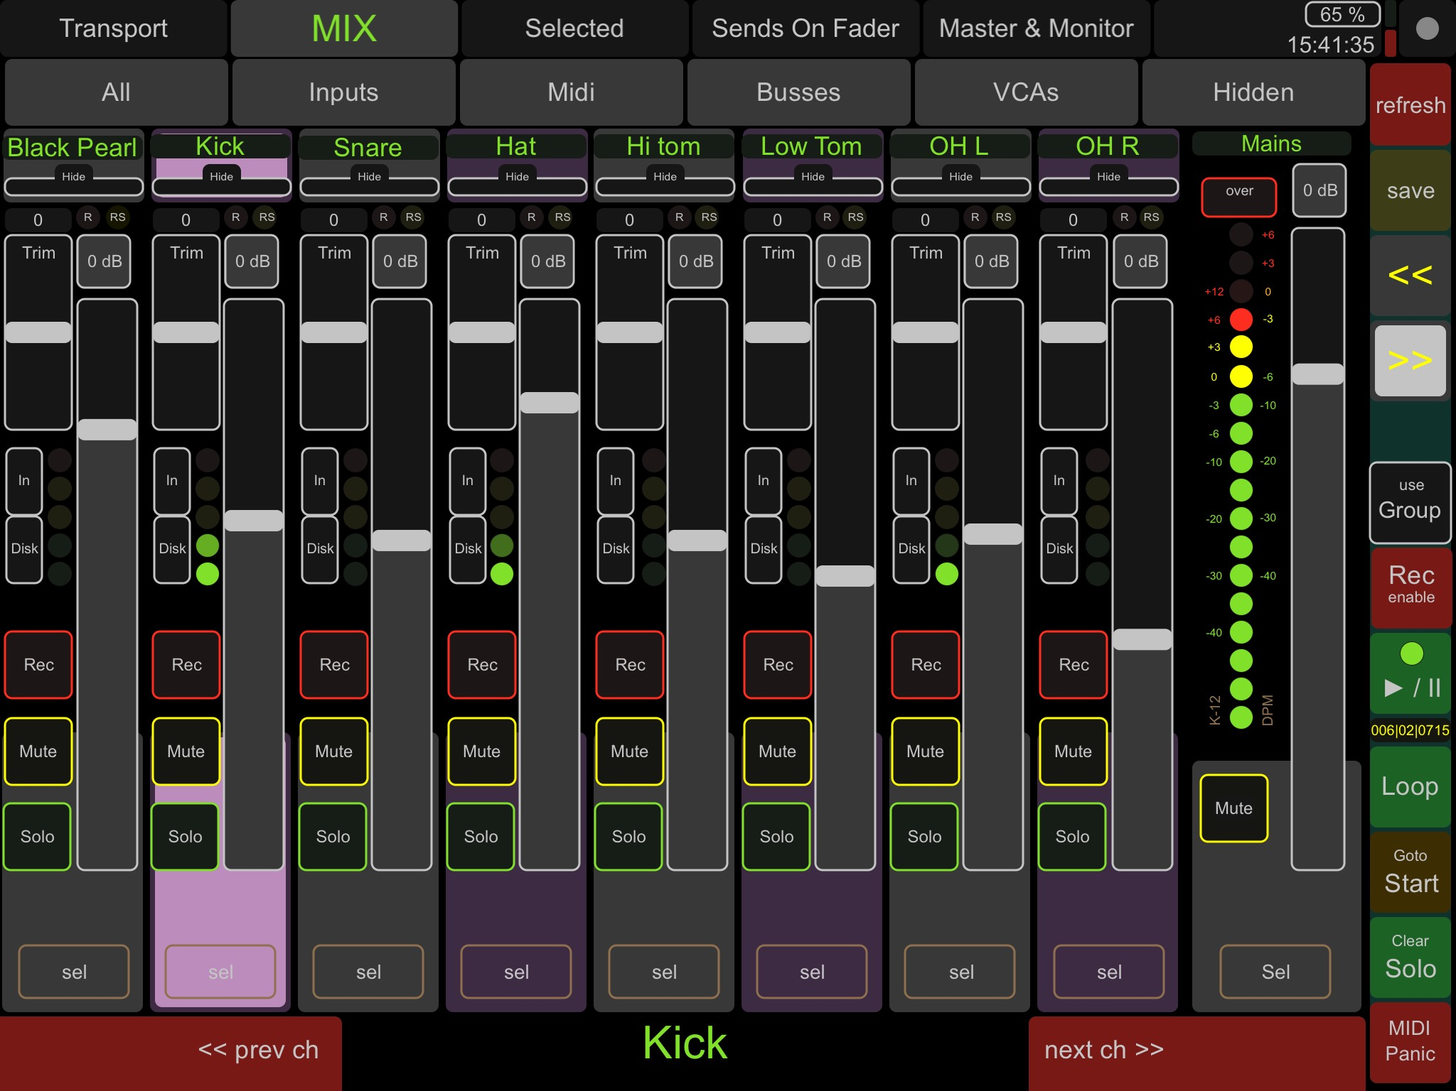
Second panel gives a 8 channels overview with per channel control, meters and more. This panel includes the master channel with a higher resolution meter.

Channel Assortment Selection
Initially the input channels are shown when you switch to this panel.
- „All“ means audio tracks, midi tracks, audio busses and midi busses
- „Inputs“ means audio and midi tracks
- „Midi“ means midi tracks only
- „Busses“ means audio and midi busses
- „VCAs“ let the VCA Master Controls appear on the faders
- „Hidden“ means hidden tracks

Channel
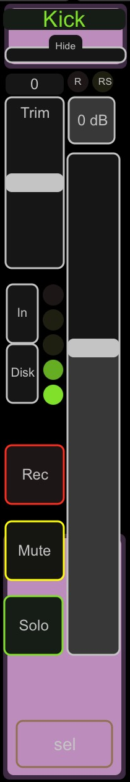
From top to bottom
- Name of the track in green,
- Small thin button called „Hide“ to toggle the hide status. Be aware to not accidentely push this button. Your channel will be no longer shown. To undo you have to select „Hidden“ in the channel assortment selection and push „Hide“ again.
- Trim fader to adjust the input gain. Above the fader the numerical value is shown. It’s in dB from -20 to 20dB.
- Two LEDs show a recording status.
  - „R“ stands for record enable,
  - „RS“ stands for record safe.
- The „0 dB“ button is for setting the channel fader to 0 dB.
- Long fader is the main fader for that channels.
- Switches for input monitoring.
  - „In“ means the channel gets its input from the assigned physical input,
  - „Disk“ means that the recorded material on disk is the input for that channels.
- The LED volume meter is to have a visual response for each channel.
- The „Rec“ button is to switch record enable on and off,
- „Mute“ mutes the channel,
- „Solo“ button’s function can be defined in Mixbus (SIP / PFL / AFL),
- „sel“ to select that channel for further editing in „Selected“ panel.

Master Fader
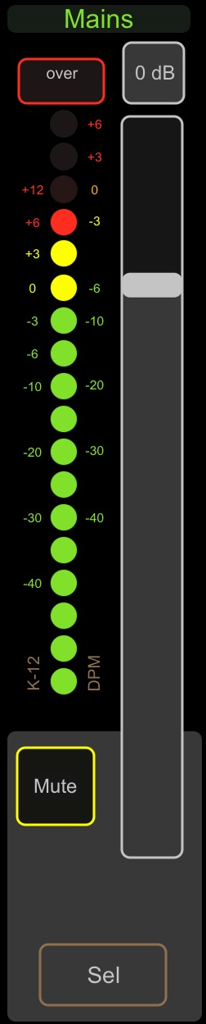
In the mains section you see the master fader with a unity level button „0 dB“ at the top.
The meter is calibrated to show the correct level in K-12 scale on the left, corresponding DPM scale on the right side.
If the signal gets too hot, „over“ will flash.
„Mute“ mutes mains,
„Sel“ selects this channel for further editing in „Selected“ Panel.

Navigation and Information Bar
You can switch your selected channel one up or down by pressing „prev ch“ or „next ch“. In the middle the track name and the track comment is shown.

Control Pane
On the right side of the panel there is an area which is nearly the same for all panels.
If the panel has not been updated properly, „refresh“ may help. Unlike initializing the panel, „refresh“ only refreshes feedback values sent from Mixbus. If transport panel has not been connected, you have to switch to another panel and switch back to transport panel, because initialization takes place when you select a panel.
„save“ saves your session file.
„«“ and „»“ switches to next faderbank. If there are more than 8 channels available, the corresponding bank switch will light up.
„use Group“ enables the use of previously build channel groups in Mixbus. For example mute groups can be controlled that way.
Global „Rec enable“ makes it possible to start recording on armed tracks by pushing the „start/stop“ button bellow. If you are rolling, the LED turns on.
Next the position is displayed in bars and beats.
„Loop“ starts looped playback if a loop range has been set,
„Goto Start“ takes you to the session start.
„Clear Solo“ turns solo off on any channel.
„MIDI Panic“ sends note-off commands to all MIDI capable receivers which only is relevant if you use MIDI.

Selected
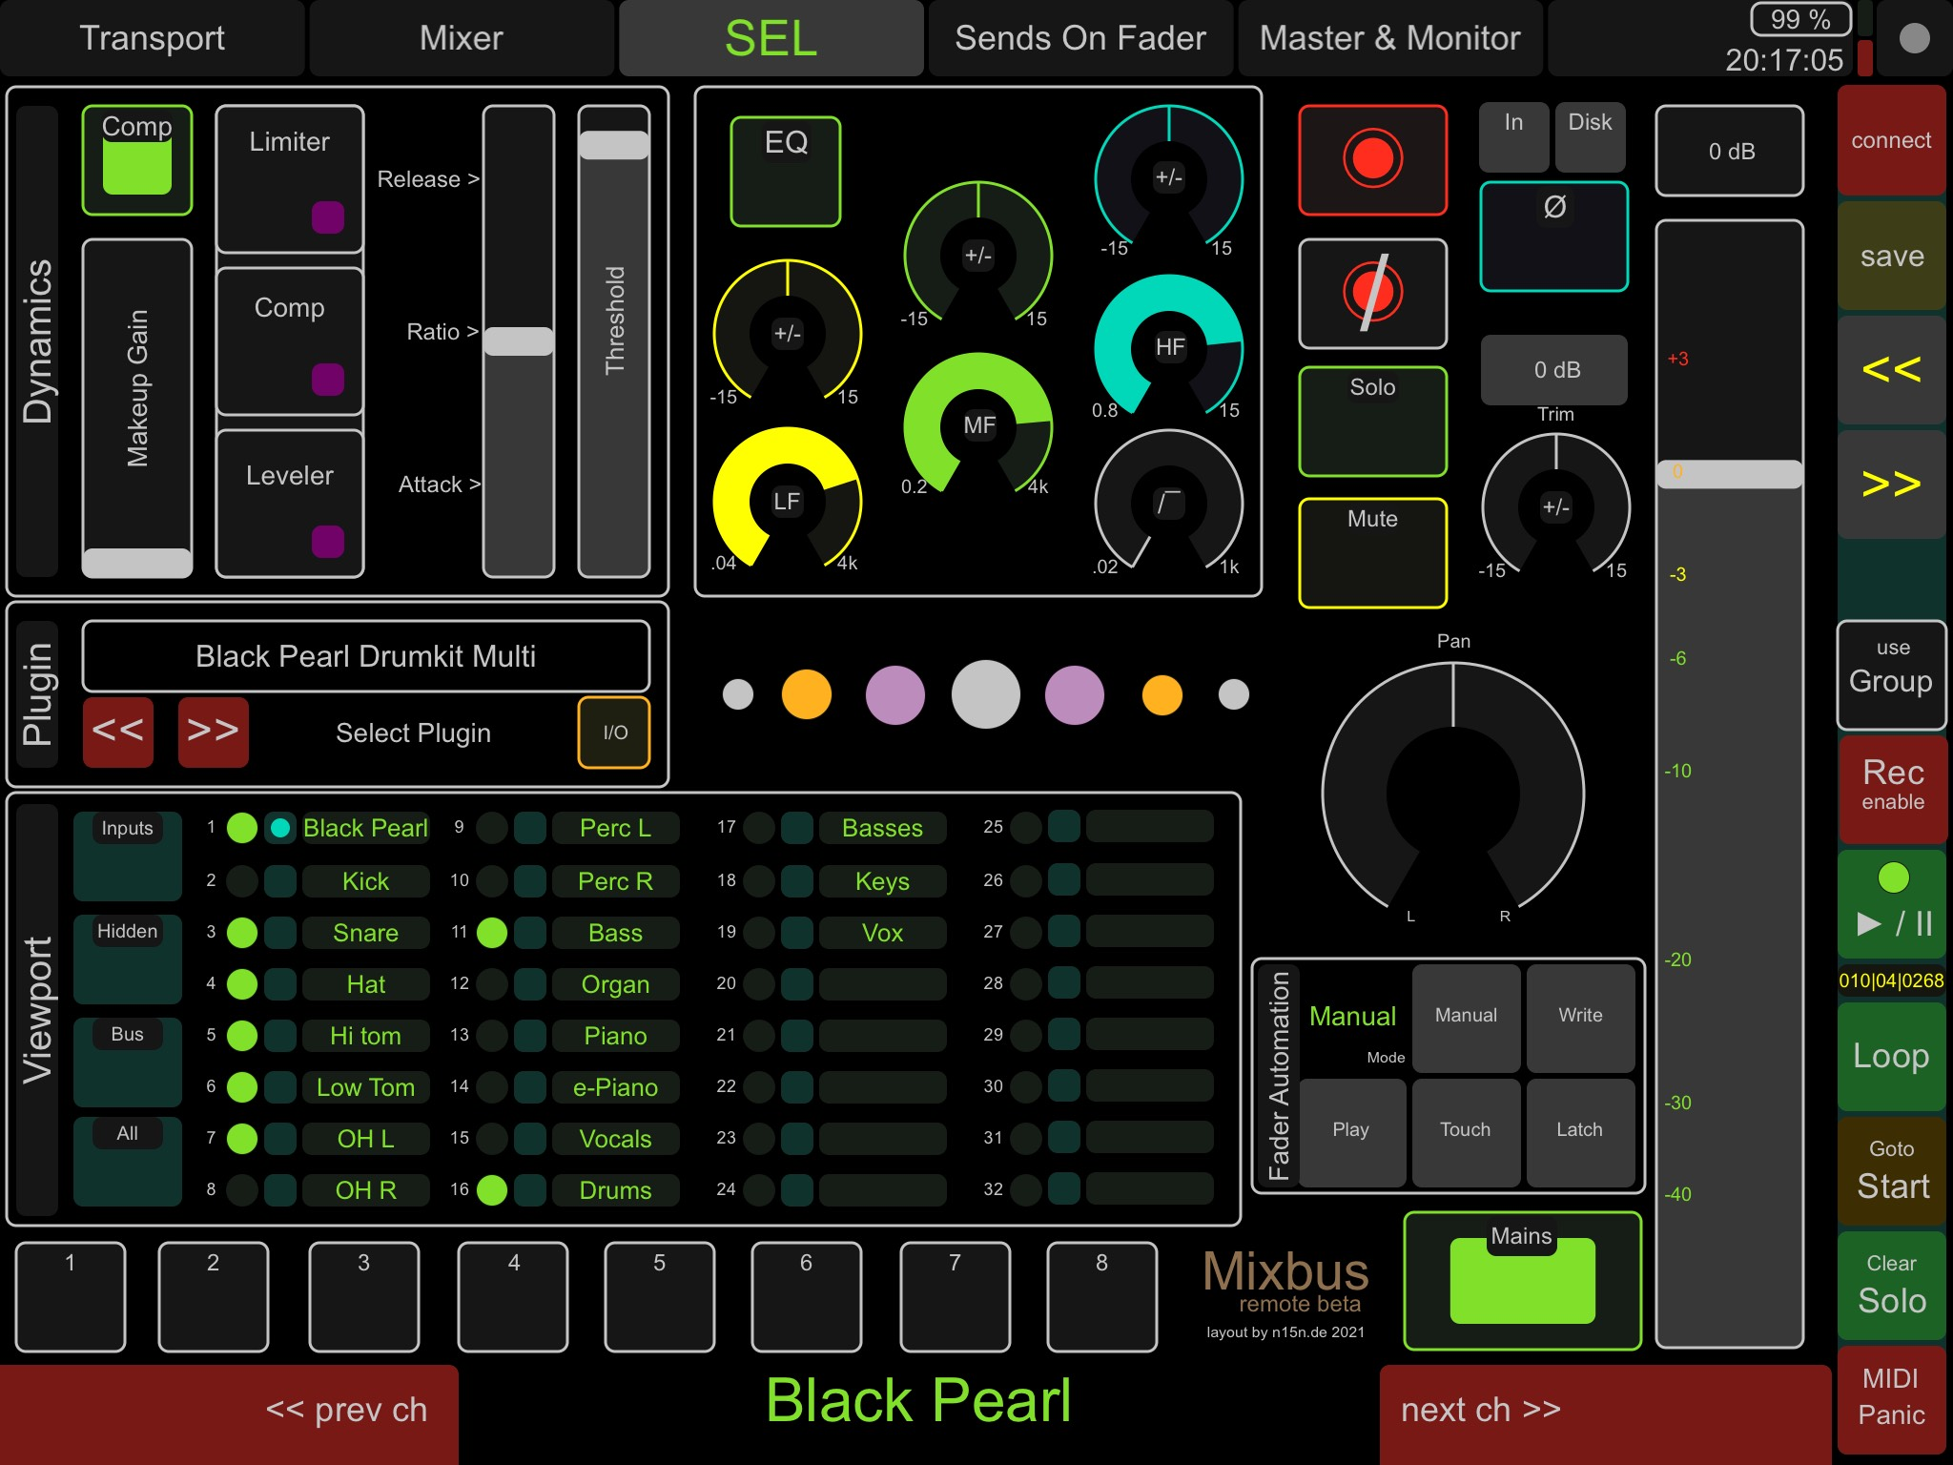

Sends on Fader
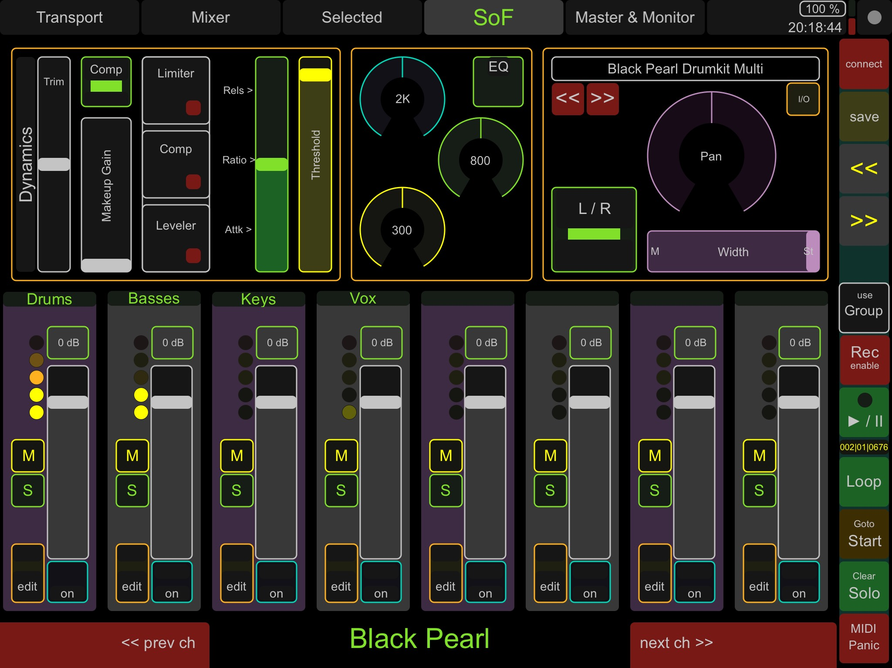

Master & Monitor
