# 

# 

# Song Recorder

Nicole Boie

June 6, 2023

UCRCS122ASpr23_P2

# 

# 

# 

# Table Of Contents

**URL:** **1**

**Purpose:** **1**

**Functionality:** **1**

**Tested:** **2**

**Challenges:** **3**

# 

# 

# 

# 

# URL:

Record Song, Play Recorded Song, Play Song that is already Saved, Pause and Play Song: <https://youtu.be/ehuP1DJ4l8U>

Record Song, Record Over Song, Play New Song:<https://youtu.be/WVmlkPw2O0I>

# Purpose:

My goal was to create a song recorder in which I could record songs, store them in an sd card, and then be able to play back the songs I recorded. I wanted to learn more about the hardware and the code surrounding serial communication as well as the sd adapter and library.

# Functionality:

The audio recorder is able to record 10 songs all up to 49 notes. The user is able to access the record and playback functionalities by pressing the on button on the ir remote. When on the lcd will prompt the user to press either Eq to record a new song or play to playback an old song. Once Eq is pushed the display prompts the user to choose a position 0-9 in which to record the song. Once the user has selected a number 0-9 the recorder is in record mode and the led will turn on. The lcd will display the max notes allowed (49) and which note the recording is on. The note count continues up until it hits 49. The user records notes by pressing buttons 0-9 which will play the corresponding note when pressed. The recorder stops recording wither when the user presser EQ again or when the max amount of notes has been recorded. The user is then asked if they will want to store the song (press 1) or discard it (press 2). If the user discards the song they are brought back to the main menu where they are prompted with EQ or play. If the user decides to save the song they are prompted to enter a name for the song. The max length of the song name is 10 characters. The user can press the up or down button on the remote to toggle up and down the alphabet. Whichever letter the user is currently being hovered above will be displayed to the lcd. If the user presses 0 they enter the letter that they are hovering over. The entered letters will display on the right of the lcd as the user enters more. To finish the name the user can either enter all 10 characters or press ST/Rept button on the remote. Once the song name is entered the song will have been pushed to the sd. The song will appear under the associated song position (example: SONG.txt). In that file will be the the song name as well as all the notes of the song. After saving the song the user is brought back to the main menu. To playback a song the user presses the play button, which will prompt the user to select a song position 0-9. If there is a song recorded in that position then the lcd will display the song name, note duration of the song, and the current note position. To pause in the middle of a playback the user can press ST/Rept button. To play from where the user paused they can press the play button once again. Once the song is played the user will be brought back to main menu. If the song does not exist the user will be brought to main menu. Because all the songs are saved to the sd songs can be played back after turning the arduino on and off. To delete a song the user can simply choose to record a new song in the song position of an old song.

* On/Off turns entire recorder on and off (main menu means on, nothing is off)

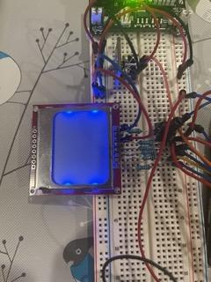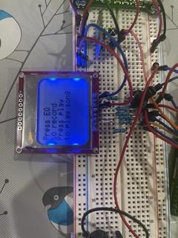

* Chose to Record Song (EQ pressed), Choose song position to record on (0-9)

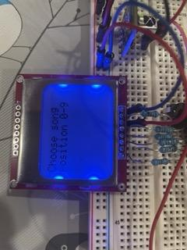

* Recording in progress

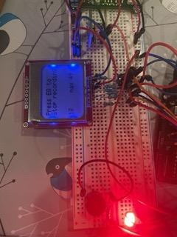

* Finished recording, decide to discard (2) or save song(1)

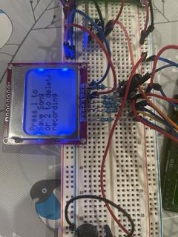

* Discard song (2) goes back to main menu
* Save song (1) choose song name (10 characters max)

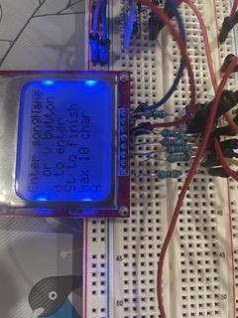

* Finished naming song goes back to main menu
* Playback song (Play), choose song to play (0-9)

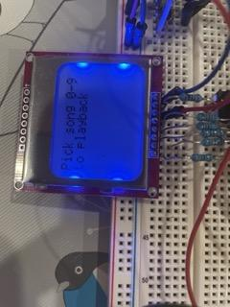

* Playing Song

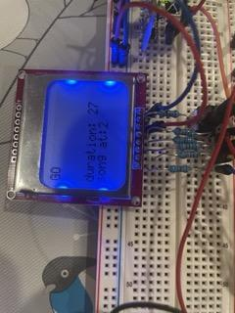

* Paused Song (St/Rept)

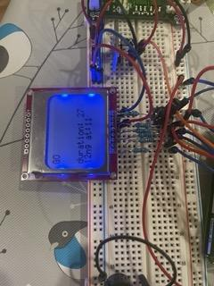

* Finished playing does back to main menu
* Sd card song data

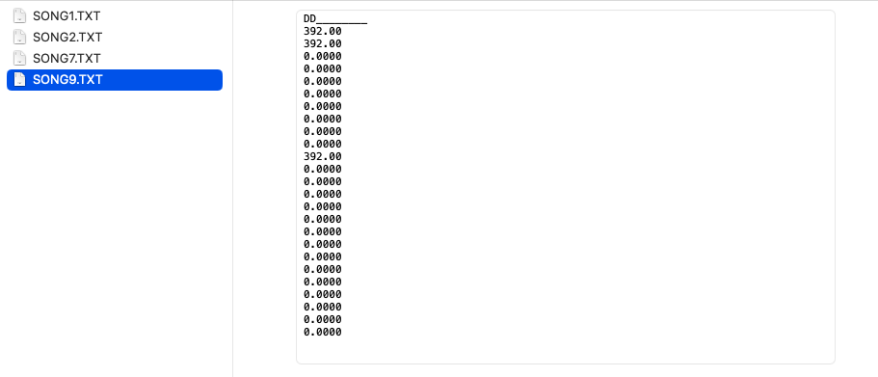

Arduino Parent Pins For Each Component:

* 13 rxpin
* 12 txpin
* 9 speaker
* 8 Ir receiver
* 7-3 nokia lcd
* 2 led

Arduino Child Pins For Each Component:

* 4 rxpin
* 2 txpin
* SD Adapter:
  + 13 SCK
  + 10 CS
  + 11 MOSI
  + 12 MISO

# Tested:

I tested my song recorder by testing each edge and pressing random buttons. I made sure that playback of a song that did’nt exist would just be brought to the main menu. Continuously outputting to the serial monitor as well as the lcd to check which state I was in as well as what values I had. I had to make sure that If I recorded a song without pressing the end record button that the song recorder would stop recording itself so both the notes in the array would not be inaccessible and that the sd would be able to close. I recorded on top of songs to make sure old data was destroyed instead of being added onto.

# Challenges:

This was probably the most difficult project I have ever attempted. The ir remote was once again reading incorrect reading sometimes, which can happen. When I started this project I was not expecting to have to use an sd to save song data or another arduino. But to record 10 songs each with a max 59 notes I needed to save data or else my dynamic memory would be too much. I figured out I couldn’t use the sd card reader with the ir remote because the ir remote and sd card reader would interfere with each other. So I hooked up another arduino for just the sd card adapter. This means I needed serial communication between both arduinos. I tried using the Wire.h library but I found out that it had a lot of hanging errors. So I scrapped all of that and wrote a whole new file just for testing serial communication for the SoftwareSerial library. However I could get child to write back to parent. I figured after a long time, that I needed to ground both the arduinos together, which I had undone because I thought I only needed to do it for Wire.h. Everything was okay after that for a while. I was able to read song info back and forth saving songs and playing songs. However the dynamic memory in the parent arduino got very close to being full, which I think interfered with the rest of the code. I have to reset the child arduino and sometimes the name is saved only partially, which I have been trying to debug for hours. It was very frustrating to have everything working and then when I tried to make it nicer, it would stop working all of a sudden and I couldn’t return it to working right.

If I were to do this project again I would not use an ir remote. I would also duplicate my code once I get a section working to ensure I could go back if I messed up my code too much.