Early Careers Program: Quality Assurance Automation

Git Fundamentals Checkpoint Guide

Trainer:

Esteban Bosques

Trainee:

Jaime Nicolás Castro Acuña

Bogotá D.C – Colombia July 2023

1. Create a new repository

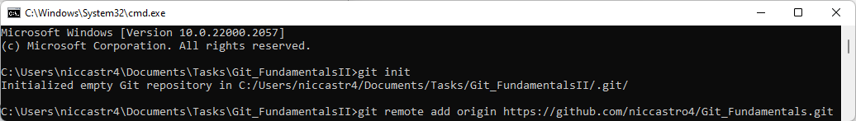

2. Create a README file

- Create a new file called `README.md` and write your name in it.

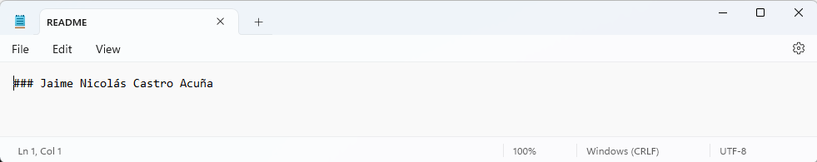

- Create another called `main-code.js` and add some small piece of code (a hello-world or something like that)

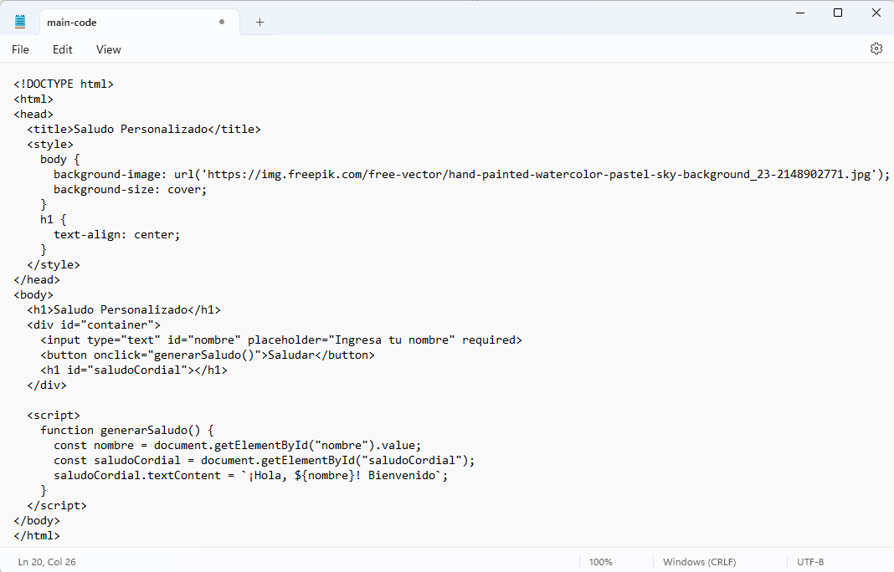

- Save the changes and commit it to your main branch

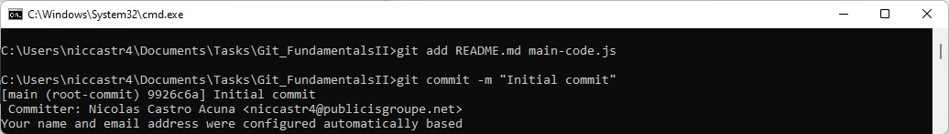

3. Create a new branch:

- Create a new branch named `feature-branch`.  
 - Switch to the newly created branch

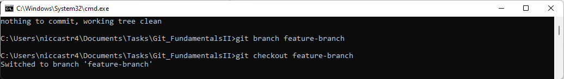

4. Make changes and commit:

- Open the `main-code.js` file and make a small change (change a variable name or a value).

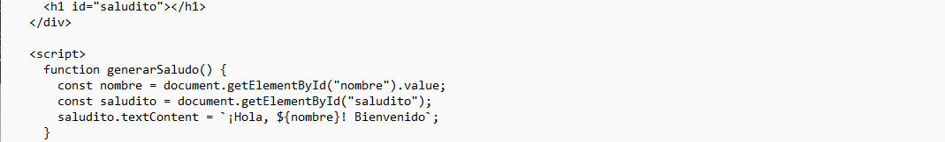

- Save the changes and commit them to the `feature-branch`.

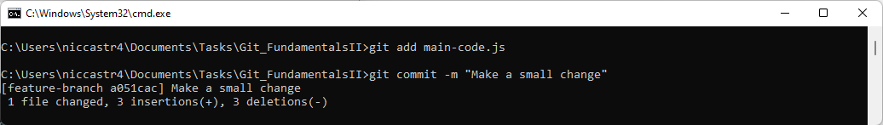

5. Switch back to the main branch:

- Switch back to the `main` branch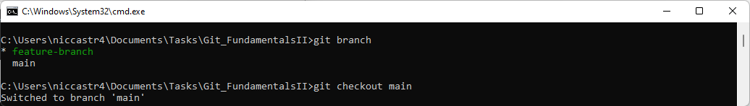

- Open the `main-code.js` file again and make a small change.

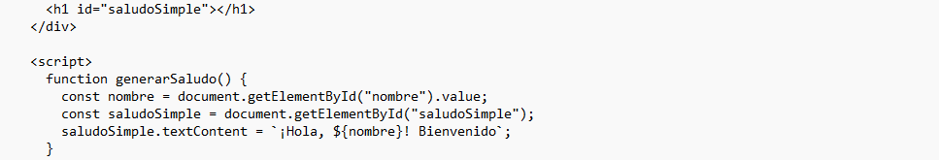

- Save the changes but don't commit them.

6. Stash some changes

- Stash the changes.

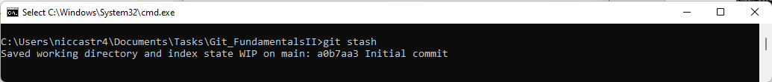

- Using `git stash list` copy the output and save it in the `README.md` file

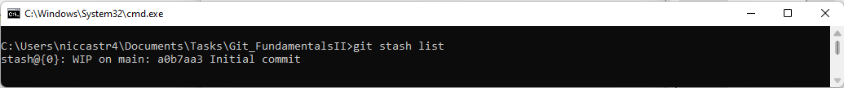

- Unstash your stashed changes.

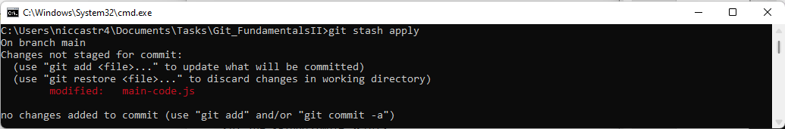

6. Merge conflict resolution:

- Still on your main branch

- Merge the `feature-branch` into the `main` branch

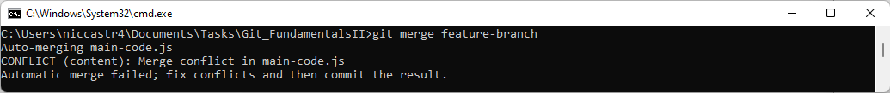

- Resolve the merge conflict that arises in the `main-code.js` file. Copy the conflict part and add it to `README.md`.

Solution

1. Open the `main-code.js` file in a text editor.

2. Look for the conflict markers ‘<<<<<<<’, ‘=======’, and ‘>>>>>>>’.

3. These markers indicate the conflicting changes between different branches.

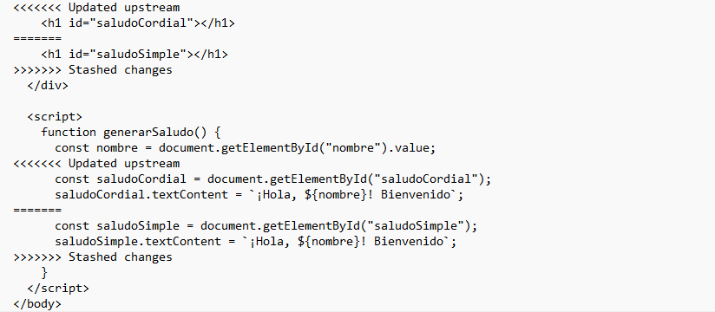

4. Edit the file to keep the desired changes and remove the conflict markers.

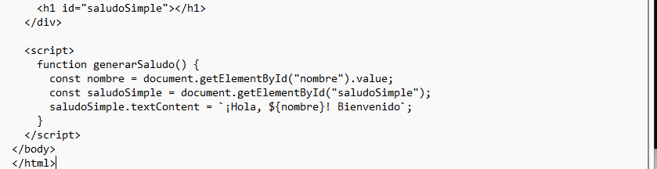

5. Save the changes in the `main-code.js` file.

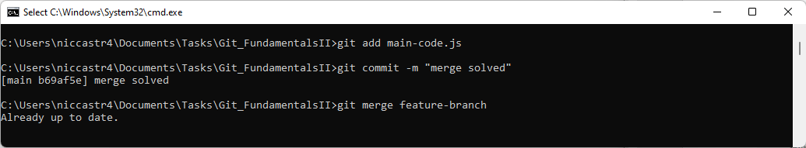

7. Finalize and submit:

- Push your changes to your remote repository

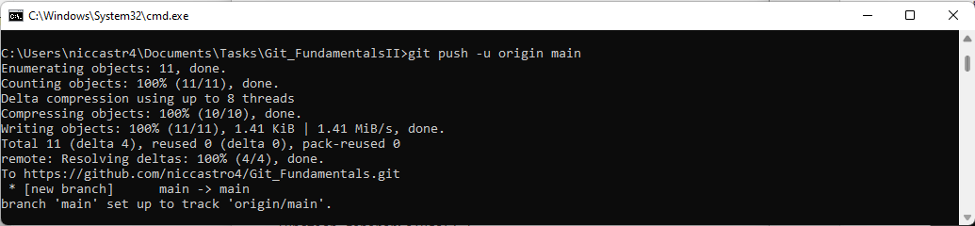

**References**

* <https://www.youtube.com/watch?v=PRgqbWf5mfk>
* <https://www.freecodecamp.org/espanol/news/git-stash-explicado/>
* <https://www.freecodecamp.org/news/the-ultimate-guide-to-git-merge-and-git-rebase/>