Early Careers Program: Quality Assurance Automation

Checkpoint Cypress Intro

Trainer:

Santiago Cabrales

Trainee:

Jaime Nicolás Castro Acuña

Bogotá D.C – Colombia August 2023

**Test Case: TC01 - Verify That the "PRS SE Silver Sky" Product Can Be Successfully Added to the Shopping Cart.**

**Description:** To validate that when the "PRS SE Silver Sky" product is selected from the solid body guitars section, it can be successfully added to the cart, and that the cart reflects the addition correctly.

**Environment:** Windows 11 (Chrome Version 116)

**Test Type:** Functional

**Precondition:**

* Cypress is properly installed and configured.
* Internet access is available, and the Reverb homepage is accessible at 'https://reverb.com/'.

**Test Steps:**

1. Open a web browser and navigate to the Reverb homepage.
2. Click on the 'Guitars' section.
3. Navigate to the 'Solid Body Guitars' category.
4. Select the "PRS SE Silver Sky" product from the list of displayed products.
5. Add the selected product to the shopping cart.
6. Select the shopping cart icon.

**Expected Results:**

* The Reverb homepage should be displayed successfully.
* The 'Guitars' section should open, showing different categories of guitars.
* The 'Solid Body Guitars' category should be displayed.
* The "PRS SE Silver Sky" product is successfully selected.
* The selected product should be "PRS SE Silver Sky."
* The selected product should be successfully added to the cart.
* The shopping cart icon is successfully selected.
* The shopping cart should reflect that "SE Silver Sky" has been added.

**Test case with Gherkin:**

Feature: View a product added in the shopping cart

Scenario: Viewing PRS SE Silver Sky in the cart

Given I visit the Reverb homepage

When I navigate to the guitars section

And I navigate to the solid body guitars

And I select the "PRS SE Silver Sky" product

Then the selected product should be "PRS SE Silver Sky"

When I add it to the cart

And I select the shopping cart icon

Then I should have "PRS SE Silver Sky" in the cart

**Actual result:**

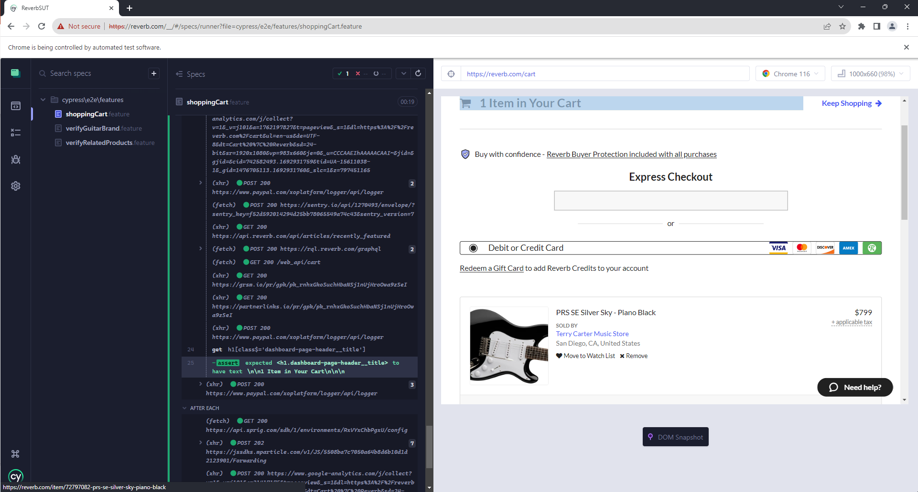

**Test Case: TC02 - Verify That All Guitars Displayed Belong to the Correct Brand When Filtered by Brand.**

**Description:** To verify that when the "Martin" brand is selected as a filter under the "Acoustic Guitars" category, all guitars displayed are from the Martin brand.

**Environment:** Windows 11 (Firefox Version 116)

**Test Type:** Functional.

**Precondition:**

* Cypress is properly installed and configured.
* Internet access is available, and the Reverb homepage is accessible at 'https://reverb.com/'.

**Test Steps:**

1. Open a web browser and navigate to the Reverb homepage.
2. Click on the 'Guitars' section.
3. Navigate to the 'Acoustic Guitars' category.
4. Apply the filter by selecting the 'Martin' brand.

**Expected Results:**

* The Reverb homepage should be displayed successfully.
* The 'Guitars' section should open, showing different categories of guitars.
* The 'Acoustic Guitars' category should be displayed.
* Only guitars from the 'Martin' brand should be displayed.
* All displayed guitars should be verified as belonging to the 'Martin' brand.

**Test case with Gherkin:**

Feature: Verify that guitars belong to the correct brand category when filtered

Scenario: Verify that all guitars are from the Martin brand when Martin is selected as a filter

Given I am on the Reverb homepage

And I navigate to the guitars section

When I choose the acoustic guitars category

And I filter by the Martin brand

Then all displayed guitars should be from the Martin brand

**Actual result:**

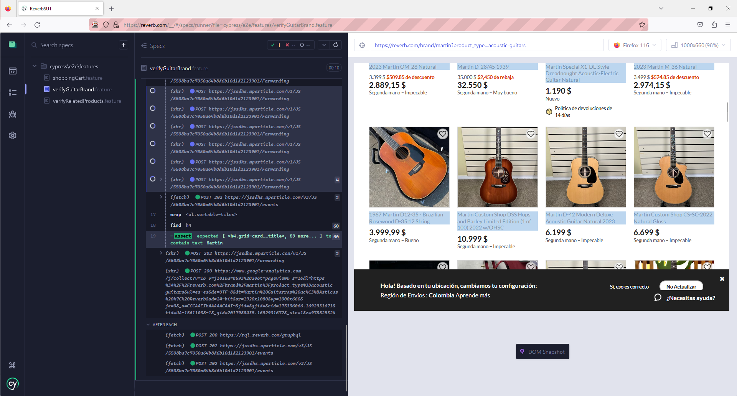

**Test Case: TC03 - Verify That Related Products Belong to the Same Brand**

**Description:** To ensure that when a user selects a random product from the 'Tenor Electric Guitars' category, all the related products displayed on the product details page belong to the same brand as the selected product.

**Environment:** Windows 11 (Firefox Version 116)

**Test Type:** Functional

**Precondition:**

* Cypress is properly installed and configured.
* Internet access is available, and the Reverb homepage is accessible at 'https://reverb.com/'.

**Test Steps:**

1. Launch the web browser and navigate to the Reverb homepage.
2. Click on the 'Guitars' section on the homepage.
3. Navigate to the 'Tenor Electric Guitars' category under the 'Guitars' section.
4. Randomly select a product from the list.

**Expected Results:**

* The Reverb homepage should be displayed successfully.
* The 'Guitars' section should open, showing different categories of guitars.
* The 'Tenor Electric Guitars' category should display a list of products.
* A random product from the list should be selected and its details should be displayed.
* All related products listed on the product details page should belong to the same brand as the initially selected product.

**Test case with Gherkin:**

Feature: Verify that related products belong to the same category

Scenario: Verify that selecting a random product displays related products from the same brand

Given I am on the Reverb homepage

And I navigate to the guitars sections

When I choose the tenor electric guitars category

And I select a random product

Then all related products should belong to the same brand as the selected product

**Actual result:**

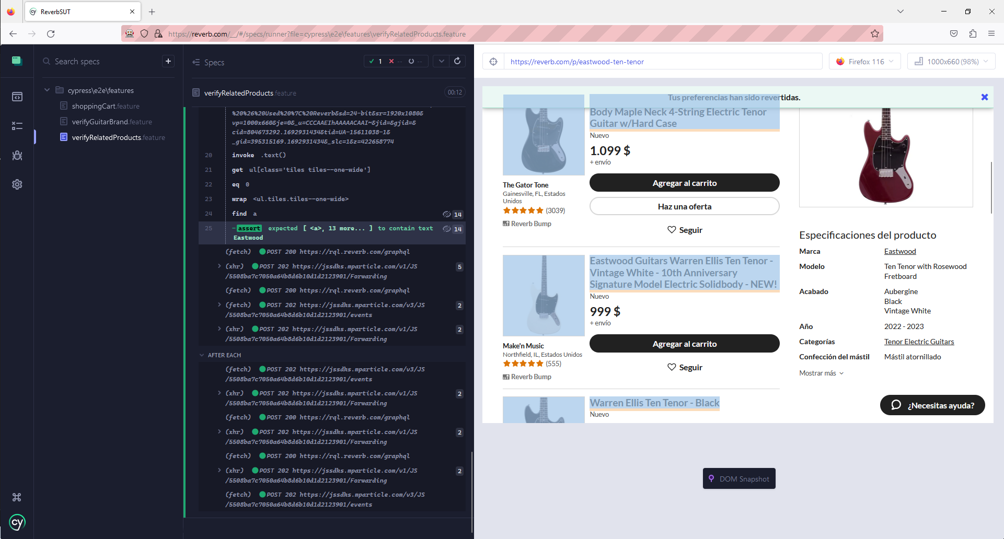

***References:***

* <https://www.youtube.com/watch?v=SDeD87dUbvE&t=1456s>