Early Careers Program: Quality Assurance Automation

Checkpoint Cypress Intro

Trainer:

Santiago Cabrales

Trainee:

Jaime Nicolás Castro Acuña

Bogotá D.C – Colombia August 2023

**Test Case: TC01 - Validate GET Request for Product Information.**

**Description:** To verify that a GET request to the endpoint "https://dummyjson.com/products/1" returns the correct information for the product with ID 1.

**Environment:** Windows 11 (Chrome Version 116)

**Test Type:** API Testing / Functional Testing

**Precondition:**

Cypress is properly installed and configured.

Internet access is available to reach the API endpoint "https://dummyjson.com/products/1".

**Test Steps:**

1. Open a terminal window.
2. Navigate to the Cypress project folder.
3. Run the command "npx cypress open".
4. Select E2E testing.
5. Select your preferred browser and click the "Start E2E Testing" button.
6. Execute the Cypress testing code "apiTestingDummyJson.cy.js" to perform a GET request to "https://dummyjson.com/products/1"

**Expected Results:**

The HTTP status code should be ‘200’.

The ‘Content-Type’ header should be ‘application/json; charset=utf-8’.

The ‘id’ field in the JSON response should be ‘1’.

The ‘title’ field in the JSON response should be "iPhone 9".

The ‘description’ field should be "An apple mobile which is nothing like apple".

The ‘price’ field should be ‘549’.

The ‘discountPercentage’ field should be ‘12.96’.

The ‘rating’ field should be ‘4.69’.

The ‘stock’ field should be ‘94’.

The ‘brand’ field should be "Apple".

The ‘category’ field should be "smartphones".

The ‘thumbnail’ field should be "https://i.dummyjson.com/data/products/1/thumbnail.jpg".

The ‘images’ field should be an array that includes the specified image URLs.

**Actual result:**

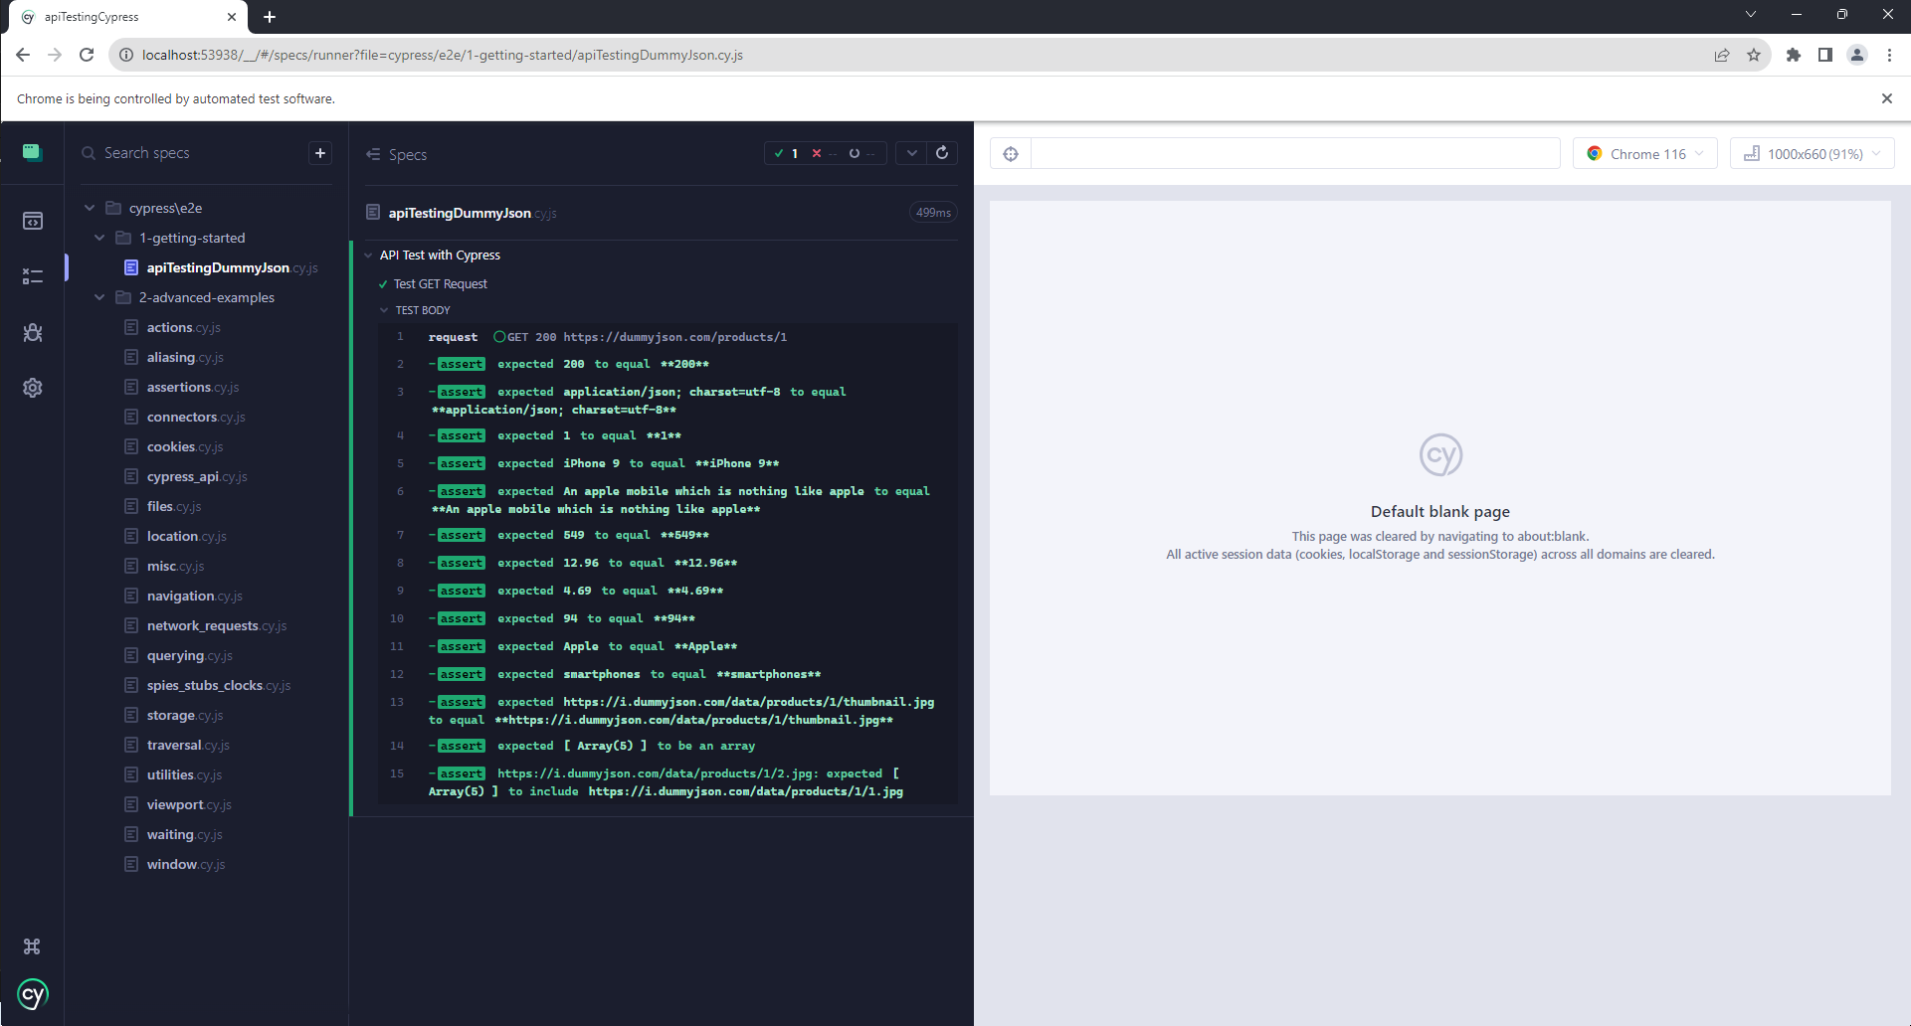

**Test Case: TC02 - Validate POST Request for Adding a New Product.**

**Description:** To verify that a POST request to the endpoint "https://dummyjson.com/products/add" successfully adds a new product with specific attributes.

**Environment:** Windows 11 (Chrome Version 116)

**Test Type:** API Testing / Functional Testing

**Precondition:**

Cypress is properly installed and configured.

Internet access is available to reach the API endpoint "https://dummyjson.com/products/add".

**Test Steps:**

1. Open a terminal window.
2. Navigate to the Cypress project folder.
3. Run the command "npx cypress open".
4. Select E2E testing.
5. Select your preferred browser and click the "Start E2E Testing" button.
6. Execute the Cypress testing code "apiTestingDummyJson.cy.js" to perform a POST request to "https://dummyjson.com/products/add"

**Expected Results:**

* The HTTP status code should be ‘200’.
* The ‘Content-Type’ header should be ‘application/json; charset=utf-8’.
* The ‘id’ field in the JSON response should match the ID ‘101’ from the request payload.
* The ‘title’ field in the JSON response should match the title "iPhone 10" from the request payload.

**Actual result:**

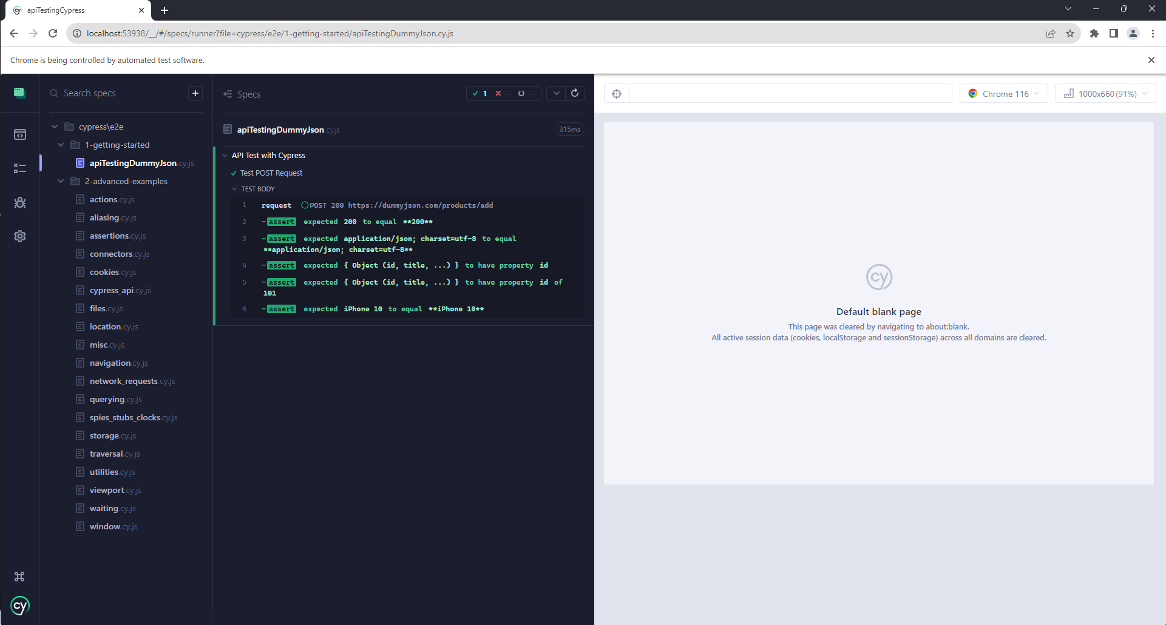

**Test Case: TC03 - Validate PUT Request for Updating a Product**

**Description:** To verify that a PUT request to the endpoint "https://dummyjson.com/products/1" successfully updates an existing product with specific attributes.

**Environment:** Windows 11 (Chrome Version 116)

**Test Type:** API Testing / Functional Testing

**Precondition:**

Cypress is properly installed and configured.

Internet access is available to reach the API endpoint "https://dummyjson.com/products/1".

**Test Steps:**

1. Open a terminal window.
2. Navigate to the Cypress project folder.
3. Run the command "npx cypress open".
4. Select E2E testing.
5. Select your preferred browser and click the "Start E2E Testing" button.

Execute the Cypress testing code "apiTestingDummyJson.cy.js" to perform a PUT request to "https://dummyjson.com/products/1".

**Expected Results:**

* The HTTP status code should be ‘200’.
* The ‘Content-Type’ header should be ‘application/json; charset=utf-8’.
* The ‘title’ field in the JSON response should match the updated title "iPhone 9S" from the request payload.
* The ‘description’ field in the JSON response should match the updated description "An updated version of the iPhone 9" from the request payload.
* The ‘price’ field in the JSON response should match the updated price ‘559’ from the request payload.

**Actual result:**

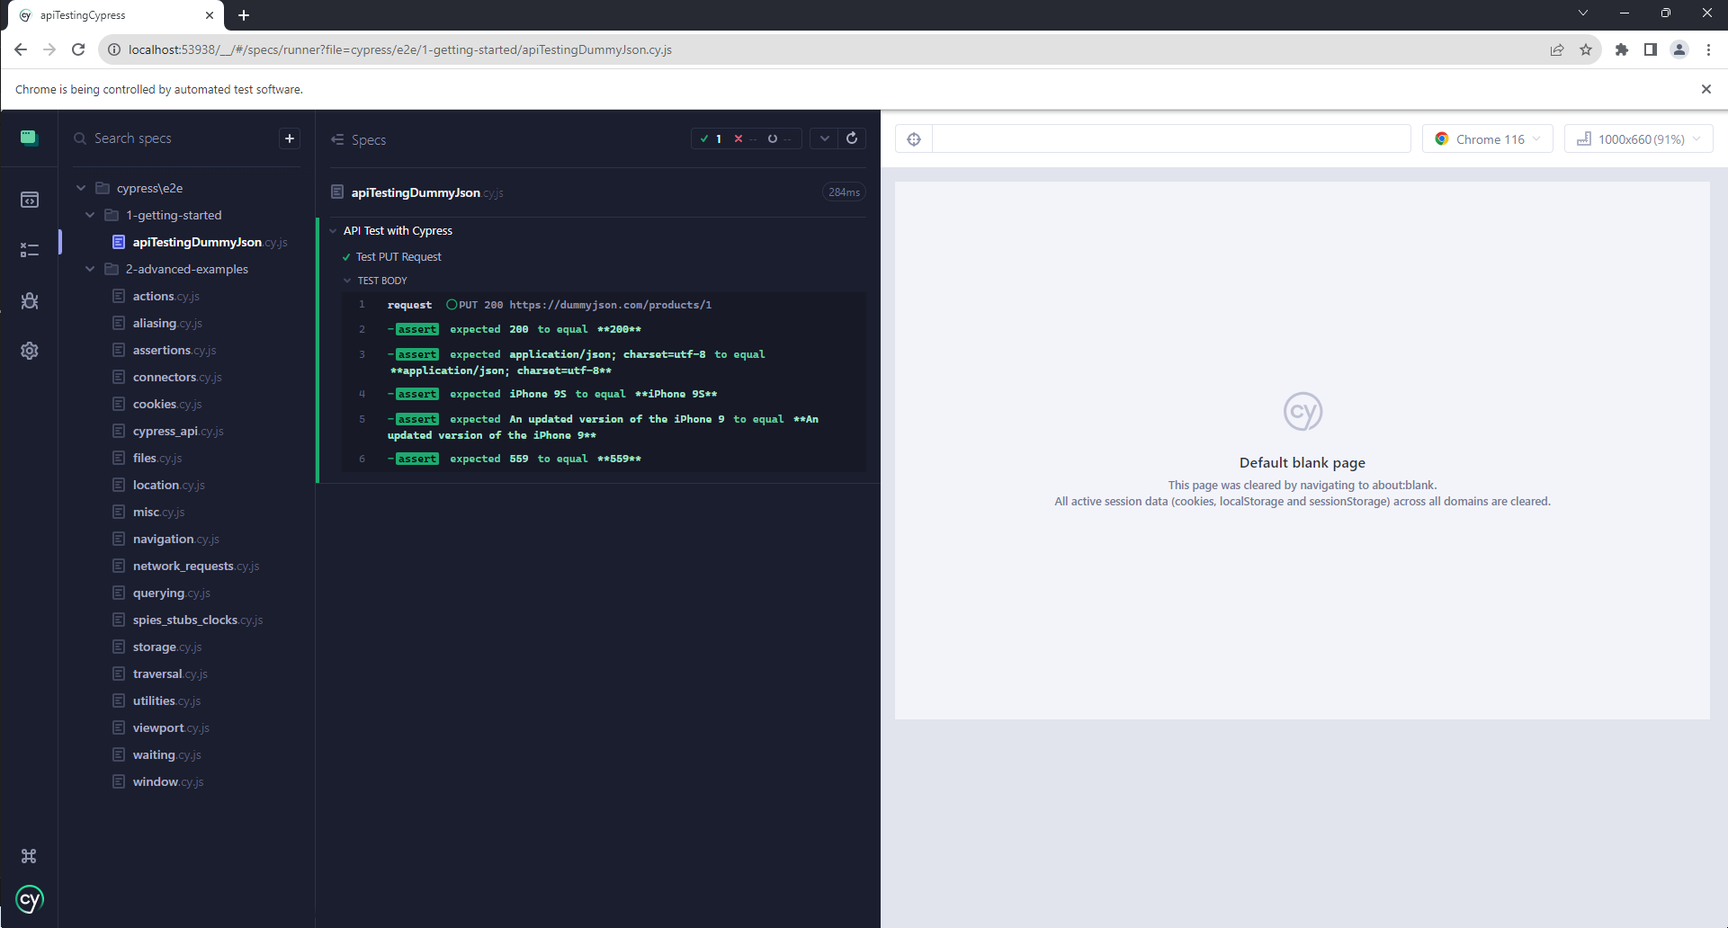

**Test Case: TC04 - Validate DELETE Request for Removing a Product**

**Description:** To verify that a DELETE request to the endpoint "https://dummyjson.com/products/1" successfully removes an existing product with the ID 1.

**Environment:** Windows 11 (Chrome Version 116)

**Test Type:** API Testing / Functional Testing

**Precondition:**

Cypress is properly installed and configured.

Internet access is available to reach the API endpoint "https://dummyjson.com/products/1".

**Test Steps:**

1. Open a terminal window.
2. Navigate to the Cypress project folder.
3. Run the command "npx cypress open".
4. Select E2E testing.
5. Execute the Cypress testing code "apiTestingDummyJson.cy.js" to perform a DELETE request to "https://dummyjson.com/products/1".

**Expected Results:**

* The HTTP status code should be ‘200’.
* The ‘Content-Type’ header should be ‘application/json; charset=utf-8’.

**Actual result:**

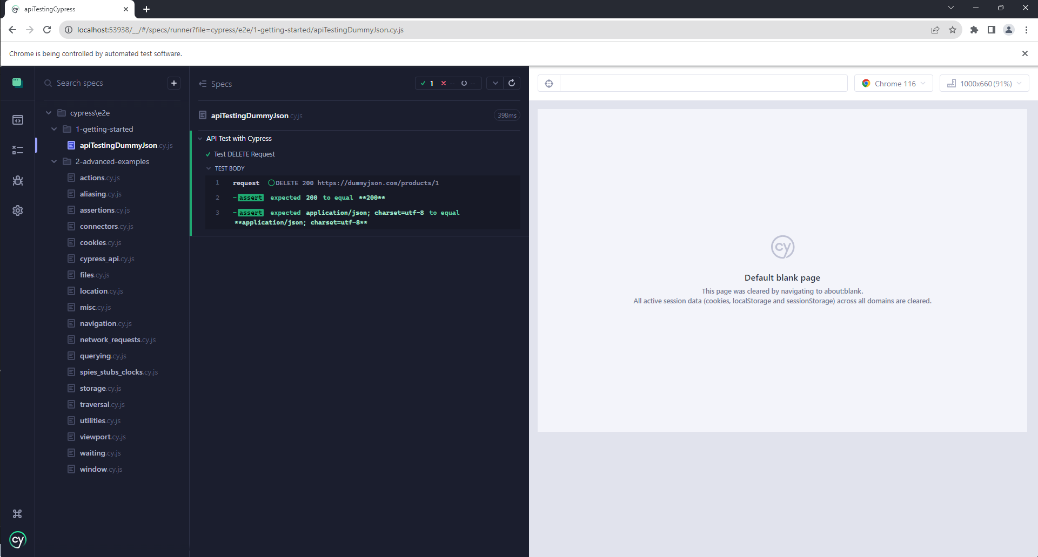

***References:***

* <https://www.browserstack.com/guide/cypress-api-testing>