Nicholas Dias

Project 2

3/5/2017

Between the ages of 16 and 30 months, language acquisition in children accelerates to unfathomable speeds. During this time, the average child multiples their vocabulary by as many as 35 times. Consequently, of course, psychologists and linguists are fascinated with this period of development, but, until recently, there was no comprehensive database of children’s language acquisition. Enter WordBank, a project from Stanford University that has made publicly available data from dozens of longitudinal language studies encompassing surveys of over 60,000 children using 23 languages. To get a sense for what the data had to offer, I decided to play around a little.

It’s not the case that children learn a bit of everything. Some types of words get more attention than others. For example, children’s vocabulary of action words—or verbs like run, cry and fall—see the most growth between months 16 and 30. The names of body parts are also highly important—which perhaps makes sense given the bumps and bruises that come with toddlers. In contrast, conjunctions or connecting words like ‘and’, ‘but’ or ‘because’ see the least growth. However, that almost certainly reflects the shortage of conjunctions in the English language rather than any lack of importance about these words.

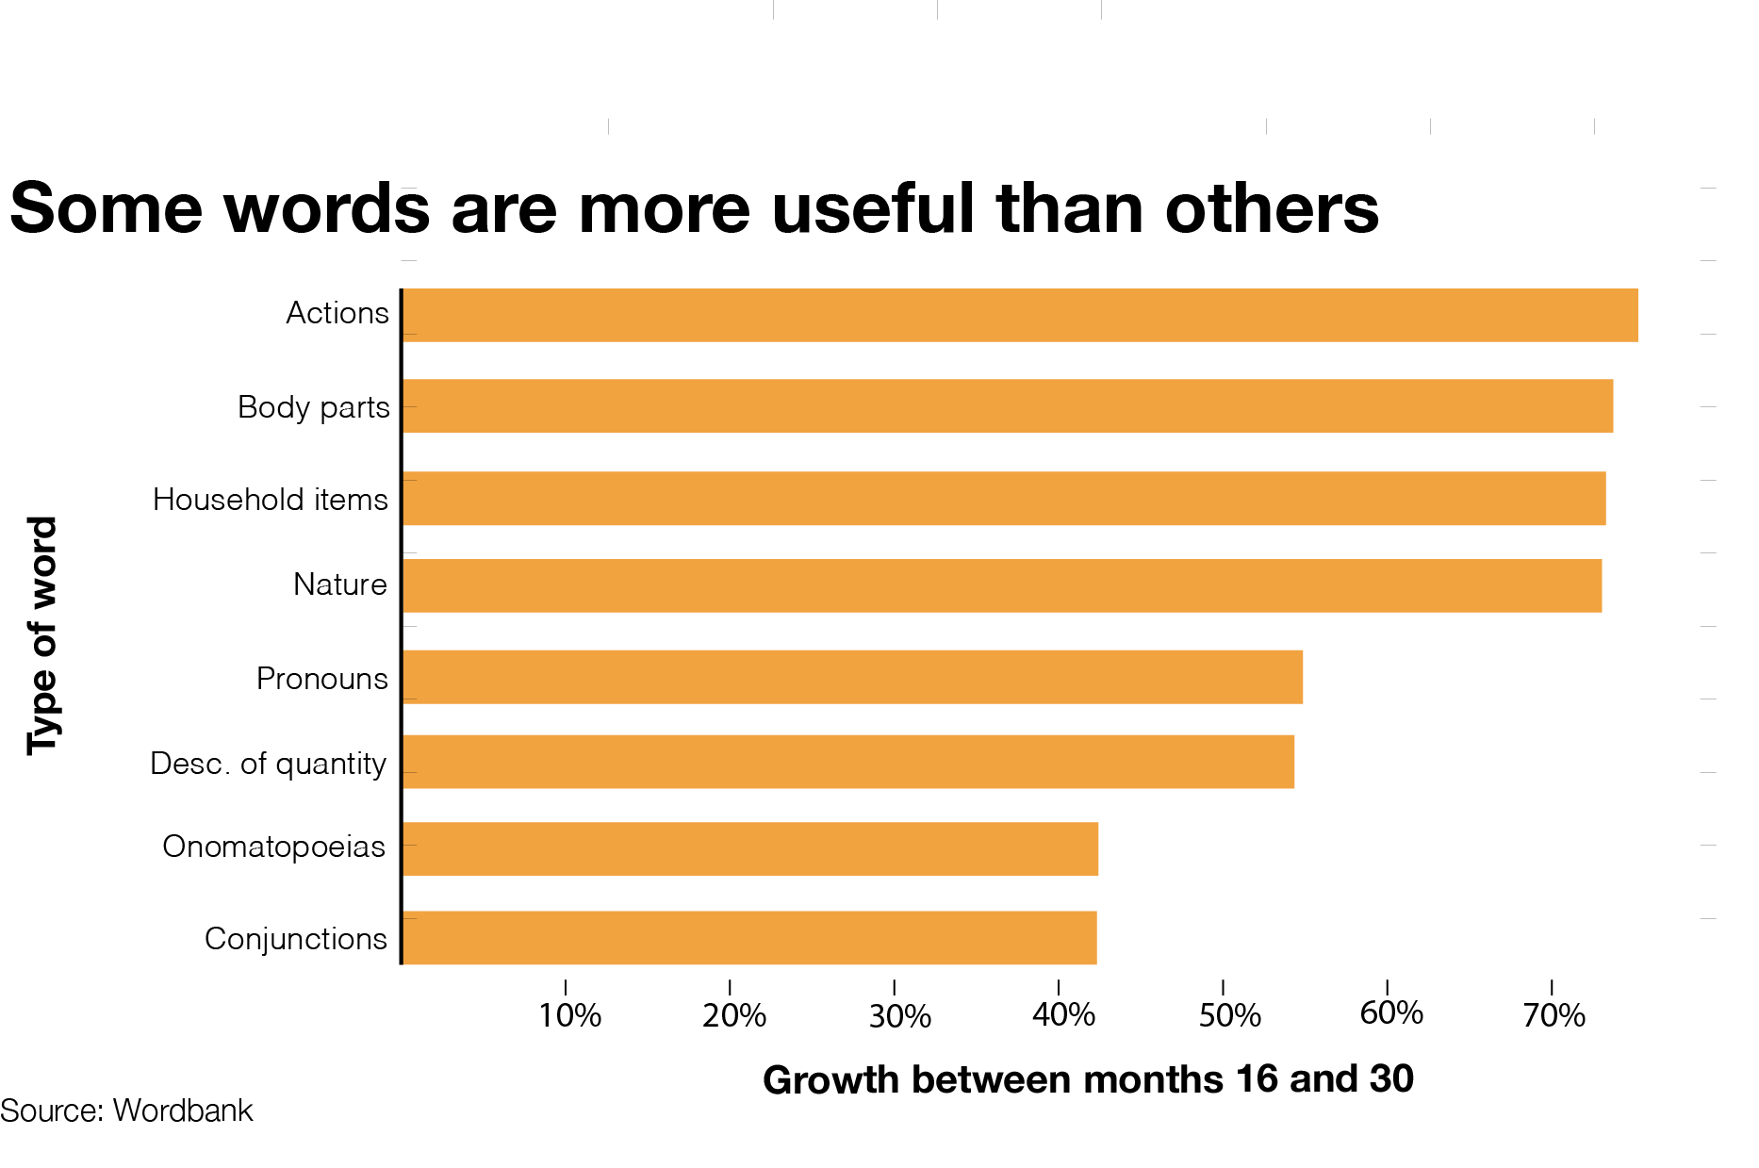

It’s also not the case that is language acquisition is comparable between children. Kids with well-educated moms excel at comprehending and using new words compared to those with less-educated mothers. And this difference is great: Children whose mothers have graduate degrees learn to understand and produce at least twice as many words on average than kids whose mothers only graduated from primary school. Furthermore, the relationship between mother’s education and child world acquisition appears to be linear. In other words, additional education continues to be tied to surges in language acquisition even after college. It’s also notable that, at this time, kids are using almost all of the words they know.

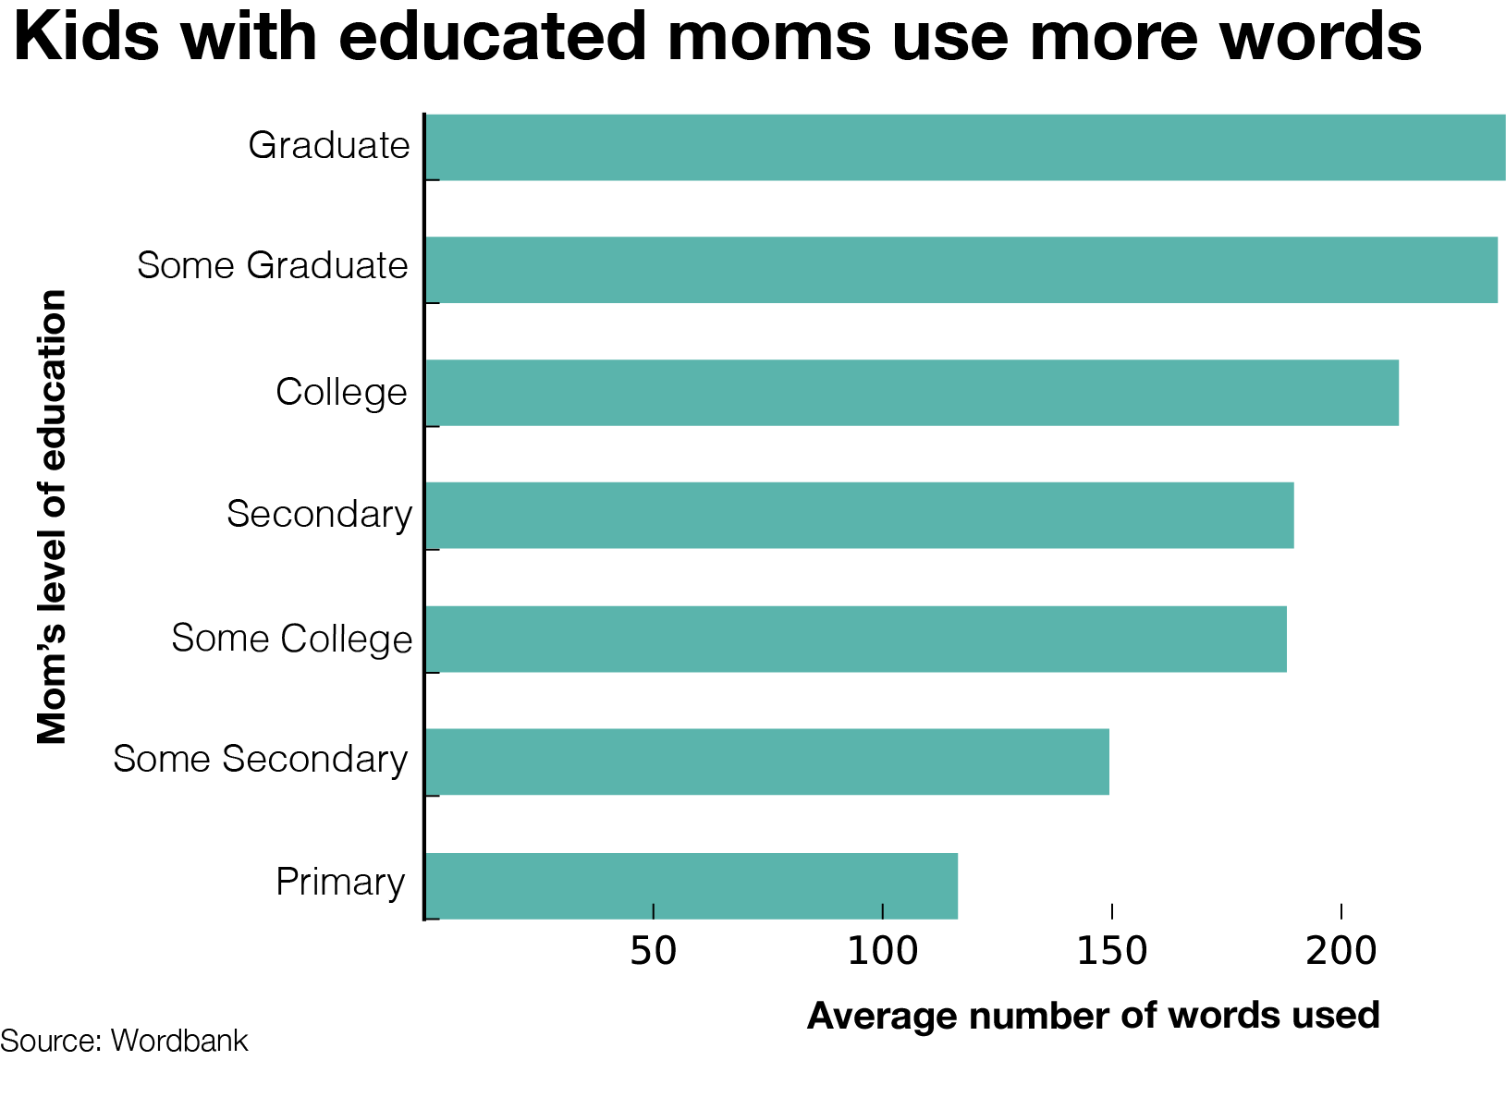

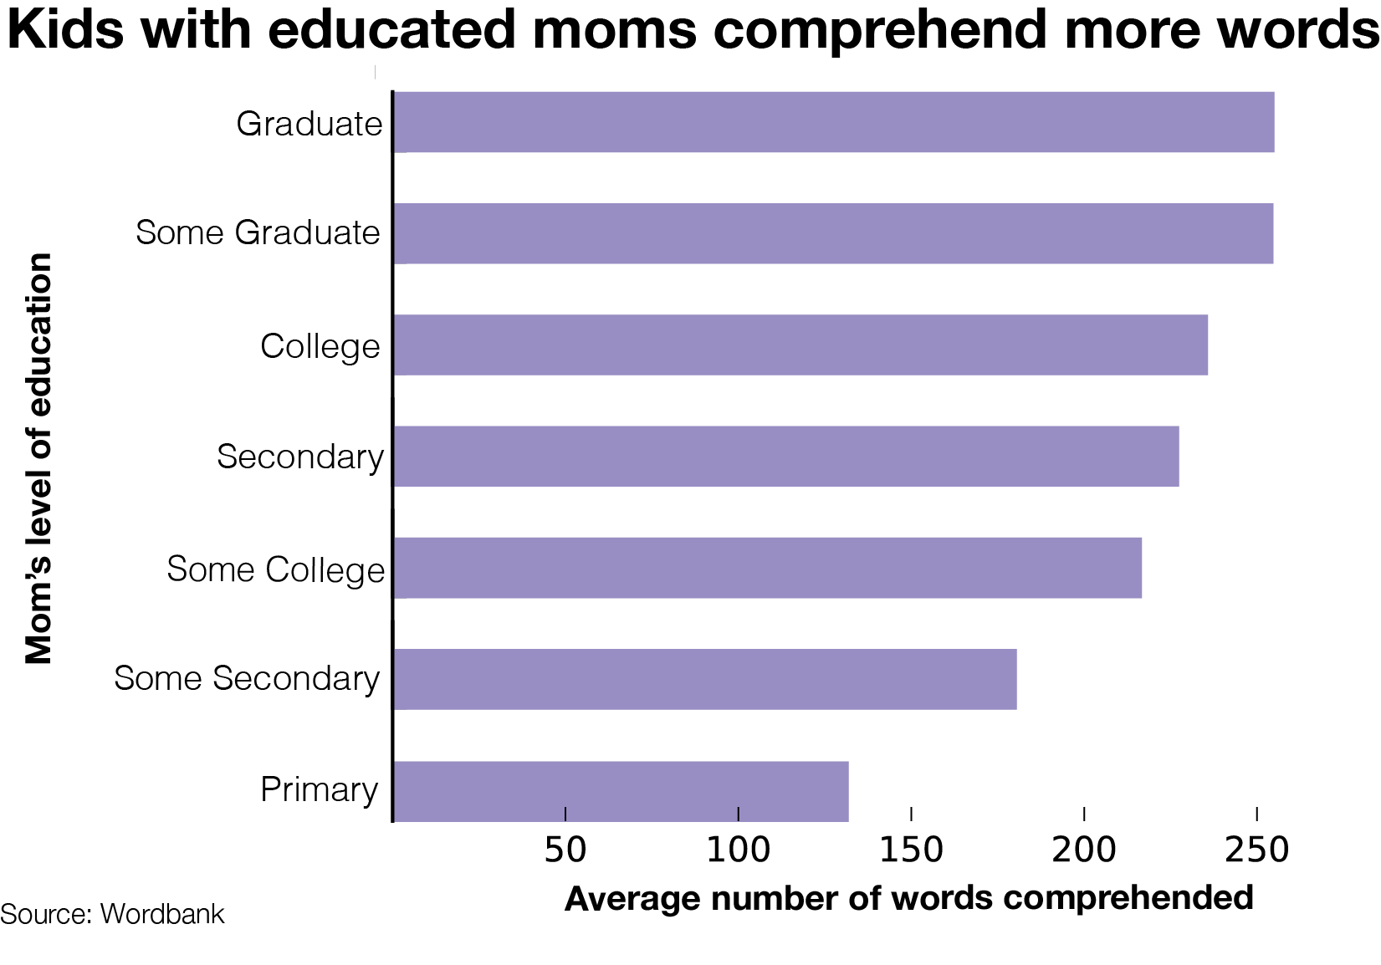

One rich feature of studying language acquisition in kids is the window it provides into the life of the average child. For example, examining which food-related words kids learn might offer some insight into when they begin eating what. Perhaps disappointingly, the two words that gain the most currency among toddlers are ‘pizza’ and ‘candy’. Of course, this is not to say that parents are gorging their children on junk food (Other [datasets](http://journal.frontiersin.org/article/10.3389/fpsyg.2015.01849/full) got that). Use of ‘banana’ does not pick up much between months 16 and 30, but that appears to be because kids already know the word by 16 months.

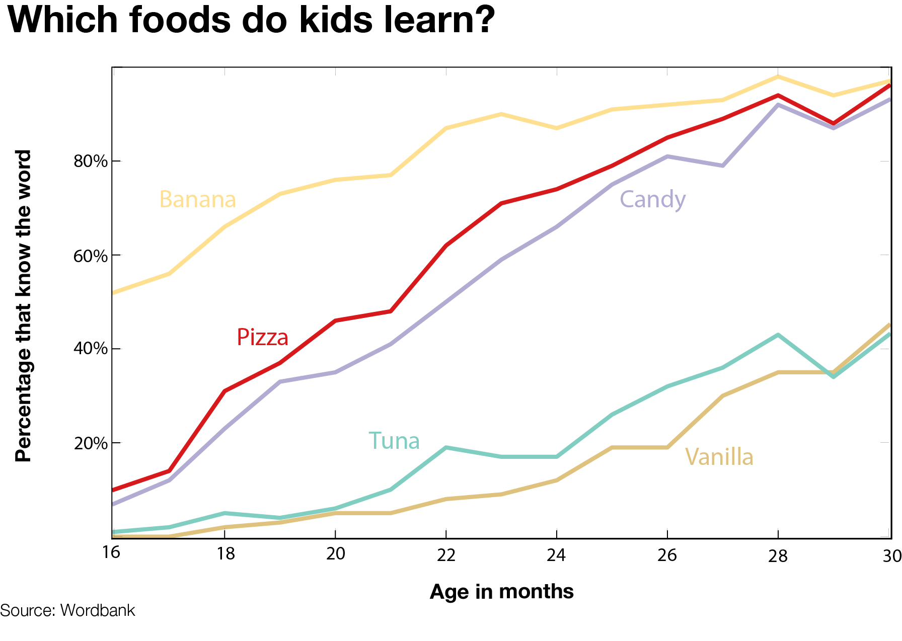

Finally, as an homage to my zoo-going days long past, I decided to take a look at what kinds of animals kids were learning about. As might be expected, ‘dog’ and ‘kitty’ didn’t undergo much growth due to their high initial use. The word ‘elephant’ sees steep gains throughout the critical period, moving from 7 percent saturation at month 16 to almost 90 percent at month 30. ‘Moose’ and ‘hen’ are the least popular animals. At 30 months, more than half of children still don’t know either term.

