1. 1. A ∗ (!A + B ∗ B) + !(B + A) ∗ (!A + B)
      1. A*(!A+B*B)+!B*!A(!A+B) 🡪 Using Demorgan’s Theorem
      2. A(!A+B)+!B*!A(!A+B) 🡪 Idempotent Law
      3. (!A+B)(!B*!A+A) 🡪 Distributive Law
      4. (!A+B)(!B+A) 🡪 Absorption Law
      5. (!B+A)!A+(!B+A)B 🡪 Distribution
      6. !A*!B+!A*A+(!B+A)*B 🡪 Distribution
      7. !A*!B+0+(!B+A)*B 🡪 Complement Law
      8. !A*!B + B*A 🡪 Identity Law

Answer: !A!B + BA

* 1. !(C ∗ B) + (A ∗ B ∗ C) + !(A + C + !B)
     1. !C*!B+A*B*C+!(A+C+!B) 🡪 Demorgan Theorem
     2. !C*!B + A*B*C + !A*!C*!!B 🡪 Demorgan Theorem
     3. !C*!B+A*B*C+!A*!C*B 🡪 Involution Law
     4. A*B*C + !C*(!A*B+!B) 🡪 Distributive Law
     5. A*B*C+!C(!A+!B) 🡪 Absorption Law
     6. A*B*C+!C*!A+!C*!B 🡪 Distribution

Answer: ABC+!C!A+!C!B

* 1. (A + B) ∗ (!A + C) ∗ (!C + B)
     1. (!A+C)(!C+B)*A+(!A+C)(!C+B)*B 🡪 Distribution
     2. (!C+B)*A*!A+(!C+B)*A*C+(!A+C)*(!C+B)*B 🡪 Distribution
     3. 0+(!C+B)*A*C+(!A+C)*(!C+B)*B 🡪 Complement Law
     4. (!C+B)*A*C+(!A+C)*(!C+B)*B 🡪 Identity Law
     5. A*C*!C+A*C*B+(!A+C)*(!C+B)*B 🡪 Distribution
     6. 0+A*C*B+(!A+C)*(!C+B)*B 🡪 Complement Law
     7. A*C*B + (!A+C)*(!C+B)*B 🡪 Identity Law
     8. A*C*B+(!C+B)*B*!A+(!C+B)*B*C 🡪 Distribution
     9. A*C*B+B*!A*!C+B*!A+(!C+B)*B*C 🡪 Distribution
     10. A*C*B + B*!A*!C+B*!A+(!C + B) B*C 🡪 Idempotent Law
     11. A*C*B + B*!A + (!C+B)B*C 🡪 Absorption Law
     12. B*(A*C+!A)+(!C+B)*B*C 🡪 Distributive Law
     13. B(C+!A)+(!C+B)*B*C 🡪 Absorption Law
     14. B*C+B*!A+(!C+B)*B*C 🡪 Distribution
     15. B*C+B*!A 🡪 Absorption Law

Answer: BC+B!A

1. 1. (!A + C) ∗ (!B + D + A) ∗ (D + A ∗ !C) ∗ (!D + A) = 1
      1. A(!B+D+A)(D+A!C)(!D+A)!A+A(!B+D+A)(D+A!C)(!D+A)C 🡪 Distribution
      2. 0+A(!B+D+A)(D+A!C)(!D+A)C 🡪 Complement Law
      3. A(!B+D+A)(D+A!C)(!D+A)C 🡪 Identity Law
      4. A(D+A!C)(!D+A)C!B+A(D+A!C)(!D+A)CD+A(D+A!C)(!D+A)CA 🡪 Distribution
      5. A(D+A!C)(!D+A)C!B+A(D+A!C)(!D+A)CD+A(D+A!C)(!D+A)C 🡪 Idempotent Law
      6. A(D+A!C)(!D+A)CD+A(D+A!C)(!D+A)C 🡪 Absorption Law
      7. A(D+A!C)(!D+A)C 🡪 Absorption Law
      8. A(!D+A)CD+A(!D+A)CA!C 🡪 Distribution
      9. A(!D+A)CD+A(!D+A)C!C 🡪 Idempotent Law
      10. A(!D+A)CD+0 🡪 Complement Law
      11. A(!D+A)CD 🡪 Identity Law
      12. ACD!D+ACDA 🡪 Distribution
      13. ACD!D+ACD 🡪 Idempotent Law
      14. 0+ACD 🡪 Complement Law
      15. Simplifies down to C * D * A = 1

Therefore, there is only 1 solution:

C = 1, D = 1, and A = 1

* 1. (((!K ∗ L ∗ N) ∗ (L + M)) + ((!K + L + N) ∗ (K ∗ !L ∗ !M))) ∗ (!K + !N) = 1
     1. (!K+!N)!KLN(L+M)+(!K+!N)(!K+L+N)K!L!M 🡪 Distribution
     2. !KLN(L+M)!K+!KLN(L+M)!N+(!K +!N)(!K+L+N)K!L!M 🡪 Distribution
     3. !KLN(L+M)+!KLN(L+M)!N+(!K +!N)(!K+L+N)K!L!M 🡪 Idempotent Law
     4. !KLN(L+M)+0+(!K+!N)(!K+L+N)K!L!M 🡪 Complement Law
     5. !KLN(L+M)+(!K+!N)(!K+L+N)K!L!M 🡪 Identity Law
     6. !KLNL + !KLNM+ (!K+!N)(!K+L+N)K!L!M 🡪 Distribution
     7. !KLN + !KLNM + (!K+!N)(!K+L+N)K!L!M 🡪 Idempotent Law
     8. !KLN + (!K+!N)(!K+L+N)K!L!M 🡪 Absorption Law
     9. !KLN + (!K+L+N)K!L!M!K+(!K+L+N)K!L!M!N 🡪 Distribution
     10. !KLN+0+(!K+L+N)K!L!M!N 🡪 Complement Law
     11. !KLN+(!K+L+N)K!L!M!N 🡪 Identity Law
     12. !KLN + K!L!M!N!K + K!L!M!NL+K!L!M!NN 🡪 Distribution
     13. !KLN + 0 + K!L!M!NL+K!L!M!NN 🡪 Complement Law
     14. !KLN + K!L!M!NL+K!L!M!NN 🡪 Identity Law
     15. !KLN + 0 +K!L!M!NN 🡪 Complement Law
     16. !KLN +K!L!M!NN 🡪 Identity Law
     17. !KLN + 0 🡪 Complement Law
     18. !KLN 🡪 Identity Law
     19. Simplifies down to !K*L*N

Therefore, there is only one solution:

K = 0, L = 1, N = 1

1. Q = !X*!Y*Z + X*Y!Z + !X*Y*!Z + X*!Y*!Z

|  |  |  |  |  |  |  |  |  |
| --- | --- | --- | --- | --- | --- | --- | --- | --- |
| X |  | Y | Z | !X*!Y*Z | X*Y*!Z | !X*Y*!Z | X*!Y*!Z | Q |
| 0 |  | 0 | 0 | 0 | 0 | 0 | 0 | 0 |
| 0 |  | 0 | 1 | 1 | 0 | 0 | 0 | 1 |
| 0 |  | 1 | 0 | 0 | 0 | 1 | 0 | 1 |
| 0 |  | 1 | 1 | 0 | 0 | 0 | 0 | 0 |
| 1 |  | 0 | 0 | 0 | 0 | 0 | 1 | 1 |
| 1 |  | 0 | 1 | 0 | 0 | 0 | 0 | 0 |
| 1 |  | 1 | 0 | 0 | 1 | 0 | 0 | 1 |
| 1 |  | 1 | 1 | 0 | 0 | 0 | 0 | 0 |

* 1. K-map:

* 1. Simplifying

!X!YZ+Y!Z(X+!X)+X!Y!Z 🡪 Distributive Law

!X!YZ+Y!Z*1+X!Y!Z 🡪 Complement Law

!X!YZ+Y!Z+X!Y!Z 🡪 Identity Law

!X!YZ+!Z(X!Y+Y) 🡪 Distributive Law

!X!YZ+!Z(X+Y) 🡪 Absorption Law

!X!YZ+!ZX+!ZY 🡪 Distribution

Answer: !XYZ+!ZX+!ZY

1. 1. !A!B!C+ !AB!C+!ABC+ABC
   2. !A!C(!B+B)+!ABC+ABC 🡪 Distributive Law
   3. !A!C*1+!ABC+ABC 🡪 Complement Law
   4. !A!C+!ABC+ABC 🡪 Identity Law
   5. !A(BC+!C)+ABC 🡪 Distributive Law
   6. !A(B+!C)+ABC 🡪 Absorption Law
   7. !AB+!A!C+ABC 🡪 Distribution
   8. !A!C + B(AC + !A) 🡪 Distributive Law
   9. !A!C+B(C+!A) 🡪 Absorption Law
   10. !A!C+BC+B!A 🡪 Distribution
   11. BC + !C!A 🡪 Consensus
   12. (B+!C)(C+!A) / BC + !C!A

Answer: BC + !C!A

1. (Submitted on Submitty hw04_SOP.circuit)

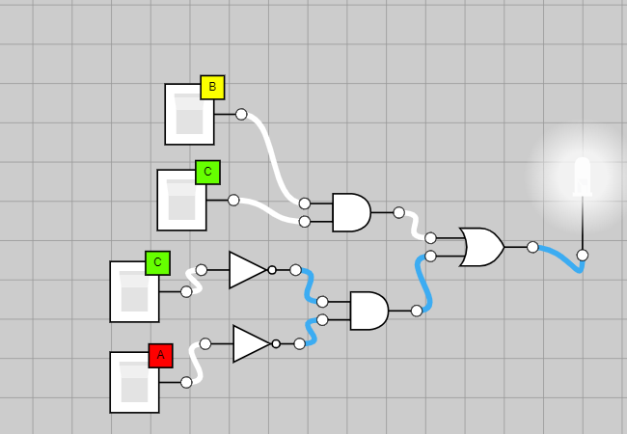

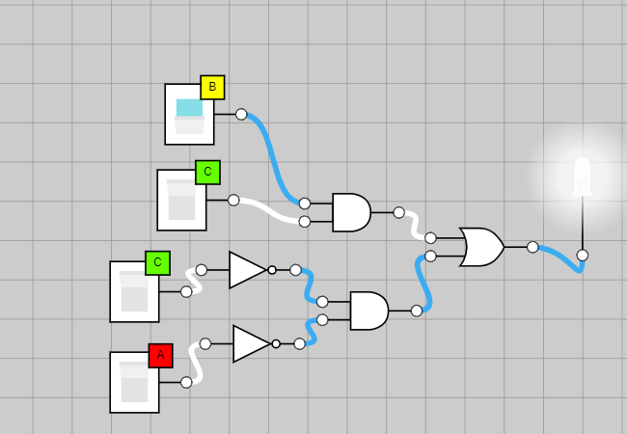

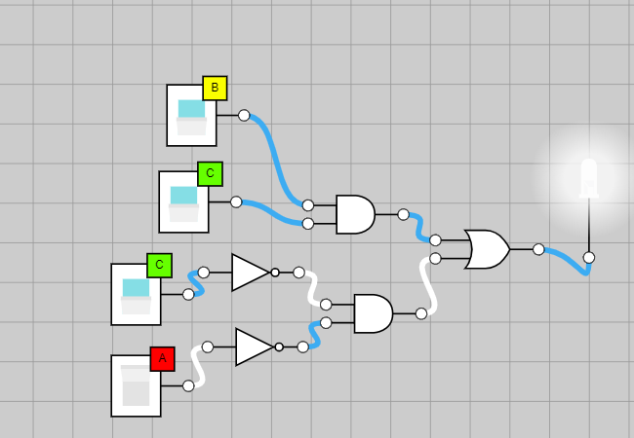

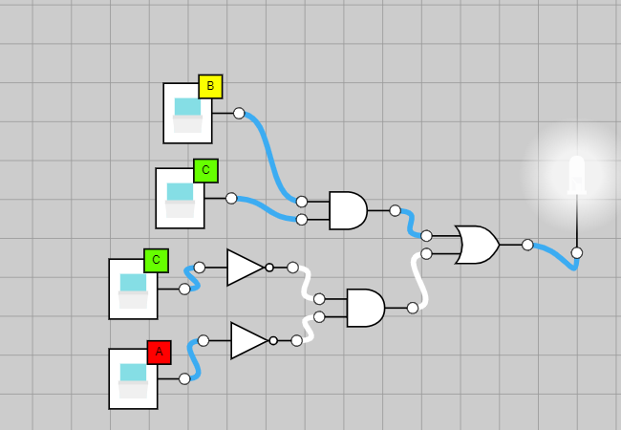

1. 1. Using OR only using NOR Gates (next page):

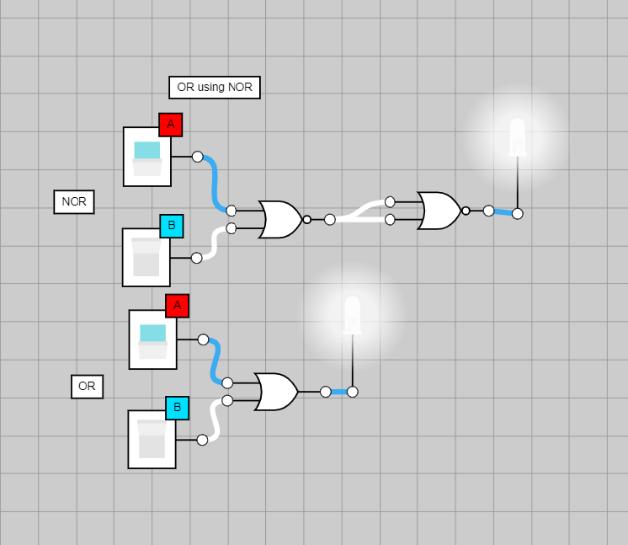

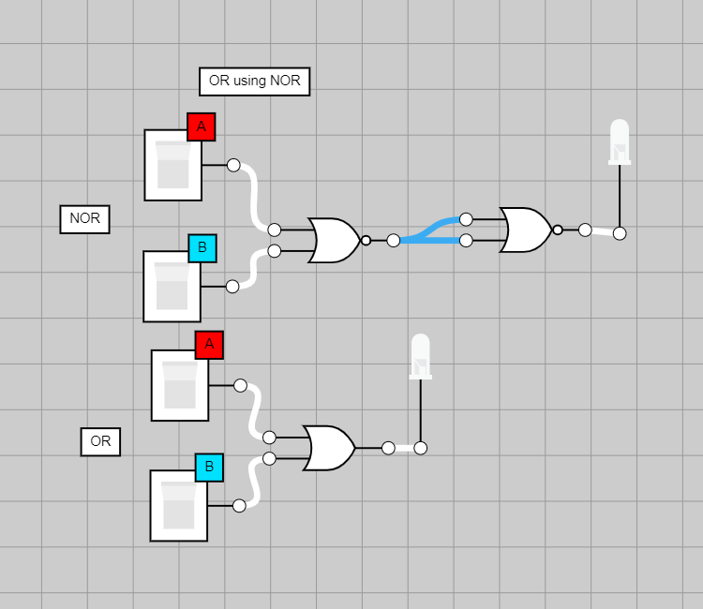

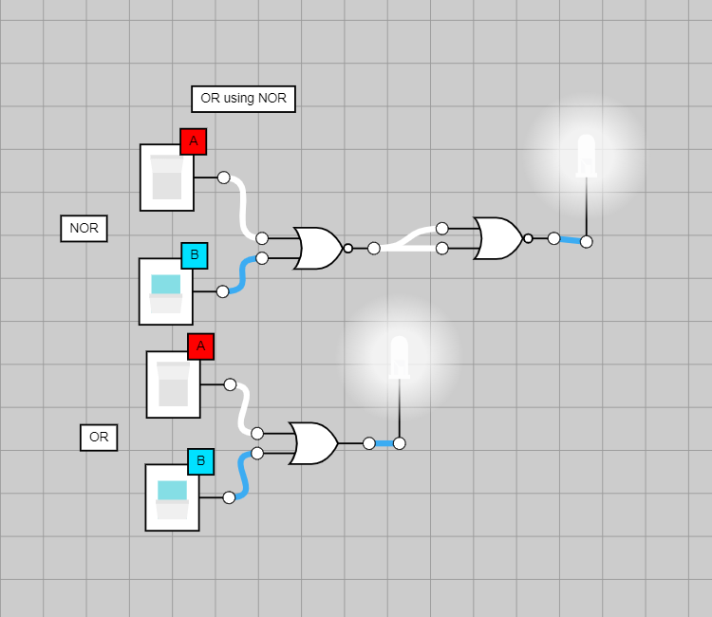

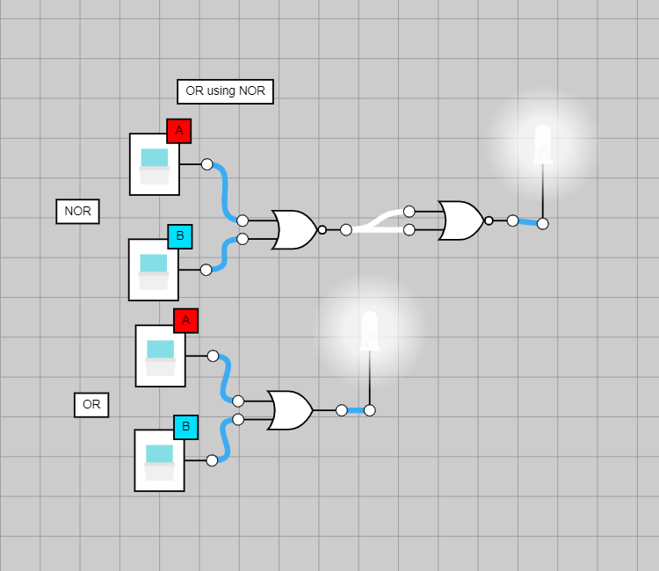

* 1. Using AND only using NOR Gates:

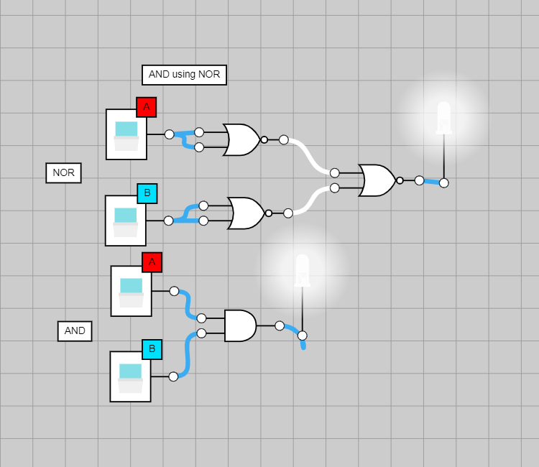

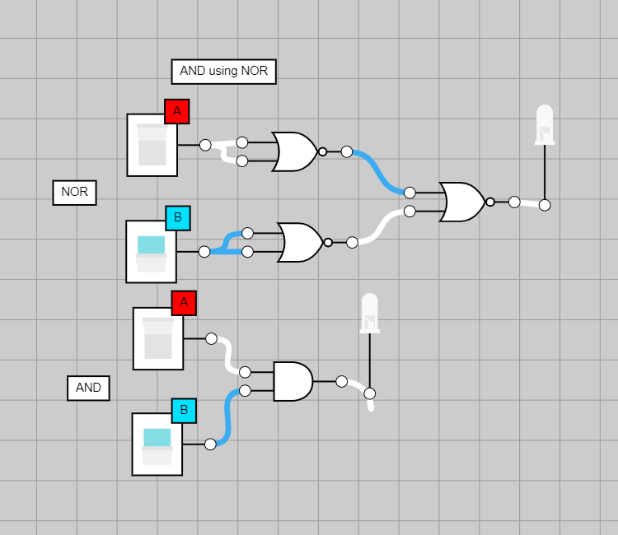

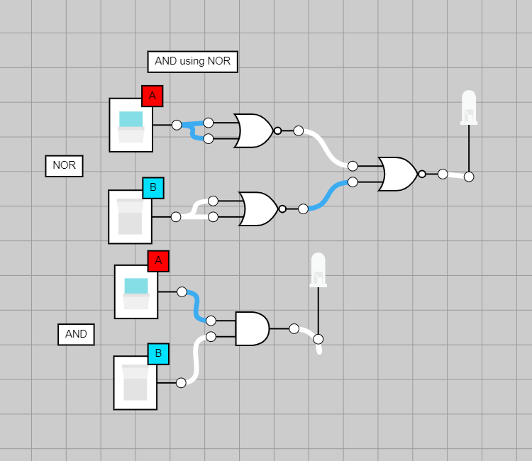

* 1. Using NOT only using NOR Gates:

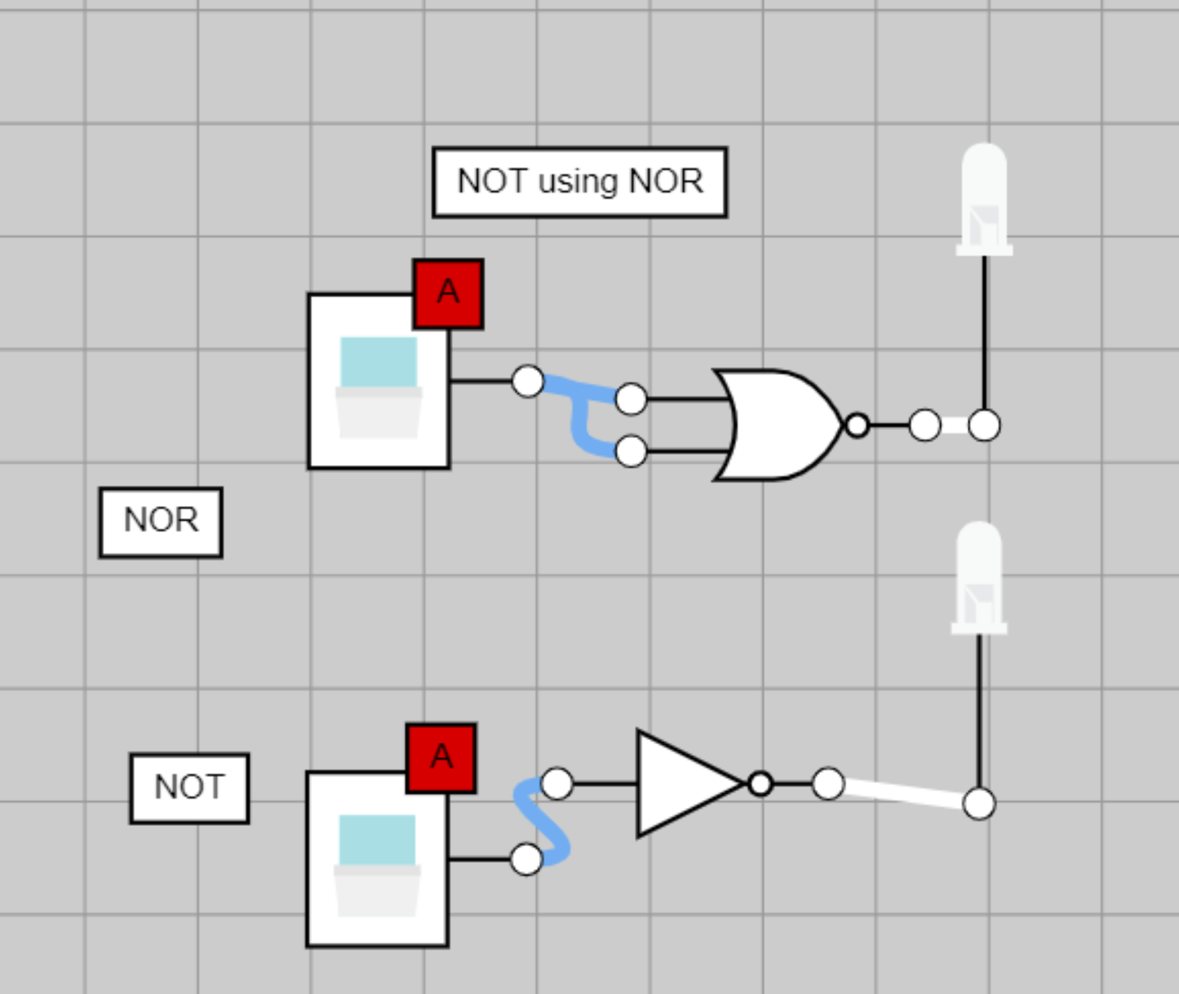

1. 10.13.1
   1. 5ED4 in binary: 0101 1110 1101 0100
   2. 07A4 in binary: 0000 0111 1010 0100
   3. 5ED4 – 07A4 = 0101 1110 1101 0100 - 0000 0111 1010 0100
   4. = 0101 0111 0011 0000 🡪 5730 in hexadecimal format

Answer: 5730 (hexadecimal)

1. 10.13.2
   1. Neither of the hexadecimal values are negative so we calculate it

|  |  |  |  |  |
| --- | --- | --- | --- | --- |
| 5ED4 | 0101 | 1110 | 1101 | 0100 |
| 07A4 | 0000 | 0111 | 1010 | 0100 |
| 5ED4 – 07A4 | 0101 | 0111 | 0001 | 0000 |
|  | 5 | 7 | 3 | 0 |

1. 10.13.6
   1. 185 = 10111001
   2. 122 = 01111010
   3. Add 1 to complement of 122 = 10000110 (2’s complement of 122)

|  |  |
| --- | --- |
| Binary value of 185 | 10111001 |
| Complement of 122 (2’s) | 10000110 |
| 185+2’s complement of 122 | 100111111 🡪 overflow |

* 1. 185 – 122 = -193

Answer: -193

1. 10.13.10
   1. 151 & 214 both are stored in 2’s complement form
   2. 151 & 214 in 2’s complement form
      1. 151 = 10010111 🡪 01101001 (2’s complement form) 🡪 105
      2. 214 = 11010110 🡪 00101010 (2’s complement form) 🡪 42
   3. So, 151-214 = 105 – 42 = 63

Answer: 63

1. 10.13.11
   1. 151 & 214 both are stored in 2’s complement form
   2. 151 & 214 in 2’s complement form
      1. 151 = 10010111 🡪 01101001 (2’s complement form) 🡪 105
      2. 214 = 11010110 🡪 00101010 (2’s complement form) 🡪 42
   3. So, 151-214 = 105 + 42 = 147

Answer: 147

1. 10.13.20
   1. 0x0C000000 = 0000 1100 0000 0000 0000 0000 0000 0000
   2. 0*167 + 12*166+ 0*165+ 0*164+ 0*163+ 0*162+ 0*161+ 0*160
   3. 0 + 12 + 16777216 + 0 + 0 + 0 + 0 + 0 + 0
   4. = 201326592

Answer: 201326592

1. 10.13.21
   1. 0x0C000000 = 0000 1100 0000 0000 0000 0000 0000 0000
   2. In Binary 0C000000 = 00001100000000000000000000000000
   3. **🡪 00001100000000000000000000000000**
   4. **🡪 000011 00000000000000000000000000**
   5. **000011 🡪 I-type instruction 🡪 000011 is jal**
   6. **🡪 therefore, it turns into jal 0**

Answer: jal 0

1. Give a reason why we use two’s complement representation for negative numbers in computer arithmetic. Give and example of its usage.
   1. 2’s complement is 1’s complement + 1
   2. 2’s complement system you can use the same logics/circuits on binary numbers for addition and subtraction. It makes the system easier to implement and have easier precision arithmetic. It also excludes any negative zero cases.
   3. For example, adding 6+3 using 5 2 but complement representation
   4. 6 🡪 00110, 3 🡪 00011
   5. 00110 + 00011 = 01001 (9), 6+3 = 9
   6. So, this is why we use 2’s complement.