Selenium WebDriver Architecture

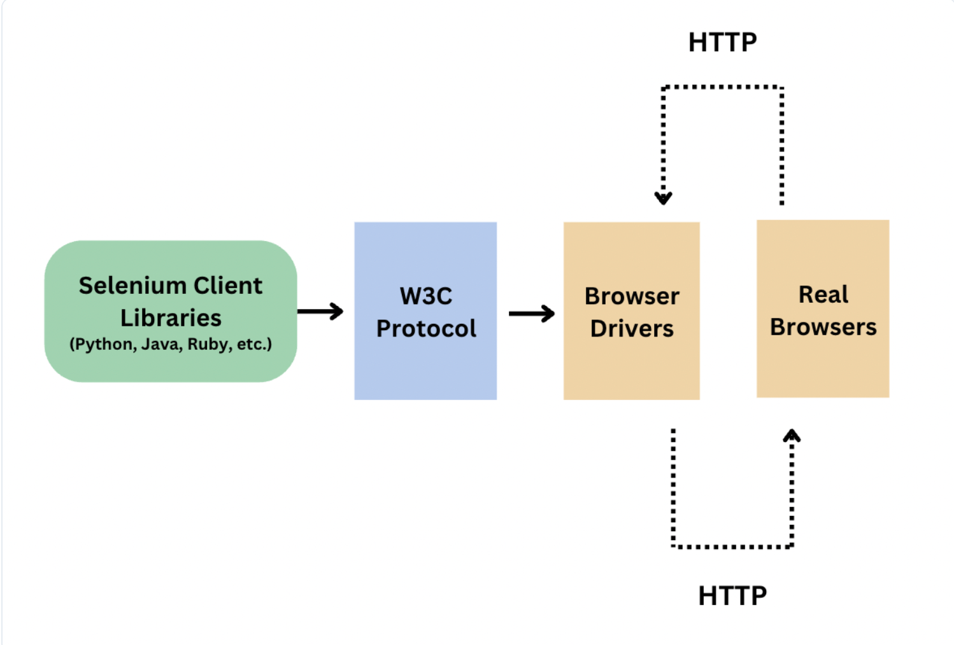
The architecture follows a specific flow of communication:
- Selenium Client Libraries: Supports multiple languages like Python, Java, Ruby, etc.
- W3C Protocol: The standard communication layer.
- Browser Drivers: Acts as the intermediary.
- Real Browsers: The final destination where actions are executed.
- Communication Flow: The WebDriver client translates script commands into HTTP requests following the W3C WebDriver Protocol.

Detailed Architectural Notes
These images provide a deep dive into how the components interact:
- W3C WebDriver Protocol:
  - The WebDriver client translates script commands into HTTP requests following this protocol.
  - All modern browsers (Chrome, Firefox, Safari, Edge) natively support the W3C protocol, which ensures consistent behavior across platforms.
- Browser Drivers:
  - HTTP requests are sent directly to Browser Drivers.
  - Each browser has its own dedicated driver.
  - The driver is a small program that acts as a translator between the WebDriver protocol and the browser itself.
- Execution Flow:
  - Browser drivers interpret the HTTP requests and control the actual web browsers.
  - They carry out defined actions such as opening pages, clicking buttons, and filling forms.
  - Finally, the browser executes the commands and returns a response to the driver, which is then relayed back to the WebDriver client.

