Prerequisites:

JDK7 or above, Maven 3.2.5

Project Structure:

ToyRobot is the root folder, having pom.xml, and the structure follows Maven conventions.

src/main/java -- all toyrobot source code
src/main/resources -- contains input testdata files(testData1.txt…testData5.txt)
src/test/java -- Test sources
src/test/resources -- Test resources
src/test/filters -- Test resource filter files
README.txt -- Project's readme

Design:

Implemented the command pattern to execute the series of commands.

Following is the class-diagram:-
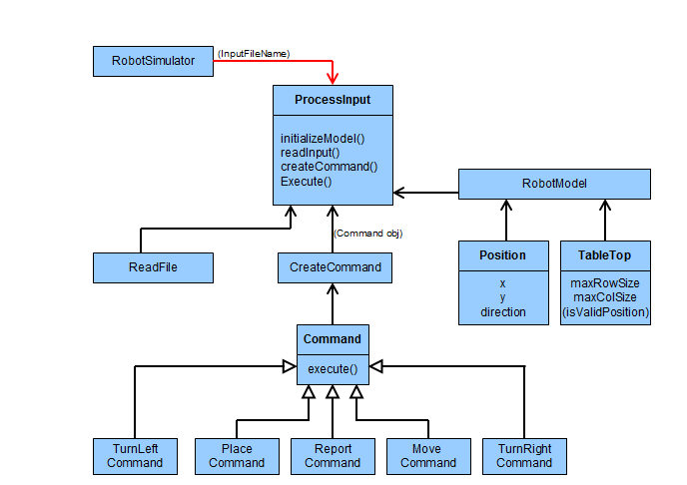

Assumptions and Constraints:-

- Robot must be prevented from falling to destruction(ignored), further valid movement commands must still be allowed.
- First command to the robot is a valid PLACE command. The application throws exception if first command is not a valid PLACE command.
- MOVE will move the toy robot one unit forward in the direction it is currently facing.
- LEFT and RIGHT will rotate the robot 90 degrees in the specified direction without changing the position of the robot.
- REPORT will announce the X,Y and F of the robot in standard output.

How To Run:-

cd ToyRobot

mvn package

java -cp target/ToyRobot-0.0.1-SNAPSHOT.jar com.anz.toyrobot.client.RobotSimulator testData1.txt
OR
java -cp target/classes com.anz.toyrobot.client.RobotSimulator testData1.txt

Inputs and Results:--

Input data Files | Expected Results
testData1.txt | 0,3,NORTH
testData2.txt | 1,4,EAST
testData3.txt | 0,1,NORTH
testData4.txt | 0,0,WEST
testData5.txt | 3,3,NORTH

