МИНОБРНАУКИ РОССИИ

Федеральное государственное автономное образовательное учреждения высшего образования

«ЮЖНЫЙ ФЕДЕРАЛЬНЫЙ УНИВЕРСИТЕТ»

Институт компьютерных технологий и информационной безопасности

Кафедра математического обеспечения и применения ЭВМ

 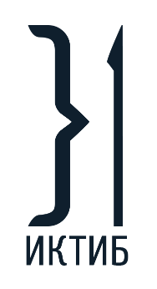 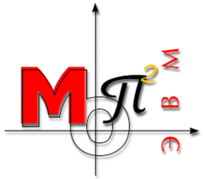

**ЛАБОРАТОРНАЯ РАБОТА № 4**

по дисциплине

**«Объектно-ориентированное программирование»**

на тему:

**«Использование библиотеки STL»**

*Вариант № 4*

Выполнил:

Студент группы

КТбо2-8

Макаров С. В.

Проверил:

Тарасов С. А.

Оценка

_________________________

«____» _____________ 2020 г.

Таганрог 2020

# **1 ФОРМУЛИРОВКА ЗАДАНИЯ**

Необходимо создать абстрактный класс Shape для создания от него объектов-фигур. Определить методы вычисления центра, площади, поворота фигуры. Создать класс операций над фигурами, в нем определить методы определения пересечения и включения фигур.

# **2 СПЕЦИФИКАЦИЯ КЛАССОВ**

struct Point

{

double x;

double y;

Point();

Point(double _x, double _y);

bool operator==(Point other);

Point& operator+=(Point other);

};

struct Line

{

Point begin;

Point end;

Line();

Line(Point _begin, Point _end);

};

class Shape

{

public:

Shape();

Shape(const Shape& other);

Shape(const Point* points, int length, std::string _name);

virtual ~Shape();

Shape& operator=(const Shape& other);

virtual double FindArea() const = 0;

virtual bool IsExisting() const = 0;

virtual Point FindCenter() const;

void Move(double xOffset, double yOffset);

void Rotate(int degrees);

std::string GetName() const;

int GetVerticesCount() const;

const Point* GetVertices() const;

Line* FindEdges() const;

private:

std::string name;

int verticesCount;

Point* vertices;

protected:

void _CheckExisting();

};

class Triangle : public Shape

{

public:

Triangle() = delete;

Triangle(const Point* points);

double FindArea() const override;

bool IsExisting() const override;

};

class Rectangle : public Shape

{

public:

Rectangle() = delete;

Rectangle(const Point* points);

double FindArea() const override;

bool IsExisting() const override;

};

class ShapeException : public std::exception

{

public:

ShapeException(const Shape& figure);

const char* what() const noexcept;

private:

std::string _aboutString;

};

class ShapeFactory

{

public:

static Shape* CreateShape(const Point* points, int length);

};

class GeometryMath

{

public:

GeometryMath();

const double pi;

const double epsilon;

double DegreesToRadian(int degrees) const;

double FindMagnitude(const Line& line) const;

double FindAngle(const Line& first, const Line& second) const;

bool IsIntersected(const Line& lFirst, const Line& lSecond) const;

bool IsIntersected(const Shape& lFirst, const Shape& lSecond) const;

// Not-strict inclusion

bool IsIncluded(Point p, const Shape& figure);

bool IsIncluded(const Shape& dest, const Shape& incl);

private:

bool _IsIncludedDontValidate(Point p, const Shape& figure);

void _ValidateShape(const Shape& shape) const;

};

class ConsoleInteractor

{

public:

ConsoleInteractor();

~ConsoleInteractor();

void Run();

private:

bool _Init();

void _PrintCommands() const;

template<class T>

void _ReadVar(T& var) const;

bool _ReadIndex(int& _index);

int totalCount;

int figuresCount;

Shape** figures;

};

# **3 ИСПОЛЬЗУЕМЫЕ МАТЕМАТИЧЕСКИЕ ЗАВИСИМОСТИ И АЛГОРИТМЫ**

В данной работе использовались следующие зависимости:

Вычисление длины вектора по формуле:

$$magnitude=\sqrt{{(x2-x1)}^{2}+{(y2-y1)}^{2}}$$

Вычисление угла между двумя векторами по формуле:

$$\cos\left(α\right)=\frac{ab}{\left|a\right|\left|b\right|}$$

Принадлежность точки фигуре вычисляется по алгоритму суммы углов: из данной точки проводятся отрезки во все вершины фигуры, сумма углов между всеми соседними отрезками должна быть равна 2*Pi.

Включение одной фигуры в другой определяется с помощью последовательной проверки всех точек на принадлежность.

Пересечение двух отрезков определяется по формуле, показанной на рисунке 1, которая была выведена из уравнения прямых.

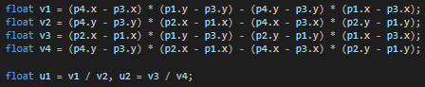

Где, p1 и p2 – точки первого вектора, остальные – второго. Если коэффициенты u1 и u2 лежат на промежутке от 0 до 1 включительно, то отрезки пересекаются.

Для проверки, пересекаются ли фигуры, выполняется проверка на пересечения всех ребер со всеми возможными.

Для поворота фигур использовалась матрица поворота, которая поворачивает точку на заданный угол в радианах.

$$\left({x \atop y}\right)\left(\begin{matrix}cos⁡(a) & -sin⁡(a) \\ sin⁡(a) & cos⁡(a)\end{matrix}\right)=\left({x' \atop y'}\right)$$

# **4 ДИАГРАММА КЛАССОВ**

Uml диаграмма классов изображена на рисунке 1.

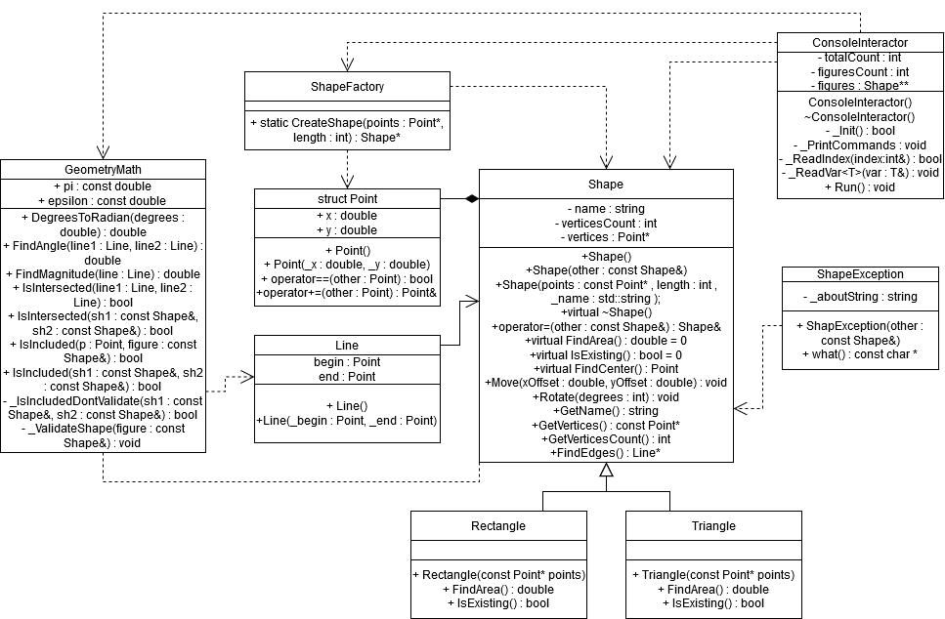

Рисунок 1 – Диаграмма классов

**ЛИСТИНГ ПРОГРАММЫ**

Point::Point()

: x(0), y(0)

{}

Point::Point(double _x, double _y)

: x(_x), y(_y)

{}

bool Point::operator==(Point other)

{

if (x == other.x && y == other.y)

{

return true;

}

return false;

}

Point& Point::operator+=(Point other)

{

x += other.x;

y += other.y;

return *this;

}

Line::Line()

: begin(), end()

{}

Line::Line(Point _begin, Point _end)

: begin(_begin), end(_end)

{}

Shape::Shape()

: vertices(nullptr),

verticesCount(0),

name("Abstract shape")

{

}

Shape::Shape(const Shape& other)

: Shape(other.vertices, other.verticesCount, other.name)

{}

Shape::Shape(const Point* points, int length, std::string _name)

: verticesCount(length),

vertices(new Point[verticesCount]),

name(_name)

{

std::copy(points, points + verticesCount, vertices);

}

Shape::~Shape()

{

if (vertices != nullptr)

{

delete[] vertices;

}

}

Shape& Shape::operator=(const Shape& other)

{

if (this == &other)

{

return *this;

}

if (vertices != nullptr)

{

delete[] vertices;

}

verticesCount = other.verticesCount;

vertices = new Point[verticesCount];

std::copy(other.vertices, other.vertices + verticesCount, vertices);

return *this;

}

Point Shape::FindCenter() const

{

double _x = 0, _y = 0;

for (int i = 0; i < verticesCount; i++)

{

_x += vertices[i].x;

_y += vertices[i].y;

}

return Point(_x / verticesCount, _y / verticesCount);

}

void Shape::Move(double xOffset, double yOffset)

{

Point _offset(xOffset, yOffset);

for (int i = 0; i < verticesCount; i++)

{

vertices[i] += _offset;

}

}

void Shape::Rotate(int degrees)

{

GeometryMath math;

double _angle = math.DegreesToRadian(degrees);

Point _old;

for (int i = 0; i < verticesCount; i++)

{

_old = vertices[i];

vertices[i] = Point(

_old.x * cos(_angle) - _old.y * sin(_angle),

_old.y * sin(_angle) + _old.y * cos(_angle)

);

}

}

std::string Shape::GetName() const

{

return name;

}

int Shape::GetVerticesCount() const

{

return verticesCount;

}

const Point* Shape::GetVertices() const

{

return vertices;

}

Line* Shape::FindEdges() const

{

int _count = GetVerticesCount();

Line* _lines = new Line[_count];

for (int i = 0; i < _count - 1; i++)

{

_lines[i] = Line(vertices[i], vertices[i + 1]);

}

_lines[_count - 1] = Line(vertices[_count - 1], vertices[0]);

return _lines;

}

void Shape::_CheckExisting()

{

if (!IsExisting())

{

throw ShapeException(*this);

}

}

Triangle::Triangle(const Point* points)

: Shape(points, 3, "Triangle")

{}

double Triangle::FindArea() const

{

GeometryMath math;

Line* _lines = FindEdges();

double A = math.FindMagnitude(_lines[0]);

double B = math.FindMagnitude(_lines[1]);

double C = math.FindMagnitude(_lines[2]);

double p = (A + B + C) / 2;

delete[] _lines;

return sqrt(p * (p - A) * (p - B) * (p - C));

}

bool Triangle::IsExisting() const

{

GeometryMath math;

Line* _lines = FindEdges();

double A = math.FindMagnitude(_lines[0]);

double B = math.FindMagnitude(_lines[1]);

double C = math.FindMagnitude(_lines[2]);

delete[] _lines;

if (A + B > C && A + C > B && B + C > A)

{

return true;

}

return false;

}

Rectangle::Rectangle(const Point* points)

: Shape(points, 4, "Rectangle")

{}

double Rectangle::FindArea() const

{

GeometryMath math;

const Point* _vertices = GetVertices();

double w = math.FindMagnitude({ _vertices[0], _vertices[1] });

double h = math.FindMagnitude({ _vertices[1], _vertices[2] });

return h * w;

}

bool Rectangle::IsExisting() const

{

GeometryMath math;

const Point* _vertices = GetVertices();

int vCount = 4;

int eCount = vCount + 1;

const Line* _originLines = FindEdges();

Line* _lines = new Line[eCount];

// Getting all edges in Rectangle + copy of first

std::copy(_originLines, _originLines + vCount, _lines);

_lines[eCount - 1] = _lines[0];

bool _ans = true;

// for all angles in Rectangle

for (int i = 0; i < eCount - 1; i++)

{

double _angle = math.FindAngle(_lines[i], _lines[i + 1]);

if (abs(_angle - math.pi / 2) > DBL_EPSILON) // if angle not equals 90 degrees

{

_ans = false;

break;

}

}

Point p1, p2;

for (int i = 0; i < vCount - 1; i++)

{

p1 = _vertices[i];

p2 = _vertices[i + 1];

if (p1 == p2)

{

_ans = false;

break;

}

}

delete[] _originLines;

delete[] _lines;

return _ans;

}

ShapeException::ShapeException(const Shape& figure)

{

std::ostringstream sstr;

sstr << "Shape [" << figure.GetName() << "] with " << figure.GetVerticesCount() << " can't be used";

_aboutString = sstr.str();

}

const char* ShapeException::what() const noexcept

{

return _aboutString.c_str();

}

Shape* ShapeFactory::CreateShape(const Point* points, int length)

{

Shape* res = nullptr;

if (length == 3)

{

Triangle t(points);

if (t.IsExisting())

{

res = new Triangle(points);

}

}

else if (length == 4)

{

Rectangle r(points);

if (r.IsExisting())

{

res = new Rectangle(points);

}

}

return res;

}

ConsoleInteractor::ConsoleInteractor()

: totalCount(0),

figuresCount(0),

figures(nullptr)

{}

ConsoleInteractor::~ConsoleInteractor()

{

for (int i = 0; i < figuresCount; i++)

{

if (figures[i] != nullptr)

{

delete figures[i];

}

}

delete[] figures;

}

void ConsoleInteractor::Run()

{

if (!_Init())

{

return;

}

int _switch;

_PrintCommands();

while (true)

{

try

{

cout << "\n enter command: ";

_ReadVar(_switch);

switch (_switch)

{

case 0:

return;

case 1:

{

if (totalCount == figuresCount)

{

cout << "failed. array of figures is full\n";

break;

}

int _ptsAmount, _index;

cout << "enter index (starts from 0) of new figure: ";

_ReadVar(_index);

if (_index < 0 || _index >= figuresCount)

{

cout << "failed. invalid index\n";

break;

}

cout << "enter amount of points: ";

_ReadVar(_ptsAmount);

auto _points = make_unique<Point[]>(_ptsAmount);

if (_ptsAmount <= 0)

{

cout << "invalid amount number\n";

break;

}

double x, y;

for (int i = 0; i < _ptsAmount; i++)

{

cout << "point " << i + 1 << ": ";

_ReadVar(x);

_ReadVar(y);

_points[i] = Point(x, y);

}

figures[_index] = ShapeFactory::CreateShape(_points.get(), _ptsAmount);

if (figures[_index] == nullptr)

{

cout << "failed. factory can't create figure from enteret points\n";

break;

}

totalCount++;

cout << figures[_index]->GetName() << " was created\n";

}

break;

case 2:

{

if (totalCount == 0)

{

cout << "already empty\n";

}

int _index;

if (!_ReadIndex(_index))

{

break;

}

delete figures[_index];

figures[_index] = nullptr;

totalCount--;

cout << "success\n";

}

break;

case 3:

{

int _index;

if (!_ReadIndex(_index))

{

break;

}

cout << "Shape : " << figures[_index]->GetName() << "\n";

const Point* _vertices = figures[_index]->GetVertices();

for (int i = 0; i < figures[_index]->GetVerticesCount(); i++)

{

Point p = _vertices[i];

cout << "Point " << i + 1 << ": " << "x - " << p.x << ", y - " << p.y << "\n";

}

}

break;

case 4:

{

int _index;

if (!_ReadIndex(_index))

{

break;

}

Point c = figures[_index]->FindCenter();

cout << "Center: x - " << c.x << ", y - " << c.y << "\n";

}

break;

case 5:

{

int _index;

if (!_ReadIndex(_index))

{

break;

}

double _area = figures[_index]->FindArea();

cout << "area = " << _area << "\n";

}

break;

case 6:

{

int _index;

if (!_ReadIndex(_index))

{

break;

}

int _degrees;

_ReadVar(_degrees);

figures[_index]->Rotate(_degrees);

cout << "success\n";

}

break;

case 7:

{

cout << "index of first figure: ";

int _firstInd;

if (!_ReadIndex(_firstInd))

{

break;

}

cout << "index of second figure: ";

int _secondInd;

if (!_ReadIndex(_secondInd))

{

break;

}

GeometryMath math;

bool ans = math.IsIntersected(*figures[_firstInd], *figures[_secondInd]);

cout << "is figures intersected? " << (ans ? "yes" : "no") << "\n";

}

break;

case 8:

{

cout << "index of first figure: ";

int _firstInd;

if (!_ReadIndex(_firstInd))

{

break;

}

cout << "index of second figure: ";

int _secondInd;

if (!_ReadIndex(_secondInd))

{

break;

}

GeometryMath math;

bool ans = math.IsIncluded(*figures[_firstInd], *figures[_secondInd]);

cout << "is first figure includes second? " << (ans ? "yes" : "no") << "\n";

}

break;

case 10:

_PrintCommands();

break;

default:

cout << "invalid command\n";

break;

}

}

catch (const std::exception & e)

{

cout << e.what() << "\n";

}

}

}

bool ConsoleInteractor::_Init()

{

int _count;

cout << "Enter a maximum amount of figures or enter 0 to quit\n";

while (true)

{

try

{

_ReadVar(_count);

if (_count == 0)

{

return false;

}

else if (_count < 0)

{

cout << "Invalid count\n";

}

else

{

cout << "Success\n";

figuresCount = _count;

figures = new Shape * [figuresCount];

std::fill(figures, figures + figuresCount, nullptr);

return true;

}

}

catch (const std::exception & e)

{

cout << e.what() << "\n";

}

}

}

void ConsoleInteractor::_PrintCommands() const

{

system("cls");

cout << "Commands: \n";

cout << " 1: create shape, 2: delete shape, 3: print shape\n";

cout << " 4: find center, 5: find area, 6 rotate shape\n";

cout << " 7: is figures intersected, 8: is figures included\n";

cout << " 9: move shape, 10: clear the console, 0: exit\n\n";

cout << " Maximum amount of figures = " << figuresCount << "\n";

}

bool ConsoleInteractor::_ReadIndex(int& _index)

{

cout << "enter index (starts from 0) of figure: ";

_ReadVar(_index);

if (_index < 0 || _index >= figuresCount)

{

cout << "failed. invalid index\n";

return false;

}

if (figures[_index] == nullptr)

{

cout << "failed. index is empty\n";

return false;

}

return true;

}

template void ConsoleInteractor::_ReadVar(int& var) const;

template void ConsoleInteractor::_ReadVar(double& var) const;

template<class T>

void ConsoleInteractor::_ReadVar(T& var) const

{

string input;

cin >> input;

istringstream sin(input);

char c;

if (!(sin >> var) || (sin >> c))

{

throw std::runtime_error("Input error. Failed to enter a variable");

}

}

GeometryMath::GeometryMath()

: pi(2 * acos(0)),

epsilon(DBL_EPSILON)

{}

double GeometryMath::DegreesToRadian(int degrees) const

{

return (degrees % 360) * pi / 180;

}

double GeometryMath::FindMagnitude(const Line& line) const

{

double _x = line.end.x - line.begin.x;

double _y = line.end.y - line.begin.y;

return sqrt(_x * _x + _y * _y);

}

double GeometryMath::FindAngle(const Line& first, const Line& second) const

{

Point _v1(first.end.x - first.begin.x, first.end.y - first.begin.y);

Point _v2(second.end.x - second.begin.x, second.end.y - second.begin.y);

double _scalar = _v1.x * _v2.x + _v1.y * _v2.y;

double _v1Magnitude = FindMagnitude(first);

double _v2Magnitude = FindMagnitude(second);

return acos(_scalar / (_v1Magnitude * _v2Magnitude));

}

bool GeometryMath::IsIntersected(const Line& lFirst, const Line& lSecond) const

{

Point p1 = lFirst.begin;

Point p2 = lFirst.end;

Point p3 = lSecond.begin;

Point p4 = lSecond.end;

if (p1 == p3 || p2 == p4)

{

return true;

}

double v1 = (p4.x - p3.x) * (p1.y - p3.y) - (p4.y - p3.y) * (p1.x - p3.x);

double v2 = (p4.y - p3.y) * (p2.x - p1.x) - (p4.x - p3.x) * (p2.y - p1.y);

double v3 = (p2.x - p1.x) * (p1.y - p3.y) - (p2.y - p1.y) * (p1.x - p3.x);

double v4 = (p4.y - p3.y) * (p2.x - p1.x) - (p4.x - p3.x) * (p2.y - p1.y);

double u1 = v1 / v2, u2 = v3 / v4;

return u1 >= 0 && u1 <= 1 && u2 >= 0 && u2 <= 1;

}

bool GeometryMath::IsIntersected(const Shape& fFirst, const Shape& fSecond) const

{

_ValidateShape(fFirst);

_ValidateShape(fSecond);

Line* _firstEdgs = fFirst.FindEdges();

Line* _secondEdgs = fSecond.FindEdges();

int _firstCnt = fFirst.GetVerticesCount();

int _secondCnt = fSecond.GetVerticesCount();

bool ans = false;

Line l1, l2;

for (int i = 0; i < _firstCnt && !ans; i++)

{

l1 = _firstEdgs[i];

for (int j = 0; j < _secondCnt; j++)

{

l2 = _secondEdgs[j];

if (IsIntersected(l1, l2))

{

ans = true;

break;

}

}

}

delete[] _firstEdgs;

delete[] _secondEdgs;

return ans;

}

bool GeometryMath::IsIncluded(Point p, const Shape& figure)

{

_ValidateShape(figure);

return _IsIncludedDontValidate(p, figure);

}

bool GeometryMath::IsIncluded(const Shape& dest, const Shape& incl)

{

_ValidateShape(dest);

_ValidateShape(incl);

bool ans = true;

const Point* _vertices = incl.GetVertices();

for (int i = 0; i < incl.GetVerticesCount() && !ans; i++)

{

if (_IsIncludedDontValidate(_vertices[i], dest) == false)

{

ans = false;

break;

}

}

return ans;

}

bool GeometryMath::_IsIncludedDontValidate(Point p, const Shape& figure)

{

const Point* _vertices = figure.GetVertices();

for (int i = 0; i < figure.GetVerticesCount(); i++)

{

Point figureP = _vertices[i];

if (figureP == p)

{

return true;

}

}

int _checkingCount = figure.GetVerticesCount() + 1;

Line* _checkingLines = new Line[_checkingCount];

for (int i = 0; i < _checkingCount - 1; i++)

{

_checkingLines[i] = Line(p, _vertices[i]);

}

_checkingLines[_checkingCount - 1] = _checkingLines[0];

double angle = 0;

for (int i = 0; i < _checkingCount - 1; i++)

{

angle += FindAngle(_checkingLines[i], _checkingLines[i + 1]);

}

bool ans = false;

if (abs(angle - 2 * pi) <= epsilon)

{

ans = true;

}

delete[] _checkingLines;

return ans;

}

void GeometryMath::_ValidateShape(const Shape& shape) const

{

if (!shape.IsExisting() || shape.GetVerticesCount() == 0)

{

throw ShapeException(shape);

}

}