SmartCourse - AI Powered Course Recommendation System
Final Report
Group ID: F25PROJECTEC4D8 | Roll No: BC240419615
Supervisor: Muhammad Bilal (bilal.saleem@vu.edu.pk)

Revision History
Date | Version | Description | Author
05-Nov-2025 | 0.6 | SRS structure, scope, actors, and initial functional requirements. | BC240419615
21-Jan-2026 | 1.0 | Design baseline including architecture, diagrams, database design, and test cases. | BC240419615
24-Feb-2026 | 1.1 | Prototype implementation covering Flask API, UI, persistence, data pipeline, and model evaluation. | BC240419615
28-Apr-2026 | 2.0 | Final deliverable report, application package, and presentation prepared for VULMS submission. | BC240419615

Executive Summary
SmartCourse is an AI-powered course recommendation system that helps learners search an online course catalog using natural-language preferences. The system combines a keyword-focused TF-IDF recommender with a semantic neural recommender so learners can compare different recommendation styles and save useful courses for later review.
The final implementation delivers a multi-page Flask web application, REST APIs, SQLite persistence, reusable data/model scripts, trained recommendation artifacts, and evaluation support. The deliverable package contains the complete application code, database, model files, final report, and presentation as required for the CS619 final submission.

Project Scope
- Preference capture through a responsive web interface and JSON REST API.
- Course recommendation using TF-IDF, neural, and hybrid scoring modes.
- Dashboard for search history, saved recommendations, and model comparison.
- SQLite storage for SearchSession and SavedRecommendation records.
- Data preparation, model-building, SQL export, and evaluation scripts.
- Final submission packaging with application, report, and presentation files.

Tools and Technologies
Layer | Technology
Backend | Python 3.10+, Flask, Flask-SQLAlchemy, Flask-Cors
Machine Learning / NLP | pandas, NumPy, scikit-learn, spaCy, sentence-transformers, joblib
Frontend | HTML5, Bootstrap 5, Jinja templates, vanilla JavaScript Fetch API
Database | SQLite
Development and Packaging | Git, startup scripts, Python packaging scripts, VULMS ZIP deliverable

System Architecture
SmartCourse uses a layered architecture with a presentation layer for user interaction, an application layer for validation and orchestration, and a data/model layer for persistence, datasets, and trained recommendation artifacts.
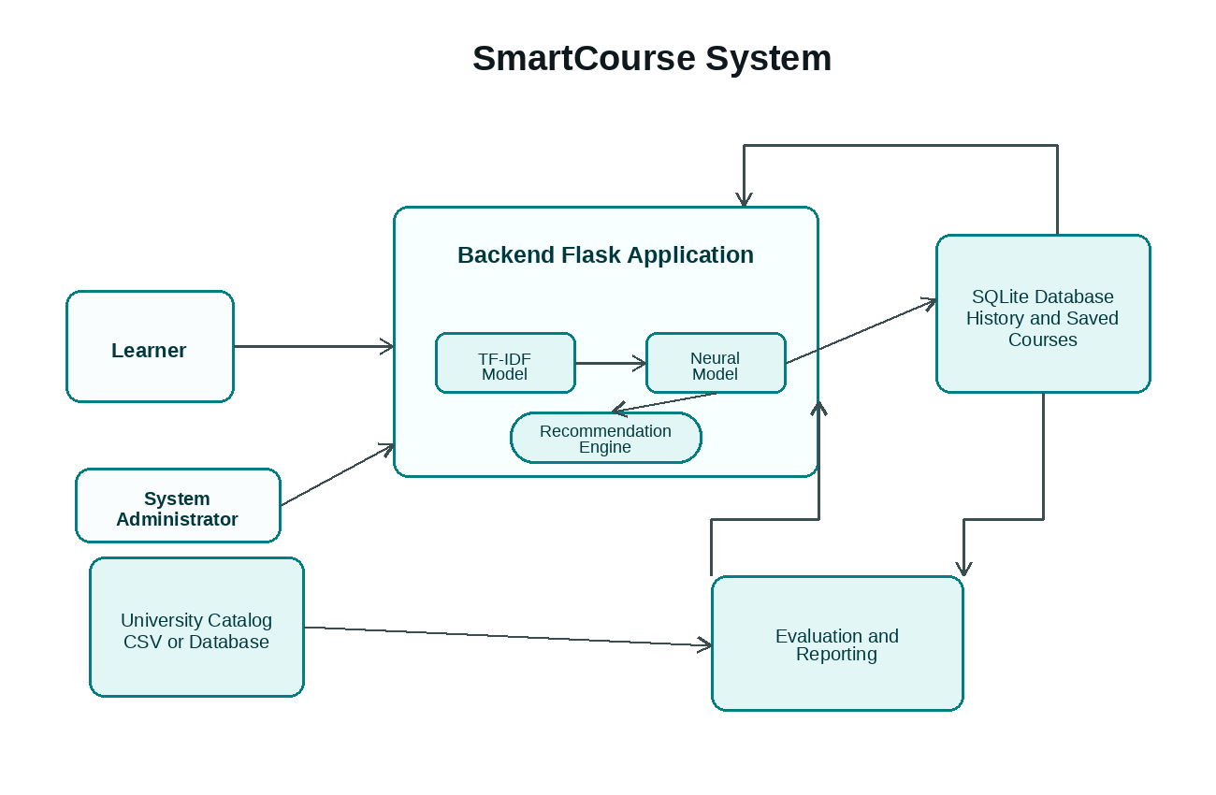
Figure 1: SmartCourse system context and main data flow.
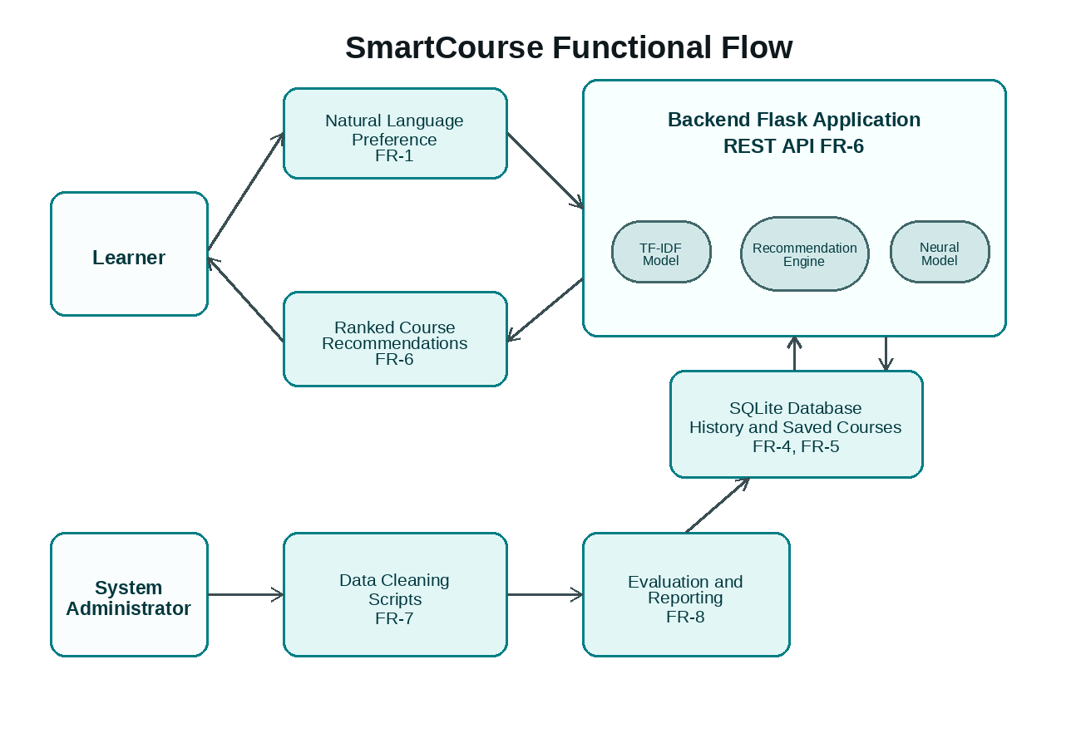
Figure 2: Functional flow from learner/admin actions to recommendation, persistence, and evaluation components.

Use Cases
The primary actors are Learner and System Administrator. Learner use cases cover recommendation request, model/result selection, ranked result viewing, model comparison, saving/removing courses, and history replay. Administrator use cases cover catalog maintenance, model training/deployment, and model-quality evaluation.
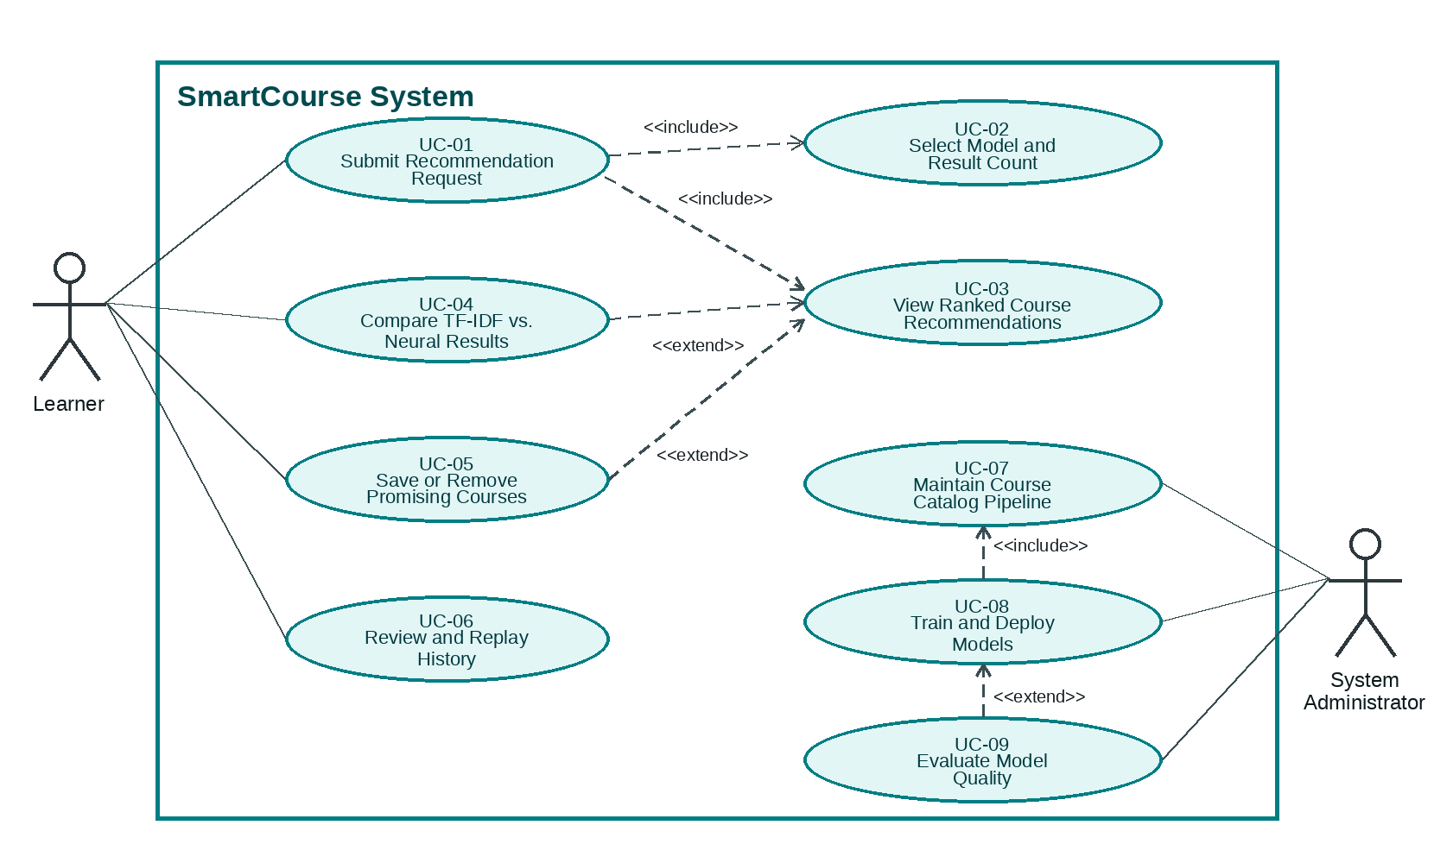
Figure 3: Final use case diagram with include and extend relationships.
Use Case | Description
UC-01 | Submit recommendation request.
UC-02 | Select model and result count.
UC-03 | View ranked course recommendations.
UC-04 | Compare TF-IDF versus neural results.
UC-05 | Save or remove promising courses.
UC-06 | Review and replay history.
UC-07 | Maintain course catalog pipeline.
UC-08 | Train and deploy models.
UC-09 | Evaluate model quality.

Implementation Details
- Application factory in smartcourse/__init__.py configures Flask, CORS, SQLAlchemy, logging, and blueprints.
- API blueprint exposes POST /api/recommend, GET/DELETE /api/history, POST /api/save, and DELETE /api/saved.
- RecommendationService loads TF-IDF and neural joblib artifacts and normalizes output into user-facing course cards.
- HistoryService persists recommendation sessions and saved courses in SQLite.
- Templates implement Home, Recommendation, Dashboard, and About pages with Bootstrap 5 styling.
- Scripts support data preparation, model building, evaluation, database SQL export, startup, and packaging.

Database Design
Table | Important Fields | Purpose
search_sessions | id, query_text, tfidf_results, neural_results, created_at | Stores every recommendation request and model outputs.
saved_recommendations | id, session_id, model_type, course_id, course_title, department, course_payload, relevance_score, saved_at | Stores learner-selected recommendations linked to sessions.

The SQLite database file included in the application package is instance/smartcourse.db, with a portable SQL dump available as instance/smartcourse_dump.sql.

Recommendation Workflow
- Learner enters a natural-language preference such as “I want to learn Python for data science.”
- The API validates the request and passes it to RecommendationService.
- TF-IDF model scores keyword overlap and course-description similarity.
- Neural model scores semantic similarity with sentence embeddings.
- Results are normalized, stored in SearchSession, returned to the UI, and optionally saved by the learner.

Testing Summary
Test Case | Focus | Expected Result | Status
TC-01 | Valid recommendation request | HTTP 200, TF-IDF/neural results, SearchSession stored. | Implemented / ready
TC-02 | Empty preference validation | HTTP 400 validation error and no saved session. | Implemented / ready
TC-03 | Save recommendation | HTTP 201 and saved record visible in dashboard/history. | Implemented / ready
TC-04 | History retrieval | Existing sessions and saved recommendations returned as JSON. | Implemented / ready
TC-05 | Model comparison UI | Side-by-side model outputs render consistently. | Implemented / ready
TC-06 | Evaluation tooling | Precision/recall reports generated from evaluation_queries.json. | Implemented / ready

Methodology and Work Plan
The project follows the VU Process Model hybrid: waterfall sequencing for deliverables and spiral feedback loops within each phase. Each phase includes risk review, implementation/prototype work, evaluation, and planning for the next iteration.
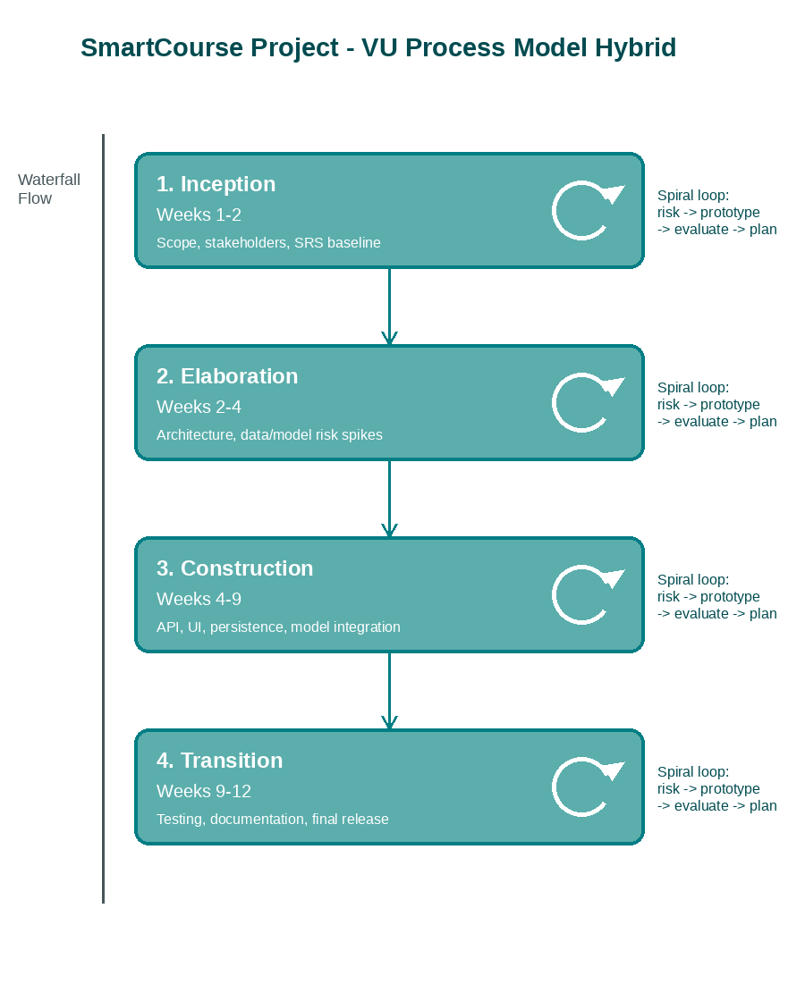
Figure 4: VU Process Model hybrid methodology.
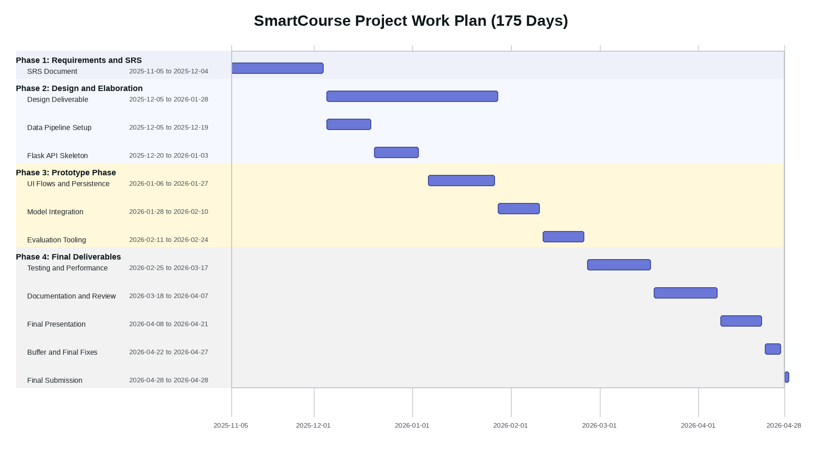
Figure 5: Final work plan and dated Gantt chart.

Deployment and Startup Instructions
- Extract 1-FinalApplication_SmartCourse_F25PROJECTEC4D8.zip.
- Install Python 3.10+ and run: pip install -r requirements.txt.
- Start through the recommended wrapper: start_project.ps1 on Windows PowerShell, start_project.cmd on CMD, or ./start_project.sh on Linux/WSL.
- Alternative direct command: set PYTHONPATH=. and run python app.py.
- Open http://127.0.0.1:5000 in a browser.

Final Deliverable Contents
File | Description
1-FinalApplication_SmartCourse_F25PROJECTEC4D8.zip | Complete application code, database, trained models, data, templates/static assets, scripts, and startup files.
2-FinalReport_SmartCourse_F25PROJECTEC4D8.docx | Final project report covering scope, design, implementation, testing, methodology, and startup instructions.
3-FinalPresentation_SmartCourse_F25PROJECTEC4D8.pptx | Presentation slides for project overview, architecture, workflow, features, testing, and conclusion.

Conclusion
SmartCourse satisfies the final deliverable requirement by providing a complete working Flask recommendation application with AI-assisted ranking, learner-facing UI, persistence, model comparison, data/model scripts, documentation, and presentation material. The final package is ready to be zipped and submitted on VULMS as instructed.

