**Login Page for both HRAdmin and General**

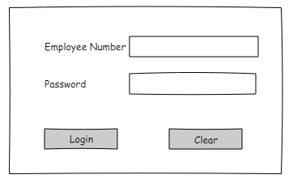

**General User Menu**



**General User Contribution Record**

Note that there are 3 different types of contribution: End of month employer, end of month employee, and employee annual contribution (the one that can optionally be allocated to charity)

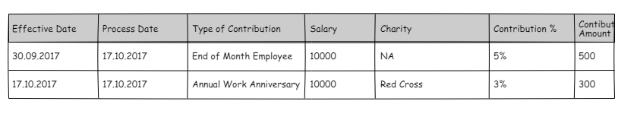

**General User can view a charity or request a new charity**

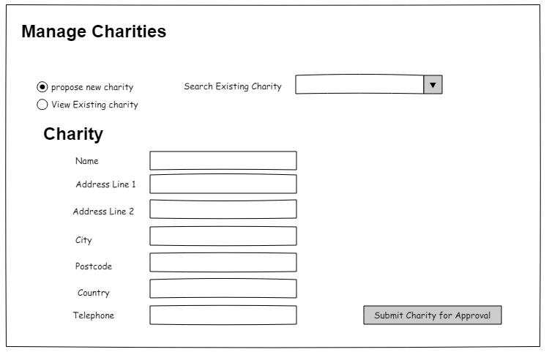

**An Admin User Menu**

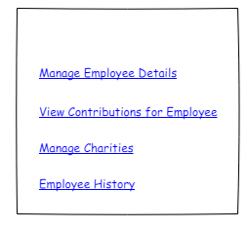

**Admin User Manage Employee Details**

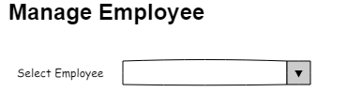

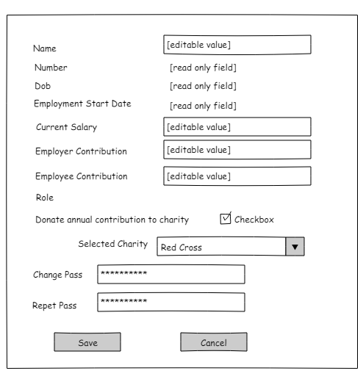

**Admin User View Contributions for any Employee**

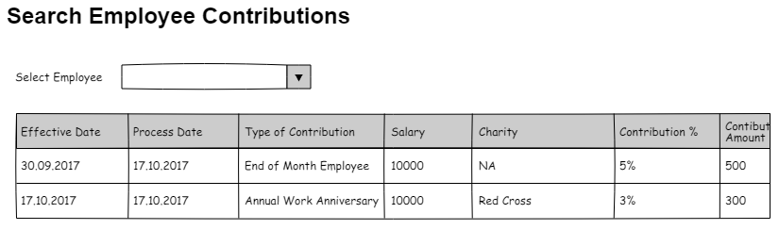

**Admin User Manage Charities (no need for approval to add new charity)**

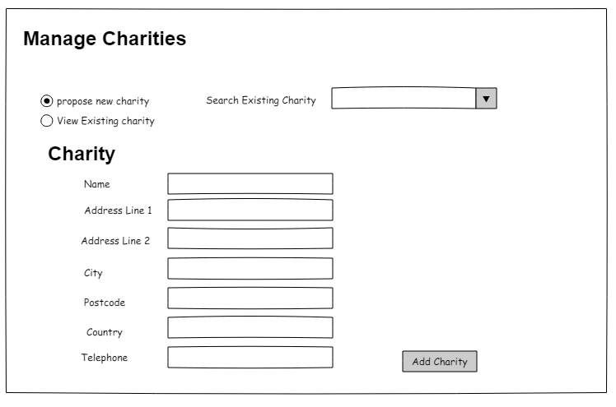

**Also listed below on this page, approve / disapprove charities:**

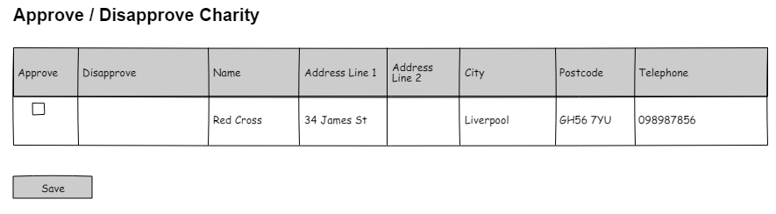

**Admin User Employee Details History**

This is an extra in the unlikely event there is time…..