

SCHOOL OF ENGINEERING AND TECHNOLOGY ACADEMIC SESSION SEPTEMBER 2023; WEB1201 WEB FUNDAMENTALS
DEADLINE: 14 DEC 2023 (Thursday), 5:00 PM

STUDENT NAME: Saef Allah Khaled Younes Dreed
NRIC/PASSPORT NO: 010403-10-0719

INSTRUCTIONS TO CANDIDATES

- This assignment will contribute 50% to your final grade.
- This is an individual assignment.
IMPORTANT

The University requires students to adhere to submission deadlines for any form of assessment. Penalties are applied in relation to unauthorized late submission of work. Coursework submitted after the deadline will be subjected to the prevailing academic regulations. Please check your respective programme handbook.

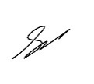
Academic Honesty Acknowledgement

“I Saef Allah Khaled Younes Dreed verify that this
paper contains entirely our own work. I have not consulted with any outside person or materials other than what was specified (an interviewee, for example) in the assignment or the syllabus requirements. Further, I have not copied or inadvertently copied ideas, sentences, or paragraphs from another student. We realize the penalties (refer to the student handbook diploma and undergraduate programme) for any kind of copying or collaboration on any assignment.”

……………………….................................. (Student’s Signature /22/12/2023)
Appendix Table of Content

Introduction………………………………………………………………………………………4
What the website is about………………………………………………………………… 4
Aims and Objectives ………………………………………………………………………4
Functionality 4
Design ………………………………………………………………………4
Colour ………………………………………………………………………… 4
Usability…………………………………………………………………………… 4
Content ………………………………………………………………4
Links ……………………………………………………………………………4
Dates ………………………………………………………………………………4
Justification ………………………………………………………………………………5
Layout Design……………………………………………………………………………………… 6
Website layout and Changes to Initial Design……………………………………………… 6
Home Page………………………………………………………………………… 6
Contact Us………………………………………………………………………… 9
Log In/Register……………………………………………………………… 11
Categories………………………………………………………………………… 12
Latest Drops……………………………………………………………………… 13
Implementation Details……………………………………………………………………… 16
Implementation details of the website and justification of the approaches……………… 16
Navbar……………………………………………………………………………… 16
Footer……………………………………………………………………………… 18
leftFooter………………………………………………………………… 18
rightFooter ………………………………………………………………20
Home Page……………………………………………………………………… 23
Image slide show……………………………………………………… 23
Latest Drops……………………………………………………………… 26
Fading Images ………………………………………………………………28
Contact Us …………………………………………………………………………30
Log In/ Register ………………………………………………………………34
Test cases and test results ………………………………………………………………………37
Testing registration functionality ………………………………………………………37
i) Test Case 1 – empty fields ………………………………………………………37
ii) Test Case 2 – Partially empty fields……………………………………………… 37
iii) Test Case 3 – No email ………………………………………………………38
iv) Test Case 4 – Wrong email ……………………………………………… 38
v) Test Case 5 – All fields correct but terms and conditions not agreed to………… 39
vi) Test Case 6 – Already existing account ………………………………………39
vii) Test Case 7 – Brand new account ………………………………………………40
Testing Log In Functionality……………………………………………………………… 41
i) Test Case 1 – empty fields……………………………………………………… 41
ii) Test case 2 – Partially empty fields……………………………………………… 41
iii) Test case 3 – complete field but wrong email format………………………… 42
iv) Test case 4 – Unexisting User ………………………………………………42
v) Test case 5 – existing user but wrong password……………………………… 43
vi) Test case 6 – Existing user……………………………………………………… 43

Testing Contact Us form Funtionality ………………………………………………………………44
i) Test Case 1 – empty form ……………………………………………………………… 44
ii) Test Case 2 – Partially empty form……………………………………………………… 44
iii) Test Case 3 – Wrong email format ………………………………………………………45
iv) Test Case 4 – Proper name and email address but empty message ………………………46
v) Test case 5 – All requirements met ………………………………………………………46

References……………………………………………………………………………………… 47

Introduction

What the website is about
Welcome to MOTION, your one-stop shop for the newest in streetwear, shoes, and general fashion. This online store is intended to provide our clients, YOU, with a smooth purchasing experience in which you can browse and buy the latest streetwear from the comfort of your own home. We have something for everyone, whether you're looking for a new pair of dunks, a collaboration between your favorite brands, or a statement item. MOTION is more than a business; it is a way of life.

Aims and Objectives
With MOTION there were multiple aims and objectives set out to be achieved. The main goal of this project was to create a working product marketplace for users to be able to experience a seamless shopping experience. For this to be achieved, I set out 7 main objectives:

Functionality
This website will showcase 2 main functions which are the contact form and a sign-up and log in function. With respect to the contact form a “Contact Us” page will be created to hold it; the form will also have various validation checks using JavaScript. Furthermore, a sign-up and log-in function will also be presented. The sign-up and log-in function will also contain user-checks and will display a notification showing the user if they have successfully logged in or signed up. Moreover, an image carousel has also been implemented into the website showcasing featured products. The validation checks, notification and image slider were implemented using JavaScript. These functionalities will be explored further in depth later in the report.

Design
For the design of the website a lot of thought and effort was put into this section to ensure that the design is consistent with the theme throughout the entire website. Much importance was given to the scaling and layout of the website, ensuring that it would fit on most if not all viewports.

Color scheme
One of the key aspects for the design of MOTION was choosing the right colors for the website. I aimed to use a color scheme the not only complements all the other elements such as the title, fonts, images, and icons but also blend to create a joyous browsing experience for the user.

Usability
One of my main purposes for this website was to ensure a seamless user experience. The placement of various elements on the page such as the buttons and links were placed with great care, so they are easily followed and located.

Content
I aimed to ensure that all the content held on the website is relevant to the main theme, ensuring that irrelevant information is nonexistent.

Link
Another objective for this website was to ensure that all relevant links are working.

Dates
Lastly, I set out to guarantee that the site contains a creation date and update data.

Justification
Why MOTION? After carefully researching my options, I created MOTION with the intention of addressing the gap in the current fashion industry online. I realized that many of the websites are uninspired and do not appeal to customers who want to indulge in streetwear culture. According to Fitzgerald (2022), bad website design can hurt a company's reputation, credibility, and sales.

Furthermore, I observed many online fashion brands with little to no online presence and very poorly designed websites. This not only decreases customer engagement but are also at risk of not being able to compete with more established brands. According to Kuik (2022), a strong online presence is critical to a company's success in the present.

These inefficiencies point out the crucial need for a present-day, user-friendly web platform that can cater to the needs and preferences of streetwear enthusiasts. MOTION is designed to fill this gap and offer a unique and enjoyable online shopping experience. MOTION features a modern and sleek design, a responsive and intuitive interface, a curated selection of products from various brands, and a video marketing component that highlights the latest trends and stories in streetwear. MOTION is not just a website, but a community of like-minded people who appreciate the art and expression of streetwear.

Layout Design

Website layout and Changes to Initial Design
In this section of the report, I will be showcasing the layout of the website and any changes that I believe are necessary. There will be 5 pages that are covered in different view ports.

Home Page
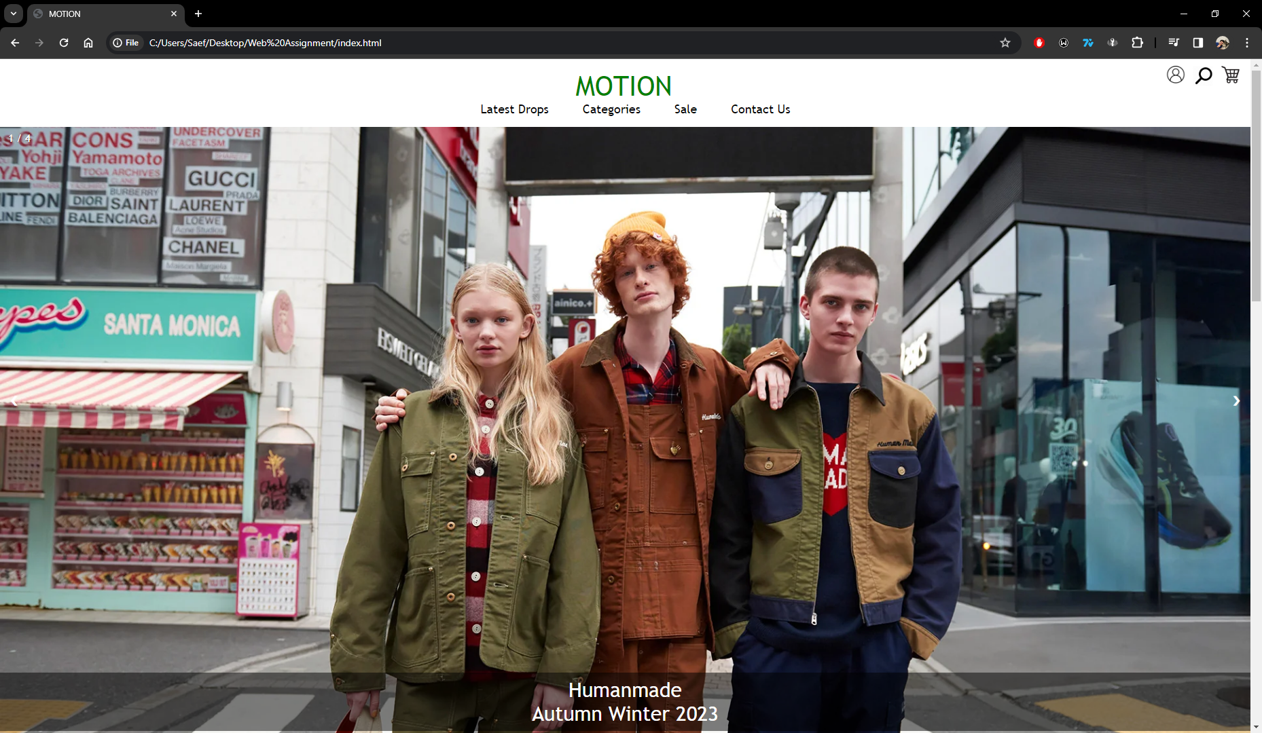
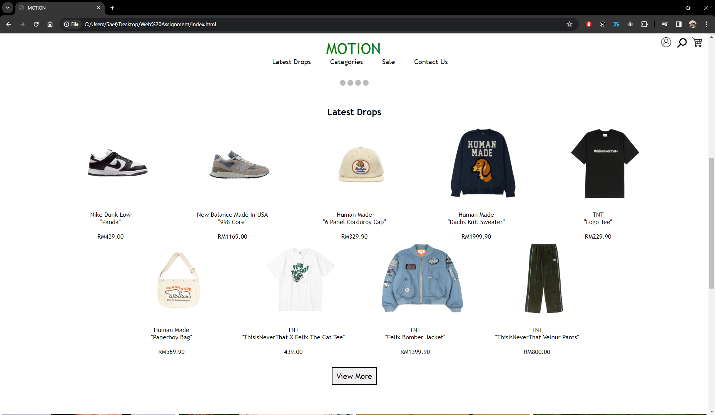
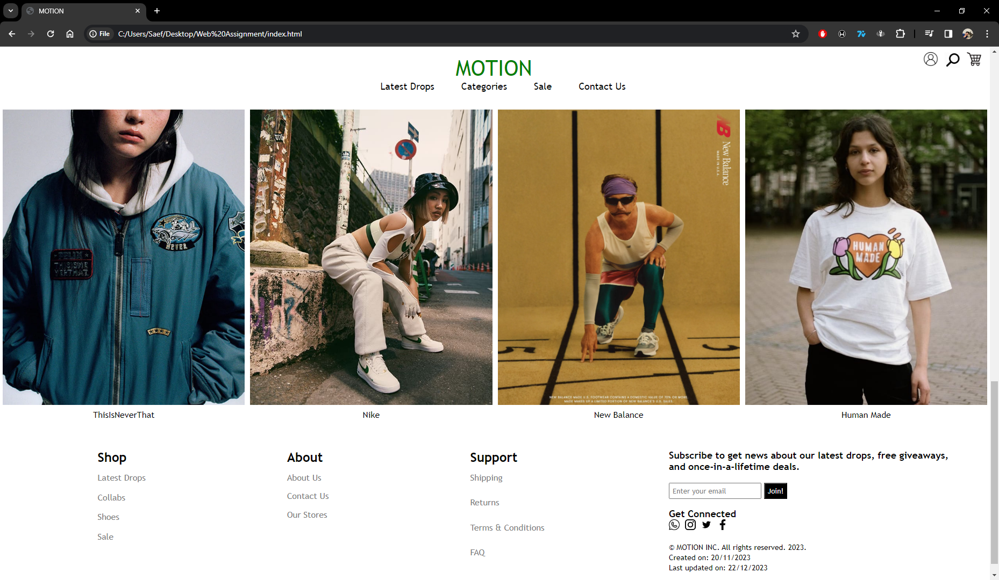

iPhone 14 Pro Max View
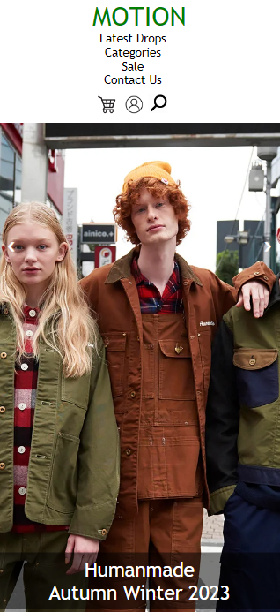
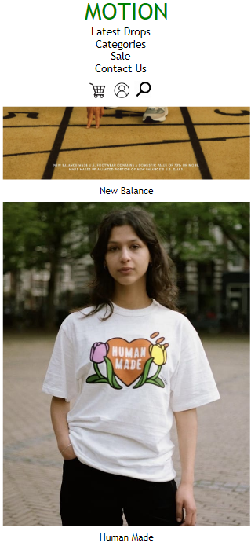
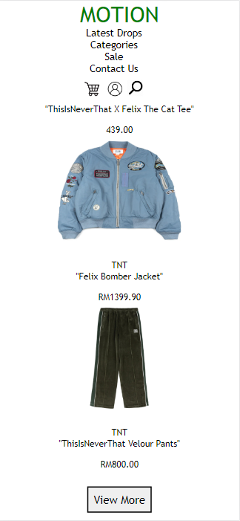
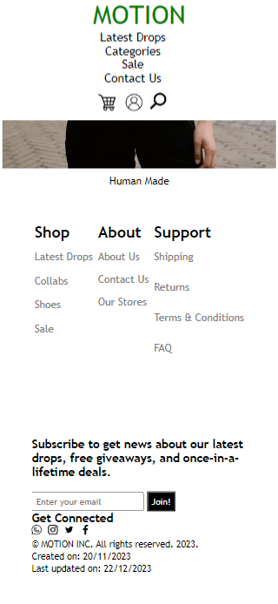

Changes made to home page design.

For the home page design, I believe that only one change should be made and that is regarding the “Latest Drops section”. The design feels the background feels empty and it doesn’t highlight white colored products well on bigger computer screens. I decided to thus stick with the white background because I believe it the other sections of the home page complement the white background as the images are the burst of color giving it a slick clean look but also a fun quality. I have tried to find an alternative solution, but I haven’t found a suitable backdrop that would fit the theme of the website without disturbing the other elements.

Furthermore, another change I believe should be implemented is more workable links and functions. Such as a working shopping cart and a functional search bar. As for workable links I believe that every item in the footer should link to a separate webpage and the “enter your email” box should have a notification pop up when a user enters their email.

Contact Us

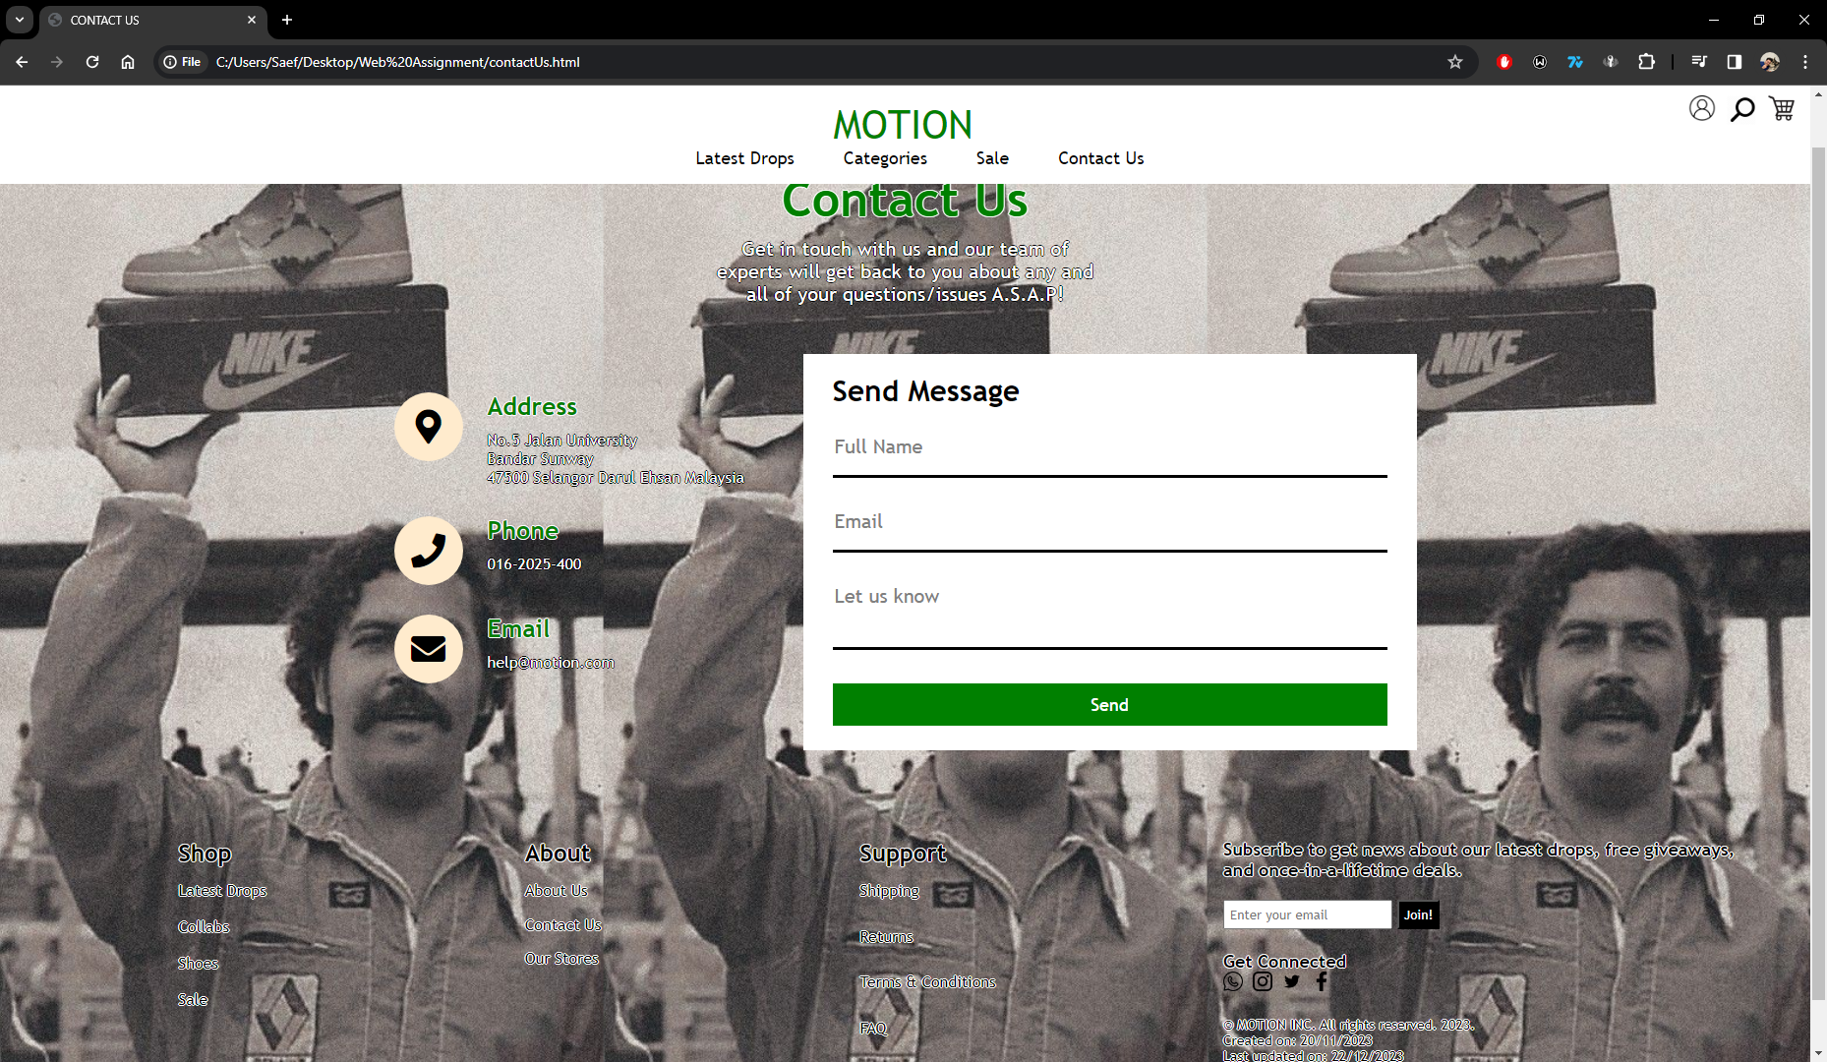

iPhone SE view
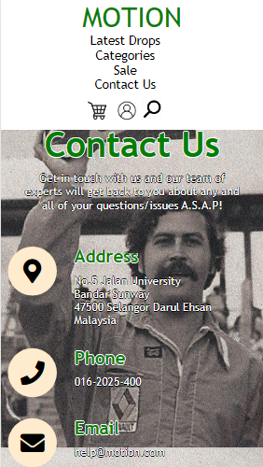
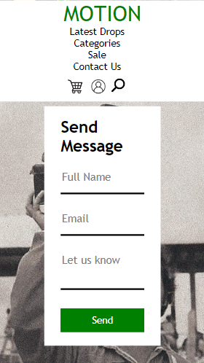

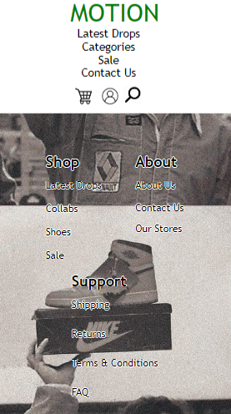
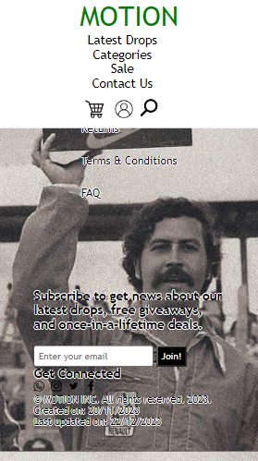

Changes made to Contact Us design.

For the contact us page I believe only one change should be made and that is regarding the font color. I suspect it might prove a slight inconvenience for those with eyesight issues to perfect ready the footer and contact details especially in the phone view. But after testing out the websites with friends and family who wear glasses, they notified me that the inconvenience was very slight and not too difficult to read. This led me to keep the initial design and not change anything.

Log In/Register Page

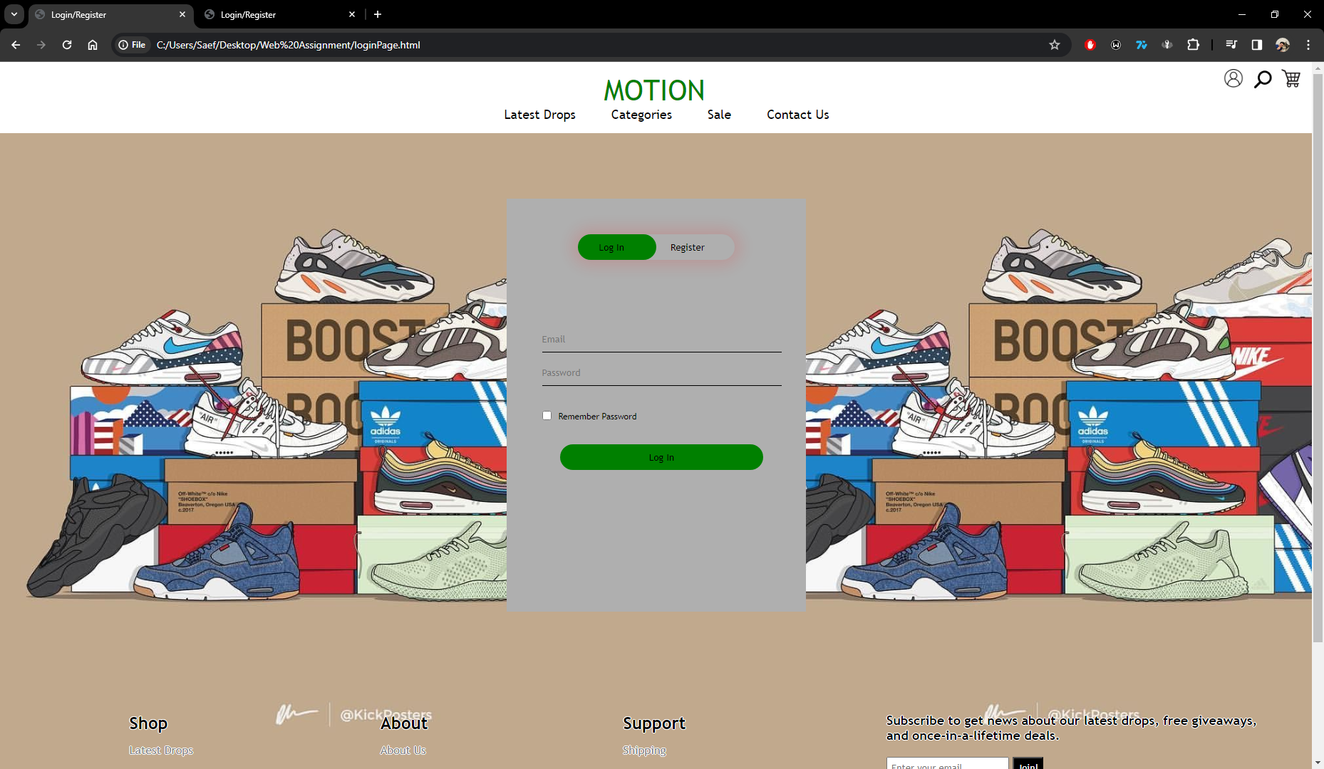

Samsung Galaxy S8+ View

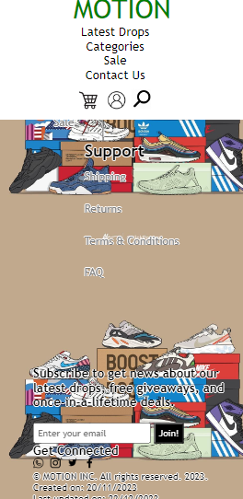
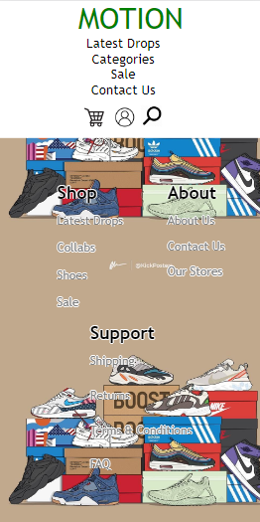
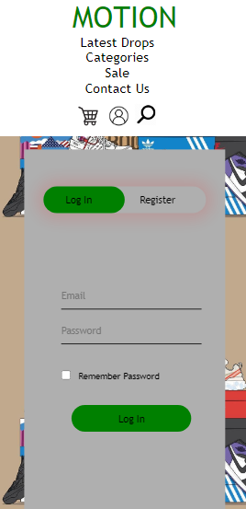

Changes made to Log-In/Register page design.
Similar to the contact us page, I suspect that the font color may prove an issue but after various tests I decided to keep it as it suits the overall theme and vibe of the page/background image.
Categories Page

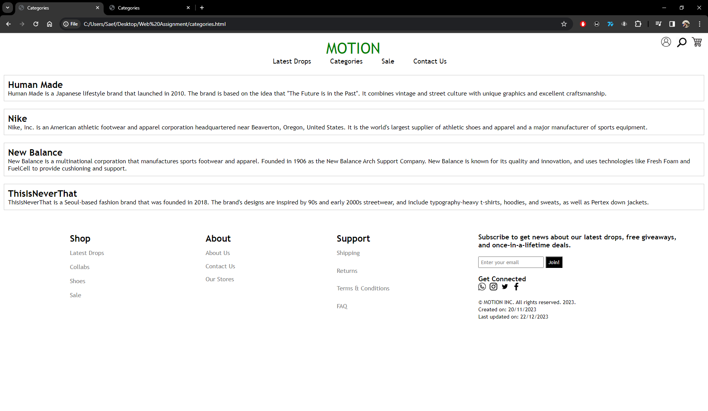
iPad Air View
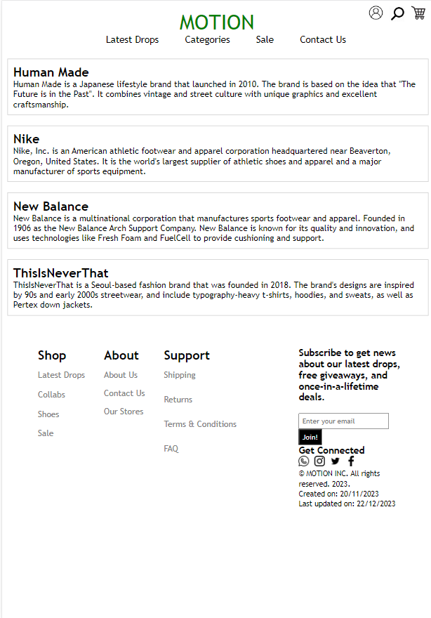
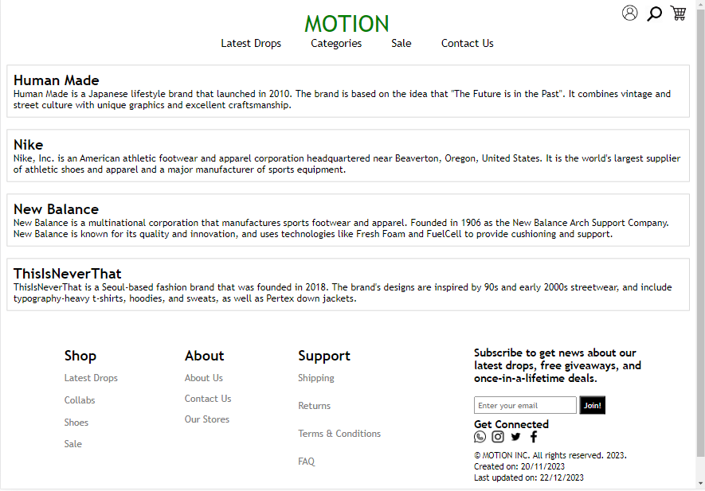

Changes to Categories Page
I believe that the categories page is quite uninspired as it is all white, may be a splash of color or a different background would be better but I decided to stick with all white as it suits the general theme of the website better and after testing with different backgrounds the readability and generally look didn’t mesh well.

Latest Drops Page

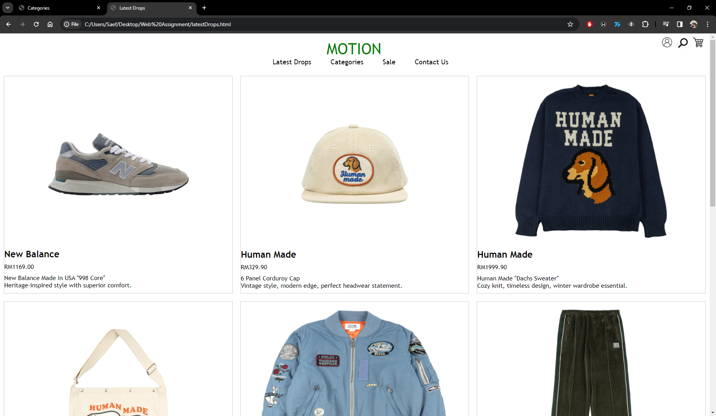
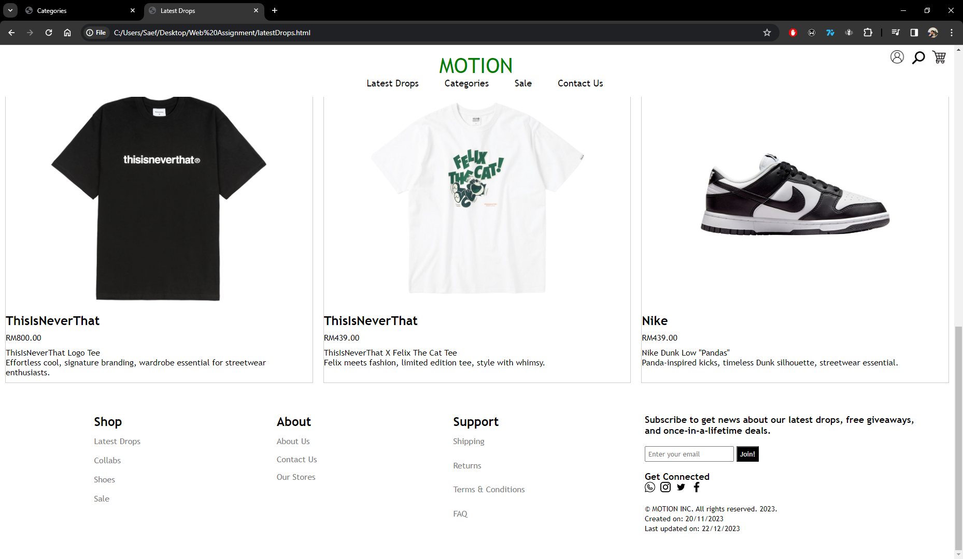

iPad Pro View

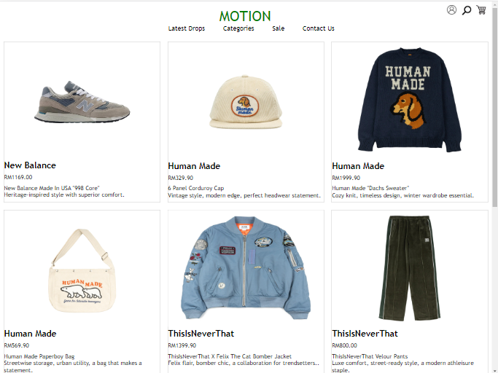

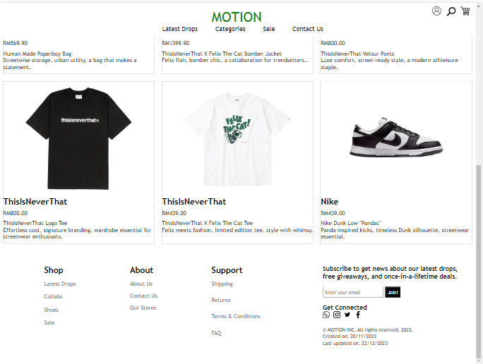

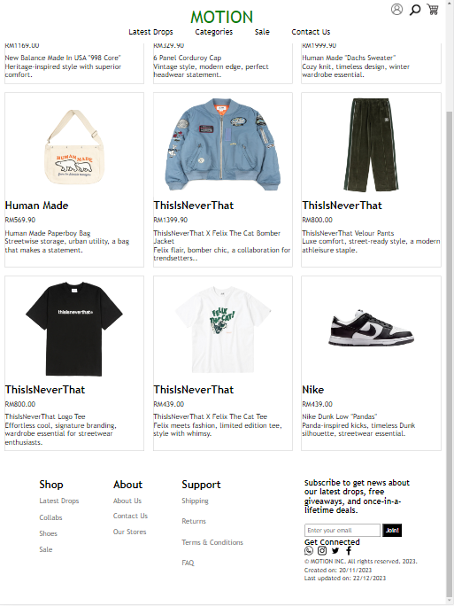

Changes to Latest Drops Page
One change I would implement to this webpage would be to have a sidebar showing different categories of brands so users could easily click onto what brand they are interested in instead of having to redirect to the categories page.

Implementation Details

Implementation details of the website and justification of the approaches
In this section of the report, I will be exhibiting the implementation details of MOTION as well the justification of the approaches I took.

Navbar
Starting with the navbar, it is a universal element which appears in every single webpage linked to the website. The image below shows the navbar held within the <nav></nav> tag with class=”navbar” which consists of a list of links known as class=”navbarmenu”. These links are gateways into different sections of the website such as “Latest Drops”, “Categories”, “Sale” and “Contact Us”. Furthermore below the list of links are 3 images which are located at the top of right corner of the navigation bar when in Fullscreen, the login-icon is a clickable image which will redirect the user to the login/registration page.
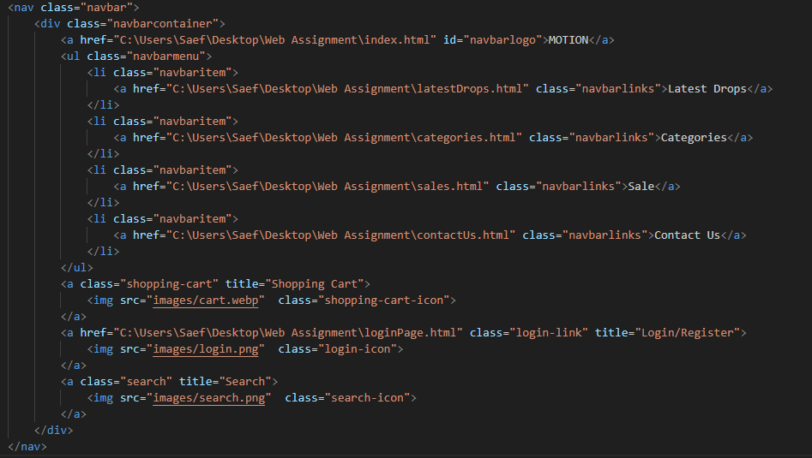

The <nav></nav> tag was used to hold the entirety of the navigation bar due to its ease of implementation and simplicity. This will not only allow other developers to properly identify which section of the webpage is the navigation bar but is also an appropriate tag to hold the contents of a navigation bar. Moreover, a navigation bar is essentially a list of links making it logical to use the <ul> and <li> tags withing the <nav> element to hold the links. As for the images, the <a> anchor tags were used this is so that the images can be linkable allowing the user to be able to click on the images and redirect them to a different page as shown in the class=”login-icon” image which will redirect the user to the login/register page.

Now moving on to the styles of the Navbar. While there are many styles there are a few important elements that I deem the most interesting that I want to share.

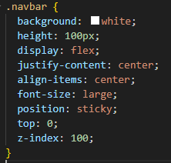

This snippet of code showcases the main styles of the navbar, the background and height were a stylistic choice as to fit the entire theme of the website. The display was set to flex to ensure that the items in the navigation bar are shown horizontally making it a pleasant viewing experience for the user. Lastly, the position of the navigation bar is set to sticky, this allows the navigation bar to move with the website if the user scrolls down. This was implemented for a more user-friendly experience so that the user is able to access the links of the navigation bar wherever they are on the website without having to scroll all the way back up again.

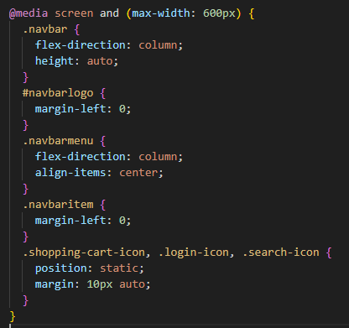

In this image, are the styles responsible for making the navigation bar responsive so that it will fit on most if not all modern phones, laptops, computers, and tablets. In this case, the condition is max-width: 600px, which means these styles will be applied when the viewport is 600 pixels wide or less. #navbarlogo { margin-left: 0; } removes the left margin from the element with the id navbarlogo, aligning it to the left edge of its container. .navbarmenu { flex-direction: column; align-items: center; } changes the direction of the items in the .navbarmenu class to a column and centers them along the cross-axis (horizontally, in this case). .navbaritem { margin-left: 0; } removes the left margin from the elements with the class navbaritem, aligning them to the left edge of their container.

.shopping-cart-icon, .login-icon, .search-icon { position: static; margin: 10px auto; } sets the position of the elements with the classes .shopping-cart-icon, .login-icon, and .search-icon to static, which is the default value. It also centers these elements horizontally within their container by setting the left and right margins to auto and gives them a margin of 10px on the top and bottom. These styles were implemented to adjust the layout of the navigation bar for smaller screens changing it from a horizontal layout to a vertical one.

Footer
Another universal element located in every webpage is the footer. The footer consists of 2 main parts leftFooter and rightFooter which will be covered.

i)leftFooter
Starting with the leftFooter this HTML code is used to create a footer for a webpage. The left footer is divided into three sections: “Shop”, “About”, and “Support”. Each section is contained within a div with the class footerMenu. There are 3 sections in total which are Shop, About and Support. Each section contains a list of “links” which are held in a <ul> because the order of these links are unimportant. The implementation of this footer was to ensure easy access to the user with a variety of hyperlinks allowing them to navigate to anywhere they want to on the website with ease.

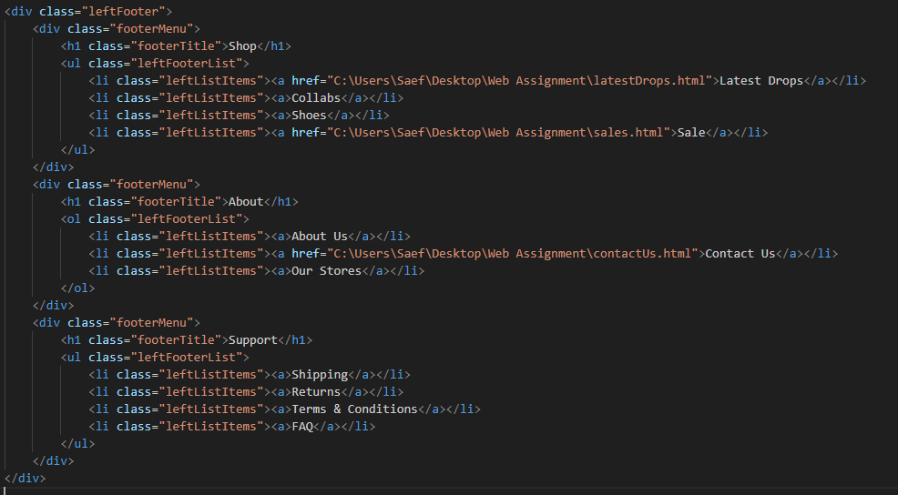

In these images are the styles of the left footer. The footer style makes the footer flexible and allows its items to wrap if there isn’t enough space in a single line. The leftFooter style makes this section take up twice as much space as its siblings, aligns its items evenly, and adds padding around its content. The footerTitle style increases the font size of the titles in the footer. The leftFooterList style removes the default list styles (like bullets or numbers) and adds some space above the list. The leftListItems style adds some space below each item, changes the text color to gray, and changes the cursor to a pointer when a user hovers over the items. The leftListItems a style removes the default underline from the links and makes the link color the same as the text color of the parent element. Lastly, the leftListItems a:hover style adds an underline to the links when a user hovers over them. This CSS code helps create a responsive and user-friendly navigation area at the bottom of the page.

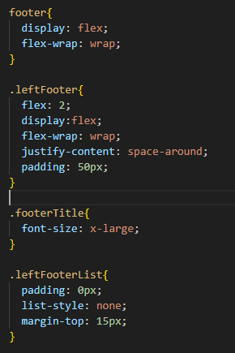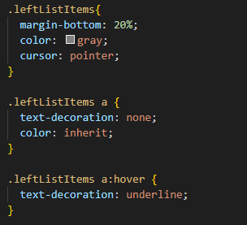

The implementation of these styles are to ensure that the left footer fits within the margins and gives a pleasant viewing experience to the user while also maintaining a level of practicality and ease of access.

ii) rightFooter
The HTML code used to create the right footer is also divided into 3 main sections which are the subscription form, social media links and copyright/creation dates. The first section invites users to subscribe for news, giveaways, and deals. It contains a text input field for users to enter their email addresses and a button to submit the form. The second section encourages users to connect on various social media platforms. It contains links to WhatsApp, Instagram, Twitter, and Facebook. Each link opens in a new tab (due to the target="_blank" attribute) and is represented by an image icon. The third section displays copyright information, including the name of the company (MOTION INC.), the year of copyright (2023), and the creation and last update dates of the webpage. All these sections are contained within a div with the class rightFooter, indicating that they are part of the right-side footer of the webpage. This structure helps organize the webpage and improves user navigation.
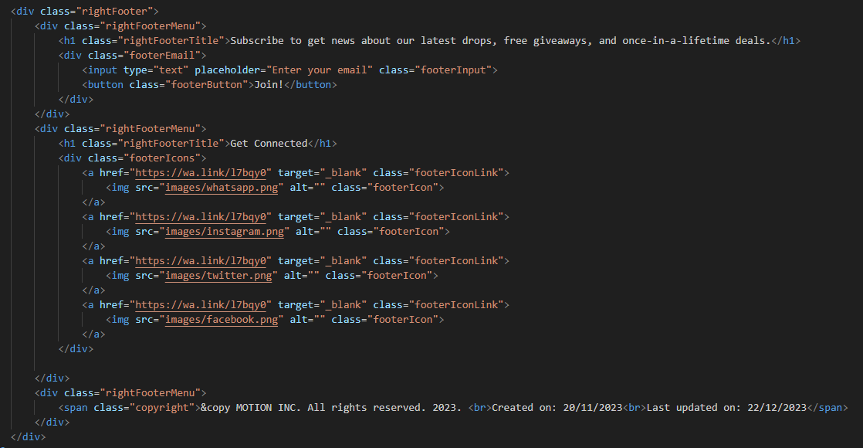

Moving on to the styles of the right footer, the images below show that the. rightFooter style sets the footer to take up equal space as its siblings, adds padding, and arranges its items in a column. The items are evenly distributed with space between them. The .rightFooterTitle style sets the font size of the footer titles to large. The .footerInput style adds padding to the input fields and some space above them. The .footerButton style adds padding to the buttons, sets their background color to black, text color to white, and changes the cursor to a pointer when hovering over them. The .footerIcons style arranges the social media icons in a row. The .footerIcon style sets the width and height of the icons and adds some space to their right.

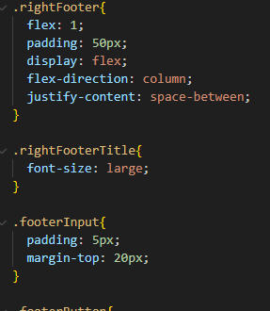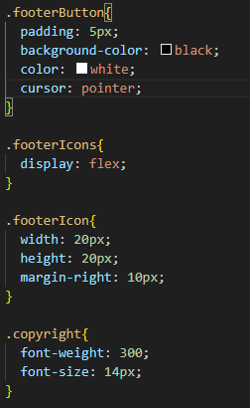

Lastly is the code responsible for making sure the footer is responsive. For the footer, 2 media queries are applied to compensate for screens of all different sizes. The first media query @media only screen and (max-width: 768px) targets screens with a maximum width of 768 pixels. For these screens, the .leftFooter and .rightFooter elements are set to take up 100% of the available space in their container (flex: 1 0 100%;). This typically means that these elements will stack vertically, each taking up the full width of the screen, instead of sitting side by side. The second media query @media only screen and (max-width: 480px) targets even smaller screens, with a maximum width of 480 pixels. In addition to the .leftFooter and .rightFooter elements taking up 100% of the available space, the .footerIcon elements are resized to a fixed width and height of 15 pixels. This CSS code basically ensures that the layout and size of the elements in the footers successfully adapt to any screen size thus providing a responsive design.

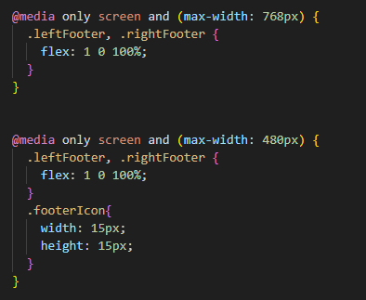

Home page
Now that the universal elements of the website have been covered, more specific elements pertaining to each webpage will be explored and justified.

i) Image slideshow
First and foremost is the image slideshow. As the user first loads onto the website, they will be greeted with an image slideshow showcasing the hottest products. The slideshow is contained within a div with the class imageSlideshow. Inside this div, there are four other div elements with the class mySlides fade. Each of these div elements represents a slide in the slideshow. The fade class applies a fading transition effect between the slides. The slideshow also includes two navigation buttons, with classes prevSlide and nextSlide, which when clicked, call JavaScript functions plusSlides(-1) and plusSlides(1) respectively to navigate through the slides. Below the slideshow, there is a div containing four span elements with the class slideDot. Each span element, when clicked, calls the JavaScript function currentSlide(n) to navigate directly to a specific slide. By implementing this image slideshow, it creates an enjoyable browsing experience for the user as they can navigate the featured products with ease.

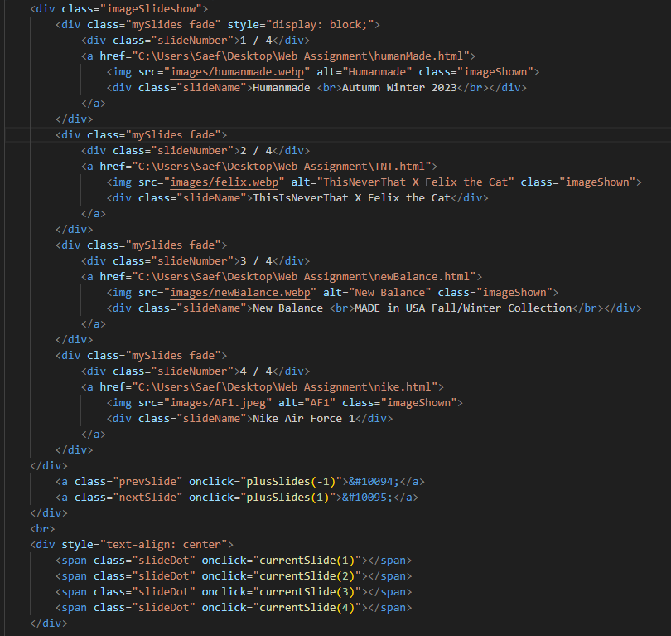

The .imageSlideshow class centers the slideshow and makes it clickable. The .mySlides class hides all slides initially. The .prevSlide and .nextSlide classes style the navigation buttons. The .slideName and .slideNumber classes style the caption and slide number. The .slideDot class styles the navigation dots, changing their color when active or hovered over. The .fade class and @keyframes fade define a fading animation for transitioning between slides. The .imageShown class sets the size and fit of the images in the slideshow. The thought behind all the effects such as the fade and the hiding the slides initially is to create a “WOW” factor for the user so when they come onto the website their attention is immediately pulled and they can browse all the latest items using the fun image slider.

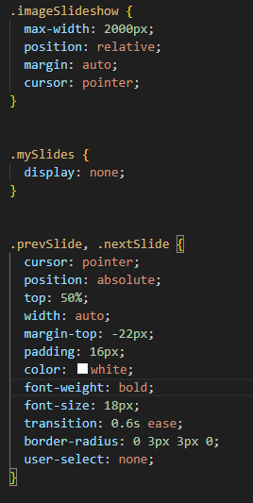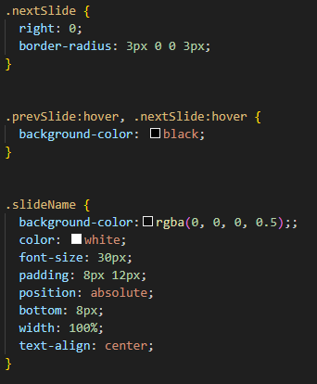
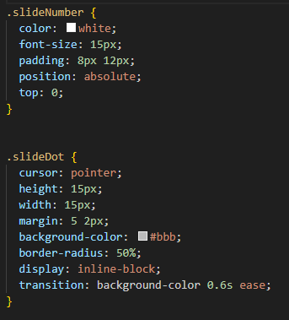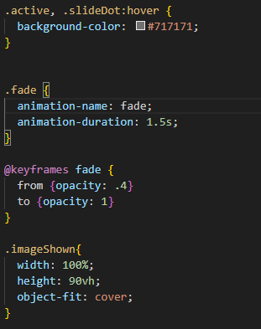

The backbone of this image slideshow is the javascript implemented so that it functions as intended. This code is designed to control a slideshow on a webpage. It starts with a variable slideIndex set to 1, indicating the first slide is displayed initially. The function showSlides(n) is the core of this slideshow. It takes an argument n which is the slide number to be shown. It first collects all the slides and dots by their class names. If n exceeds the total number of slides, it wraps around to the first slide. If n is less than 1, it wraps around to the last slide. Then, it hides all slides and removes the “active” class from all dots. Finally, it displays the desired slide and marks the corresponding dot as “active”. The functions plusSlides(n) and currentSlide(n) are used to navigate through the slides. plusSlides(n) increments the slideIndex by n, moving the slideshow forward or backward by n slides. currentSlide(n) sets the slideIndex to n, directly showing the nth slide. This setup allows users to interactively navigate through the slides by clicking on the dots or using next/previous arrows. The slideshow also wraps around, meaning after the last slide, it goes back to the first one and vice versa. This code allows for a dynamic and interactive slideshow on a webpage. The user can navigate through the slides by clicking on the dots or using the next/previous arrows. This will be showcased more in depth in the video.

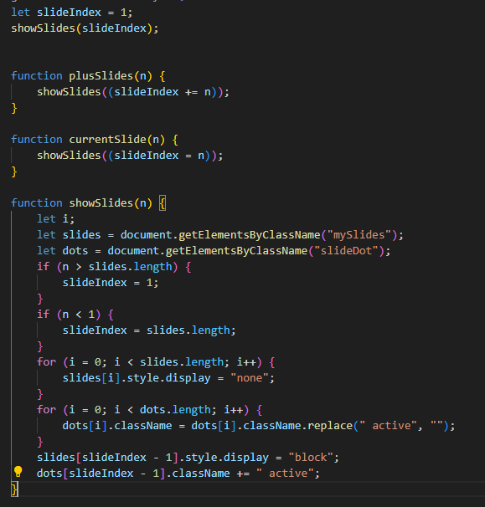

ii) Latest drops
Moving on, I will be discussing how the “Latest Drops” section of the home page was implemented and my ideas behind my implementation method. This HTML code represents the “Latest Drops” section. The section is contained within a <div> element with the class latest-drops. The title “Latest Drops” is displayed using an <h2> element. The products are listed within a <div> with the class newDrops. Each product is represented by an <a> element with the class latest-image-link, which contains an <img> element for the product image and a <p> element for the product’s name and price. The src attribute in the <img> tag specifies the path to the image file, and the alt attribute provides a text description of the image. Line breaks in the product’s name and price are created using <br> tags. After the list of products, there’s a <div> with the class view-more that contains a <button>. When this button is clicked, it redirects the user to a page with more products. The redirection is achieved using the onclick attribute in the <button> tag, which executes JavaScript code. The main purpose of this implementation method is its simplicity. By stacking <a> tags I am able to showcase all the latest products side by side with their relevant information beneath the photos and also make them linkable.

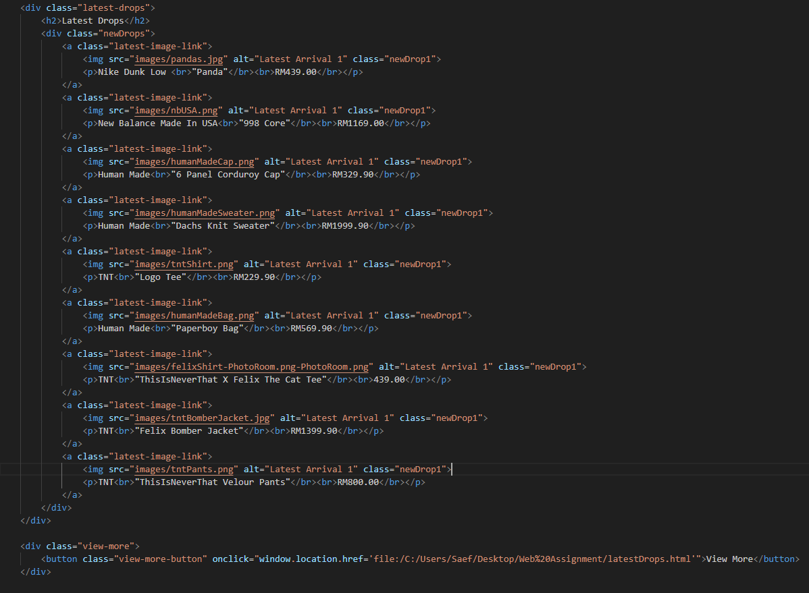

It begins by targeting the <h2> element within the latest-drops class, centering the text and adding a top margin of 50 pixels for spacing. The newDrops class is then styled to display its contents in a flexible and responsive layout, with items centered and able to wrap onto multiple lines. The paragraph elements within newDrops are given a top margin for spacing, a pointer cursor for interactivity, and centered text for aesthetics. Elements with the newDrop1 class are styled to take up 80% of the width of their parent element, have a height of 200 pixels, and a left margin of 50 pixels for spacing. They also have a pointer cursor for interactivity. The view-more class is given a top margin for spacing and centered text. The button within this class is styled with padding for size, a larger font size for readability, a black color scheme, a pointer cursor for interactivity, and a top margin for spacing. Finally, media queries are used to make the webpage responsive. If the viewport is 1600 pixels wide or less, the width of the newDrop1 elements is set to 80% and the left margin is removed. If the viewport is 600 pixels wide or less, the width is set to 100%. This ensures that the webpage looks good on all devices, from desktops to mobile phones. The use of the cursor: pointer style on clickable elements improves usability by providing visual feedback to the user when they hover over these elements.

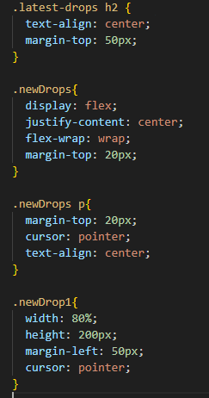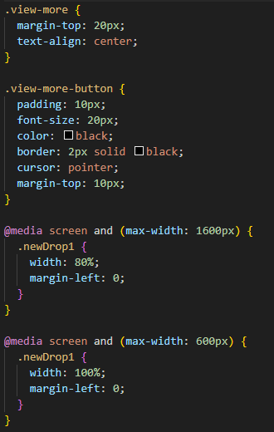

iii) Fading images
The last part of the homepage are the fading images located right above the footer. The images are contained within an element with the class image-container. Each image is wrapped in an <a> tag, which makes the image a clickable link that redirects the user to a specific webpage when clicked. The <p> tag displays the title of the image.

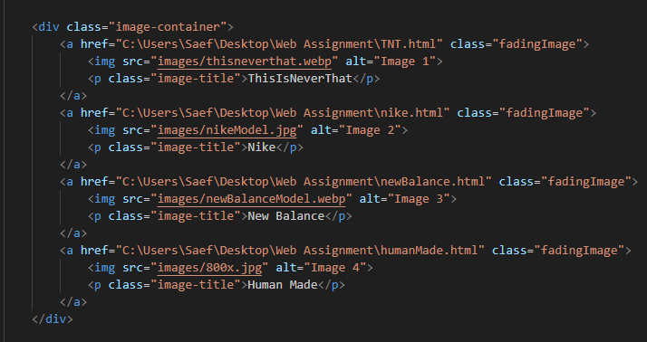

Now for the styles where all the magic happens. The image-container class uses a flex layout, which allows the images to be laid out in a row that wraps onto new lines as needed. This makes the layout responsive and adaptable to different screen sizes. The justify-content: space-around property evenly distributes the images with equal space around them, creating a balanced and aesthetically pleasing layout. The cursor: pointer property changes the cursor to a pointer when hovering over the images, indicating that the images are clickable. The fadingImage class centers the text and removes the underline from the links, creating a clean and modern look. The flex: 1 0 21% property allows the images to grow and shrink as needed while taking up 21% of the container’s width, ensuring that there are always multiple images per row. The margin: 5px property adds a little space around each image, preventing them from touching each other. The image-container img and image-container img:hover classes add a smooth transition effect to the images when they’re hovered over. The images scale up and their brightness decreases, creating a visually pleasing hover effect that also indicates interactivity. The media queries make the layout responsive on smaller screens. When the screen width is 768 pixels or less, the fadingImage elements take up 96% of the container’s width, ensuring that they don’t become too small. The same adjustment is made for screen widths of 375 pixels or less. Finally, the image-container img class sets a fixed width and height for the images and uses object-fit: cover to ensure that the images maintain their aspect ratio while filling their container. From a user standpoint, the design choices made in this code contribute to a clean, responsive, and interactive fun shopping experience. As for a technical standpoint the code uses a flexible layout, media queries, and transition effects to create a responsive and interactive user interface

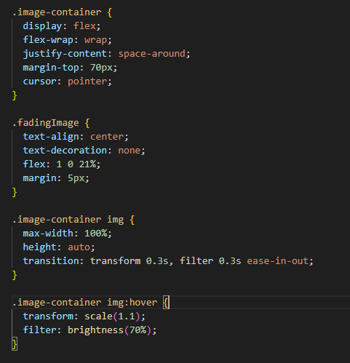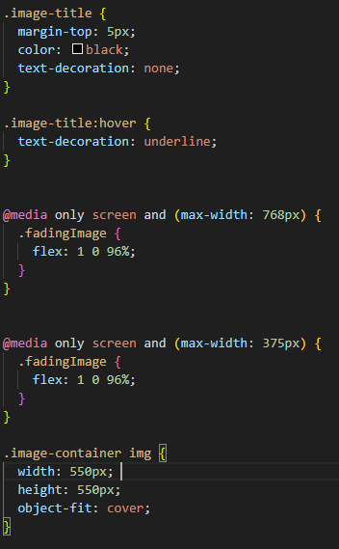

Contact Us

For the “Contact Us” page t starts with a <section> tag that encapsulates the entire contact section. Inside this, there are two main divisions: the contactHeader and the contactUsContainer. The contactHeader division contains a heading and a paragraph that invites users to get in touch with the team. The contactUsContainer division is further divided into two parts: the customerInfo and the contactUsForm. The customerInfo division contains three contactItems, each consisting of an icon (represented by <i> tags with Font Awesome classes) and contact information (address, phone, and email). Each contactItem has a contactIcons division for the icon and a contactUsInfo division for the information. The contactUsForm division contains a form where users can send a message. The form includes fields for the user’s full name and email, a textarea for the message, and a submit button. The required="true" attribute in the input fields and textarea ensures that these fields must be filled out before the form can be submitted. The implementation of this code provides a structured and user-friendly way for visitors to find contact information and send a message directly from the webpage. It’s a common and effective design for a “Contact Us” section.

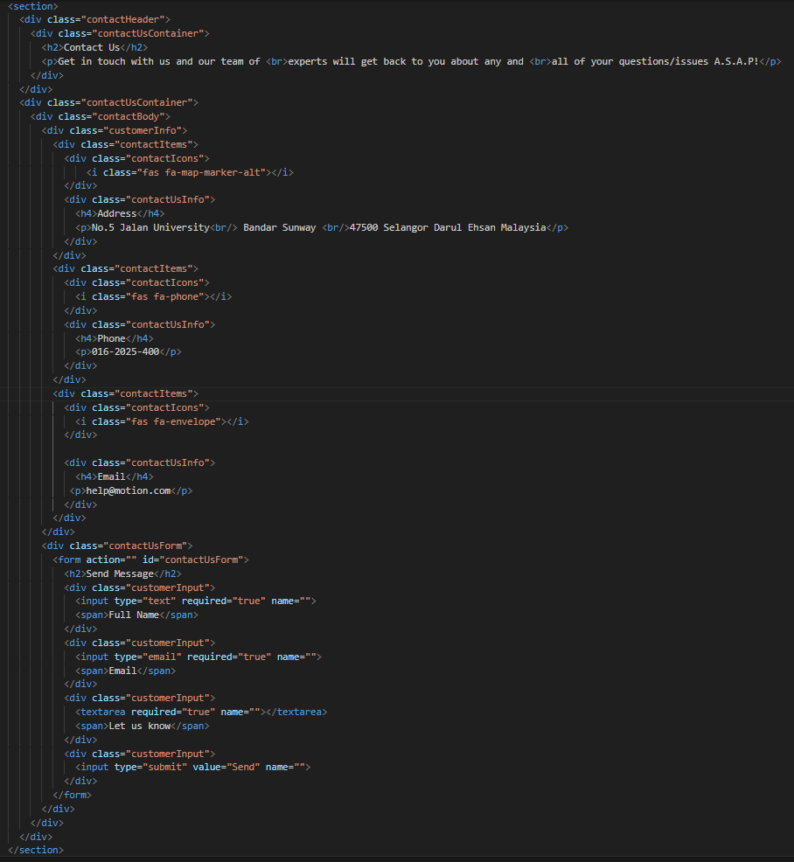

As for the styles of the log in/register page, it creates a flexible layout for the contact form and items and adds transition effects to the contact us box. The code also takes advantage of media queries to ensure a responsive webpage that is able to adapt to various screen sizes. Overall, the CSS code enhances the user experience by making the contact section visually pleasing and easy to use.
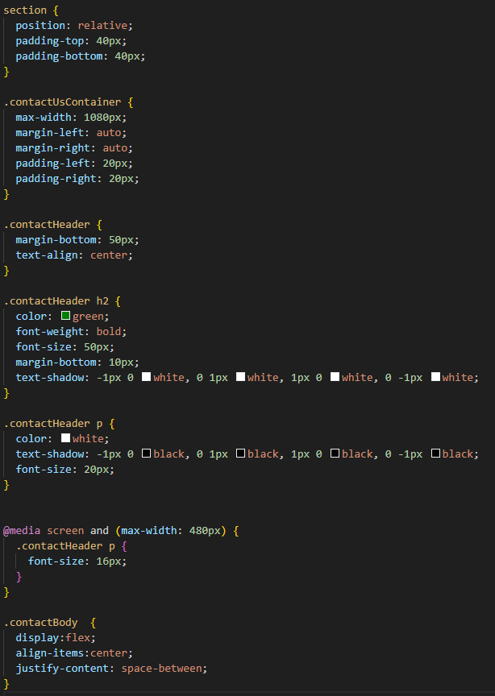

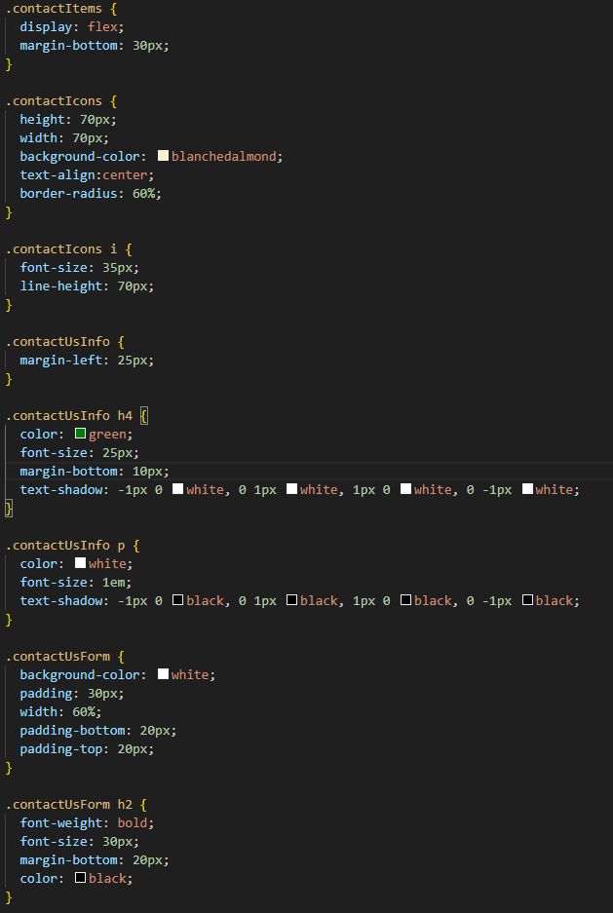

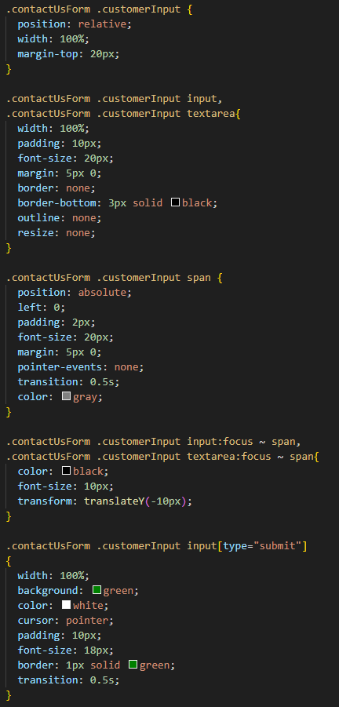

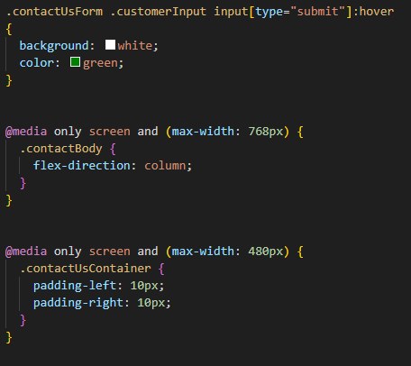

Furthermore, the contact us page also takes advantage of javascript. It starts by waiting for the webpage to fully load using the DOMContentLoaded event. Once the page is fully loaded, all input fields and textareas within elements with the class customerInput are then selected. For each input field and textarea, an event listener is added for the input event, which is triggered every time the user types into the field. The code also selects the form with the ID contactUsForm and adds an event listener for the submit event. When the form is submitted, the default form submission action is prevented using event.preventDefault().An alert is then shown to the user saying “Message sent! We will get right back to you.”, the form is reset using form.reset(), and the next sibling element of each input field and textarea is then cleared. The implementation of this javascript creates a wonderful experience for the user as it is a simple yet effective contact from allowing the user to easily send out messages to the retailer whenever they please.

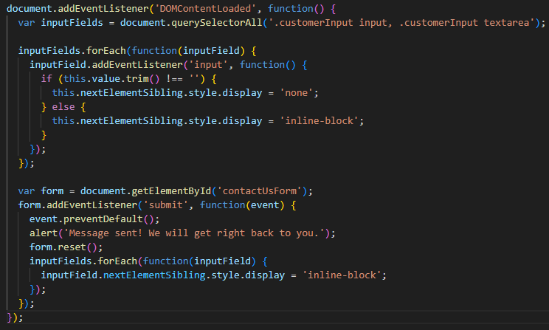

Log In/Register
Lastly, I will be showcasing the implementation of the log in/register webpage. As we can see from the code, the outer div with the id login-form is the container for the entire form. Inside this are two main elements which are message-container and loginBox. The loginBox contains two sections one for login and another for registration. Each form has their own unique set of input fields for users to enter their information. Each form also has a submit button. When clicked, it triggers a JavaScript function (finalLogBtn() for the login form and finalRegBtn() for the registration form) and prevents the form from being submitted in the traditional way using return false.

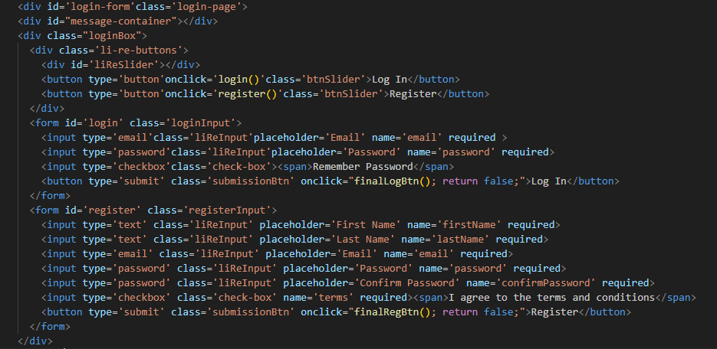

The loginBox class styles the container for the forms, setting its size, position, margin, background color, padding, and overflow. The li-re-buttons class styles the buttons for switching between the login and registration forms, setting their size, margin, position, box shadow, and border radius. The btnSlider class styles the individual buttons, setting their padding, cursor, background, border, and outline. The #liReSlider id styles the slider that indicates the currently selected form, setting its position, size, background, border radius, and transition. The loginInput and registerInput classes style the login and registration forms, setting their position, transition, top offset, and width. The liReInput class styles the input fields in the forms, setting their width, padding, margin, border, outline, and background. The submissionBtn class styles the submit buttons in the forms, setting their width, padding, cursor, display, margin, background, border, outline, and border radius. The code also includes media queries that adjust the width of the loginBox, loginInput, and registerInput when the viewport width is 600 pixels or less, making the form responsive and ensuring it looks good on all devices.
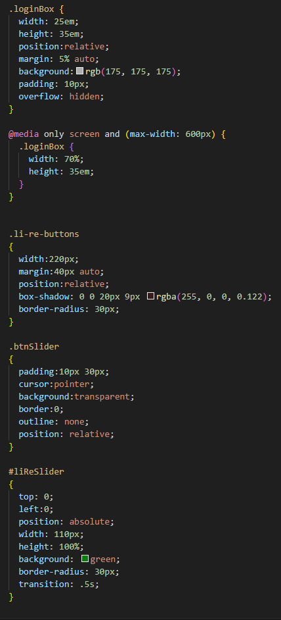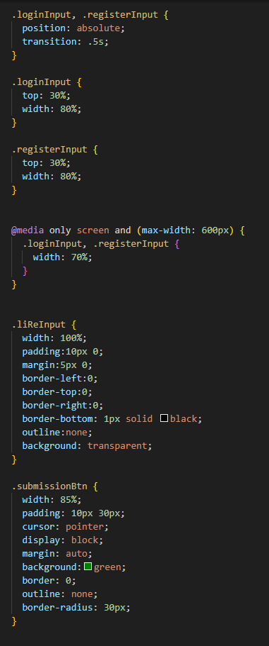

The log-in/register page utilizes 4 different javascript functions. The register and login functions are used to switch between the login and registration forms. This is achieved by changing the left CSS property of the forms and a slider element, essentially moving them out of view. The finalLogBtn function triggers when the user tries to submit a form. There are numerous checks in place to ensure the user has filled in the form completely with the correct email format also cross checking the browsers local storage to see if there are any matching existing users. If a match is found it alerts the user that the login was successful. If not, it alerts the user that the user does not exist. It also checks if all fields are filled. The finalRegBtn is triggered when the user submits the registration form. There are various checks in place to ensure that all fields are filled in with the proper information. It checks if all fields are filled, the terms and conditions are agreed to, and the email format is valid. If an account with the entered email already exists, it alerts the user to use a different email. If not, it adds the new user to the existing users in the local storage and alerts the user that the registration was successful. After each submission the forms are cleared.

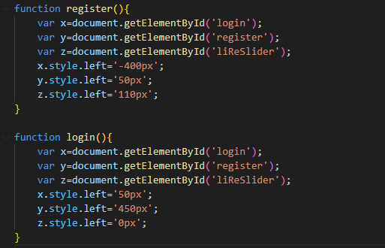
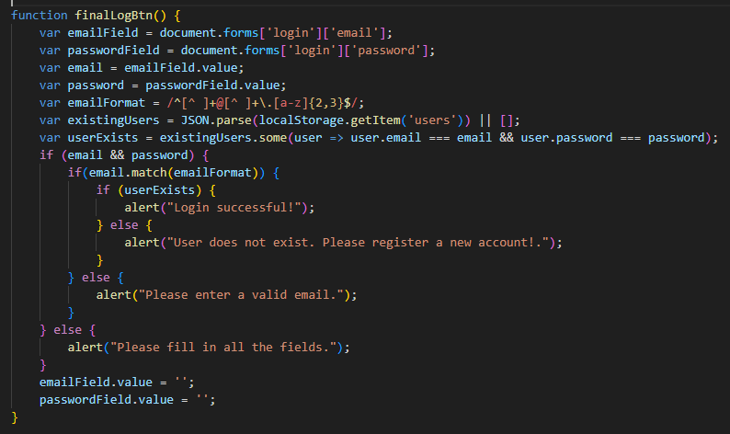

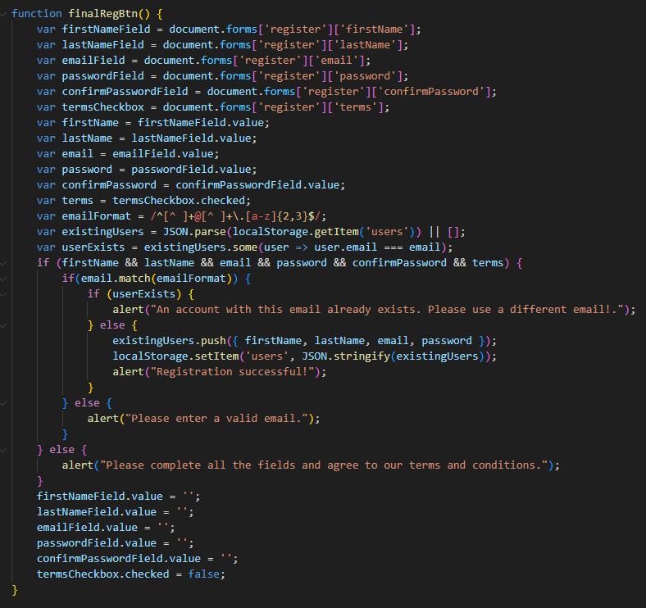
Test cases and test results

Testing register functionality

i) Test Case 1 – empty fields

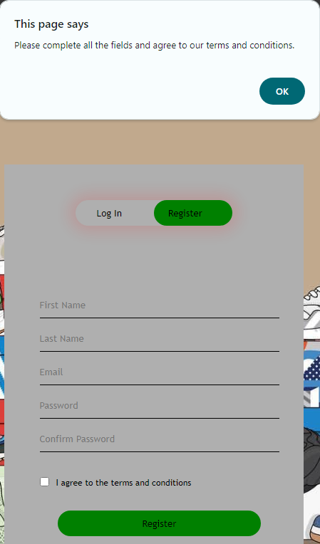

ii) Test Case 2 – Partially empty fields
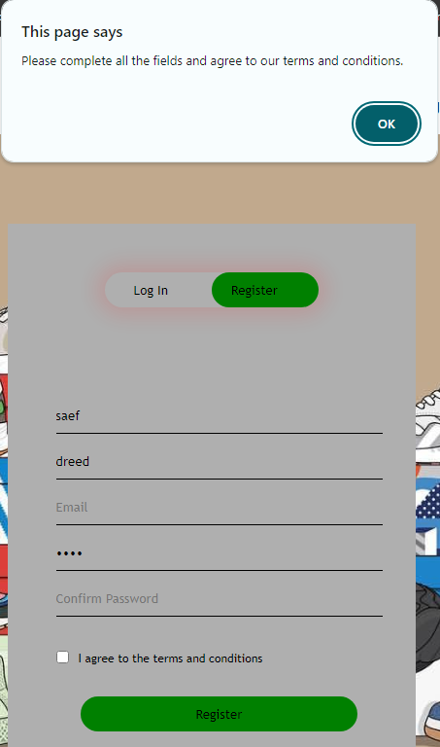

iii) Test Case 3 – No email
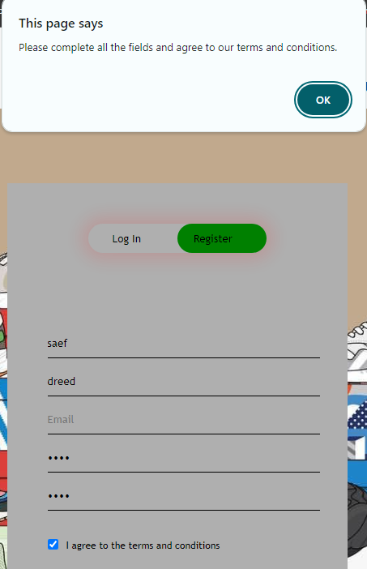

iv) Test Case 4 – Wrong email
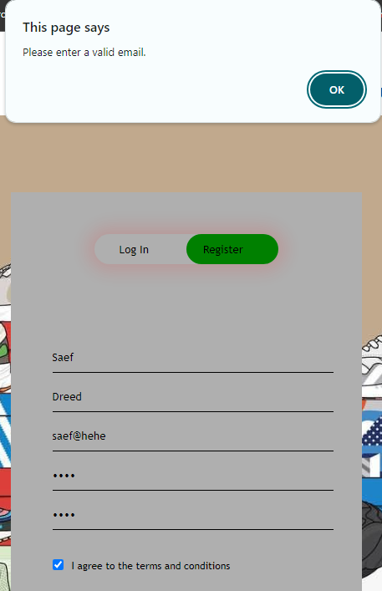

v) Test Case 5 – All fields correct but terms and conditions not agreed to
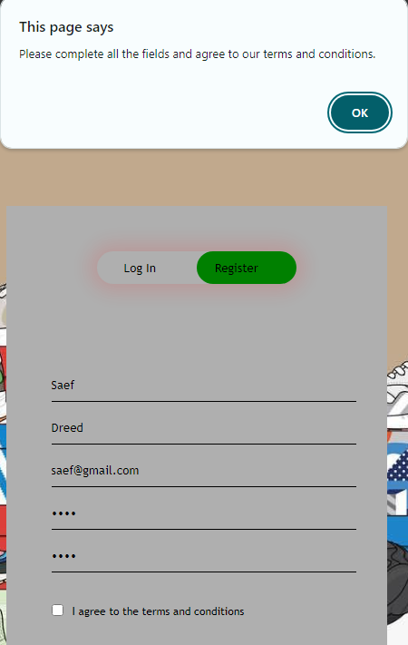

vi) Test Case 6 – Already existing account
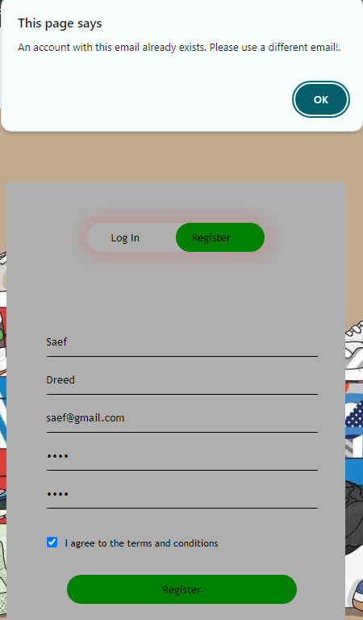
vii) Test Case 7 – Brand new account
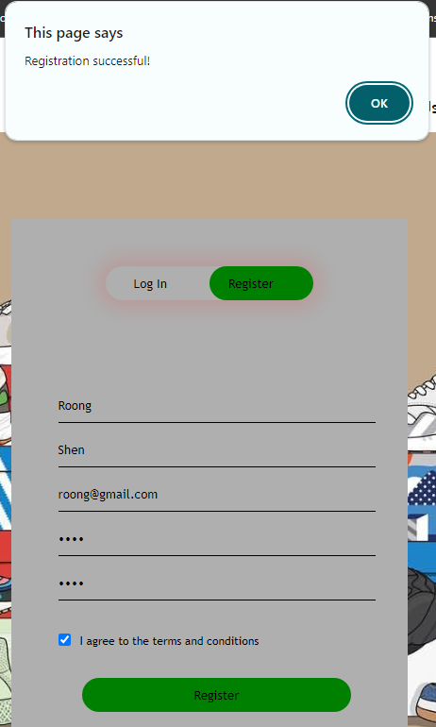

Testing log in functionality

i) Test Case 1 – empty fields
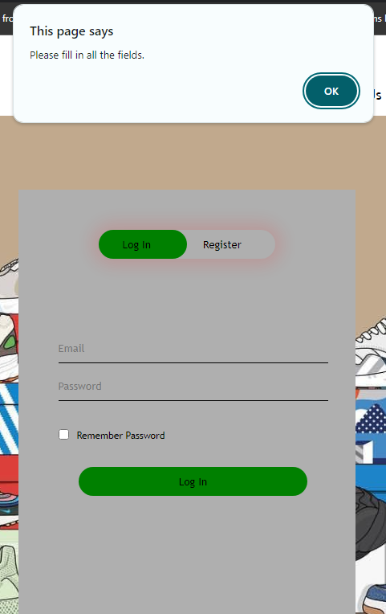

ii) Test case 2 – Partially empty fields
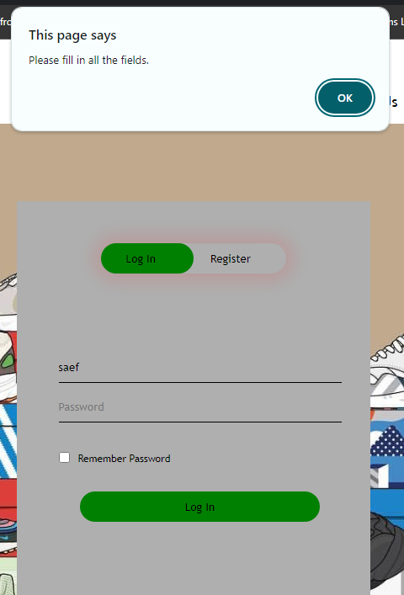

iii) Test case 3 – complete field but wrong email format

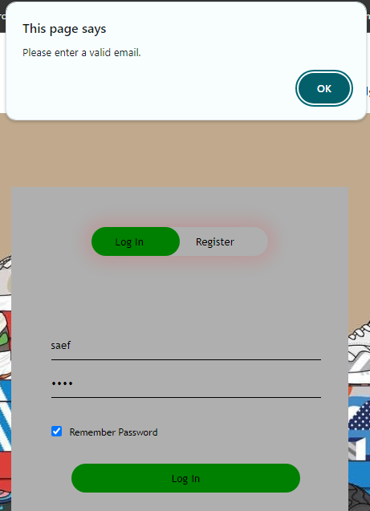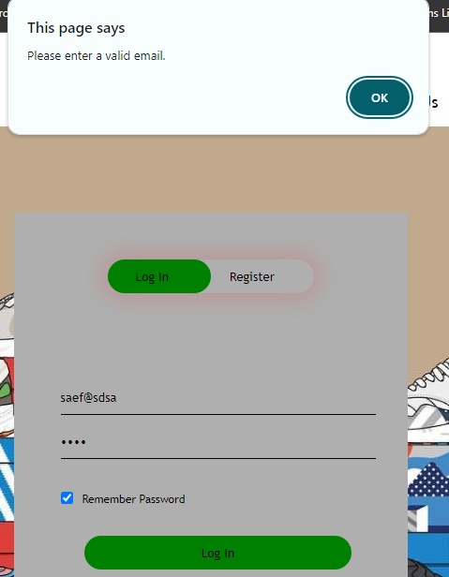

iv) Test case 4 – Unexisting User
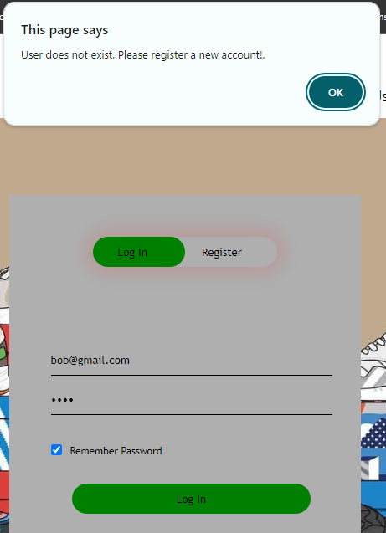

v) Test case 5 – existing user but wrong password
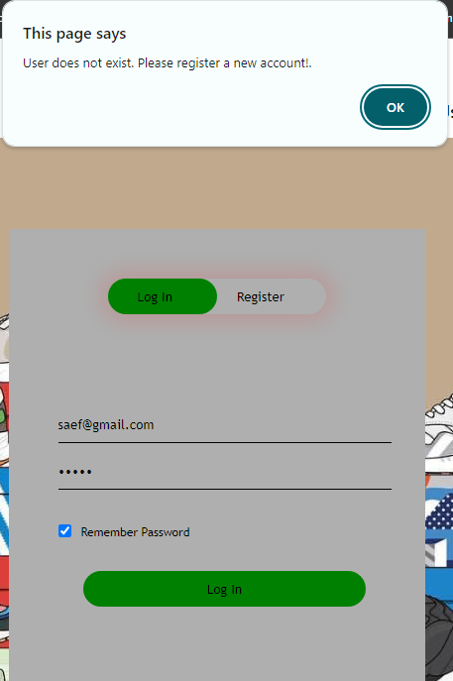

vi) Test case 6 – Existing user
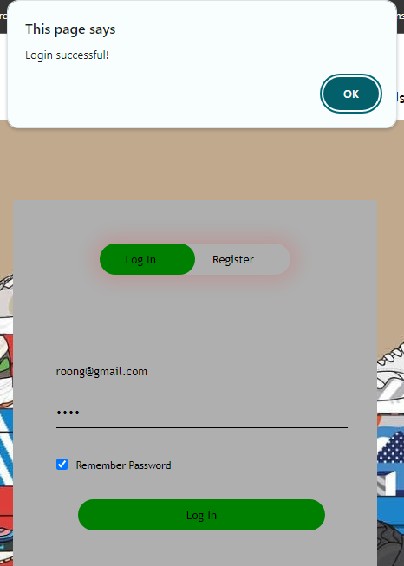

Testing contact us form functionality

i) Test Case 1 – empty form
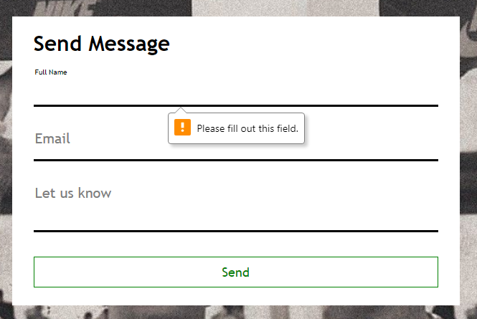

ii) Test Case 2 – Partially empty form
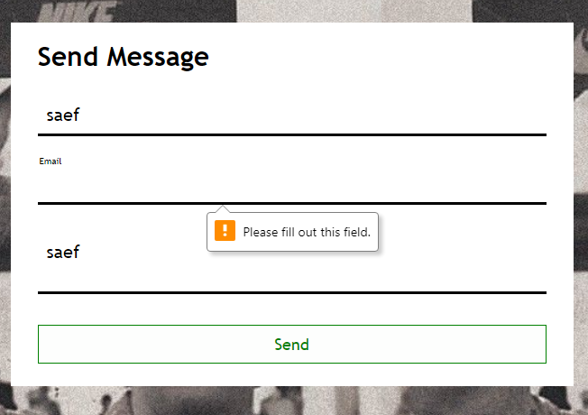

iii) Test Case 3 – Wrong email format
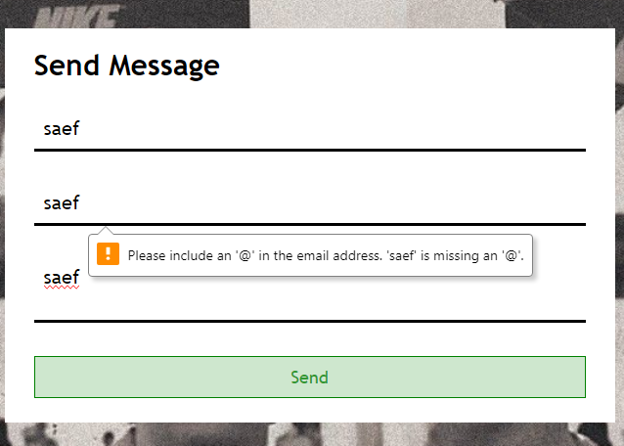
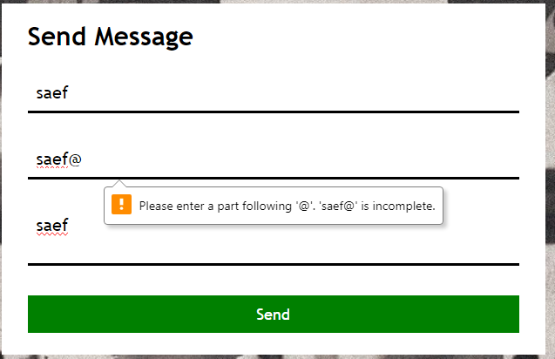

iv) Test Case 4 – Proper name and email address but empty message
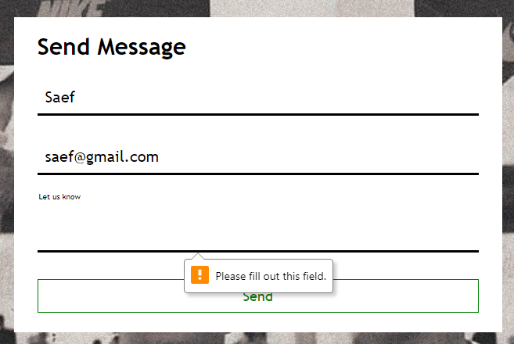

v) Test case 5 – All requirements met
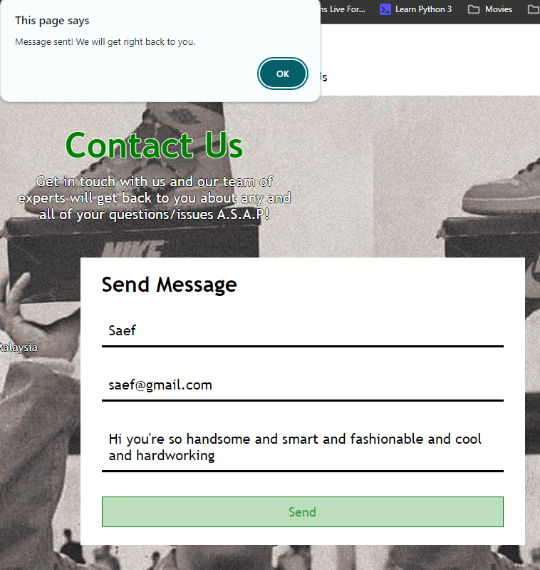

References

Fitzgerald, A. (2022, September 15). 19 Examples of Bad Website Design in 2021 [+ What They Got Wrong]. Blog.hubspot.com. https://blog.hubspot.com/website/bad-vs-good-design

Kuik, S.-V. (2022, February 16). How to Increase Your Brand’s Online Presence in 2023. SMACK. https://smack.agency/blog/strategy/how-to-increase-your-brands-online-presence-in-2022/

