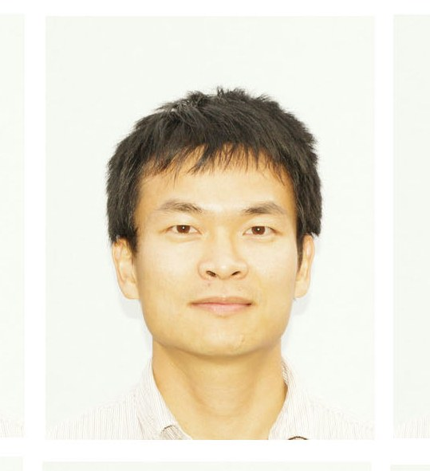**Curriculum Vitae**

**Lin Huang**

Telephone: +44-1382388709

Mobile: +44-7402031573

E-mail: lyhuang@dundee.ac.uk

|  |  |  |  |  |  |
| --- | --- | --- | --- | --- | --- |
| Name (first name(s), surname, title): Lin, Huang, Dr. | | | | | |
| Nationality: China  Date of birth: 14 Jan 1984 | | | | | |
| **Undergraduate and postgraduate studies (details of all degrees held):** | | | | | |
| Dates (month/year) | | Universities or institutes attended | Subjects read and examinations taken | Degree with details of class of honours, prizes awarded etc. | Actual date degree obtained |
| Sep-2001 | Jun-2005 | Hubei University of  Technology | Biology | BSc in Biology,  Outstanding graduate student | 30/06/2005 |
| Sep-2005 | Dec-2010 | Wuhan University | Biochemistry &  Molecular biology | PhD | 31/12/2010 |
| May-2007 | Dec-2010 | National Institute of Biological Sciences, Beijing | Biochemistry &  Structure Biology | PhD | 31/12/2010 |

|  |  |  |  |
| --- | --- | --- | --- |
| **Details of employment in chronological date order (most recent first) since completing PhD studies and including present position in the table below** | | | |
| Dates (month/year)  From To | | Name of organization and position held | Type of appointment e.g. permanent, fixed-term, full-time, part-time etc. |
| Jan-2015 | Present | University of Dundee,  Senior research associate | Full-time, open ended contract with a funding review date of 31 December  2020. |
| Jan-2011 | Jan-2015 | University of Dundee,  Postdoctoral research assistant | Full-time |

|  |
| --- |
| **Give details of personal achievements to date e.g. any prizes, awards, honours, presentations, collaborations, membership of committees, lectures given etc.**  **Prizes**  The plasticity of a structural motif in RNA. International Conference on Riboregulation. Shanghai,  China 2012 The best poster prize  **Presentations**  Molecular mechanism of type Ib active plasmid partition. The 17th Meeting of CLSS-UK. 2011 Oral presentation.  The plasticity of a structural motif in RNA. The 18th RNA meeting. 2013 Poster.  The combination of U1A protein and a G•U pair facilitates RNA-protein crystallization and structure determination. The 28th ECM. 2013 Poster.  From sequence to nanostructure. The 29th ECM. 2015 Oral presentation.  The kink turn in the organization of the architecture of RNA, and as a building block in nano-engineering. The 12th Nucleic Acids Forum. 2016 Oral presentation.  Member of RNA society  Member of the European Crystallographic Association  Member of Royal society of chemistry |

|  |
| --- |
| **A brief statement of past and current research:**  I started my PhD at Wuhan University with Professor Yi Zhang. We use biochemical methods study on the RNA conformational change between the two-transesterification steps of group I intron self-splicing. After two years biochemistry training I moved to Dr. Keqiong Ye’s lab in National Institute of Biological Sciences, Beijing, working on crystallization of group I intron before the first transesterification step. Then I used biochemical and structural methods to study the type Ib plasmid partition complex. In the Zhang lab I learned a lot of RNA-related techniques. In the Ye lab I gathered valuable skills to dealing with RNA-protein, DNA-protein complex assembly, purification, crystallization and data collection.  To expand my scientific experience, I moved to the UK start my postdoctoral research supervised by Professor David Lilley in 2011. During the five years in the Lilley lab, I focused on an RNA motif called kink turn (k-turn), analyzing both structure and function. I developed a number of approaches that have enabled us to crystallize structures that were previously not possible.  At the present time I have determined more than 40 k-turn structures.  I have solved a 2.3 Å structure of L7Ae bound to the standard k-turn Kt-7, and as a result presented a general model for the recognition of k-turn structure by the L7Ae class proteins. I also solved the structure of Kt-7 as the first simple duplex structure at 2.2 Å. These data suggested that the folding of Kt-7 occurs by conformational selection. I determined a 2.0 Å structure of free Kt-7, in which we observed two metal ions directly bonded to the O6 atoms of G2n and G3n, thus providing a molecular explanation for why 3n = G is associated with ion-induced folding. This Kt-7 structure is the first structure showing how metal ions stabilize a folded k-turn structure.  By analysis over 25 structures determined by myself, we found that 3b•3n basepair is the critical determinant of a k-turn’s structure conformation (N3 or N1), in agreement with phylogenetic analysis. The deduced sequence rules for k-turn folding and structure conformation have strong predictive value, and can be applied to many natural RNA sequences. To show those sequence rules are well understood and applicable to modelling and design, I successfully designed a nanostructure comprising six k-turns in a circular arrangement, the structure of which has been determined by X-ray crystallography at 2.75 Å resolution. |

**Publications**

**L Huang**, S Ashraf, DMJ Lilley (2017) Control of box C/D snoRNP assembly by N6-methylation of adenine. Under review by EMBO report.

**L Huang**, DMJ Lilley (2016) A quasi-cyclic RNA nano-scale molecular object constructed using kink turns. Nanoscale 8 (33), 15189-15195 *(2016 Nanoscale HOT Article Collection)*

**L Huang**, DMJ Lilley (2016) A critical base pair in k-turns determines the conformational class adopted, and correlates with biological function. Nucleic Acids Research 44 (11): 5390-5398.

X Shi**, L Huang**, DMJ Lilley, P Harbury, D Herschlag (2016) The structural ensembles of RNA kink-turn motifs and their protein complexes in solution. Nature Chemical Biology

**L Huang**, DMJ Lilley (2015) The Kink Turn, a Key Architectural Element in RNA Structure. Journal of molecular biology

SA McPhee, **L Huang**, Lilley DM (2014) A critical base pair in k-turns that confers folding characteristics and correlates with biological function. Nature Communication 5: 5127-5132

**L Huang**, DMJ Lilley (2014) Structure of a rare non-standard sequence k-turn bound by L7Ae protein Nucleic acids research 42 (7), 4734-4740

J Wang, P Daldrop, **L Huang**, DMJ Lilley (2014) The k-junction motif in RNA structure. Nucleic acids research 42 (8), 5322-5331

P Daldrop, **L Huang**, K T Schroeder, J Wang, DMI Lilley (2013) Kink turn structural motif in RNA. RNA Nanotechnology and Therapeutics, 59

**L Huang**, DMJ Lilley (2013) The molecular recognition of kink-turn structure by the L7Ae class of proteins. RNA 19 (12), 1703-1710

**L Huang**, P Yin, X Zhu, Y Zhang, K Ye (2011) Crystal structure and centromere binding of the plasmid segregation protein ParB from pCXC100. Nucleic Acids Research 39 (7), 2954-2968

D Mo, LWu, Y Xu, J Ren, L Wang, **L Huang**, Q Wu, P Bao, M Xie, P Yin, B Liu, Y Liang, Y Zhang (2011) A maturase that specifically stabilizes and activates its cognate group I intron at high temperatures. Biochimie 93 (3), 533-541

QJ Wu, **L Huang**, Y Zhang (2009) The structure and function of catalytic RNAs. Science in China Series C: Life Sciences 52 (3), 232-244

P Bao, Q Wu, P Yin, Y Jiang, X Wang, M Xie, T Sun, **L Huang**, D Mo, Y Zhang (2008) Coordination of two sequential ester-transfer reactions: exogenous guanosine binding promotes the subsequent ωG binding to a group I intron. Nucleic acids research 36 (21), 6934-6943