**Jamil Shafi**

**OBJECTIVE:**

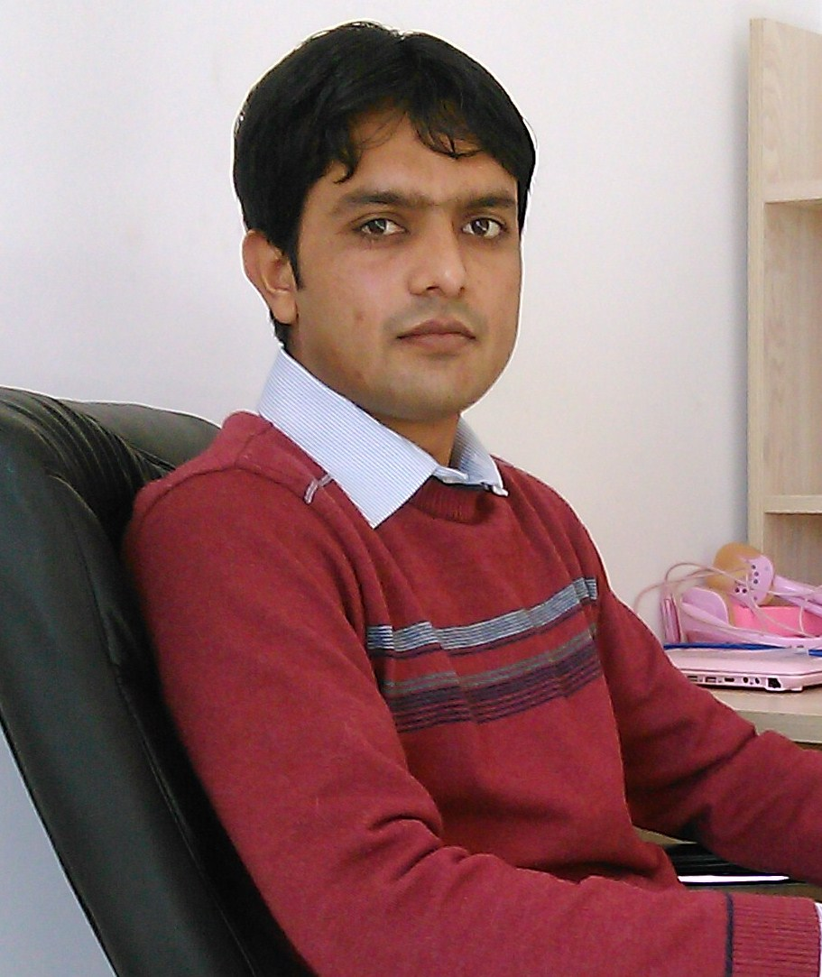

House # 309-B, Al

Cell) (+86) 156402213445

[jamil_shafi786@yahoo.com](mailto:jamil_shafi786@yahoo.com)

A scientific graduate seeking challenging and creative position in a progressive, stimulating and challenging working environment where my skills can be fully utilized while sharing and gaining new experiences and knowledge.

**PROFESSIONAL SUMMARY:**

➢ Excellent work force & time management skills. ➢ Demonstrated written, communication and presentation skills with strong interpersonal skills. ➢ Fluent in English,Urdu and Punjabi. Valuable experiences of living in multi-dimensional societies.

**EDUCATION:**

**Ph.D. Scholar,** Shenyang Agricultural University, Liaoning China (will graduate in June 2017)

**2012-2014, M.Sc. (Hons), Plant Pathology, 3.79 CGPA,** University of Agriculture, Faisalabad-Pakistan.

**“**Epidemiology of Mungbean Yellow Mosaic Disease (MYMD) and its integrated management”

**2007-2011, B.Sc. (Hons), Plant Pathology, 3.76 CGPA,** University of Agriculture, Faisalabad.

**WRITING EXPERIENCE:**

**Research articles**

1. **Jamil Shafi**, H Tian, and M Ji .2017. Bacillus species as versatile weapons for plant pathogens: a review. Biotechnology & Biotechnological Equipment:1-14.
2. **Jamil Shafi**, Ji Mingshan, Qi Zhiqiu, Li Xiuwei, Gu Zumin, Li Xinghai, Zhang Yang, Qin Peiwen, Tian Hongzhe, Che Wunan and Wang Kai. 2016. Optimization of *Bacillus aerius* strain JS-786 cell dry mass and its antifungal activity against *Botrytis cinerea* using response surface methodology. Archives of biological sciences. DOI: 10.2298/ABS160421122S
3. Taswar Ahsan, Jianguang Chen, Yuanhua Wu, Muhammad Irfan and **Jamil Shafi**. 2016. Screening, identification, optimization of fermentation conditions, and extraction of secondary metabolites for the biocontrol of Rhizoctonia Solani AG-3. Biotechnology & Biotechnological Equipment. DOI: 10.1080/13102818.2016.1259016
4. **Jamil Shafi**, Sun Zhonghua, Ji Mingshan, Gu Zumin. Artificial Neural Network and Response Surface Methodology Based Modeling for Optimization of Cell Dry Mass of Bacillus sp. Strain B67 and Its Antifungal Activity Against Botrytis cinerea. Biotechnology & Biotechnological Equipment. In revision
5. **Jamil Shafi**, Hui Tian, Zhiguo Yu, Danni Fu, Bochui Zhao, Sun Zhonghua and Ji Mingshan. Stimulation of reactive oxygen intermediates based plant defense system against *Botrytis cinerea* and plant growth by *Bacillus aerius* strain JS-786. Frontiers in plant science. In review
6. Danni Fu; Bochui Zhao; **Jamil Shafi**; Songhong Wei; Xiuwei Li; Mingshan Ji . Molecular Basis of Cross-Resistance in Sagittaria trifolia L. against Acetolactate-Synthase (ALS) Inhibitors. Weed science. In review
7. Tian Hui, **Jamil Shafi**, Ji Mingshan, Bi Yuhui, Yu Zhiguo. Identification of Antimicrobial Molecules from Streptomyces sp. SN0280 and their Activities against Phytopathogens. Journal of Natural Products. Final revision submitted.
8. Sarwar, M.A., A. Ali, W. Ahmad, **J. Shafi**, K. Shafique. Physiological and Biochemical Response of Maize (*Zea mays* L.) to Exogenic Application of Boron Under Drought Stress. International Journal of Advanced Research. 1 (10): 6-16. (Impact factor= 1.659)
9. Ali, M., A. Hannan, **J. Shafi**, W. Ahmad, C. M. Ayyub, S. Asad, H. T. Abbas and M.A. Sarwar. 2013. Nutrient Supplement Efficacy Against Powdery Mildew of Pumpkin (*Sphaerotheca fuliginea*) and Its Correlation with Environmental Factors. International Journal of Advanced Research. 1 (10): 17-20. (Impact factor= 1.659)
10. Rehman, M.W.U., M. Hussain, M. Ali2, C. B. Mustafa, **J. Shafi** and F. Iqbal. 2013. Allelopathy of Brassica. A review. Sci. Agri. 1 (8): 222-229. (Impact factor= 0.84)
11. Sarwar, M., S.U. Rehman, C.M. Ayyub, W. Ahmad, **J. Shafi,** K. Shafique. 2013. Modeling Growth of Cut-Flower Stock (*Matthiola incana* R. Br.) in Response to Differing in nutrient Level. Universal Journal of Food and Nutrition Science. 1(1): 4-10.
12. Adil, M., W. Ahmad, K.S. Ahmad, **J. Shafi**, M. A. Shehzad, M.A. Sarwar, M. Salman, M. I. Ghani, M. Iqabal. 2013. Effect of Different Planting Dates on Growth and Development of *Gladiolus grandiflorus* under the Ecological Conditions of Faisalabad, Pakistan. Universal Journal of Agricultural Research 1(3):110-117.
13. Mehmood, T., W. Ahmad, K. S. Ahmad, **J. Shafi**, M. A. Shehzad, M.A. Sarwar. 2013. Comparative Effect of Different Potting Media on Vegetative and Reproductive Growth of Floral Shower (*Antirrhinum majus* L.). Universal Journal of Plant Science 1(3): 104-111.
14. Ashraf, J., M. A. Ali, W. Ahmad, C. M. Ayyub, **J. Shafi**. 2013. Effect of Different Substrate Supplements on Oyster Mushroom (*Pleurotus* spp.) Production. Food Science and Technology 1(3): 44-51.
15. Bashir, A.M., W. ahmad, K. S. Ahmad, **J. Shafi.** M. A. Shehzad, M. A. Sarwar, I. Ghani, M. Iqabal. 2013. Efficacy of Foliar Application of Micro Nutrients on Growth and Flowering of *Gerbera jamesonii* L. Universal Journal of Agricultural Research 1(4): 145-149.
16. Imran, A., **J. Shafi**, N. Akbar, W. Ahmad, M. Ali, Sohail Tariq. 2013. Response of Wheat (*Triticum aestivum*) Cultivars To Different Tillage Practices Grown Under Rice-Wheat Cropping System. Universal Journal of Plant Science 1(4): 125-131.
17. Iqbal, M., W. Ahmad, **J. Shafi**, C. M. Ayub, M. Atiq, M. Shahid, M. Saleem. 2013. Comparative Genetic variability and Heritability in Some Tomato Varieties Against Fruit Borer, Shape Disorders and Their Correlation. Bioengineering and Bioscience. 1(2): 17-23.
18. Murtaza1, Z., W. Ahmad, **J. Shafi**, M. Shoaib, M. A. Sarwar, M. A. Shehzad. 2013. Effect of Prolonged Irrigated Fodders on Soil Physical Properties and Agronomic Water Use Efficiency. Natural Resources and Conservation 1(3): 77-93.
19. Rehman, R.U., **J. Shafi**, W. Ahmad, M. Atiq, S. Asad, M. Iqbal. Population Dynamics of Thrips on Transgenic and Non-Transgenic Cultivars of Cotton. Advances in Zoology and Botany 1(4): 71-77, 2013.
20. Iqbal, R.F., M. Ali, **J. Shafi**, W. Ahmad. Agronomic Performance of Transgenic and Non Trangenic Cotton against cotton Leaf Curl Virus. Bioengineering and Bioscience 1(3): 37-46.
21. Rehman, A.U., A. Riaz, M. Iqbal, **J. Shafi** and W. Ahmad. 2014. Responses of Different Morphological Attribute of *Rosa hybrida* L. cv. Kardinal to Saline Water Irrigation. Environment and Ecology Research. 2(1): 21-26.
22. Nawaz, A., W. Ahmad, **J. Shafi**, C.M. Ayub, M. Ali. 2014. Characterization of Some Quantitative Traits of Locally Developed Tomato Hybrids Under Plastic Tunnels. Universal Journal of Plant Science 2(3): 69-76.
23. Yaseen, R., **J. Shafi**, W. Ahmad, M. Shoaib. Effect of Deficit Irrigation and Mulch on Soil Physical Properties, Growth and Yield of Maize. 2014. Environment and Ecology Research 2(3): 122-137.
24. Raza, M. M., M. A. Khan, M. Arshad, M. Sagheer, Z. Sattar, **J. Shafi**, E. Haq, A. Ali, U. Aslam, A. Mushtaq, I. Ishfaq, Z. Sabir and A. Sattar. 2014. Impact of global warming on insects. Archives Of Phytopathology And Plant Protection

**Abstract**

1. Sarwer, A., M.Asif, Z.A.Cheema, Waqas Ahmad, M.Shahid, Sohail Asad, **Jamil Shafi**, Rizwan Zubair. Weed management in cotton through intercropping of allelopathic crops. internztional confirence on prospect and challenges to sustainabl agriculture14-16 July 2011.
2. Atiq, M., S.Asad, **J.Shafi**, S.Urooj, T.M.Ahmad. 2013. Impact of Climate Factors in Development of Charcoal Rot of Mungbean. AgMIP-Pakistan Kickoff Workshop & International Seminar on Climate Change, June 4-6, 2013. 29pp.
3. Atiq, M., S.Asad, **J.Shafi**, S.Urooj, T.M.Ahmad. 2013. Environmental Characterization of Mungbean Yellow Mosaic Virus Under Changing Climatic Conditions. AgMIP-Pakistan Kickoff Workshop & International Seminar on Climate Change, June 4-6, 2013. 77p

**Urdu articles**

1. Dr. Atiq, Adnan Hussain, **Jamil Shafi**, Tehmina Javed, Aadil Nawaz, M. Mohsin Raza. Sep 2010. Black Shrank of Sweat potato. Niday Kisan. 44 pp.
2. Dr. M. Atiq, Aslam Khan, Ahmad Raza, **Jamil Shafi**, Suhail Asad, Humara Saeed. August, 2010. Stem and Root Rot of Maiz. . Kisan Risala. 9 pp.
3. Dr. M. Atiq, Dr. Shahbaz, Humara Saeed, Rana Abdul Waheed, **Jamil Shafi**, M.Mohsin Ali. March, 2010. Scab of Chilies. Kisan World. 40 pp.
4. Dr. M. Atiq, Dr. Aslam Khan, **Jamil Shafi**, Suhail Asad, M. Muzmal, Zeeeshan Ahmad. December, 2010. Apple Scab. Niday Kisan. 52 pp.
5. Dr. Abdul Hannan, Dr. M. Atiq**, Jamil Shafi**, Tahir Monir Butt, Mubasher Ali, Waqas Hussain, Parsa Seher. February, 2010. Rhizocotonia Solani of Potato. Niday Kisan. 27 pp.
6. Dr. M. Atiq, Jamil Shafi. 2012. Cultivation of Mushroom at Home. Niday Kisan. 27 pp.

**English articles in newspapers**

1. Waqas Ahmad, **Jamil Shafi**. January 28- 2013. Need for Crop Insurance. Dawn News paper.

**WORKSHOP & SHORT COURSE:**

1. Attended international training workshop on safe production of grains form September 10, 2014 to September 30, 2014 at Shenyang Agricultural University, China.
2. Attended one day training workshop on 3D- landscape designing on 13 April, 2013, organized by Institute of Horticultural Sciences, University of Agriculture, Faisalabad.
3. Participated in One weak Training course on “Mushroom Cultivation Technology” on May 27-31, 2013, organized by Medicinal & Mushroom Lab, Institute of Horticultural Sciences, University of Agriculture, Faisalabad.
4. Participated in One day workshop on “Scientific Writing & Plagiarism” May 28, 2013, Organized by Office of the Senior Tutor and Carear Development Center, University of Agriculture, Faisalabad.
5. Participated in “Poster Competition held on June, 13, 2013. Organized by Young Phytodoctor’s Forum, Department of Plant Pathology, University of Agriculture, Faisalabad.
6. Participated in “workshop on Molecular Techniques for Breeding Horticultural and Agronomic Crops, held on 30 September to 2 October, 2013. Organized by Institute of Horticultural Sciences, University of Agriculture, Faisalabad.

**PROFESSIONAL EXPERIENCE:**

1. 3 months internship at Ayub Agriculture Research Institute,Faisalabad.
2. Experience of wheat sowing, emasculation, crossing, Wheat rust.
3. 6 Month Work as TTSO in Swat Agro Chemicals.
4. 4 months experience as quality Assurance officer in PepsiCo (lays).

**References:**

1. **Professor Ji Mingshan**

College of Plant Protection,

Shenyang Agricultural University,

P.R. China.

Email: jimingshan@163.com

1. **Professor Yu Zhiguo**

College of Plant Protection,

Shenyang Agricultural University,

P.R. China.

Email: [yu_zhiguo2012@163.com](mailto:yu_zhiguo2012@163.com)