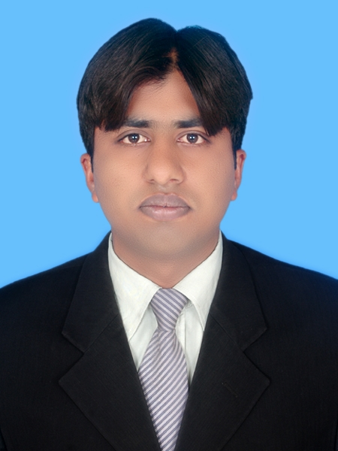
Dr. UMAR IJAZ AHMED s/o Mushtaq Ahmed
HEC Approved PhD Supervisor

Permanent Address: Chak No. 47/P, Tehsil and District Rahim Yar Khan, Pakistan
Postal Address: Ali Faheem Electro Traders, Bano Bazar, Rahim Yar Khan, Pakistan
E-mail: ahmedumarijaz@gmail.com
Phone: +923008547247

EDUCATIONAL BACKGROUND
- PhD Agricultural Economics and Management Percentage: 84%
Huazhong Agricultural University, Wuhan, China (2015)
- M.Sc. (Hons.) Agri. Economics (2010) CGPA: 3.48/4.00
University of Agriculture Faisalabad
- B.Sc. (Hons.) Agricultural and Resource Economics (2008) CGPA: 3.61/4.00
University of Agriculture Faisalabad
- F.Sc. Pre-Engineering (2003) Marks: 786/1100
B.I.S.E Bahawalpur
- Matric (2001) Marks: 699/850
B.I.S.E Bahawalpur

CAREER OBJECTIVE
- To achieve excellence in academic research and contribute to R& D in area of agricultural and resource economics at the national and international level, particularly in developing countries for the benefit of the poor.

PhD DISSERTATION TITLE
- “Rural Household Food Security and Market Accessibility: The case of Small Farmers of the Punjab, Pakistan” under supervision of Prof. Liu Ying, College of Economics and Management, Huazhong Agricultural University Wuhan, China.

RESEARCH PUBLICATIONS
- Ahmed, U.I., L. Ying, M.K. Bashir, M. Abid, E. Elahi and M.A. Iqbal. 2016. Access to output market by small farmers: The case of Punjab, Pakistan. The Journal of Animal and Plant Sciences, Vol. 26(3), 787-793 [IF=0.442]
- Ping Q., M. A. Iqbal, M. Abid, U. I. Ahmed, A. Nazir, A. Rehman. 2016. Adoption of off-farm diversification income sources in managing agricultural risks among cotton farmers in Punjab Pakistan. Journal of Applied Environmental and Biological Sciences, Vol. 6(8). (Thomson Reuters ISI Indexed)
- Ahmed, U.I., L. Ying, M.K. Bashir, M. Abid, F. Zulfiqar, Status and determinants of small farming household’s food security and role of market access in enhancing food security in rural Pakistan. (Revision Submitted in Plos One [IF=3.02]).
- Ahmed, U.I., L. Ying, M.K. Bashir, M.A. Iqbal and M. Rizwan. 2015. Spatial price transmission in Pakistan: The case of wheat and rice markets. Pakistan Journal of Agricultural Research, Vol. 28(4), 254-262 (HEC recognized)
- Ahmed, U.I., L. Ying and M.K. Bashir, 2015. Food Insecurity and Coping Strategies by Micro Growers in Punjab, Pakistan. Journal of Environmental and Agricultural Sciences, Vol. 3: 31-34
- Ahmed, U.I., L. Ying, K. Mushtaq and M.K. Bashir. 2015. An Econometric Estimation of Post Harvest Losses of Kinnow in Pakistan. International Journal of Economics, Commerce and Management, United Kingdom, Vol. 3(5): 773-783
- Iqbal. M.A., Q. Ping, U.I. Ahmed and A. Nazir. 2015. Determinants of Off-farm Activity Participation among Cotton Farmers in Punjab, Pakistan. International Journal of Management, Accounting and Economics, Vol. 2(7): 707-718.
- Elahi, E., L. Zhang, M. Abid, O. Altangerel, K. Bakhsh, B. Uyanga, U.I. Ahmed and H. Xinru. 2014. Impact of Balance Use of Fertilizers on Wheat Efficiency in Cotton Wheat Cropping System of Pakistan. International Journal of Agriculture Innovations and Research, Vol. 3(5): 1470-1474

CONFERENCE PAPERS
- Ishaq, M., Z. Haq, L. Xiangsen, A. Hassan, U.I. Ahmed. 2013. An empirical study of consumer behaviour: Food demand in Pakistan. 2013 CAER-IFPRI Annual International Conference on Institutional Innovation and Rural Development, Wuhan, China

PROFESSIONAL EXPERIENCE
- Currently working as Assistant Professor at Muhammad Nawaz Shareef University of Agriculture Multan since November, 2016
- Worked as Assistant Professor, University College of Agriculture, University of Sargodha under IPFP program of HEC from September 30, 2015 to September 29, 2016.
- Worked as Surveyor in Project Impact Evaluation Study of National Programme for Improvement of Watercourses in Pakistan from Feb. 01, 2010 to July 31, 2010, funded by Federal Water Management Cell, Ministry of Food and Agriculture, Govt. of Pakistan, being run by AAB (pvt) Ltd. Islamabad.
- Worked as Research Assistant in RADP sub-project titled “Assessment of harvest and post harvest losses in selected fruits in Pakistan” from July 01, 2009 to Nov. 14, 2009 at Technology Transfer Institute (PARC), AARI, Faisalabad.

PROFESSIONAL TRAININGS
- Attend two days Training Course on Agricultural Commodities Analysis held on December 7-8, 2016 at University of Agriculture Faisalabad organized by US-Pak Centre for Advance Studies.
RESEARCH/ PROFESSIONAL ASSIGNMENTS
- Worked in a project titled “IP policy and Legal framework for Commercialization (Auction) of crop Varieties/ Hybrids developed by the Public Sector Institutions” funded by USPCAS, UC Davis and USAID at Muhammad Nawaz Shareef University of Agriculture Multan.
- Engaged in the formulation of policy draft on “A case for reducing cotton imports to enhance cotton production in Pakistan” at Muhammad Nawaz Shareef University of Agriculture Multan.
- Engaged in Outreach activities at MNS University of Agriculture Multan.
- Engaged in establishing Rover Scouts Unit at MNS University of Agriculture Multan.
AWARDS AND DISTINCTIONS
- Group Scout Leader of Agrivarsity Scouts Group, University of Agriculture Faisalabad.
- Presidents Rover Scout Award in 2007.
- President Rover Scout Gold Medalist 2008.
- Best Rover Scout of Pakistan 2008.
- The Scout Wood Badge by Pakistan Boy Scouts Association
- Visit of China with Youth Delegation under Ministry of Youth Affairs from May 6, 2010 to May 14, 2010.
- Khudam-ul-Hujjaj at Hajji Camp Multan during Hajj Operation 2010.
COMPUTER SKILLS
- M.S. Office Applications (Word, Excel, Power Point, Access, Paint)
- SPSS, E-Views, Stata, Amos, GPS (Global Positioning System)
REFERENCES
- Dr. Liu Ying
Professor, College of Economics and Management,
Huazhong Agricultural University Wuhan, China
Email: liuying@mail.hzau.edu.cn
Phone: +86-13797087223
- Dr. Khuda Baksh
Associate Professor,
Department of Management Sciences,
COMSATS Institute of Information Technology, Vehari, Pakistan.
Email: kbakhsh@ciitvehari.edu.pk
Phone: +92-3006693012
- Dr. Ahmad Sattar Khan
Associate Professor,
Institute of Horticultural Sciences,
University of Agriculture Faisalabad
Email: ahmad_khan157@yahoo.com
Phone: 0333-8364813

