CURRICULUM VITAE

Dr. AYAZ ALI, SOOMRO

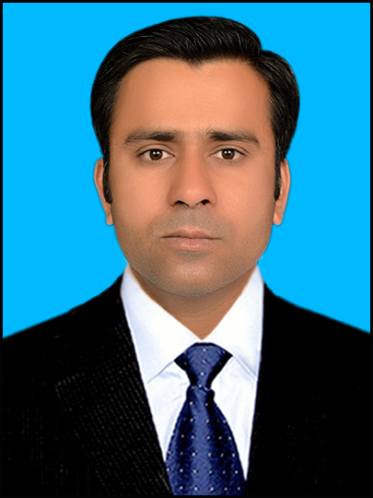
PERSONAL INFORMATION

Nationality: | Pakistani
Passport: | ZX1790092
CNIC:  Date of birth: | 43404-0342009-3  01-06-1986
Cell: | +92-3342918476
E-mail: | soomro_ayazali@yahoo.com
Address: | House No. 143, Block Q, WAPDA Colony Guddu, Kashmor, Sindh, Pakistan

Academic Qualification

Degree | Board/Institution | Year of Completion | Division / Grade
PhD  (Plant Nutrition) | China Agricultural University Beijing China | 2016 | First Division (3.15) GPA
Post-Graduation/  M.Sc Hons  (Plant Breeding & Genetics) | Sindh Agriculture University TandoJam .Pakistan | 2010 | First Division (79.33%)
Graduation/  (B.Sc Hons. Agriculture) | Sindh Agriculture University TandoJam Pakistan | 2008 | First Division (69.04%)
Higher Secondary Certification (HSC)  (Pre-Medical) | B.I.S.E Larkana Sindh .Pakistan | 2003 | Second Division (53.7%)
Secondary School  Certification (SSC)  (Science Group) | B.I.S.E Larkana Sindh .Pakistan | 2001 | First Division (67.4%)
SCHOLARSHIP AWARDED

Chinese Scholarship Council (CSC): Awarded scholarship for doing PhD at CAU, Beijing, China (September 2011-July 2016).

SKILLS AND TECHNIQUES

Proficient in recombinant DNA technology/Analysis methods including development of primers, PCR analysis, DNA, RNA genomic extraction, protein analysis, and other lab techniques etc.

RESEARCH TITLE OF PhD:

Physiological and Genetic Characterization of a Maize Dwarf Mutant.

Importance of research done: Discovering the dwarf gene is an important goal for future advances in plant breeding and Genetics. Understanding where dwarf mutant plays an essential role in controlling morphology of maize plant.

extra curriculum activites

- Participated in International Students Badminton Competition October 2014
- Cooking Competition held by Beijing Higher Education Institute in March 2012.
- Acted as an artist in Celebrations of Spring Festival organized by international Students Office CAU 2013.
- Participated in all the social visits organized by International Students Office CAU
- Won Badminton tournament played at National Level in 2005, Hyderabad .
- Participation in Social Forum.

Publications

Ayaz Ali Soomro, Muhammad Abdul Rehman Rashid and Farah Naz Kaleri. Direct and Indirect Influence of Yield Components on Grain Yield of Wheat. American-Eurasian J. Agric. & Environ. Sci., 15 (4): 603-606, 2015.ISSN 1818-6769

Habib R. Lakho1, Ayaz A. Soomro, Muhammad A. R. Rashid, & Shabana Memon. Determination of General and Specific Combining Ability of Five Upland Cotton Cultivars. Lasbela University of Agriculture, Uthal, Pakistan.

Riliang Gu, Fanjun Chen, Bingran Liu, Xin Wang, Jianchao Liu, Pengcheng Li, Qingchun Pan, Jordon Pace, Ayaz-Ali Soomro, Thomas Lübberstedt, Guohua Mi, Lixing Yuan. Comprehensive phenotypic analysis and quantitative trait locus identification for grain mineral concentration, content, and yield in maize (Zea mays L.) Theor Appl Genet DOI 10.1007/s00122-015-2546-5.

Pengcheng Li, Zhongjuan Zhuang, Hongguang Cai, Shuai Cheng, Ayaz Ali Soomro, Zhigang Liu, Riliang Gu, Guohua Mi, Lixing Yuan and Fanjun Chen. Use of genotype-environment interactions to elucidate the pattern of maize root plasticity to nitrogen deficiency Journal of Integrative Plant Biology DOI: 10.1111/jipb.12384.

Zhigang Liu, Riling Gu, Shengchen Shan, Ayaz Ali Soomro, Kun Gao, Guohua Mi, lixing Yuan and Fanjun Chen. Comparative analysis of root traits and the associated QTLs for maize seedlings grown in paper roll, hydroponic and vermiculite culture system (Under review)

COMPUTER SKILLS
Computer literacy/ Statistical analysis
IT Skills: Proficient in MS Word, Excel, Power point, Adobe Photoshop, SPSS, Basic Bioinformatics tools like Web-cutter, BLAST, Genomic data-mining (using Mapviewer etc.), primer generation (manually and using Gene Fisher etc) and sequence alignment software’s like ClustalW2 and Gene Align.

LANGUAGES
- Sindhi ,URDU: Native level competency
- English: Excellent - all skills (Listening, speaking, reading, and writing)
- Arabic, Sindhi , Siraiki, Punjabi and Hindi
- Chinese: Beginner’s level proficiency including conversational skills

Sports:
Badminton and Table-tennis. Cricket

