實作圖片:

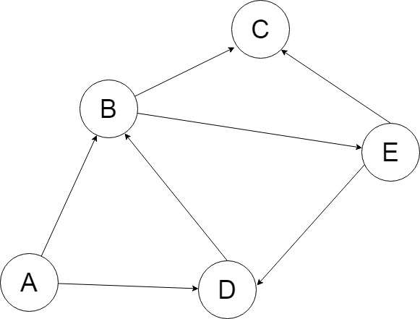

分支度: A:2, B:3, C:2, D:3, E:2

TOTAL=12

|  |  |  |  |  |  |
| --- | --- | --- | --- | --- | --- |
|  | A | B | C | D | E |
| A | 0 | 1 | 0 | 1 | 0 |
| B | 1 | 0 | 1 | 1 | 0 |
| C | 0 | 1 | 0 | 0 | 1 |
| D | 1 | 1 | 0 | 0 | 1 |
| E | 0 | 0 | 1 | 1 | 0 |

分支度:

A: IN()+OUT()=1+1=2

B: IN()+OUT()=1+2=3

C: IN()+OUT()=1+1=2

D: IN()+OUT()=2+1=3

E: IN()+OUT()=1+1=2

TOTAL=12

串列:

A → B

**B** → C → D

**C** → E

**D** → A

**E** → D

|  |  |  |  |  |  |
| --- | --- | --- | --- | --- | --- |
|  | A | B | C | D | E |
| A | 0 | 1 | 0 | 0 | 0 |
| B | 0 | 0 | 1 | 1 | 0 |
| C | 0 | 0 | 0 | 0 | 1 |
| D | 1 | 0 | 0 | 0 | 0 |
| E | 0 | 0 | 0 | 1 | 0 |