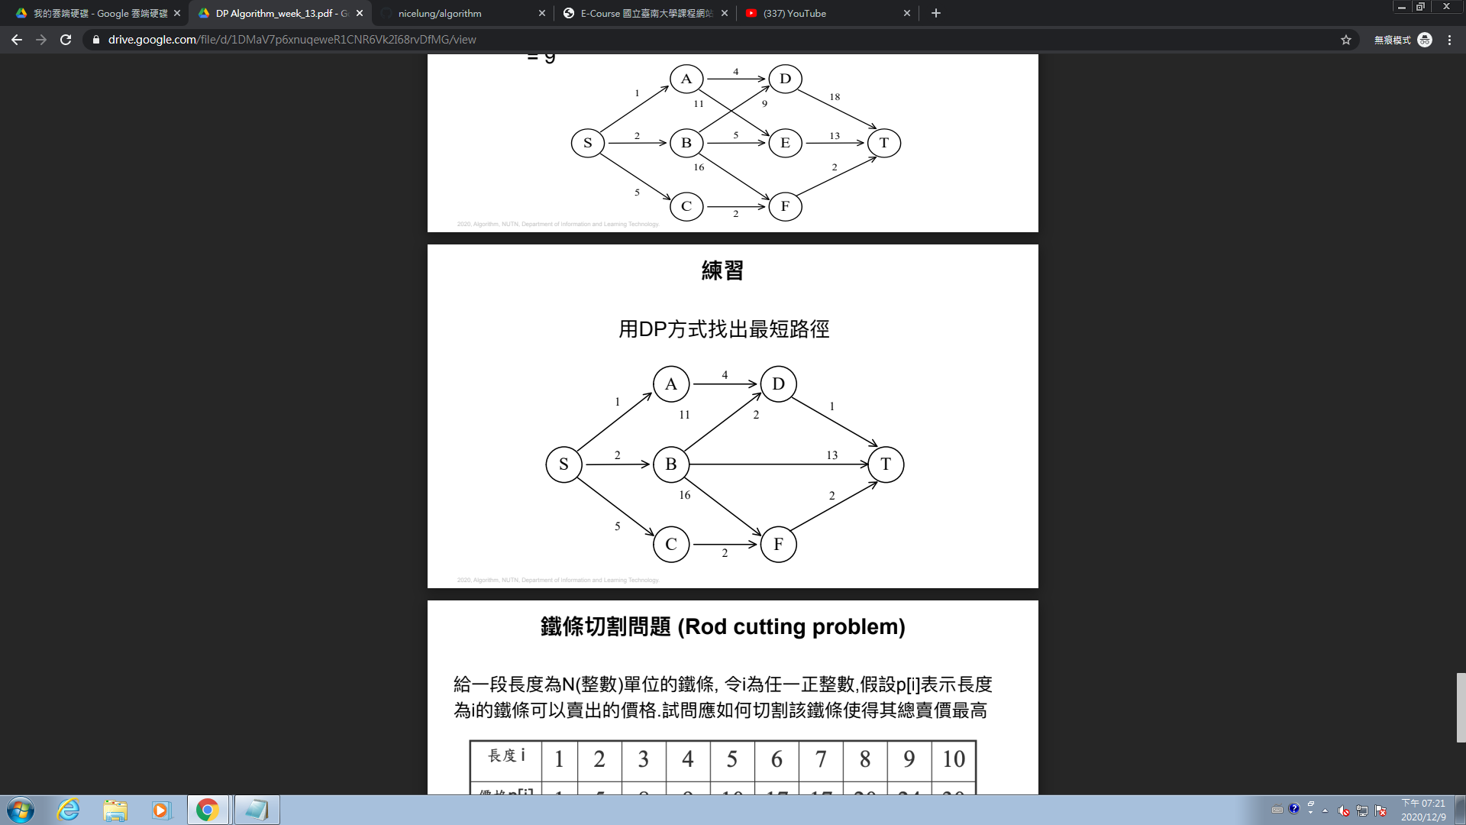

d(s,t) = min( 1+d(a,t),2+d(b,t), 5+d(c.t) )

d(a,t) = min( 4+d(d,t) )

d(b,t) = min( 11+d(d,t),d(b,t),16+d(f,t) ) =min( 12,13,18 ) =12

d(c,t) = min( 2+d(f,t))

d(d,t) = 1

d(b,t) = 13

d(f,t) = 2

所以 d(s,t) = min( 4+1+1, 2+12 , 5+4) =min(6,14,9) =6

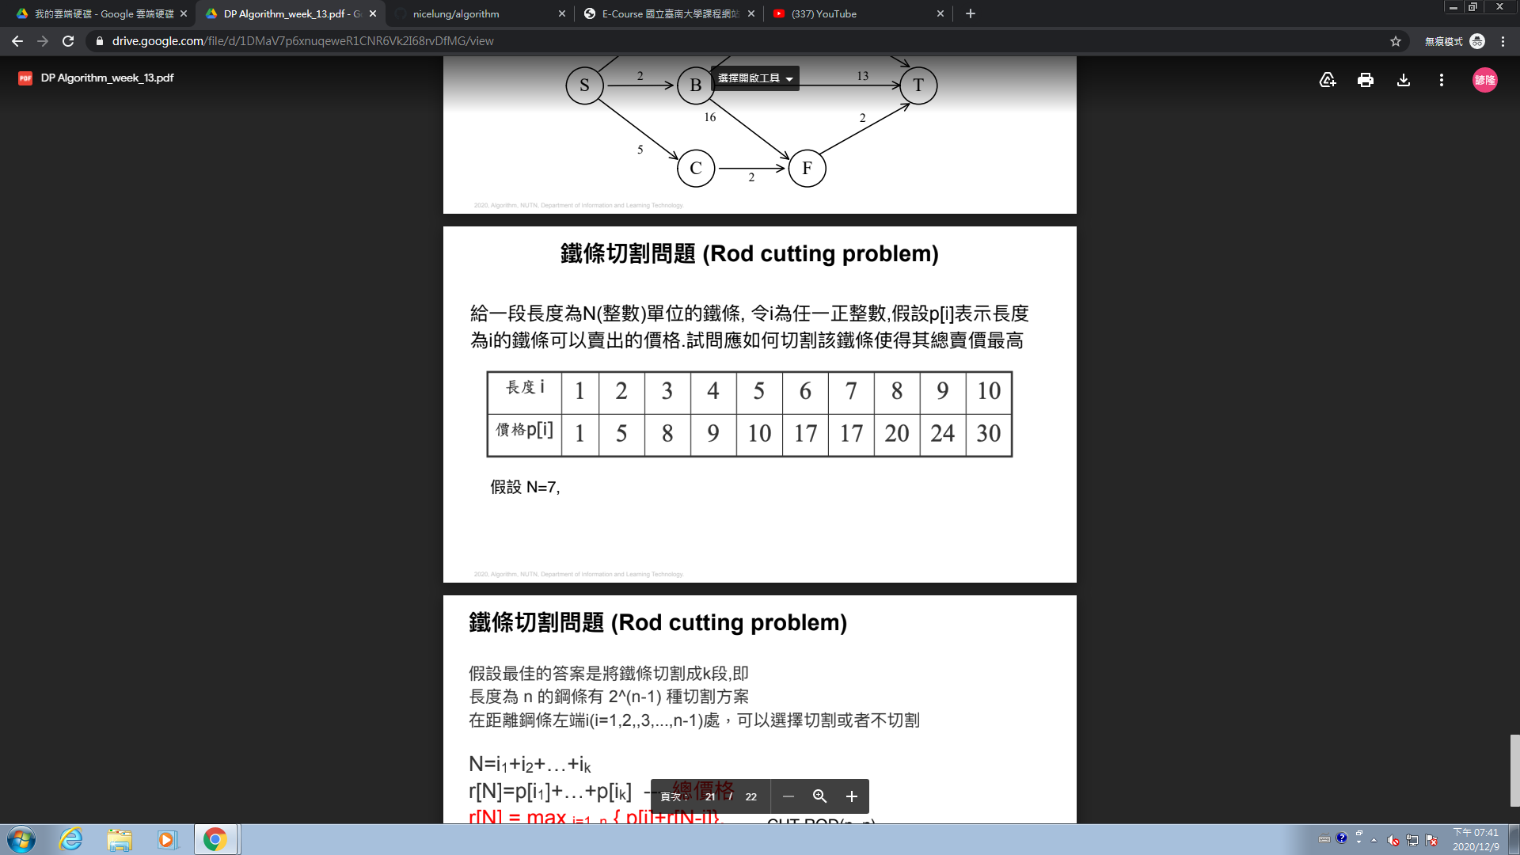

N = 7

(0,7)=17

(6,1)=18

(5 ,2)=15

(5,1,1)=12

(4,3) = 17

(4 ,2 ,1)=15

(4,1,1,1)=12

(3,2,2) = 18

(3,3,1)=17

(3,1,1,1,1)=12

(3,2,1,1) = 15