# Nutrition Labels at a Glance

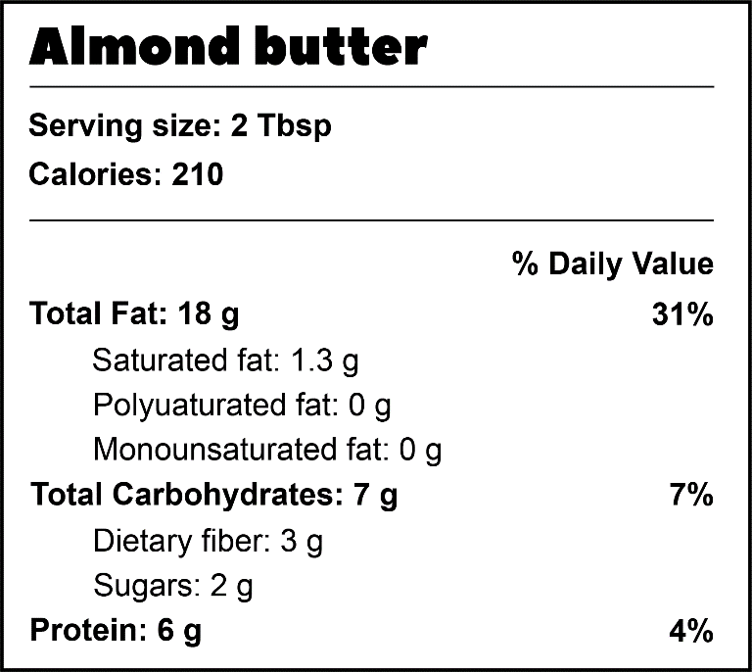

**Fats**  
The total fat is the total number of grams of fat in the food. Saturated fats come mainly from animal fats, which should be limited. Each gram of fat has 9 calories.

**Serving size**  
This is the amount of the food in a single serving. Make sure to measure your food, especially when you’re just starting to balance your macros. If you eat two portions, double all the numbers!

**Protein**  
The number of grams of protein that is in a single serving of the food. Each gram of protein has 4 calories.

**% Daily Value**How much of your daily calories for each macronutrient are in a single serving of the food. For almond butter, the 18g of fat makes up 31% of the fat calories you should eat all day (in a 2000-calorie per day diet).

**Calories**  
The number of calories in the serving size of the food. If you eat more than a serving, the actual calories you consume will be more.

**Carbohydrates**  
The total carbohydrates is the total number of grams of carbs in the food. Foods that are higher in dietary fiber tend to be healthier choices. Each gram of carbohydrates has 4 calories.

# Food Trackers Macros Screen

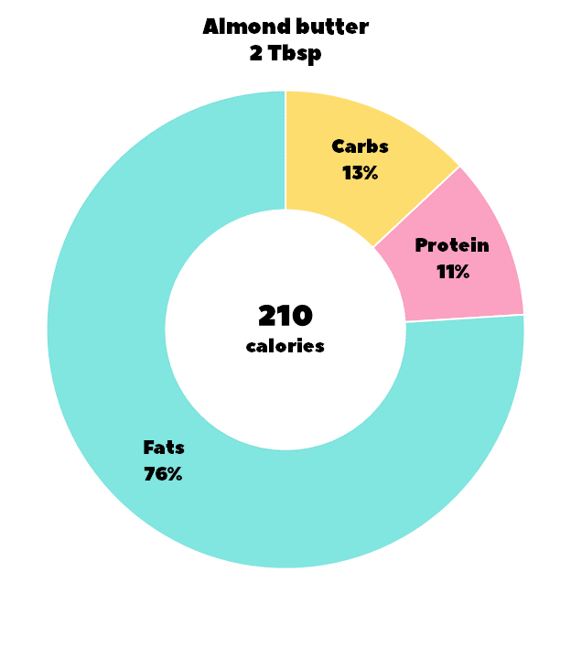

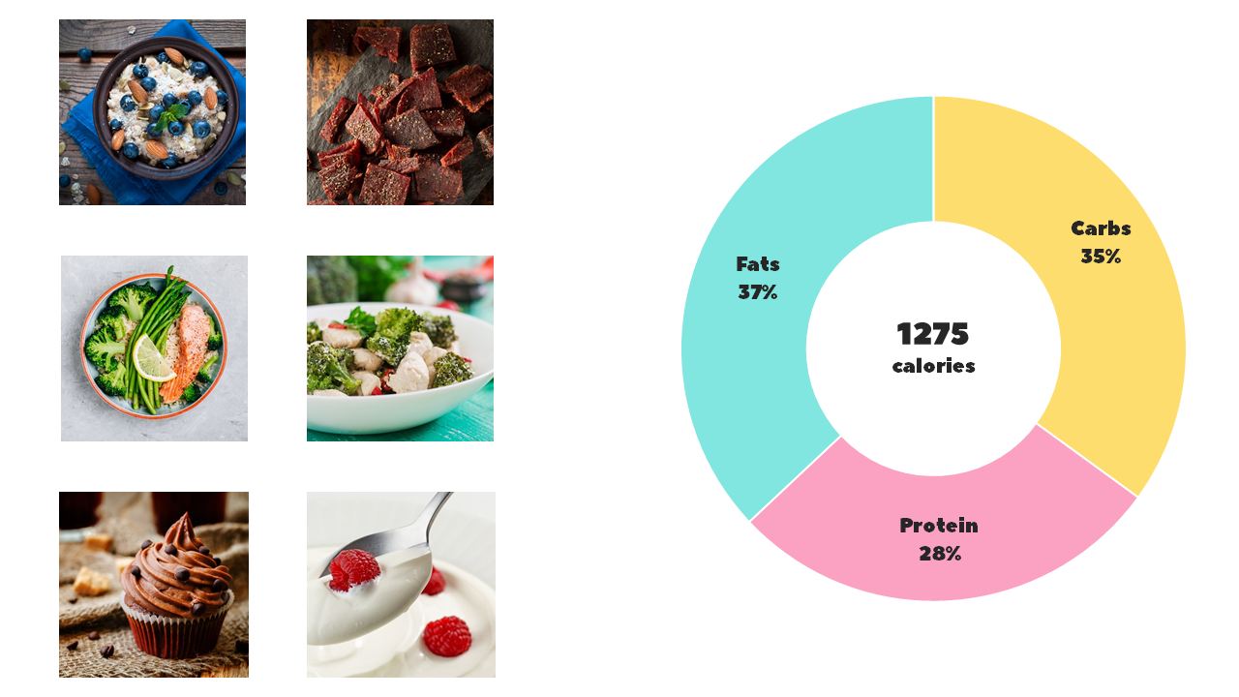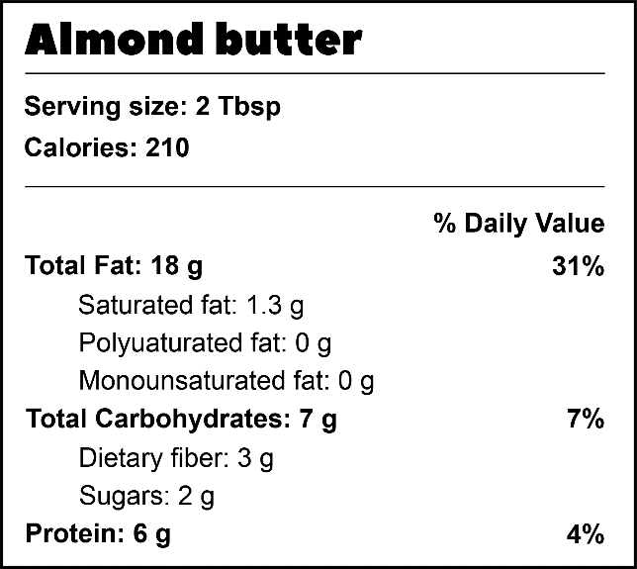

**Nutrition labels**  
Food tracker apps let you see all the information that you’d find in a nutrition label. Remember, the $ Daily Value is the total number of calories per day that you should eat in that macronutrient category. The 18 g of fat the almond butter is 31% of your fats for the day (in a 2000-calorie diet).

**Macros for your entire day**  
Food tracker apps let you see the macronutrient breakdown for everything you’ve eaten that day. This is usually displayed in a pie chart. You can keep tabs on this throughout the day as you track your food, so that you know if you need more or less of each macro to balance your day.

**Macros for a single food**  
Food tracker apps let you see the macronutrient breakdown for individual foods. The calories in almond butter are made up of 78% fats, 13% carbohydrates, and 11% protein. That indicates that almond butter is a high-fat food.