Title

-Fix citations: use whatever thesis requies

-Previous work section: bigger

-math notation and font consistency: bold all params

-Capitalize terms like Recall, Precision?

-caps all abbrevs

-Possibly test other realworld datasets, eg ones I rejected previously

-NASA anomalous substructures and a priori explanation

Abstract

Learning structural information from stochastic, noisy environments remains an important area of process mining and graph mining research. In this work, we present an unsupervised, threshold-based method of process mining and anomaly detection using the iterative SUBDUE graph-compression method and the Inductive Miner. The method generates a dendrogram of compressing structural features of a workflow log, a taxonomical representation by which further analysis can be performed. We demonstrate such a use for anomaly detection via this feature representation of a process log, by applying a Bayesian threshold to detect unusual trace components. First, we provide an overview of process mining definitions and existing approaches, then evaluate the method on synthetic data over a ranges of parameter values. Experimental results show 96% accuracy on an anomaly detection task for reasonable data and algorithmic parameters, reliable performance metrics across a range of these parameters, and competitive performance against a previously studied anomaly detection method known as the Sampling Algorithm. A real-world demonstration is provided for software-testing log data generated from a unit-test suite of function calls of the NASA Crew Exploration Vehicle (CEV) mission platform, with results identifying anomalous components of its software design. We close with detailed conclusions and potential future work.

Introduction

As described in [1], a process aware information system (PAIS) is, “a software system that manages and executes operational processes involving people, applications, and/or information sources on the basis of process models” (p. 5). This definition formalizes operational management systems as systems that centralize awareness of process data as well as the ability to prescribe tasks and activities via process models. These tasks form a loop by which process models can be defined, tracked, and evaluated; likewise, process models may be derived and analyzed from process data.

However, many institutions instead rely on interwoven, non-interoperable systems to monitor and control processes, making the formal requirements of a centralized PAIS infeasible or intrusive. This paper focuses on contexts where a PAIS is instead an abstraction integrating process data derived from multiple systems. This is amenable to realistic scenarios in which processes are embedded within a non-stationary framework of changing people, tools, resources, and tribal knowledge, often in the absence of prescribed process models. These scenarios are frequent, since modeling such environments may only occur due to some ad hoc objective, such as an audit or root-cause analysis of a process failure. In these scenarios, a PAIS is a disparate collection of operational systems and data sources by which to derive traces characterizing the underlying process-oriented view of a system.

The ability to mine and analyze normative process patterns in these unstructured contexts is critical for mining regular activity and detecting anomalies. The latter requires prior normative activity patterns, thus anomaly detection and normative pattern mining are complementary tasks. For this, we present a method for mining process patterns from workflow logs that possesses useful anomaly detection properties. We use the Inductive Miner [2] to construct a graphical process model from log data, then iteratively apply SUBDUE [3], a graph compression method, to extract a hierarchical dendrogram of normative patterns executed on this model. In subsequent post-processing, anomalies and other frequent process features are discovered.

This hybrid approach is practical since the Inductive Miner extracts generality from process log data, outputting a graphical model *M* capable of generating all traces in a process log, including noise. SUBDUE then extracts from *M* only its most informative components, constructing a hierarchy of sub-structures of *M* most relevant to the log as a dendrogram. Using this unsupervised method, one can mine normative process patterns, detect anomalies to those patterns, and perform other analyses. In the rest of this work, we define key terms and problem definition, provide further background on previous graph compression approaches, provide explicit anomaly-detection algorithm details, and then demonstrate the algorithm on synthetically generated data over a range of data generation parameters. Finally, we demonstrate the method on real world data derived from a NASA mission model implementation, then close with conclusions and future work.

Problem Definition

The above captures the spirit and contribution of our method but requires definitions within the scope of this work. From the control-flow perspective, common process mining terms can be framed in a graph theoretic manner:

* Process model: A graph with vertices representing activities, and edges representing one-step transitions between activities. Processes can contain many constructs representing linear and non-linear constructs, and a variety of notations and languages have been defined over the space of process models. A canonical example is the Petri-Net [4] [5], shown below at left. Its control-flow counterpart is shown at right, a simpler model description used in this paper to describe structural activity patterns.

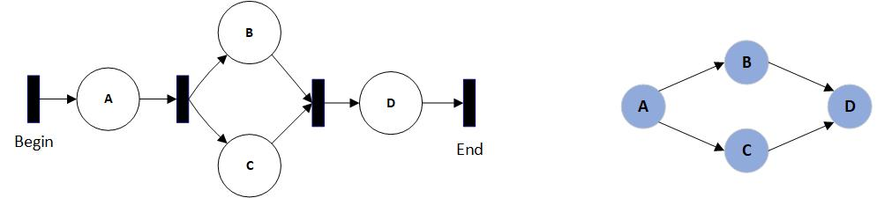

Figure 1 Petri model (left) and its simple control flow counterpart (right).

* Workflow trace: A single execution of a process as a partially-ordered sequence of activities, following any valid path from a START to an END node on a process model. These are represented as a string composed of letters representing the activities traversed.
* Workflow log: A set of workflow traces, for which various measures are taken to mitigate properties of noise or incompleteness. Synonymous with ‘trace log’ or ‘process log’.
* Process miner: Any algorithm for constructing a process model from a workflow log, and often incorporating criteria for model complexity, specificity, and generality. Specificity favors restrictive models including only or even less than the behavior described by the workflow log, whereas generality favors larger models describing all traces and possibly additional behavior.
* Partial-order property [18]: A property of workflow traces whereby activities may be randomly-ordered with respect to parallel sub-processes. ‘ABCD’ and ‘ACBD’ might be workflow traces from some model, where ‘C’ and ‘B’ represent parallel sub-processes, or may recursively embody further parallel sub-processes, and ‘A’ always occurs before ‘D’. The primary task of process mining algorithms is disambiguating these partial-orderings, applying rules and heuristics to generate models with desired properties of complexity, specificity, and generality. The enormous space of possible graphical models defined over a set of partially-ordered traces constitutes the primary search problem for these algorithms.
* Process grammar: Recursively-defined constructs for common process patterns. An AND-SPLIT is a set of edges branching from a single node and traversing activities in parallel before synchronizing at some later activity. Other basic constructs include OR-SPLIT, XOR-SPLIT, LOOP, and JOIN [14] [15].
* Replayability: The ability for a partially-ordered trace *t* to be generated from some process model *M*.
* Spaghetti model: A workflow defined by highly diverse, informal, and disorderly behavior, typically containing many scattered, repetitive events. These represent unstructured business processes, in contrast to orderly “lasagna” processes with prescriptive, stratified behavior.
* Inductive miner: A process mining algorithm capable of generating the most general, all-inclusive process model of the traces in some log. For our purposes, this model is used to convert a workflow log of traces into a collection of subgraphs for input to SUBDUE [2].
* SUBDUE: Short for “Substructure Discovery”, this method implements a subgraph beam search over a graph collection and, by applying the minimum-description length (MDL) heuristic, returns the top-k most compressing sub-graphs of the collection [3].
* GBAD: Acronym for “graph-based anomaly detection” [6], this method internally calls SUBDUE, then implements methods for detecting anomalies occurring in the context of discovered patterns.

An in-depth overview of process mining terms and methods can be found in [1] and [7]. In this work, we are given a log , of traces generated from some unknown process model *,* a graphical process miner , and a graph-compression method . The formal problem is to mine a graphical process model by which to convert into a collection of graphs via (a preliminary step), and then to mine the normative patterns of using s. The patterns can then be used for post-processing tasks, such as anomaly detection: given , identify anomalous traces .

Previous Work

The SUBDUE graph-compression method mines normative patterns from graph data, working as a graphical feature detector. It was previously used for knowledge representation systems [1], and more recently in security applications for intrusion detection [8]. Using SUBDUE as a process mining tool was successfully performed by [9] and more recently by Genga [10], whose results demonstrated the method’s utility for “spaghetti processes” describing more realistic institutional processes. An extensive overview of graph compression and anomaly detection is provided by Akoglu [20].

GBAD builds on SUBDUE to provide anomaly-detection capabilities, particularly within the immediate proximity of normative graphical patterns. This is appropriate for safety-critical and security contexts possessing some underlying process model by which normative patterns can be assumed to have a ground-truth behavioral policy, but less so when there is no such policy or model. An application is given by Holder and Eberle, in which GBAD was used for insider threat detection by combining three anomaly detection algorithms [16].

Process-mining anomaly detection focuses primarily on the mining process itself and on trace-scoring schemes. W. van der Aalst [12] details scoring schemes, by which work traces are replayed on a discovered model, assigned a numeric fitness score, and anomalies flagged based on a discriminative threshold. Bezerra’s work [11] examined anomaly detection using several threshold-based approaches within the process mining algorithm itself. Bezerra decomposed this family of process-based anomaly detection into three groups: scoring based, iterative, and sampling. Our approach does not fit squarely into these categories since it is compression based: a generic process model is mined, graphical features detected, and anomalies are detected and reported in post-processing. Likewise, whereas previous works focused on individual traces, our feature-based approach provides structural insights into normative patterns and anomalous features. Our work replicates Bezerra’s data generation scheme, but otherwise adds a new method to this work.

The Method

Under our relaxed definition, a PAIS is a composition of process monitoring systems by which workflow traces are extracted for process mining in a standard log format, such as Extensible Event Stream (XES) [17]. Our method decomposes to three tasks: converting a trace log to a collection of subgraphs via a mined process model, extracting descriptive normative graphical patterns of the log with respect to this model, compiling these patterns into a dendrogram of graphical features, and lastly detecting outliers and anomalous behavior.

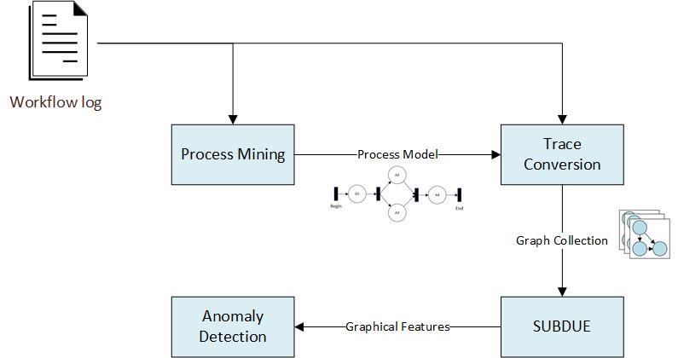

For the first task, the Inductive Miner was suitable for mining the most general graphical process model described by some log. This model is typically overly-inclusive, whereas the second and third tasks discover the patterns and features precisely relevant to the log. For this, we used the SUBDUE graph-compression method to discover normative behavioral patterns, subsequently permitting anomaly detection.

The workflow extends the discovery of process characteristics irrespective of prior constraints, such as a prescribed process model or a formal PAIS. For instance, it is tolerable for the process mining algorithm to produce overly general models, since graphical features are extracted in later post-processing, rather than within the mining algorithm itself. Separating the graphical feature analysis and mining steps simply offers greater tuning for noisy or poorly structured data. This facilitates more realistic and informal “spaghetti” model scenarios in which processes are ad hoc and highly unstructured, such as enterprises, communication networks, distributed systems, software system executions, or natural processes.

Using Graph Compression to Discover Patterns and Cluster Traces

SUBDUE discovers compressing patterns in graph data via the minimum description length (MDL) principle and a beam search over candidate subgraph patterns. This satisfies the requirement for an unsupervised method of discovering a hierarchy of meaningful components of a graphical process model, since a workflow log is also a set of subgraphs generated by a process model. The Inductive Miner complements this approach by providing the super-graph for converting a log of partially-ordered traces into subgraphs; these subgraphs are passed to SUBDUE to discover meaningful graphical patterns.

Prior work showed strong anomaly-detection results when running SUBDUE iteratively on a set of graphs [8]. At each iteration, instances of the most compressing subgraph were replaced with a single meta-node, and the method was repeated until no further compression was possible. At the end, the authors obtained a recursive and hierarchical description of a set of graphs, by which they modelled their anomaly-detection scheme.

We tested a similar approach using GBAD, by which workflow traces were iteratively recompressed using the most-compressing subgraph found at each iteration. The three anomaly detection methods of GBAD were used to detect anomalies at each iteration. While successful at discovering patterns, this method suffered a high false positive rate for anomaly detection. Ultimately the issue was iterative recompression: on successive iterations, the most highly compressing subgraph was often only a small alteration (node substitution, deletion, or insertion) to a compressing subgraph found by the previous iteration. GBAD’s primary deficiency in this context is that its anomaly-detection methods apply to the local vicinity of the compressing pattern discovered by SUBDUE. Hence, the search space was highly redundant, repeatedly analyzing the same regions of the process model, progressing very slowly toward the outlying model regions where compressing structure decays, and where anomalies often lie.

Since the desire was to force SUBDUE to analyze new regions, the remedy was to delete all instances of the most-compressing subgraph from the traces at each iteration. This forces SUBDUE to discover regularity in new regions, and thus to discover dissimilar graphical features at each iteration. Compressing graphical features (substructures) are thus compressed away in order of decreasing information, as below.

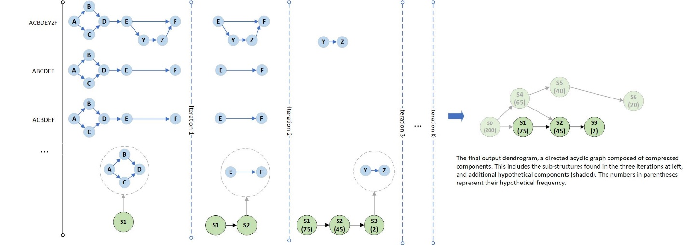

Iterations are portrayed from left to right, with the original activity traces shown leftmost as strings, and their graphical counterparts in blue. In the first iteration, S1 is discovered, a graph of four nodes. S1 is then deleted from all traces (notably, along with any incident or outgoing edges). On the next iteration, S2, a substructure of two nodes, is discovered and deleted. In this fashion, the entire log is compressed away, building a hierarchical dendrogram of substructures as shown rightmost, each labeled with its frequency.

The approach loosely resembles data dimensionality reduction, in which data is compressed via an ordered set of vectors of decreasing information. Except vectors are replaced by graphical substructures, forming a lossy hierarchical derivation of process substructures as a dendrogram. Lossy, since any edges incident to or exiting from a compressing substructure are deleted with the substructure and cannot be deterministically reconstructed from the dendrogram. Otherwise the dendrogram comprises the entire behavior of the log, with the ancestral components reflecting its most relevant, most compressing graphical features. This is amenable to anomaly detection since the less compressing a feature is, the greater its deviation from normative patterns and normal overall behavior, and hence it will be located “deeper” in the dendrogram and with lower frequency.

This gives the following process-oriented pattern-mining algorithm:

**Algorithm 1: SUBDUE-based Process Log Compression**

**Input** *mine*: A process mining algorithm (e.g., the Inductive Miner)

*log*: A trace log from some process

**Output** *dendrogram*: A graphical decomposition of the log’s structural features

1. model = *mine*(miner, log) #mine the graphical process model
2. traceGraphs = convert(model, log) #regenerate the log traces as graphs, using model
3. *dendrogram* = {}
4. while not empty(traceGraphs):
5. bestSubstructure = MineBestSubstructure(SUBDUE, traceGraphs)
6. *dendrogram* = AddSubstructure(*dendrogram*, bestSubstructure)
7. traceGraphs = DeleteSubstructure(traceGraphs, bestSubstructure)
8. return *dendrogram*

As described, the Inductive Miner takes a workflow log and returns a process model by which the traces are converted to graphs. This collection is iteratively fed to SUBDUE to discover the most compressing substructure, which is appended to the dendrogram and deleted from all traces. This repeats until all traces have been compressed to their most elementary substructures. The dendrogram is returned, whose vertices represent compressed substructures, and whose edges represent trace-ancestry between compressing substructures.

The strength of this method lies in the dendrogram as a descriptive model of the input log. The dendrogram can be analyzed in post-processing for frequent process features, redundant behavior, outliers, and anomalies. Diamintini *et al.* [13] successfully implemented a variety of uses for similar SUBDUE-based dendrograms, especially in the context of spaghetti processes.

This method of frequent-subgraph mining of workflow logs belongs to the family of dendrogram- or tree-induction methods in process mining literature [19], for which anomaly detection is only one application. For instance, while the low-frequency, outlier components of the dendrogram characterize anomalies, outliers, and noise, the ancestral components encode the most relevant substructures of the log. Using this information, the process model returned by the Inductive Miner could be reduced for greater specificity. The recurrent behavior of an unstructured institution could be discovered, and thereby the process could be identified, measured, and improved via business process formalisms.

In this regard, coupling SUBDUE with the generality feature of the Inductive Miner provides a framework for concise modelling of unstructured “spaghetti” process environments. Similarly, an analyst may examine highly similar components of the dendrogram, likely indicating duplicate work or poor cohesion among business processes. In sum, the dendrogram offers a range of pattern mining and other enterprise uses.

Anomaly Detection Method

Anomaly detection lends an illustrative example because of the structural characteristics of the dendrogram: given that anomalies are assumed to be infrequent events in the context of regular structure, subgraphs containing anomalies will be among its lower-frequency components. As a result, the size of the dendrogram components decreases smoothly then drops suddenly, such that the only remaining traces/subgraphs are those representing anomalies, outliers, and noise.

This property is useful for anomaly detection since many discriminating metrics can be devised to differentiate anomalies, noise, and regular patterns. Given that anomalies occur in the context of regular behavior, the anomalous structures tend to have sharply lower frequency than their parent substructures in the dendrogram. They are also distinguished from noise in the input log, which tends to result in poorer structural decomposition of a trace, and as such, substructures characterized by noise and their parents tend to both have lower frequency. Hence, finding anomalies resolves to finding these sharp boundaries between high frequency substructures and relatively lower frequency substructures adjacent to them.

A Bayesian metric was selected to capture this property, based on the frequency of substructures and their parent (immediate ancestor) substructures in the dendrogram. The metric was chosen because it discriminatively quantifies the relationships between parent and child substructures such that unusual child substructures have very low probability. Under this model, each substructure is assigned a Bayesian probability defined as:

Where unconditional prior substructure probabilities like are defined in terms of the global probability of a substructure in any trace, or , where the ‘#’ operator returns the frequency of substructure *s*. Characterizing involves defining the probability of a parent relating to one of any of its children, where parents may have multiple children, and children may have multiple parents. Hence, one must sum over all parents of a given child, a set of independent events (since substructures assumed independent), and weight each event by its likelihood :

The repeated looks unusual, but correctly weights each summation component as required to obtain a proper probability distribution. Substituting ‘c’ for child, ‘p’ for ‘parent’, and ‘P’ for ‘parents’, the fully-defined metric becomes:

An awkward looking probability, but the properly weighted Bayesian definition of a child’s probability given its parents. Anomalous substructures are expected to have a low value for , and a substructure is flagged as anomalous when , where is the anomaly threshold in . Traces containing the anomalous substructure are then flagged, as follows:

**Algorithm 2: Dendrogram-based Anomaly Detection, Using a Bayesian Threshold**

**Input** *dendrogram*: A dendrogram, as output by Algorithm 1

*bayesThreshold*: The anomaly detection threshold

**Output** *anomalyIds*: A set of trace id’s flagged as anomalous

1. *anomalyIds* = {}
2. for vertex in *dendrogram*:
3. bayesProbability = (vertex)
4. if bayesProbability < *bayesThreshold*:
5. traceIds = GetVertexTraceIds(vertex)
6. *anomalyIds* = *anomalyIds* traceIds
7. return *anomalyIds*

Algorithm Evaluation

Although real process-oriented datasets are available, they do not offer controlled conditions sufficient to compare the characteristics of algorithms over a range of data parameters. Instead we used a synthetic data generation algorithm as found in appendix A of [11], modified slightly to generate data directly from probability distributions embedded in the generated models. This approach generates random process models from which synthetic traces are generated, and thus the performance of an anomaly detection method can be assessed with respect to a known model and known trace-generation parameters. To cohere to a stable performance baseline, we also used the same experimental set up as described in [11]: 60 randomly-generated process models and 1000 traces per log.

Data Generation Algorithm

Data generation consisted of two steps: generating process models and generating traces from them. The parameters described the probability of recursively generating various structural features, including SEQ, OR-SPLIT, AND-SPLIT, and LOOP, defined as follows.

SEQ: the appending of a single activity.

OR-SPLIT: a single activity splitting to one of two successors.

AND-SPLIT: a single activity splitting to two parallel activities, both of which are traversed.

LOOP: An activity splitting to an optional loop, then returning to the activity.

These recursive operators generate directed, potentially cyclic graphs of arbitrary complexity, with the constraint that the graph start at a single START node and all paths eventually terminate at a single END node. Additional complexity results by including the null transitions in the set of “activities”, and as such the split constructs may divert to more than two activity paths or may bypass components of a model. The parameters constrain model complexity to a probability distribution over these operators, replicated from *Bezerra et al.* [11] and fixed throughout this work.

Since probabilistic model-generation allows for the possibility of unusual or task-trivializing models, additional basic tests were applied to ensure sufficient complexity. These included verifying models contained a minimum START to END path length of one, maximum of one anomalous structures, maximum of four anomalous edges within an anomaly to (constrain anomaly size), minimum of 10 unique activities, and minimum of 10 unique paths from START to END for adequate model complexity.

A second parameter set defined the trace-generation distribution constraining the graphical walks of traces, which is only defined for the choice operators OR-SPLIT and LOOP. These parameters determine trace diversity, from very uniform to very non-uniform. A value of implies the trace-generation scheme has a 0.9 probability of traversing one branch and a for its alternative. By varying from very uniform (0.5) to very non-uniform (0.9), one derives a less uniform distribution of traces, making anomaly detection more difficult. To ensure maximum partial-order entropy, activities lying ambiguously within the same timestep were shuffled to achieve uniform random partial order.

Lastly, the parameters defined the probability of generating anomalies, and encompassed both the generation of anomalous structures, and their embedded traversal probability when generating traces. Anomalies in this context are defined as unusual behavior occurring in the context of regular behavior, hence in this work we desired to generate insertion, substitution, or deletion anomalies in the context of frequent behavior. LOOP and OR constructs were marked as anomalous with fixed probability 0.3. Anomalous paths were marked with traversal probability that was experimentally varied between 0.0 and 0.2, and was evaluated in increments of 0.02. This overall method generated insertion, substitution, and deletion anomalies (since OR branches may be mere null transitions). Notably, embedding anomalies probabilistically allows for generated logs to contain no anomalies. This was important to include in synthetic data, to verify that the method was not simply over-generalizing and flagging anomalies even when none were present.

In this manner, the models output by this method were guaranteed to achieve sufficient complexity, and to generate an exponential distribution of unique traces.

Experiment

In our first experiment, 60 models were generated under fixed . From each of these, 1000 traces were generated separately for values 0.5, 0.6, 0.7 and 0.9. We refer to this complete dataset D1. For each value, the method was evaluated for values of in increments of 0.02. The run-time per log was around 1 minute, and the experiment required about 6 hours total, some of which was merely result compilation. Accuracy, precision, recall, and f1-measure were averaged over the 60 test models for the cross product of and values, giving the following plots and ROC curve:

|  |  |
| --- | --- |
|  |  |
|  |  |
| Fig XX. Dataset D1 result plots. For Recall, note the x- and y-axis ranges are reversed for visualization. | |

Notably, for all four performance curves, performance degraded only slightly along the axis for higher values, indicating the method worked well for very skewed trace distributions. Instead, impacted performance most strongly. From the top-left, accuracy maximized around , then tapered gradually as higher values reduced the true-negative (TN) rate. Recall, the ability to flag all anomalies, quickly maximized for lower values of as expected for a binary probabilistic anomaly-detection threshold. Precision and the f-1 score were more informative, since precision clearly dominated the f-1 score compared with the contribution of recall. The plots for precision and f1-measure are nearly identical since recall quickly maximized for **>** 0.15, beyond which precision dominated the f1-measure. The f-1 score results are most informative in terms of selection, suggesting one choose an value of around 0.07, with a corresponding accuracy of 96%.

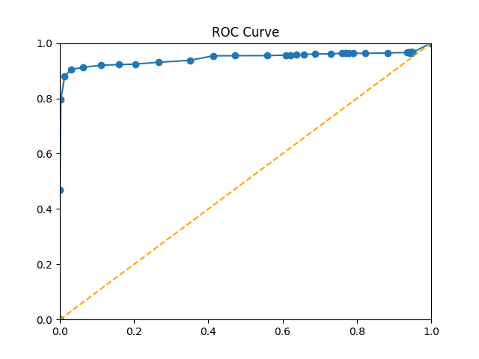

Additionally, we plotted the receiver-operator characteristic (ROC) curve TPR/FPR values for all values of in 0.02 increments, averaged over all 60 models and all values of . The area under the ROC curve is clearly very near 1.0, indicating a high true-positive rate.

The results show lower values (0.04-0.10) of are preferable, and tunable to suit recall vs. precision objectives. From a risk perspective, recall is most important in terms of capturing all anomalies, at the expense of decreasing accuracy and precision. On the other hand, precision and f1-measure provide better comparative performance metrics, and show significant room for improvement. However, the sharp maximum of the precision curve along the axis indicates the method and the Bayesian metric worked as intended, distinguishing anomalies from regular structure with a sharp boundary, for the synthetic data parameters.

The previous experiment analyzed performance over a range of and , but with fixed to 0.05.A second experiment analyzed the sensitivity of the method with respect to ,with fixed. This was to verify that the previously selected did not trivialize the task of anomaly detection. In this case, , and was varied between 0.0 and 0.2 in increments of 0.02, then in increments of 0.05 between 0.25 and . The choice of yields a more uniform distribution of traces; and the low range of was expected to trivialize the discovery of anomalies due to their low frequency, whereas the high range approached , making anomalous substructures and normal substructures ambiguous.

|  |  |
| --- | --- |
|  |  |
|  |  |

As expected, the four metrics show performance worsening along the axis approaching 0.5. However, the decay was smooth, showing the method works satisfactorily for a range of very rare and somewhat frequent anomaly occurrence rates, with respect to a somewhat regular process. The ROC curve bears this out, and likely anticipates expected performance on real world data, for which  and are not known in advance.

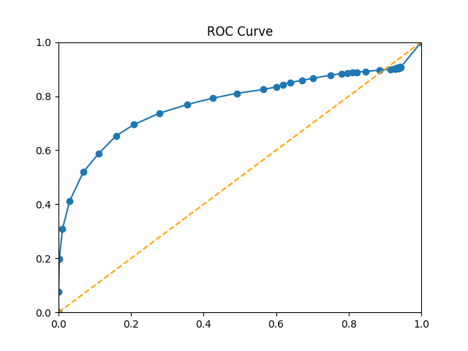

Lastly, the same two experiments were performed with a different anomaly characteristic. Whereas the previous dataset D1 included both insertion and deletion anomalies, it did not include substitution anomalies: anomalous structure consisting of existing model activities. Such anomalies represent activities occurring out of order with respect to their usual context. The same two experiments were performed on the same data, but with the anomalous activities in each model replaced by an existing activity randomly chosen from the model’s non-anomalous activities. New traces were then generated.

[VISUALS]

As shown, the shape of the performance curves showed no significant changes, but overall performance decreased slightly, as shown in the ROC curves. The decrease in performance is due to the less obvious nature of anomalies when replaced by existing activities. Another contributing factor may have been the random selection of non-anomalous activities: in some cases, anomalous activities could be replaced by non-anomalous activities already very close to the anomalous structure, making anomalous and non-anomalous traces ambiguous.

Comparison with Existing Methods

To provide context for these results, we tested the sampling algorithm from (Bezerra et al, 2013), upon which our data generation method was based. The authors reported their best results using this algorithm with optimized parameters, using similar synthetic data and anomalies. The sampling algorithm is defined as:

|  |  |
| --- | --- |
| **Algorithm 3: Sampling Algorithm** | |
|  | **Input** A log, *L*  Sampling proportion,  Mining algorithm, *mine,* outputting a process model |
|  | **Output** *TA*, the set of traces flagged as anomalous |
| 1. | T = set of all unique traces from the log *L* |
| 2. | TC = { } used to contain anomalous candidate traces |
| 3. | *TA* = { } used to contain traces flagged as anomalous |
| 4. | **foreach** **do:** |
| 5. | if then: |
| 6. |  |
| 7. | **foreach**  **do:** |
| 8. | *S* = sample of *s%* of traces of *L* |
| 9. | *M = mine(S)* |
| 10. | if t is not replayable on M: |
| 11. | *TA* += t |
| 12. | **return** *TA* |

To detect anomalies, the sampling algorithm expects that an anomalous trace will deviate significantly from the expected process model derived from a randomly chosen subset of the traces. Anomalous traces are defined as outliers that are also inconsistent with the expected behavior of a log. To exploit this property, the sampling algorithm begins by gathering low-frequency outlier traces from a log. For each trace in this set, a process model is mined from a randomly selected subset of all the traces. The trace is added to the anomalous trace set if it is not replayable on the mined model. In contrast with our method, the sampling algorithm flags anomalies without providing causal, structural context for the flag, though additional processing could provide it.

To test the sampling algorithm, we implemented and ran it on datasets D1 and D2, for , using a frequency threshold of 0.02 and a sampling rate of 0.7. Our goal was only to derive a straightforward performance baseline with which to compare our results, and we did not exhaustively test over a range of values. Exhaustive testing was difficult because of implementation dependencies on ProM [22], which required significant test run time; this was not a fault of the sampling algorithm nor of ProM, but of our system’s integration with ProM’s command line features. As a result, we only tested and averaged performance over 30 0f the 60 models, which is still a confident set of models. Results for D1 and D2 were virtually identical, so only D1 are shown for brevity.

|  |  |
| --- | --- |
| Table 1: Algorithm 3 Results | |
| Dataset: D1 | |
|  |  |
|  |  |

Table 1 below compares performance of our method (Algorithm 2) with a generic value of , beside the sampling algorithm (Algorithm 3). Results were simply averaged over all values under test.

|  |  |  |  |
| --- | --- | --- | --- |
| Table 1: Dataset D1 Results | | | |
| Algorithm | Algorithm 2 | Algorithm 3 |  |
| Accuracy | 0.972 | 0.717 | +0.255 |
| Recall | 0.892 | 0.924 | -0.032 |
| Precision | 0.700 | 0.186 | +0.514 |
| F1-Measure | 0.721 | 0.233 | +0.488 |

As shown, the sampling algorithm performed well, but below our method for all metrics except Recall. The performance discrepancies are attributable to differences in their objectives: our method targets anomalous behavior in the context of regular behavior for higher precision, whereas the sampling algorithm is concerned with detecting deviation with respect to expected model structure. Its authors described high recall as a primary performance objective, which is justified by these results and explains the lower precision. The sampling algorithm’s frequency threshold and sampling rate were the best values reported by the authors, but could be optimized to improve performance on this data.

Real Data Testing

For real system data evaluation, we applied our method to a dataset consisting of 2,566 traces representing activity-sequences of code function calls made by software unit-tests of the NASA Crew Exploration Vehicle (CEV) [33]. The CEV system implements the complete UML-design of a structured aerospace mission model, and the unit-test suite executes components of this implementation. Thus, the test data provided a description of called components and code paths, albeit triggered by unit test calls, providing the perfect context for using our pattern mining and anomaly detection method to evaluate discrepancies between system design and behavior, and to detect unusual code executions.

Unit-testing emphasizes code coverage, which entails repetitive software component calls and extreme value testing. Hence the distribution of traces in this data model the test design, whereas traces representing normal system operation are desirable. Nonetheless, the dataset comprised a normative view of the system from the design perspective, and provided a suitable demonstration of the method’s model-checking and anomaly-detection potential. The demonstration is unsupervised, since the traces in this dataset are not labeled as anomalous. We are instead claiming that the findings of the method are ‘anomalous’ per unit test design or system behavior, in terms of unusual behavior in the context of normative patterns. We tracked the number of anomalies detected various Bayesian thresholds, shown below in Table 1.

|  |  |
| --- | --- |
| Table 1: NASA CEV test suite | |
| Number of traces: 2,566 | |
| Number of activities: 34 | |
| Bayes threshold | Number of anomalies detected |
| 0.01 | 18 |
| 0.03 | 183 |
| 0.05 | 966 |
| 0.07 | 1,348 |
| 0.09 | 1,620 |

The results showed that did not generalize well from our synthetic experiments, and flagged over half of the traces in this data. This was because these traces exhibited an extremely heavy-tailed distribution, and most of traces would be considered outliers. Likely this was because the data consisted of “whitebox” unit tests, not “blackbox” data reflecting the distribution of function calls under normal system operation. The long-tailed decay of central, compressing patterns and behavior means that information by which to distinguish outliers from anomalies in this tail is severely reduced, and forms an important observation about how the properties of real data affect algorithmic performance. By reducing in increments of 0.02, we partitioned the subset of traces that were marked anomalous into those of more critical importance.

Using such subsets, a system evaluator can identify exception-like behavior included but not intended within a system, a critical task in software verification and model checking. For instance, “anomalies” and normative patterns provide useful insights into the distribution of risk across code regions, by identifying “spaghetti” code in need of more rigorous testing, refactoring, or code interfaces straying from design. Non-anomalous substructures identify reusable code components defined by recurring subgraphs of function calls (frequent code paths), hence, high-cohesion. Loosely, the alignment of substructures with respect to design components lends insight into code quality (strong alignment), or the need to refactor (poor alignment). In summary, this data demonstrates how our method can be used as a design and verification tool, by providing insight into unusual system behavior that is often overlooked by more isolated, granular test strategies.

Conclusions and Future Work

Overall, the results indicate our method succeeds for a range of model complexity, trace complexity, and anomaly characteristics. The requirement is that real-world data contains enough traces and sufficient regularity to discover regular graphical patterns. Additionally, the method is tunable via the parameter to suit different datasets or performance objectives.

A notable advantage of our method is that such an unsupervised approach requires no prior process model, nor exceptional tuning to derive normative patterns. This makes it an extensible analysis tool when applied to processes with no prior definition or pre-defined policy. Such scenarios occur frequently for computer networks, distributed systems, and communication protocols, for which detecting anomalies in system behavior is crucial. A final advantage is that the method is capable not only of flagging anomalous traces, but also of causally identifying anomalous features.

The drawback to this method is its noise intolerance, a recurring problem faced by mining algorithms. The graphical patterns discovered by SUBDUE become the only patterns by which the log is recompressed, such that even small deviations to a normative pattern are ignored and consequently may later be flagged as anomalies. This strongly discriminatory property is in fact why the method works as desired, and the high dimensionality of graphical data typically requires such heuristics. However, a frequent goal of process mining is to create a tunable, noise-tolerant balance between specificity and generality. Essentially, the substructure decomposition of our approach is both a strength and a potential criticism, yielding the recurring process-mining discussion on specificity-generalization tradeoffs. Future work lies in making the approach more noise tolerant, much like the GBAD system determines acceptable deviations in the local context of a normative pattern using graph distance metrics.

The method also exemplifies an algorithm purpose-built from the perspective of searching over discrete graphical representations. However, emerging graphical deep learning models, such as auto-encoders, can encode normative patterns in real-valued parameters, softening the discrete problems mentioned prior. These models generally often require less hand tuning and fewer hyper-parameters, a primary objective of deep learning. Lastly, the runtime of the algorithm may be increased by specializing the complexity of the beam search over candidate compressing substructures to be more specific to process mining.

“the method” vs “algorithm xyz”

References

[1] M. Dumas, W.M.P. van der Aalst, and A.H.M. ter Hofstede. Process-Aware Information Systems: Bridging People and Software through Process Technology. Wiley & Sons, 2005.

[2] Leemans, S., Fahland, D., van der Aalst, W.: Discovering block-structured process

models from event logs containing infrequent behaviour. In: Business Process Man-

agement Workshops. pp. 66–78 (2013).

[3] L. B. Holder. Empirical Substructure Discovery. In *Proceedings of the Sixth International Workshop on Machine Learning*, pages 133-136, 1989.

[4] Petri, Carl Adam; Reisig, Wolfgang (2008). "Petri net". Scholarpedia. **3** (4): 6477. doi:10.4249/scholarpedia.6477.

[5] Murata, Tadao. "Petri nets: Properties, analysis and applications." *Proceedings of the IEEE* 77.4 (1989): 541-580.

[6] Eberle, W. and Holder, L., Anomaly Detection in Data Represented as Graphs, *Intelligent Data Analysis, An International Journal*, Volume 11(6), 2007.

[7] Wil M.P. van der Aalst. *Process Mining Discovery, Conformance and Enhancement of Business Processes.* Heidelburg, Germany: Springer, 2011.

[8] Noble, Caleb C., and Diane J. Cook. "Graph-based anomaly detection." *Proceedings of the ninth ACM SIGKDD international conference on Knowledge discovery and data mining*. ACM, 2003.

[9] Diamantini, Claudia, et al. "Pattern discovery from innovation processes." *Collaboration technologies and systems (CTS), 2013 international conference on*. IEEE, 2013.

[10] Genga, Laura, et al. "Subgraph mining for anomalous pattern discovery in event logs." (2016).

[11] Bezerra, Fábio, and Jacques Wainer. "Algorithms for anomaly detection of traces in logs of process aware information systems." *Information Systems* 38.1 (2013): 33-44.

[12] Bezerra, Fábio, Jacques Wainer, and Wil MP van der Aalst. "Anomaly detection using process mining." *Enterprise, business-process and information systems modeling* 29 (2009): 149-161.

[13] Diamantini, Claudia, Laura Genga, and Domenico Potena. "Esub: Exploration of subgraphs." *Proceedings of the BPM Demo Session* (2015): 70-74.

[14] N. Russell, A.H.M. ter Hofstede, W.M.P. van der Aalst, and N. Mulyar. Workflow Control-Flow Patterns: A Revised View. *BPM Center Report BPM-06-22* , BPMcenter.org, 2006.

[15] Control-Flow Patterns. Retrieved on September 13, 2017, from http://www.workflowpatterns.com/patterns/control/.

[16] Eberle, W., & Holder, L. (2009, April). Graph-Based Approaches to Insider Threat Detection. In *Proceedings of the 5th annual workshop on cyber security and information intelligence research: cyber security and information intelligence challenges and strategies* (p. 44). ACM.

[17] http://www.xes-standard.org/

[18] Herbst, Joachim. "A machine learning approach to workflow management." *ECML*. Vol. 1810. 2000.

[19] Song, M., Günther, C. W., & Van der Aalst, W. M. (2008, September). Trace clustering in process mining. In International Conference on Business Process Management (pp. 109-120). Springer, Berlin, Heidelberg.

[20] Akoglu, L., Tong, H., & Koutra, D. (2015). Graph based anomaly detection and description: a survey. Data Mining and Knowledge Discovery, 29(3), 626-688.

[21] Grünwald, P. (2005). A tutorial introduction to the minimum description length principle. Accessed from <https://arxiv.org/pdf/math/0406077.pdf>, December 12, 2017.

[22] CITE PROM

[23] M. Leemans. NASA Crew Exploration Vehicle (CEV) software event log. http://doi.org/10.4121/uuid: 60383406-ffcd-441f-aa5e-4ec763426b76, 2017

Noise Generation [obsolete?]

The model and trace generation methods are sufficient to generate spaghetti-like process data in terms of model complexity via θ_model and activity complexity via θ_traces, but remain constrained to the given model. For example, under this data generation method there will be no log ambiguity as to whether an activity occurs before another if it always lies upstream in the paths contained in the model; hence, the underlying model strongly constrains the generated data. Although likely unusual, one might expect unstructured work environments to inevitably lead to occasional repetitions, whereby sub-components of some model are repeated or activities do not always follow one another. Such a scenario occurs, for instance, if prior to some software release a bug is detected after final testing, causing components of the testing activities to be repeated arbitrarily with respect to the software development process.

The simplest way to simulate worst-case noise is to randomly inject activities into the traces after trace generation. For every activity in each trace, with probability α a random activity is inserted. The chosen activity is selected at uniform random from the set of all activities defined over the log. This method of noise addition is necessary to test our approach’s resilience to noise, and is justified since it creates many data outliers that would be too easily declared anomalous by an anomaly detection method that does not distinguish outliers from anomalies. Note that even small values of α tend to create highly obfuscated partially-orderings for a process mining algorithm to mine: for a log of 1000 traces, for which the average trace length is 25, an α value of 0.1 will have an expected number of “noise” activity occurrences of 0.1 * 25 * 1000 = 2500. This is an extreme number of random activities, since even a single misplaced activity with respect to the underlying model, breaks the logical rules and heuristics applied by process mining algorithms to mine the regular features of the underlying process model.

Raw plottable data values (of 2566 traces):f for bayes xs [0.01, 0.03, 0.05, 0.07, 0.09] ys were [18,183,966,1348,1620].