Exploring Non-Communicable Disease Morbidity
I0P16a: Applied Multivariate Data Analysis
Michael Neilson

- Introduction
Non-communicable diseases (NCDs) are the cause of more than 40 million deaths worldwide and have been extensively studied to mitigate this morbidity rate. Well-documented risk factors have been determined, as well as raw population data collected in each country on the planet. The goal of this exploratory analysis is to determine the effects of these risk factors on a wider scale and how they directly impact the morbidity rate in those living with NCDs.

Column | Description
country | Character: Country of origin
sex | Binary: Male or Female
disease | Factor: 4 non-communicable diseases: Malignant neoplasms, Diabetes mellitus, Cardiovascular diseases, Chronic obstructive pulmonary disease
ncd_deaths | Float: Number of deaths caused by the non-communicable disease per 1000 people
underweight | Float: Number of underweight people (BMI <= 18) per 1000 people
overweight | Float: Number of overweight people (BMI >= 30) per 1000 people
water | Float: Number of people that have access to basic drinking water services per 1000 people
pollution | Float: Number of people that are exposed to air pollution (Fine particulate matter: PM>2.5) per 1000 people
raised_cholesterol | Float: Number of people that have a raised total cholesterol level (mmoL/L>=0.5) per 1000 people
fasting_blood | Float: Number of people with a raised fasting blood glucose level (mmol/L>=7) per 1000 people
raised_bp | Float: Number of people with raised blood pressure (SBP>=140/DBP>=90) per 1000 people
phys_activity | Float: Prevalence of insufficient physical activity amongst adults
The dataset used was compiled from data sourced from the WHO Global Health Observatory database (Table 1). Raised cholesterol levels, fasting blood glucose levels, levels of obesity (overweight), raised blood pressure, and a lack of physical activity were cited directly as risk factors for NCDs on the website. The indicators for rates of underweight people, access to basic clean drinking water, exposure to pollution were not directly related to NCDs. All rates were normalized to each country’s population by sex, per 1000 people. Preprocessing was done to download and standardize all data and is available through GitHub.
Table 1: Description of GHO dataset

- Methods

This analysis will be done in R and consist of a brief description of the dataset, a principle component analysis and biplot to determine if there is any correlation between variables, K-means clustering to determine if there is any clear grouping structure within the observations, and a tree-based classification model that will attempt to predict the disease that was the cause of death based on these variables alone.

- Results
The dataset consists of 3 identifiers (country, sex, disease) and 9 variables (ncd_deaths, underweight, overweight, water, pollution, raised_cholesterol, fasting_blood, raised_bp, and phys_activity). Among this data are 151 countries and 4 diseases (Malignant neoplasms, diabetes mellitus, cardiovascular disease, and chronic obstructive pulmonary disease), totalling 1208 observations. In the boxplot (Fig. 1) of the 9 indicators, some measurements vary much more than others. Intuitively understanding some of the countries in the study, it makes sense that the mean value for access to basic drinking water is nearly 980 as some countries struggle, whereas there is an inverse relationship visible with exposure to airborne particulates.
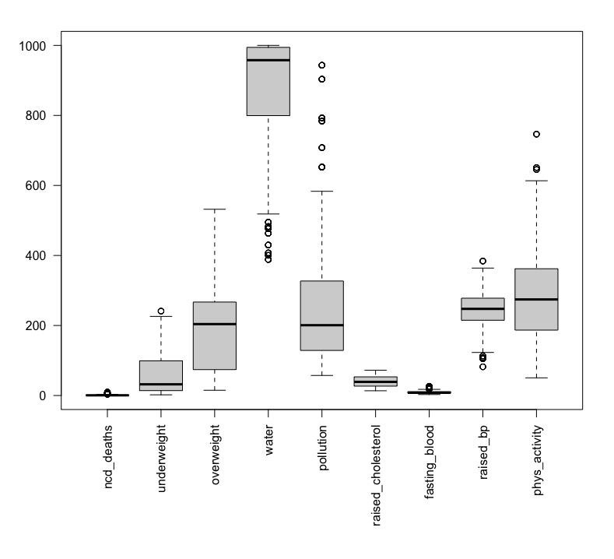
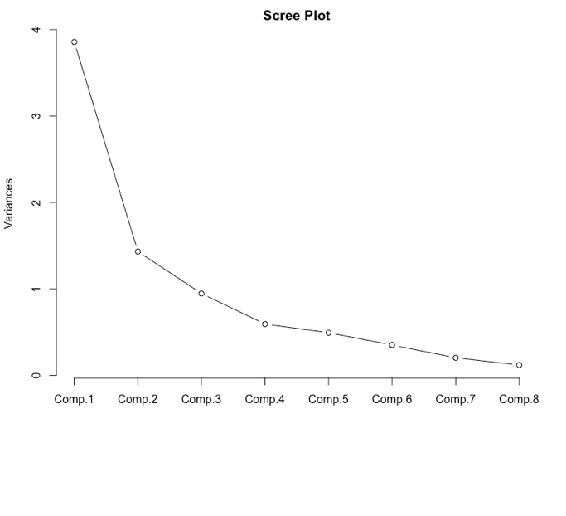
Figure 1: Boxplot of indicators
Figure 2: Scree plot from PCA indicators
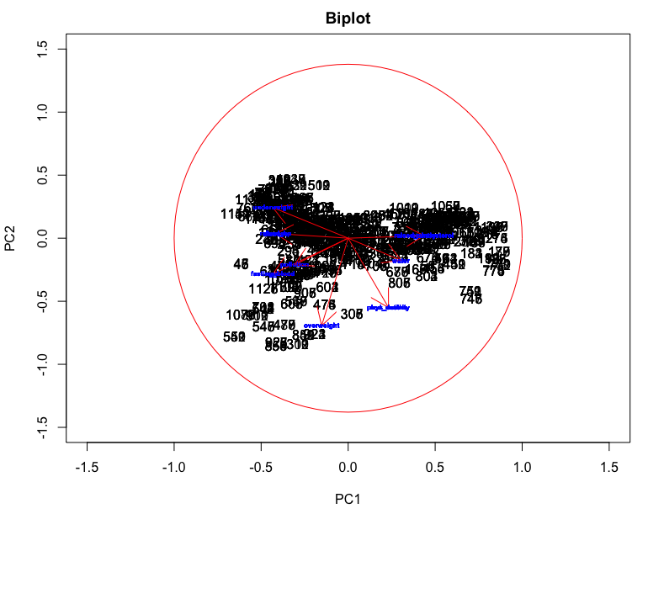
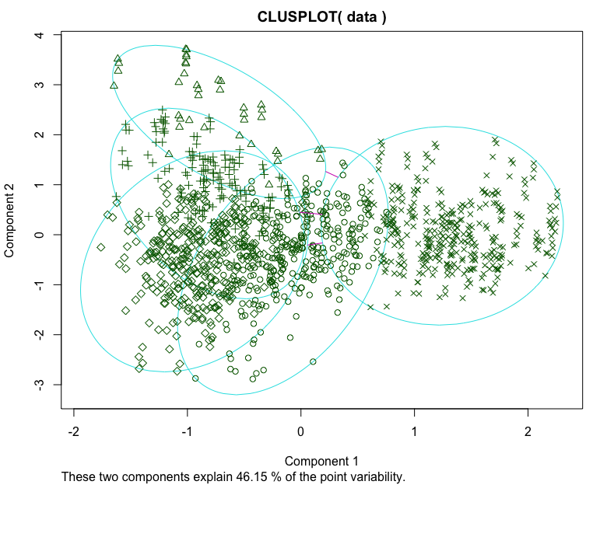
By executing a PCA on 8 of the previously mentioned indicators (excluding ncd_death), the Scree plot produced (Fig. 2) illustrates that, though it would account for the most variance, the best number of PCs to use would be 4. Using 4 PCs would balance the trade-off between bias and variance. The issue with using all 8 PCs is that it would be incredibly biased towards the training data and wouldn’t be useful in constructing a meaningful model. Projecting the PCs onto a biplot can show if there is any correlation amongst variables (Fig. 3). The biplot shows that there is strong positive correlation between some variables (raised_bp & raised_cholesterol) as well as negative correlation between others (fasting_blood & pollution). The most important contributors to explain variance in PC1 appear to be raised_cholesterol and raised_bp, whereas the most important contributors to PC2 are overweight and phys_activity. An attempt at K-means clustering (Fig. 4) showed that there was no clear grouping structure amongst the variables, with an error rate exceeding 94%.
Figure 3: Biplot of 8 variables
Figure 4: K-means clustering

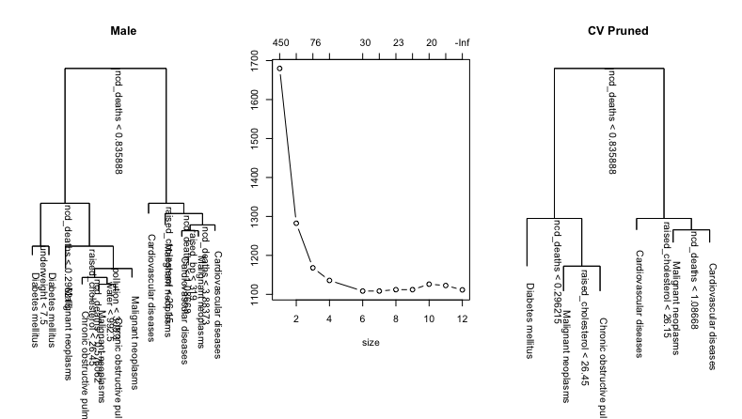
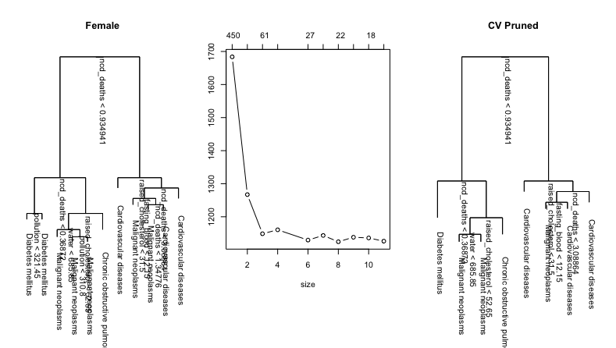
Figure 5: Trees, CV plots, and pruned trees to predict the NCD that was the cause of morbidity.
Finally, a tree was constructed to predict the most likely cause of death in females and males, given the variables (Fig. 5). For each tree, an original tree was constructed, then using 10-fold cross validation, a pruned tree was also constructed. For both men and women, the most favourable number of splits in their trees was 6, which allowed the tree to be pruned down substantially. In males, the difference between misclassification error rate between the original tree and the pruned tree was 30.96% and 35.75% respectively, and for females the rate was 37.75% and 38.58%. The misclassification error rate actually increases after pruning, as using CV determines by how much the bias to the training data can be lost in exchange for variance to later fit test data more accurately.

- Remarks
It is important to remember that these analyses are done on a global scale, and there are more important factors that contribute to the wellbeing of groups across the globe in finer detail. It is difficult to try to solve a large-scale problem through oversimplification, as these results are only a reflection of the analysis possible through statistical analysis.
- R Code

library(mvoutlier)
library(cluster)
library(mclust)
library(heplots)
library(MASS)
library(plotrix)

data <- read.csv('full_data.csv')
dim(data)
summary(data)
attach(data)

par(mfrow=c(1,1))
par(mar=c(10, 4.1, 2.1, 2.1))
boxplot(data[, 4:12], las=2)
pairs(data[,4:12])
out <- chisq.plot(data[,4:12])
par(mfrow=c(3,3))
for (i in (4:12)) {hist(data[,i], main=names(data)[i], xlab="Countries")}

# PCA
pca.matrix <- data[,5:12]
names(pca.matrix)
pca.data <- princomp(pca.matrix, cor=T)
names(pca.data)
attributes(pca.data)
summary(pca.data)
par(mfrow=c(1,1))
screeplot(pca.data, type="line", main="Scree Plot")

# Biplot
scalefactor<-.2
scores <- pca.data$scores*scalefactor
par(mfrow=c(1,1))
par(srt=0)
plot(scores[,2]~ scores[,1], xlim=c(-1.5,1.5), ylim=c(-1.5,1.5), type="n",main='Biplot',xlab='PC1',ylab='PC2')
text(scores[,1], scores[,2], col=as.numeric(data[,1]))
for (i in seq(1,nrow(pca.data$loadings))){
arrows(0,0,pca.data$loadings[i,1],pca.data$loadings[i,2],lwd=1, col="red")
text(pca.data$loadings[,1],pca.data$loadings[,2],as.character(dimnames(data)[[2]]),cex=0.5,font=2, col="blue")}
draw.circle(0,0,1,border='red')

# K-means
data.kmc <- kmeans(pca.data$scores,5,20) # Diseases
plot(pca.data$scores[,1:2], col = data.kmc$cluster)
points(data.kmc$centers[,c(1,3)], col = "blue", pch ="+", cex=2)
clusplot(data, data.kmc$cluster, stand=TRUE)
classError(data.kmc$cluster, data[,1])

# Tree
data$sex <- as.factor(data$sex)
data$country <- as.factor(data$country)
data$disease <- as.factor(data$disease)

set.seed(1)
par(mfrow=c(2,3))
par(mar=c(5.1, 4.1, 4.1, 2.1))
for (i in 1:length(unique(data$sex))) {
disease.data <- data[data$sex == unique(data$sex)[i],]
data.tree <- tree(disease~ncd_deaths+pollution+underweight+overweight+water+raised_cholesterol+fasting_blood+raised_bp+phys_activity, data=disease.data)
par(srt=270)
plot(data.tree)
text(data.tree, cex=1, adj=c(-0.1,0))
title(unique(data$sex)[i])
cv.datatree <- cv.tree(data.tree, FUN=prune.tree, K=10)
plot(cv.datatree, type="b")
prune.datatree <- prune.tree(data.tree, best=6)
plot(prune.datatree)
text(prune.datatree,cex=1, adj=c(-0.1,0))
title("CV Pruned")
print(summary(data.tree))
print(summary(prune.datatree))
}

https://www.who.int/data/gho/data/themes/noncommunicable-diseases
https://www.who.int/data/gho/data
github

