How to TMT with FragPipe
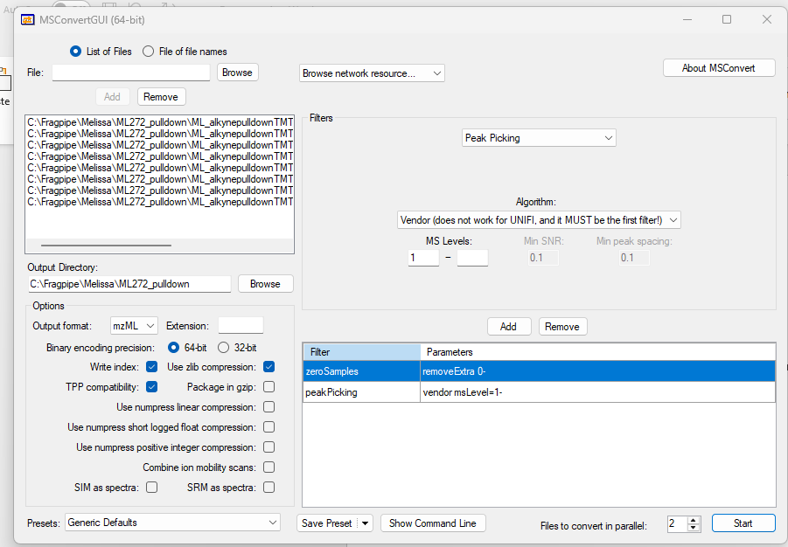
- Convert your .raw files to mzML files using MS Convert
Select Peak Picking & zero Samples from the dropdown
Select your .raw files here

Press start…..file conversion will take approx.. 15 min

- Load TMT-10 MS3 workflow in FragPipe

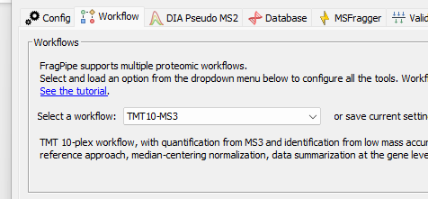
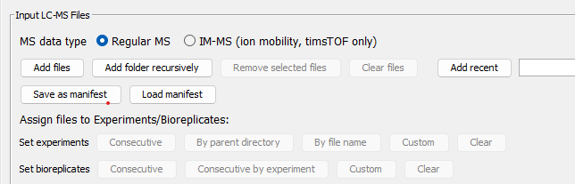
- Load converted files into FragPipe
Just load the folder

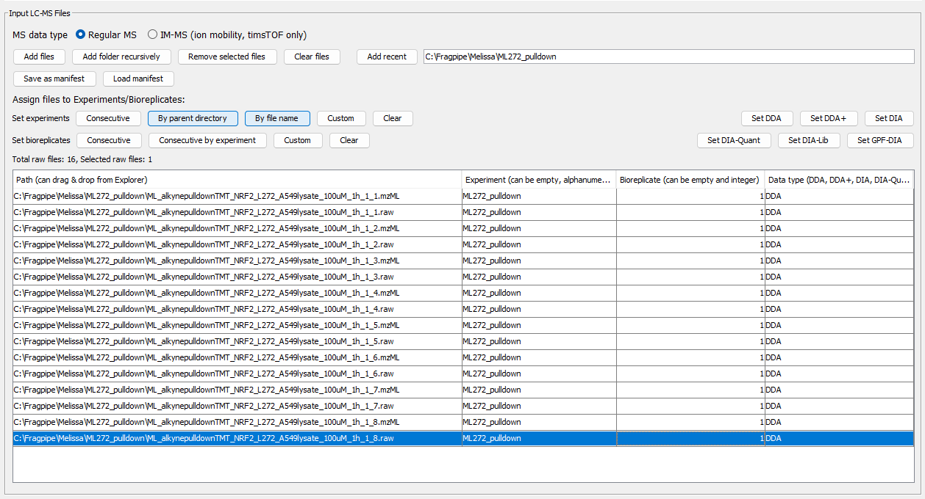
- Set experimental detail/bio-replicates if applicable
If Bioreplicates are contained within TMT channels (e.g. rep1 126, rep2 127N, rep3 127C, etc.) set Bioreplicate to 1.

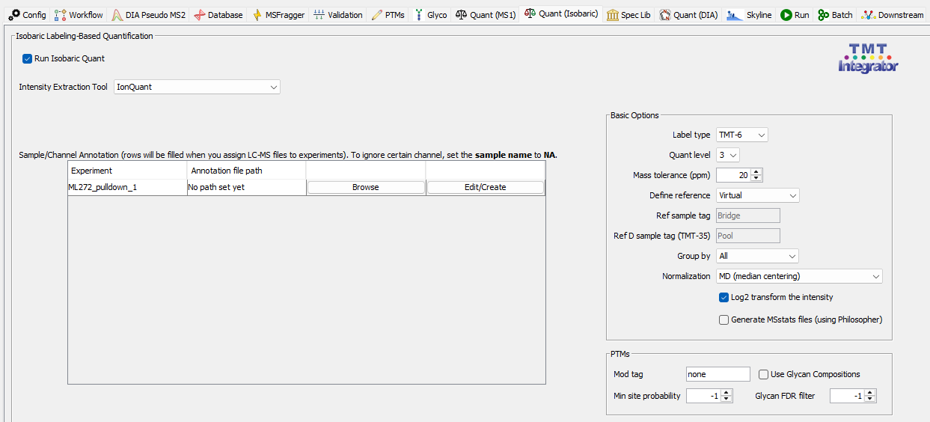
- Define TMT-channels
Define replicates
Select the appropriate tag set
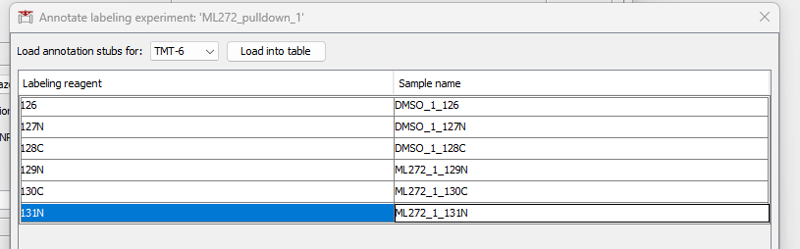

- Keep the 126, 127N, etc. description for each channel in Sample name! And save to the raw-file folder

- Run the analysis
“”
- Look at your Data using FragPipe Analysit
Run the following R-script to obtain the correct experimental annotation file for downstream analysis with FragPipe Analyst: C:\Users\Daniel Nomura\Desktop\correct_experimental_annotation_for_Fragpipe-TMT
Use the abundance_gene_MD.tsv and the newly generated experimental_annotation.tsv as input for FragPipe Analyst (http://fragpipe-analyst.nesvilab.org). Filter

for 100% non missing values in all replicates for best data quality.

