isoDTB via Fragpipe:

Works for standard isoDTB experiments that use iodoacetamide alkyne (C6) and (commercial) isoDTB reagents according to Zanon et al. The workflow is designed for Trypsin digested samples.
Can be adjusted for other reagents/enzymes!

- Load raw files, define experiment, set replicates:

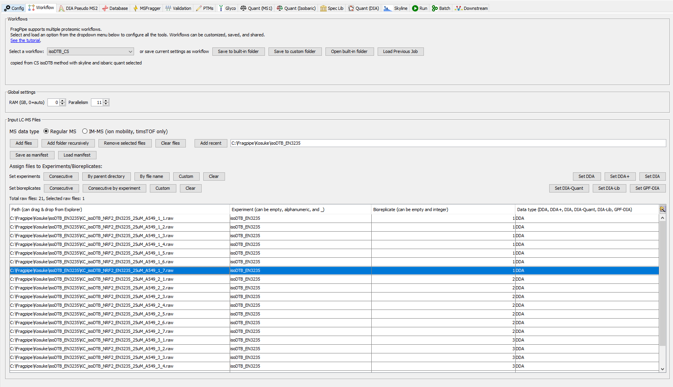
Define replicate
Enter experiment name
Select files from raw-folder

- Directory must not contain any spaces!

- Briefly check for correct database:
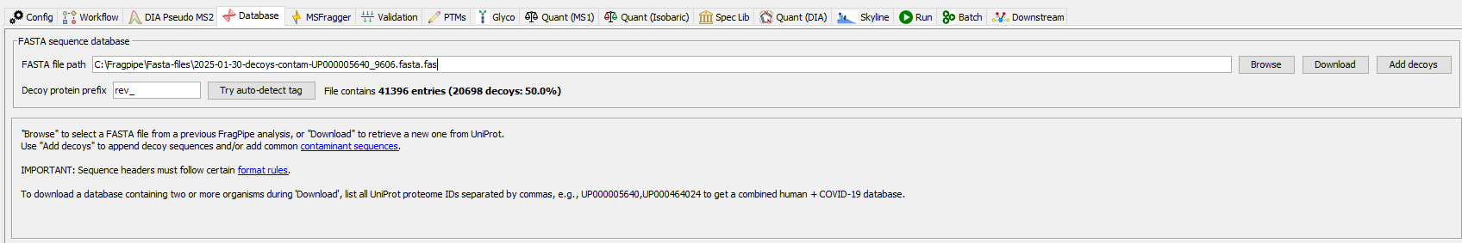
This is human whole proteome

- Check Quantification Tab:
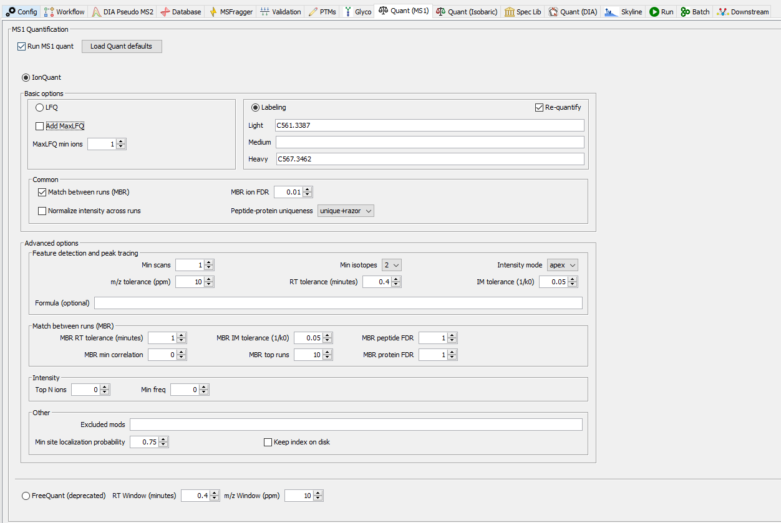
Make sure Match between runs (MBR) is checked

- Output and start run:
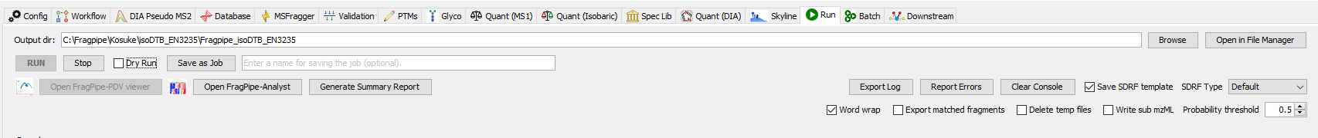
Set output directory
Make sure this is an empty folder

- This will take ~30-60 minutes for 3x7 fractions
- Once done you have to group the peptides group them to labelled sites by using this R-Script

  - open R by double-clicking:
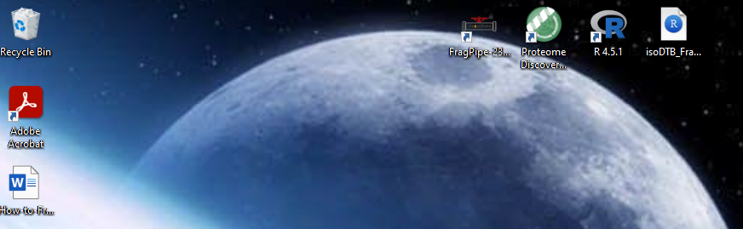

  - Change the input/output_tsv directory to your Fragpipe output folder
  - Change the sample_prefix to your experiment name from 1
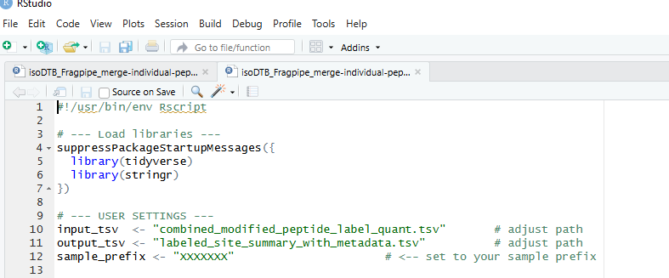

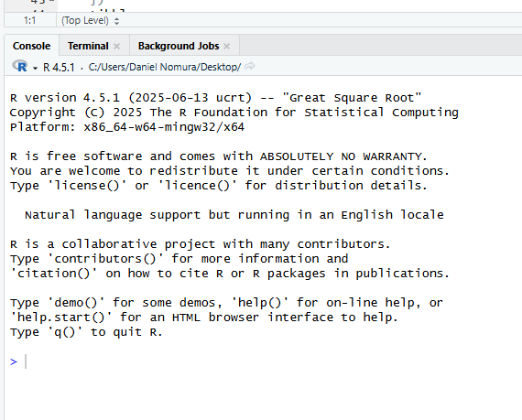
  - copy the code to the console and press enter

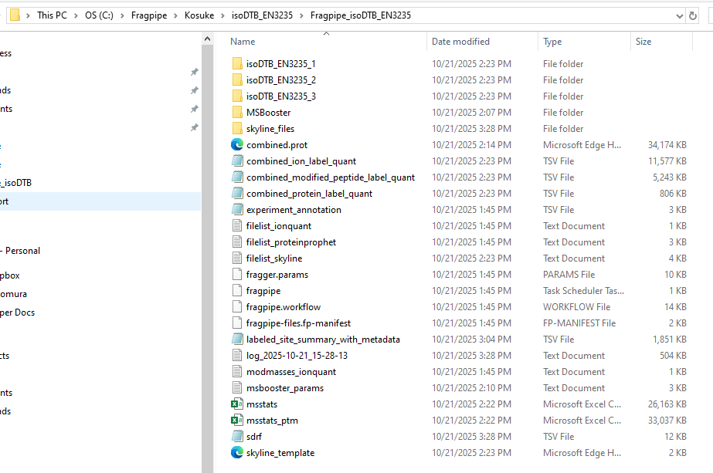
  - Your processes/grouped output file is in the defined output directory

