**Databases Laboratory Work Nr.2**

Pasecinic Nichita

FAF – 192

09.11.2020

**Title: Creating and maintaining the database**

**Prerequisites:**

* PC with MySQL tools installed
* Lab book with steps
* Basic knowledge about MySQL

**Tasks:**

* Create a database physically placed in the MyDocs \ Data folder, setting a file growth of the 16MB base with a growth limit of 128 MB and of the 64 MB log with the1024 MB growth. For secondary files to define a new default Filegroup, setting the growth of secondary files to 64 MB with a limit of 1024 MB. Configuration of SQL Server 2017
* Create a database, where the log file is physically placed in the MyDocs\Log folder, name the log file of the operating system environment must differ from the logically defined e m physical scheme. It is important that the database created is compatible with the MS SQL system
* Create the database maintenance plan, built in task 1. Unused space by the database files must be removed when it reaches the size 2000Mb. Space released must be returned to the operating system. This operation must run m every Friday at 00:00. The maintenance plan execution report must be saved to the docker MyDocs \ SQL_event_logs. Initialize the execution of the plan. After execution, check results m log file.
* Create the database maintenance plan, built in exercise 2. The name of the plan will be: "Index reconstruction". In this plan, the system must perform the reconstruction indices only on the basic tables (excluding visions) from all existing schemes form database in cause. The free space on the page must be 10%. Sorting of indexes must be done in tempdb. After the reconstruction, the collection of statistics must follow complete about reconstructed indices. The third step of the plan should be the task of Clear history of Backup-Restore operations on SQL Server. Must Delete the history that is older than 6 weeks. This plan must be executed in each the first Sunday of the month. Create the MyDocs\ SQL_reports folder. Execution report of This file must be added to the plan. Maintenance process - to be logged in mod extended. Initialize the execution of the plan. After execution, check the results in the log file generated.

**Implementation:**

**Task 1:**

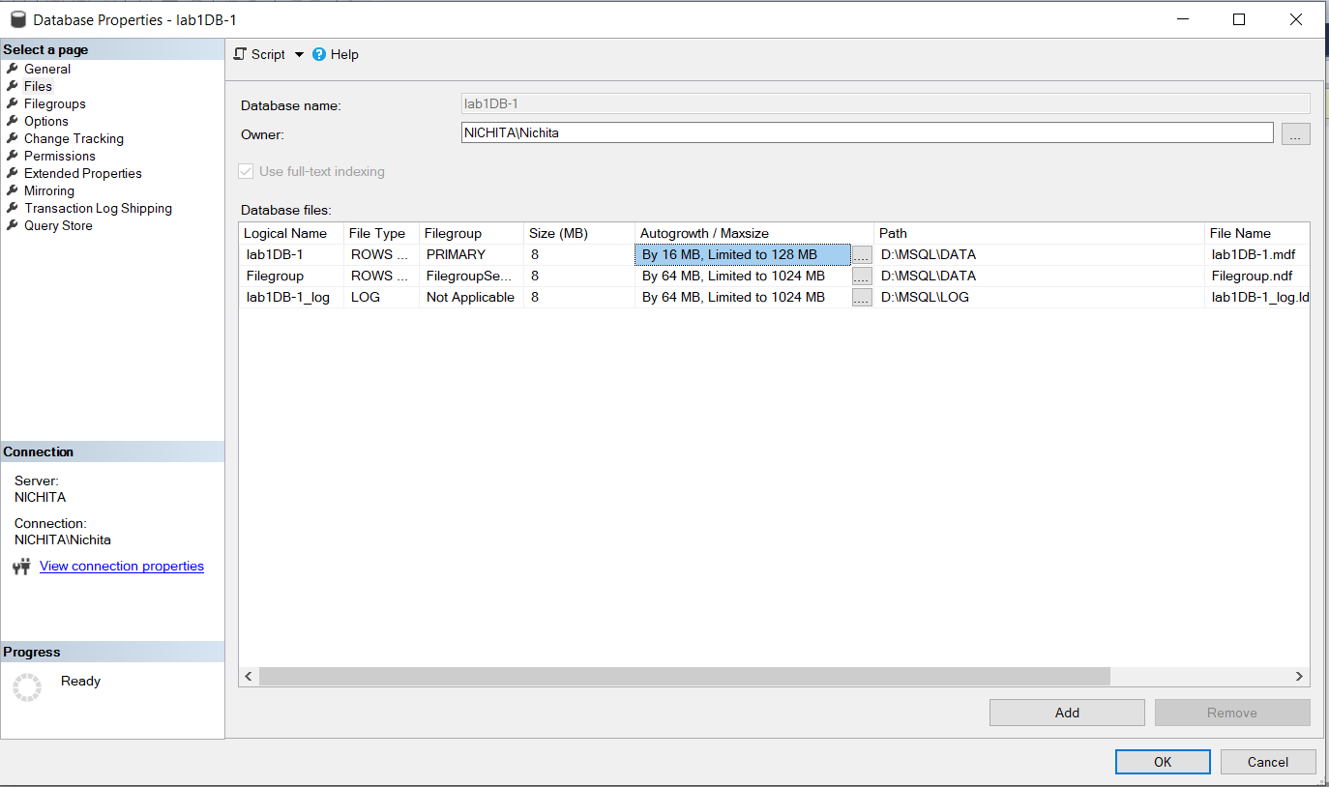

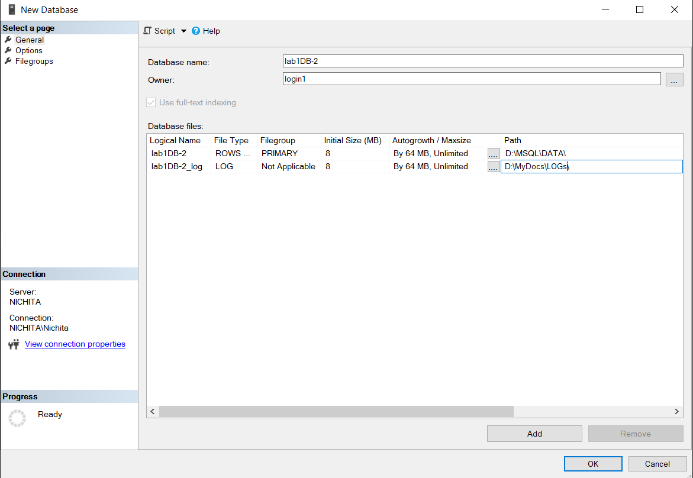**Task 2:**

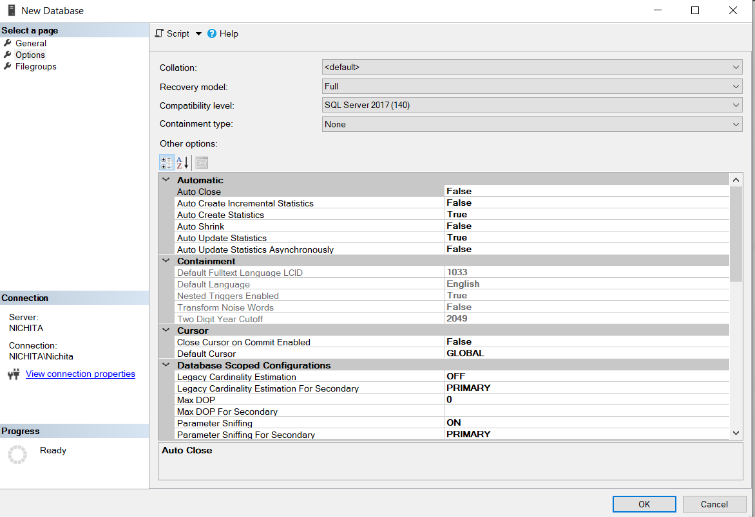

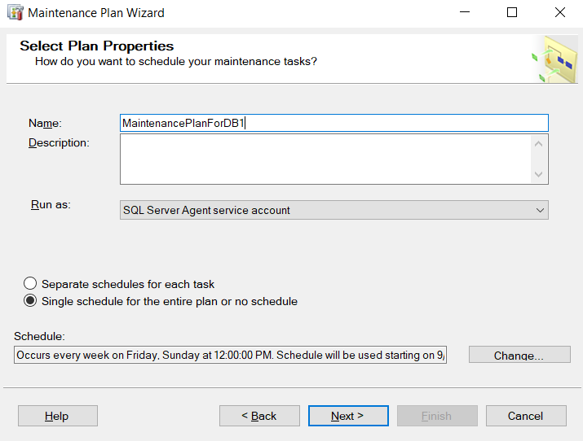**Task 3:**

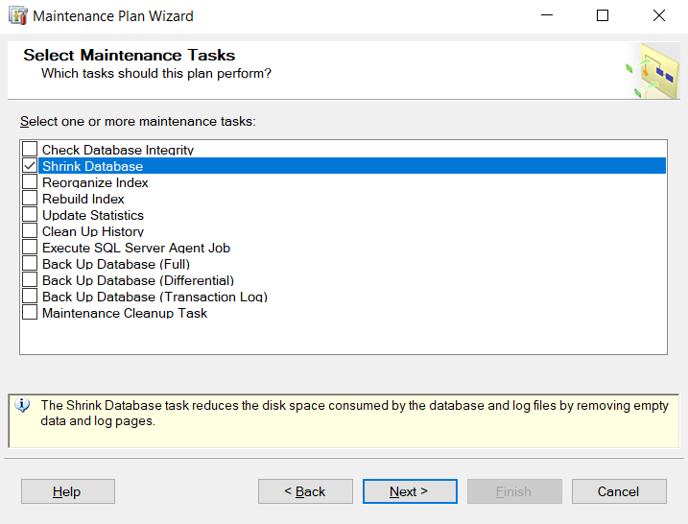

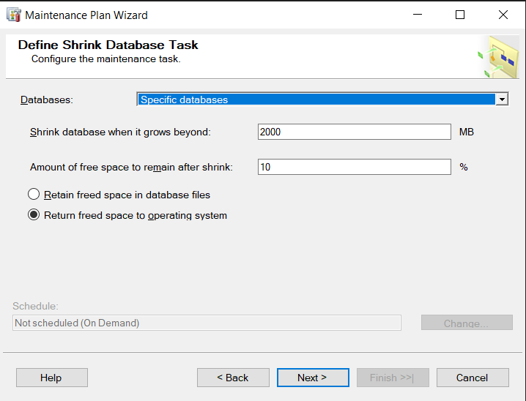

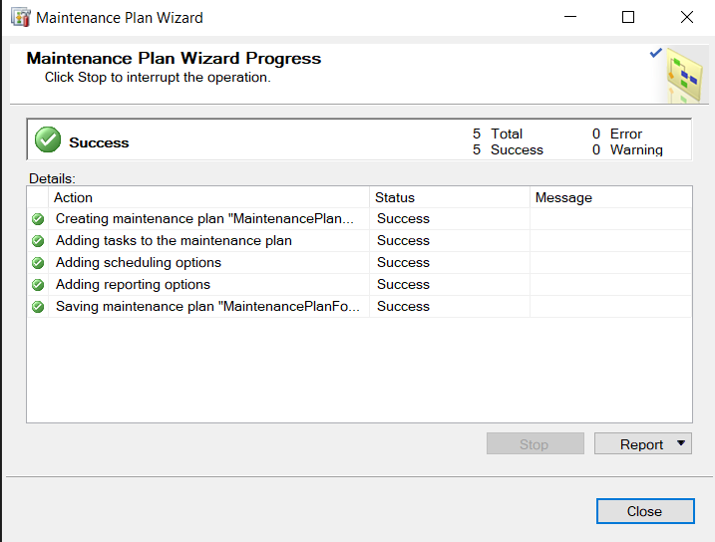

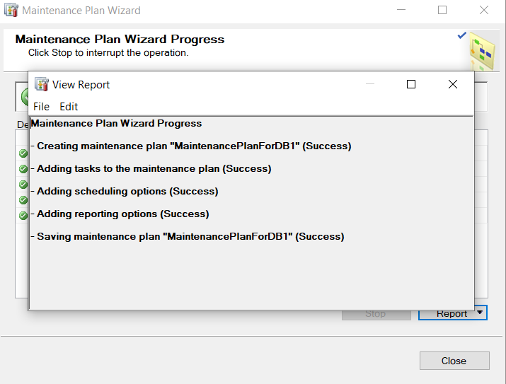

**Task 4:**

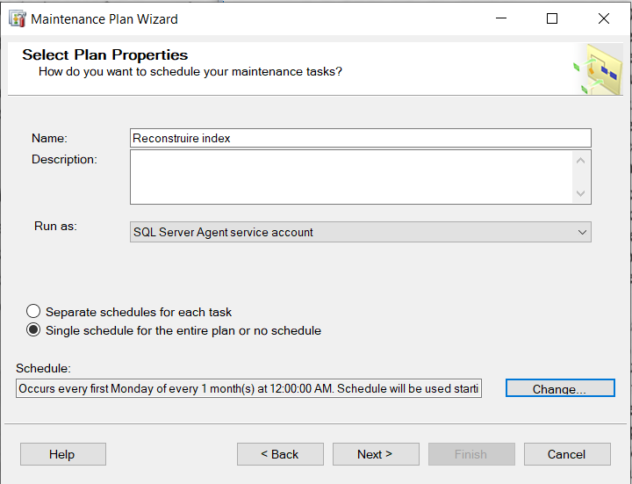

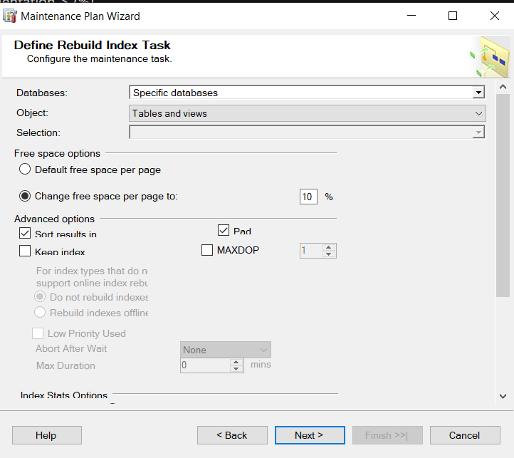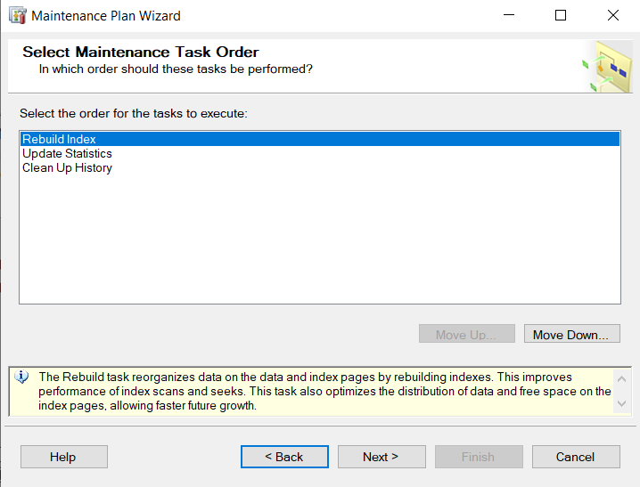

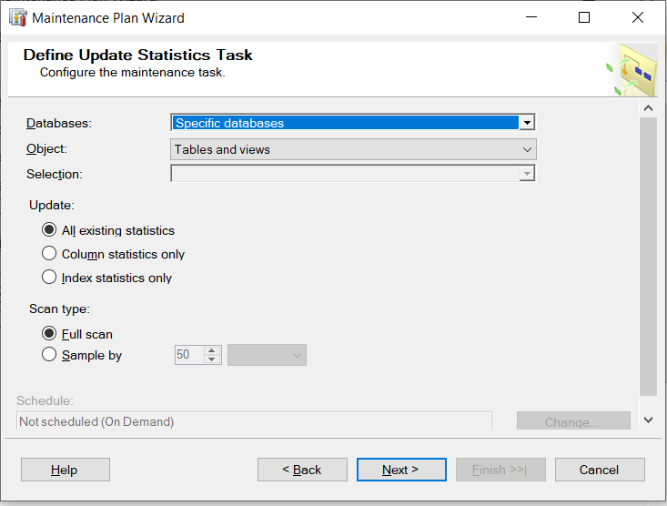

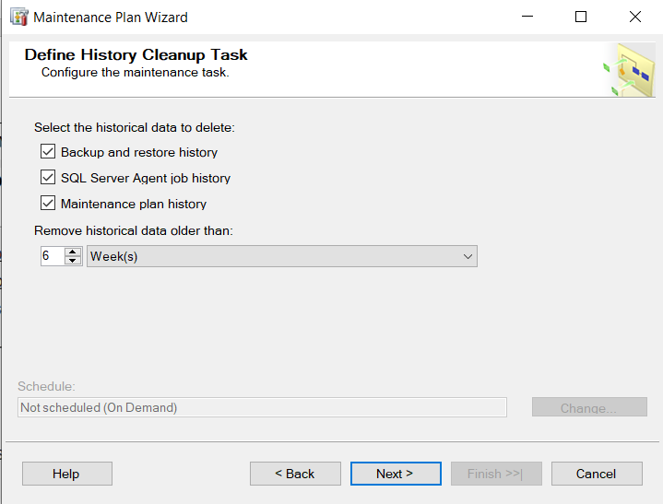

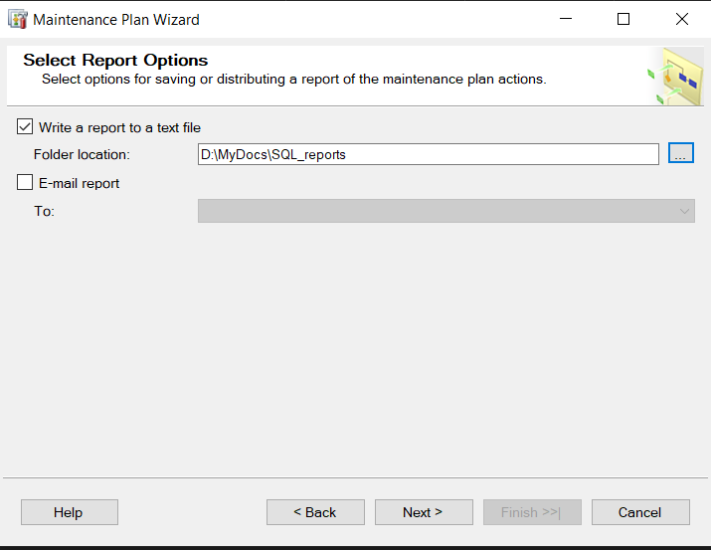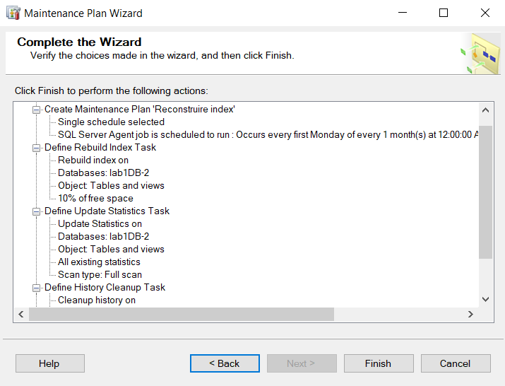

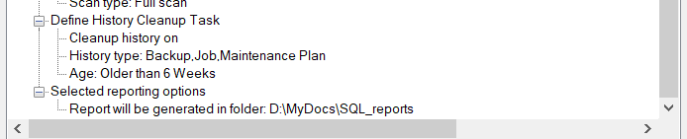

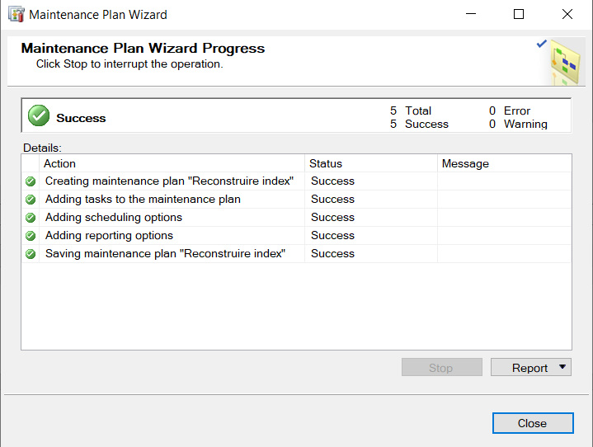

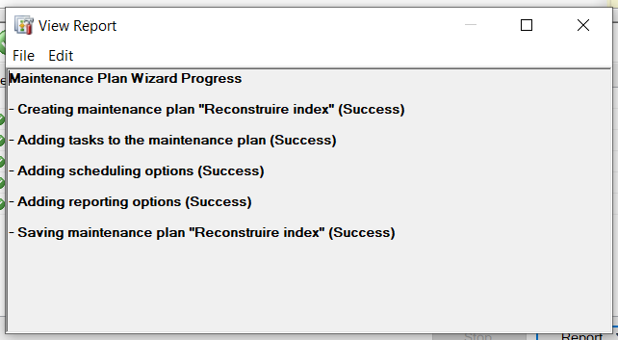

**Conclusions**:

After performing the laboratory work no. 2, I learned how to create a new data base in SQL Server 2017 and modify it’s proprieties as well I found out how to create a mantaince plan for the data bases using Mantaince Wizard and Manualy. The practical exercises strengthened the basis of the theoretical knowledge accumulated in chapter 2