Pasecinic Nichita

FAF – 192

05.10.2020

**Databases Laboratory Work Nr.4**

**Title: SELECT TRANSACT-SQL INSTRUCTION**

**Tasks:**

* Exercises 1 to 10
* Exercises 20, 21, 22
* Exercises 30,31,35

Chisinau 2020

1. SELECT * FROM grupe;

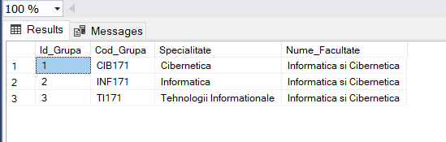

1. SElECT Disciplina, Nr_ore_plan_disciplina FROM discipline

ORDER BY Nr_ore_plan_disciplina DESC;

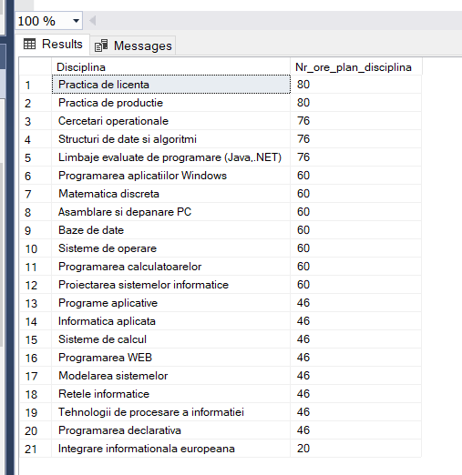

1. SElECT DISTINCT p.Nume_Profesor, p.Prenume_Profesor,

d.Disciplina AS Disciplina_D

FROM profesori AS p, studenti_reusita AS r, discipline AS d

WHERE p.Id_Profesor = r.Id_Profesor AND r.Id_Disciplina = d.Id_Disciplina

ORDER BY p.Nume_Profesor, p.Prenume_Profesor;

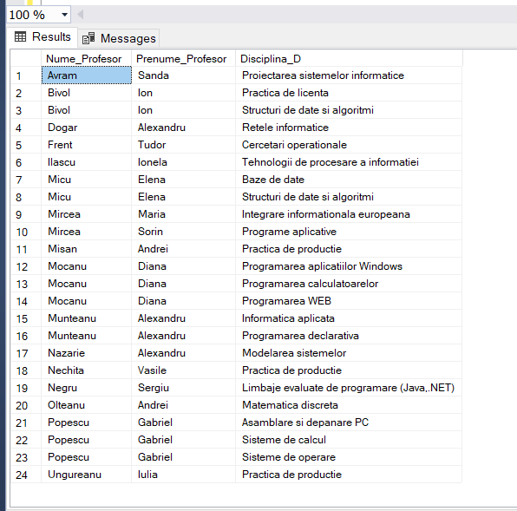

1. select Disciplina from discipline

where len(Disciplina) > 20;

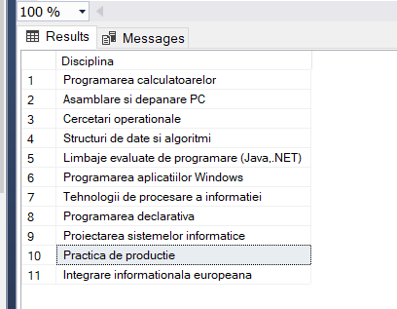

1. select Nume_Student from studenti

where Nume_Student like '%u'

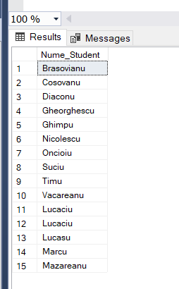

1. select distinct top 5 with ties s.Nume_Student, s.Prenume_Student, r.Tip_Evaluare, r.Nota, d.Disciplina

from studenti as s, studenti_reusita as r, discipline as d

where r.Tip_Evaluare = 'Testul 2' and d.Disciplina = 'Baze de date'

order by r.Nota desc;

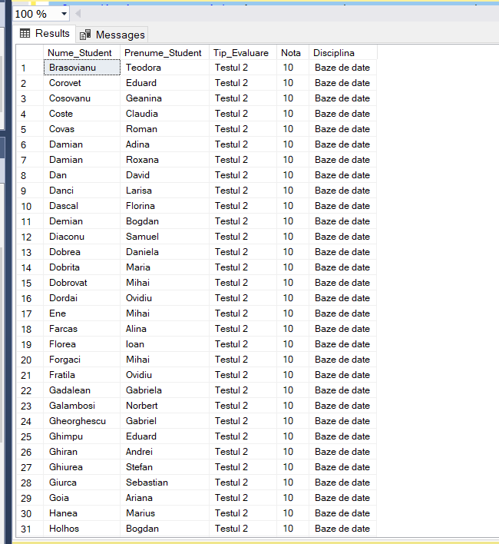

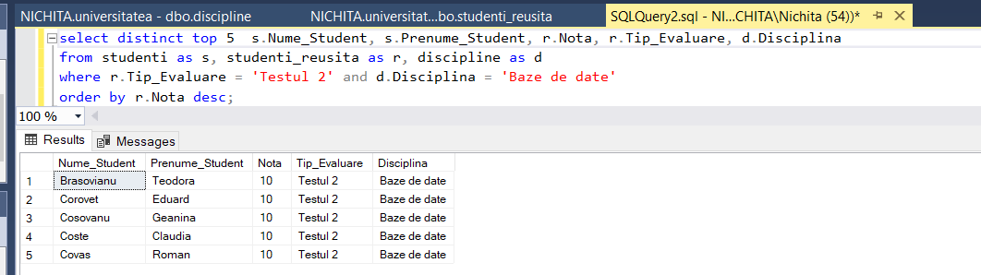

1. select distinct g.Cod_Grupa, s.Adresa_Postala_Student, s.Nume_Student, s.Prenume_Student

from grupe as g, studenti_reusita as r, studenti as s

where s.Adresa_Postala_Student like '%31 August%';

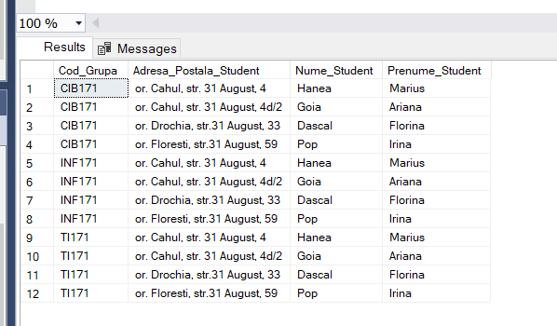

1. select distinct s.Id_Student, s.Prenume_Student, s.Nume_Student

from studenti_reusita as r, studenti as s

where r.Data_Evaluare like '%2018%' and r.Tip_Evaluare = 'Examen'

order by s.Id_Student;

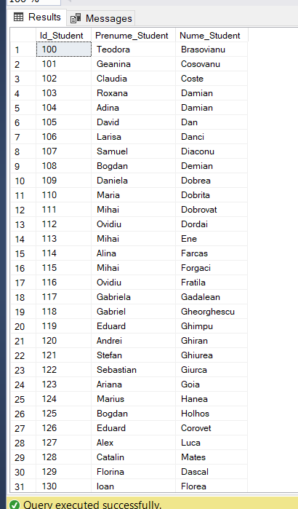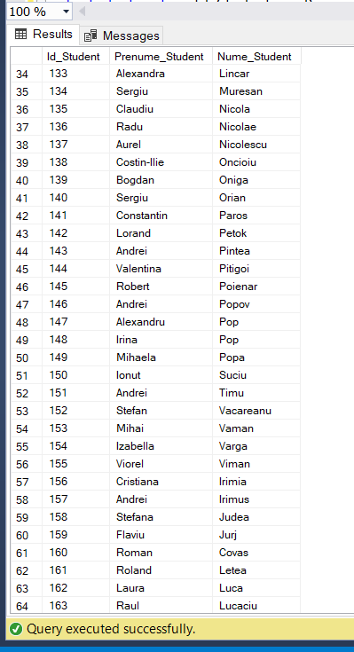

1. select distinct s.Nume_Student, s.Adresa_Postala_Student

from studenti as s, studenti_reusita as r

where r.Nota > 8 and r.Data_Evaluare like '%2018%'

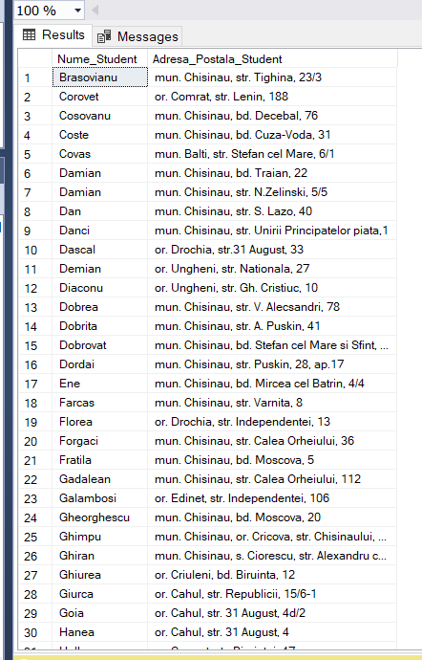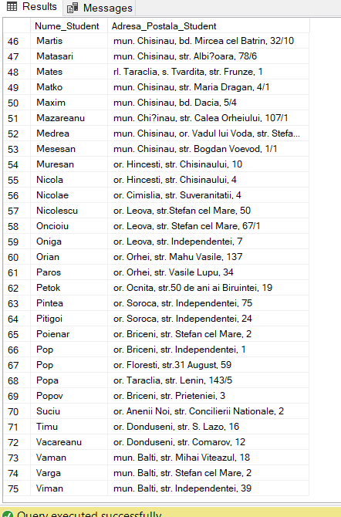

1. select distinct s.Nume_Student, s.Prenume_Student

from studenti as s, studenti_reusita as r, discipline as d

where

r.Nota < 8 and r.Nota > 4 and r.Data_Evaluare like '%2018%'

and r.Tip_Evaluare = 'Examen' and d.Disciplina = 'Baze de date'

and d.Id_Disciplina = r.Id_Disciplina

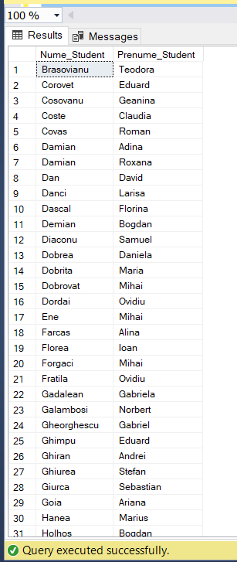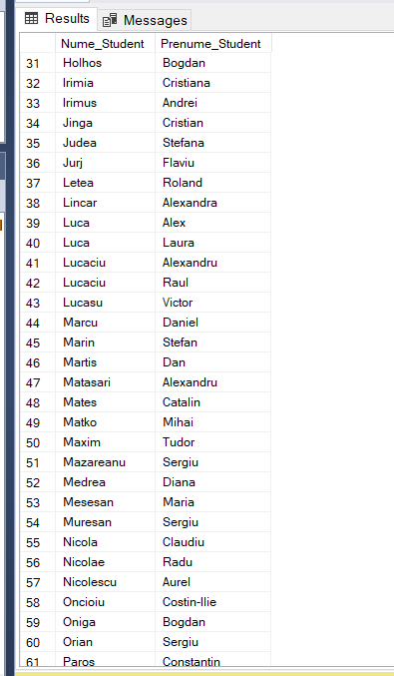

20. select distinct count(r.Id_Student)

from studenti as s, studenti_reusita as r, discipline as d

where

r.Nota > 4 and r.Data_Evaluare like '%2018%'

and d.Disciplina = 'Baze de date' and r.Tip_Evaluare = 'Testul 2'

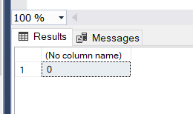

21. select s.Nume_Student, s.Prenume_Student, count(r.Nota) as Nr_de_Note_Student

from studenti_reusita as r, studenti as s

where r.Id_Student = s.Id_Student

group by s.Nume_Student, s.Prenume_Student

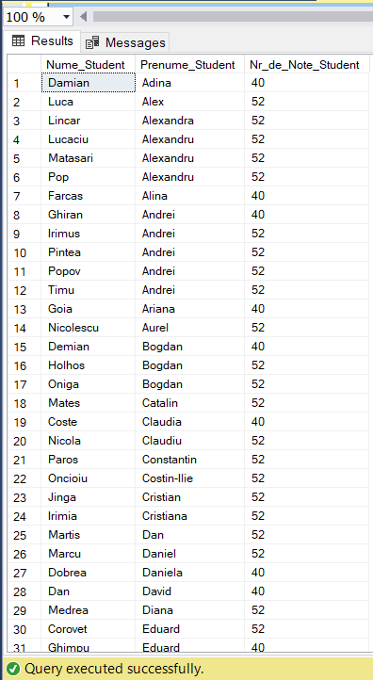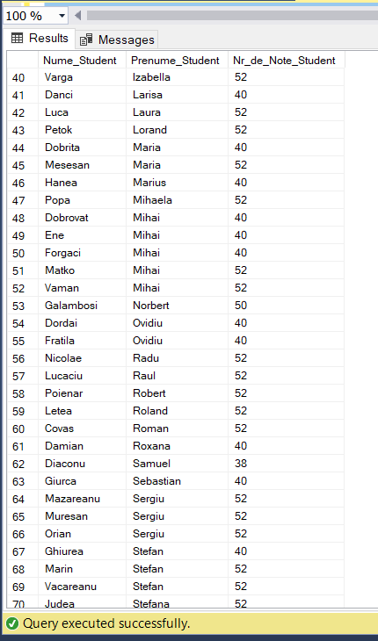

22. select p.Nume_Profesor, p.Prenume_Profesor, count( distinct r.Id_Disciplina) as Nr_de_Disipline

from profesori as p, studenti_reusita as r

where r.Id_Profesor = p.Id_Profesor

group by p.Nume_Profesor, p.Prenume_Profesor

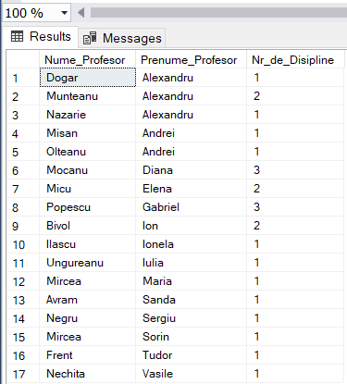

30. select count(r.Id_Student) as Nr_de_Studenti,

avg(cast(r.Nota as Float)) as Media_la_Reusita_Curenta,

d.Disciplina

from discipline as d, studenti_reusita as r, studenti as s

where d.Disciplina = 'Baze de date' and

d.Id_Disciplina = r.Id_Disciplina and

s.Id_Student = r.Id_Student and

r.Tip_Evaluare = 'Reusita Curenta' and

r.Data_Evaluare like '%2018%'

group by d.Disciplina

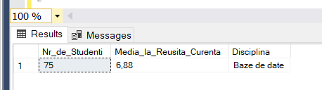

31. select distinct s.Nume_Student, s.Prenume_Student, count(r.Nota) as Nr_de_Respingeri, d.Disciplina

from discipline as d, studenti_reusita as r, studenti as s

where r.Nota < 5 and

d.Id_Disciplina = r.Id_Disciplina and

s.Id_Student = r.Id_Student

group by s.Nume_Student, s.Prenume_Student, d.Disciplina having count(r.Nota) > 2

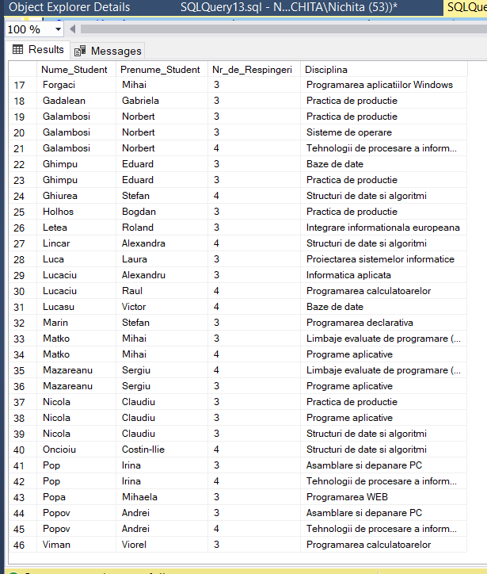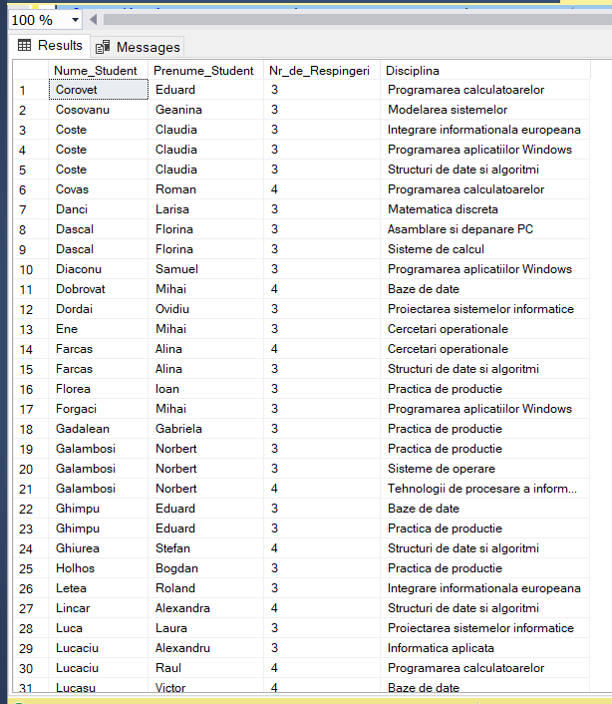

35. select d.Id_Disciplina, d.Disciplina, avg(cast(r.Nota as float)) as Media_pe_Disciplina

from discipline as d, studenti_reusita as r

where d.Id_Disciplina = r.Id_Disciplina

group by d.Id_Disciplina, d.Disciplina having avg(cast(r.Nota as float)) > 7

