Pasecinic Nichita

FAF – 192

21.10.2020

**Databases Laboratory Work Nr.4**

**Title: TRANSACT-SQL: PROCEDURAL INSTRUCTIONS**

**Prerequisites:** computer, connection to the network, book: Microsoft SQL Server 2017 by Vitalie Cotelea and Marian Cotelea, Soft: Microsoft SQL Management Server.

**Tasks:**

* Exercises 1, 2, 3, 4 from the SQL Lab Book

Chisinau 2020

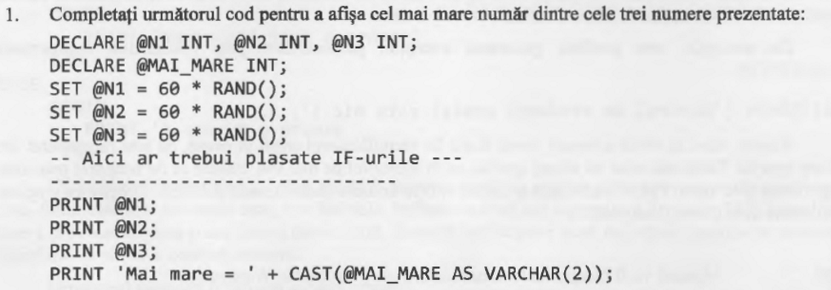

**Exercitiul 1:**

declare @n1 int, @n2 int, @n3 int;

declare @maiMare int;

set @n1 = 60*rand();

set @n2 = 60*rand();

set @n3 = 60*rand();

if @n1 >= @n2 and @n1 >= @n3

set @maiMare = @n1

else if @n2 >= @n1 and @n2 >= @n3

set @maiMare = @n2

else if @n3 >= @n1 and @n3 >= @n1

set @maiMare = @n3

print @n1;

print @n2;

print @n3;

print 'Cel mai mare nr: ' + cast(@maiMare as varchar(2));



**Exercitiul 2:**

declare @counter int,@sId int, @nume varchar(20), @prenume varchar(30), @mark int

set @counter = 10

set @sId = 0

while @counter <> 0

begin

select @nume = s.Nume_Student, @prenume = s.Prenume_Student, @mark = r.Nota

from discipline as d, studenti as s, studenti_reusita as r

where

s.Id_Student = r.Id_Student and

d.Disciplina = 'Baze de date' and

r.Tip_Evaluare = 'Testul 1' and

d.Id_Disciplina = r.Id_Disciplina and

s.Id_Student = @sId + 100

if @mark <> 8 and @mark <> 6

begin

print @nume + ' ' + @prenume + ' ' + ',Nota -> ' + cast(@mark as varchar(2))

-- update counter

set @counter = @counter - 1

end

-- update studentId

set @sId = @sId + 1

end

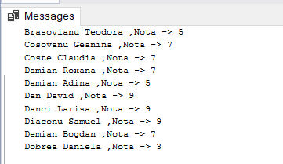



**Exercitiul 1 modificat:**

declare @n1 int, @n2 int, @n3 int, @maiMare int;

set @n1 = 60*rand();

set @n2 = 60*rand();

set @n3 = 60*rand();

select @maiMare =

case

when @n1 >= @n2 and @n1 >= @n3 then @n1

when @n2 >= @n1 and @n2 >= @n3 then @n2

when @n3 >= @n1 and @n3 >= @n1 then @n3

end

print @n1;

print @n2;

print @n3;

print 'Cel mai mare numar: ' + cast(@maiMare as varchar(2)) 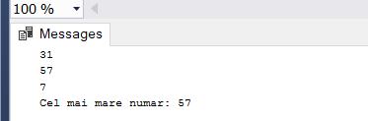



**Exercitiul 1 modificat:**

declare @n1 int, @n2 int, @n3 int, @maiMare int;

set @n1 = 0;

set @n2 = 0;

set @n3 = 0;

select @maiMare =

case

when @n1 >= @n2 and @n1 >= @n3 then @n1

when @n2 >= @n1 and @n2 >= @n3 then @n2

when @n3 >= @n1 and @n3 >= @n1 then @n3

end

if @maiMare = @n1 and @maiMare = @n2 and @maiMare = @n3

begin

raiserror('The numbers are equal!!!', 16, 1)

end

else

begin

print @n1;

print @n2;

print @n3;

print 'Cel mai mare numar: ' + cast(@maiMare as varchar(2))

endend catch

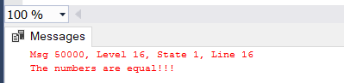

**Ex 2 modificat:**

declare @counter int,@sId int, @nume varchar(20), @prenume varchar(30), @mark int

set @counter = 10

set @sId = 0

while @counter <> 0

begin

select @nume = s.Nume_Student, @prenume = s.Prenume_Student, @mark = r.Nota

from discipline as d, studenti as s, studenti_reusita as r

where

s.Id_Student = r.Id_Student and

d.Disciplina = 'Baze de date' and

r.Tip_Evaluare = 'Testul 1' and

d.Id_Disciplina = r.Id_Disciplina and

s.Id_Student = @sId + 100

begin try

if @mark <> 8 and @mark <> 6

begin

print @nume + ' ' + @prenume + ' ' + ',Nota -> ' + cast(@mark as varchar(2))

-- update counter

set @counter = @counter - 1

end

end try

begin catch

print 'A error occured!'

end catch

-- update studentId

set @sId = @sId + 1

end

**Conclusion:** In this work I learned and applied in practice Procedural Instructions of the SQL Transact, which have common things to other popular programming languages. Transact SQL extends the SQL standard with the implementation of programming structures.