Pasecinic Nichita

FAF – 192

11.11.2020

**Databases Laboratory Work Nr.6**

**Title: CREATION OF TABLES AND INDEXES**

**Prerequisites:** computer, connection to the network, book: Microsoft SQL Server 2017 by Vitalie Cotelea and Marian Cotelea, Soft: Microsoft SQL Management Server.

Chisinau 2020



update profesori

set Adresa_Postala_Profesor = 'mun.Chisinau'

where Adresa_Postala_Profesor is null

select p.Adresa_Postala_Profesor

from profesori as p

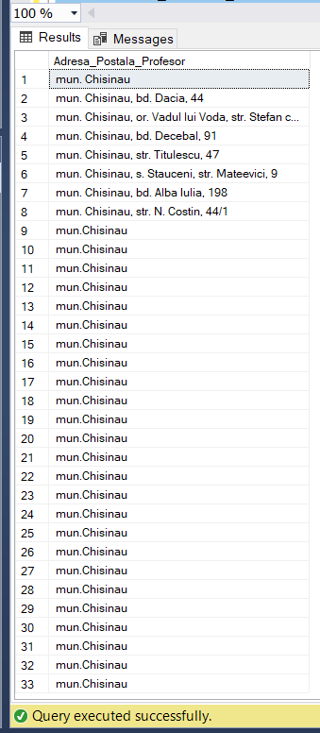

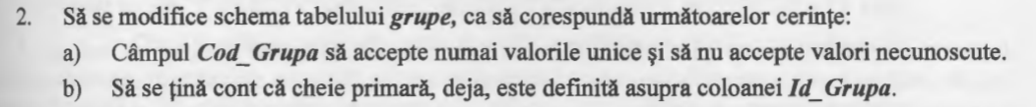

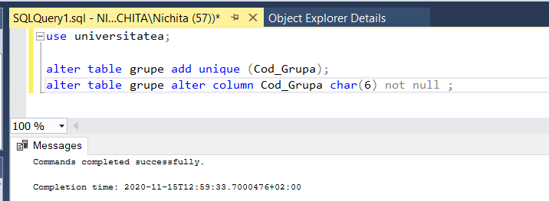



use universitatea;

alter table grupe add Sef_Grupa int;

alter table grupe add Prof_Indrumator int;



use universitatea;

update grupe set Sef_Grupa = (

select Sef_Grupa from (

select Id_Grupa, min(Id_Student)

Sef_Grupa, max(Med) as Max_Nota

from (

select Id_Student, Id_Grupa, avg(Nota) as Med from studenti_reusita

group by Id_Student, Id_Grupa

) as r1

group by Id_Grupa

) as r2

where grupe.Id_Grupa = r2.Id_Grupa );

select Sef_Grupa from grupe;

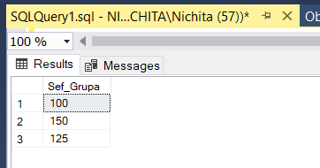

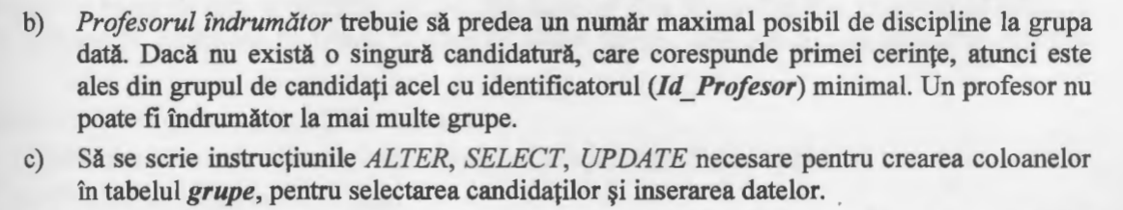

use universitatea;

update grupe set Prof_Indrumator = (

select Prof_Indrumator from (

select Id_Grupa, max(Obiecte) as Max_Ore,

min(Id_Profesor) Prof_Indrumator from (

select Id_Profesor, Id_Grupa, count(distinct Id_Disciplina) as Obiecte

from studenti_reusita

group by Id_Profesor, Id_Grupa) as r1

group by Id_Grupa

) as r2

where grupe.Id_Grupa = r2.Id_Grupa

);

select Prof_Indrumator from grupe;

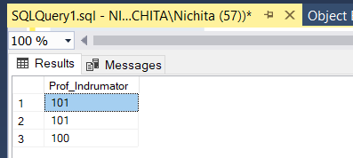



use universitatea;

update studenti_reusita

set Nota =

case when (Nota = 10) then 10

else (Nota + 1)

end

where Id_Student in (select Id_Student

from grupe g join studenti s on Sef_Grupa = Id_Student);

select * from studenti_reusita;

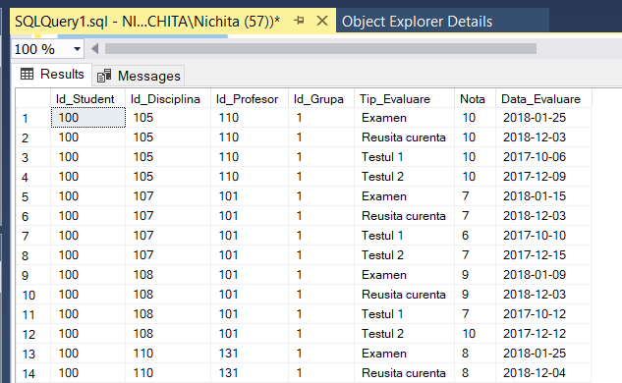…

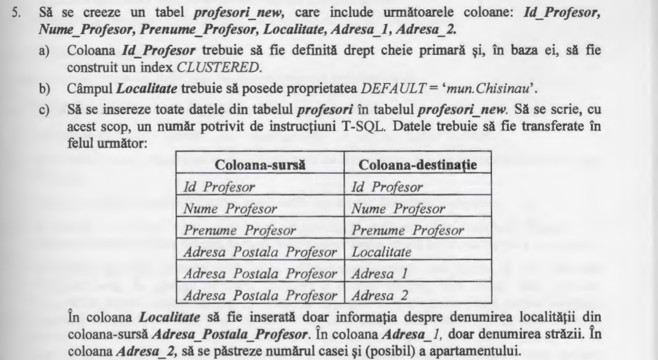

use universitatea;

drop table if exists profesori_new

go

create table profesori_new (

Id_Profesor int not null,

constraint IX_Profesor primary key clustered (Id_Profesor),

Nume_Profesor varchar(50) not null,

Prenume_Profesor varchar(50) not null,

Localitate varchar(255),

Adresa_1 varchar (60),

Adresa_2 varchar (60),

)

go

exec sp_helpindex profesori_new;

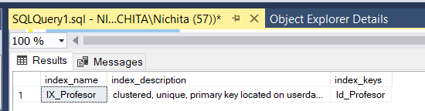

use universitatea;

select * from profesori_new;

insert into profesori_new

select Id_Profesor, Nume_Profesor, Prenume_Profesor,

substring (Adresa_Postala_Profesor, 1, patindex('%, %', Adresa_Postala_Profesor)-1),

substring (Adresa_Postala_Profesor, 15, patindex('%[0-9]%', Adresa_Postala_Profesor)-17),

substring (Adresa_Postala_Profesor, patindex('%[0-9]%', Adresa_Postala_Profesor), len(Adresa_Postala_Profesor))

from profesori

where len(Adresa_Postala_Profesor) > 13

insert into profesori_new

select Id_Profesor, Nume_Profesor, Prenume_Profesor, Adresa_Postala_Profesor, null, null

from profesori

where len(Adresa_Postala_Profesor) = 13

select * from profesori_new;

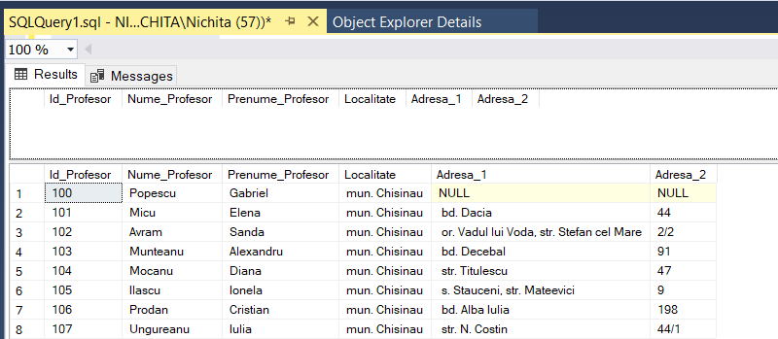

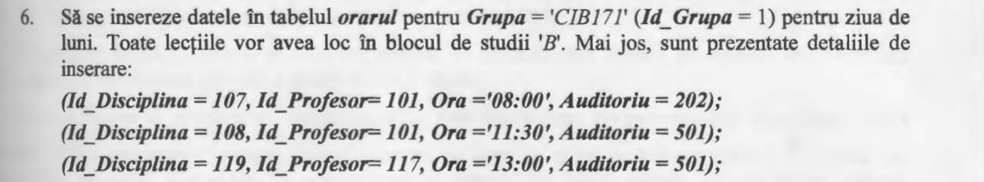

use universitatea;

create table orarul (Id_Disciplina int, Id_Profesor int,

Id_Grupa smallint, Zi varchar(50),

Ora time, Bloc char(1), Auditoriu int);

insert into orarul values(107, 101, 1, 'Luni', '08:00', 'B', 202);

insert into orarul values(108, 101, 1, 'Luni', '11:30', 'B', 501);

insert into orarul values(119, 117, 1, 'Luni', '13:00', 'B', 502);

select * from orarul

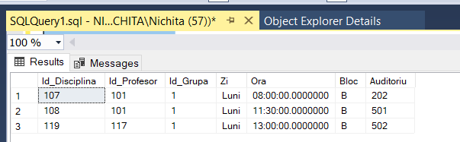

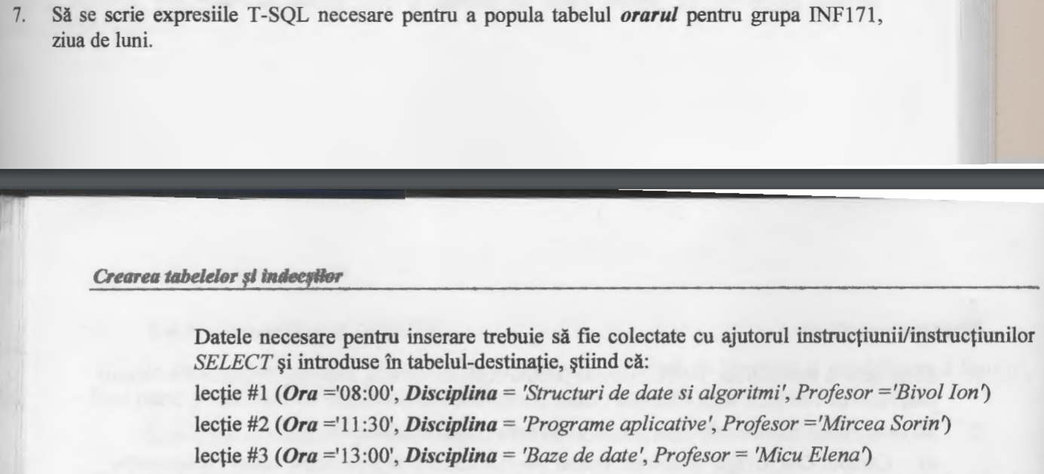

use universitatea;

select * from orarul;

insert into orarul values( (select Id_Disciplina from discipline where Disciplina = 'Structuri de date si algoritmi'),

(select Id_Profesor from profesori where Nume_Profesor='Bivol' and Prenume_Profesor='Ion'),

2, 'Luni', '08:00', 'A', 501);

insert into orarul values( (select Id_Disciplina from discipline where Disciplina = 'Programe aplicative'),

(select Id_Profesor from profesori where Nume_Profesor='Mircea' and Prenume_Profesor='Sorin'),

2, 'Luni', '11:30', 'B', 502);

insert into orarul values( (select Id_Disciplina from discipline where Disciplina = 'Baze de date'),

(select Id_Profesor from profesori where Nume_Profesor='Micu' and Prenume_Profesor='Elena'),

2, 'Luni', '13:00', 'c', 503);

select * from orarul;

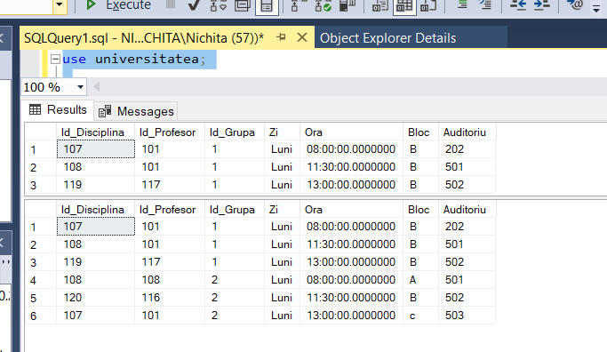

Conclusions: This laboratory work is a great example on a part of CRUD operations in SQL server. We have learned how to create and modify the structure of a table, which is one of the most important parts while working with SQL Server.