O-LEVEL PHYSICS • PAPER 3 PRACTICAL
Mock Question Pack
Syllabus 6091 • ~4-Hour Teaching Set
Tutor edition — questions, diagrams & full answer key
How to use this pack
Eight questions arranged as two mock sections plus a focused planning & evaluation block — roughly four hours of teaching once you talk through technique.
• Each question is tagged by skill area (P / MMO / PDO / ACE) so you can target weaknesses.
• Dashed boxes are teaching notes — what to emphasise, common pitfalls.
• Diagrams are drawn so the tutee can read scales and take off values.
• The full answer key with worked marks is at the very end.

Written to the SEAB Singapore–Cambridge O-Level Physics syllabus 6091 (first examined 2026): Paper 3 is 40 marks / 20%, two 55-minute sections, assessing Planning, MMO, PDO and ACE. Figures and data are illustrative teaching material, not past-paper reproductions.

Teaching plan — four hours
A workable order. Teach the technique first, then let the tutee attempt each question cold before you mark it together against the key.
Start | Focus | Time
0:00 | Warm-up: how Paper 3 is marked (P/MMO/PDO/ACE), reading instruments, the consistency rule for tables | 20 min
0:20 | Q1 Density of an irregular solid — MMO + PDO (displacement method, parallax) | 25 min
0:45 | Q2 Simple pendulum → g — PDO + ACE (plotting T² vs L, gradients) | 35 min
1:20 | Q3 Principle of moments — MMO + ACE. Break after | 25 min
1:45 | Q4 Resistance of a wire — MMO + PDO + ACE (the classic circuit) | 35 min
2:20 | Q5 Refraction through a glass block — MMO + PDO (ray tracing) | 30 min
2:50 | Q6 Cooling / specific heat — PDO + ACE (reading a curve, heat-loss error) | 30 min
3:20 | Q7 Planning task — the 15% (model the five-part skeleton) | 25 min
3:45 | Q8 Errors & evaluation drill — short-answer ACE. Wrap-up & checklist | 15 min

Marking together
Don't just give the answer — have the tutee find the mark they missed. Most lost marks in Paper 3 are technique (units in headings, sensible scales, gradient triangle too small, vague improvements), not physics.

Mock Section A
Questions 1–3. In a real exam these share a 55-minute apparatus window worth 20 marks. Here they are spaced out for teaching.
Question 1 Density of an irregular solid | [7 marks]
MMO PDO
A student is given a small irregular stone, a 100 cm³ measuring cylinder, water, an electronic balance and a length of thread. She is asked to find the density of the stone.
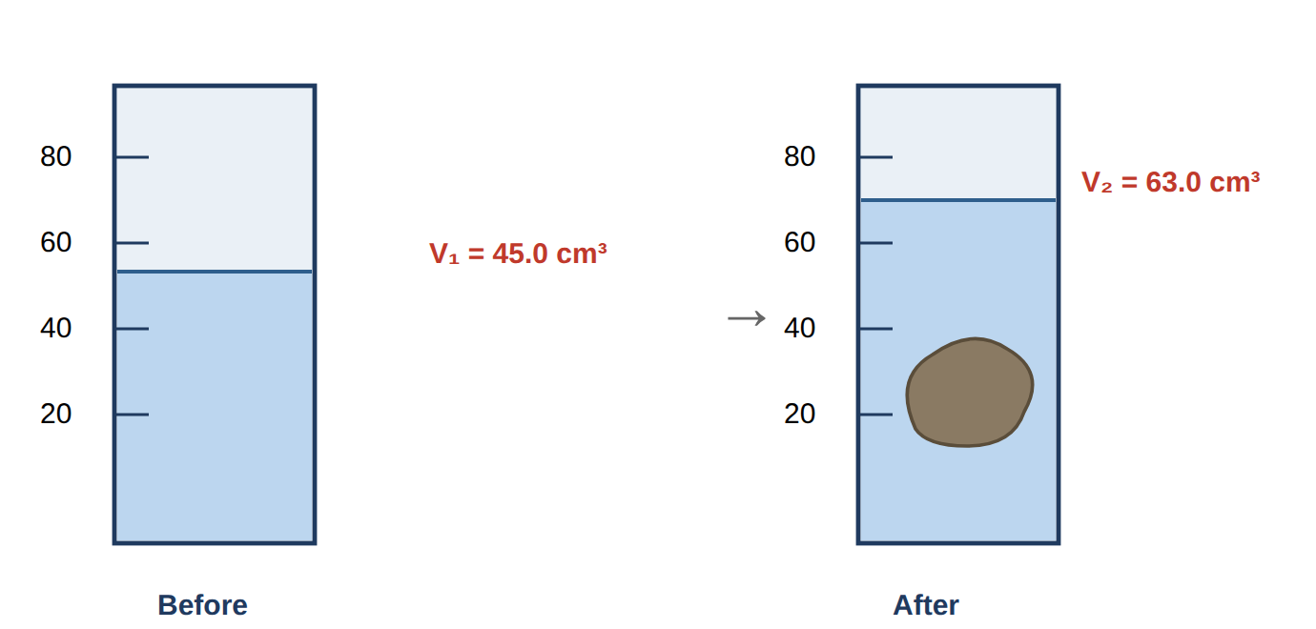
Fig. 1.1 — water level before and after the stone is lowered in. Balance reads mass of stone = 47.25 g.
- State how the student should place her eye when reading the water level, and explain why. [2]
- Using the readings in Fig. 1.1, determine the volume of the stone. [1]
- The balance reads the mass of the stone as 47.25 g. Calculate the density of the stone, giving your answer to an appropriate number of significant figures and a unit. [2]
- Suggest one reason the measured volume might be slightly too large, and how to avoid it. [2]
Teach here: the displacement method and parallax. Ask the tutee why we read the bottom of the meniscus at eye level before giving the rule. For (c), drill the s.f. logic: raw data has 3 s.f., so the answer has 3 s.f.

Question 2 Simple pendulum → acceleration of free fall | [11 marks]
PDO ACE
A student investigates how the period T of a simple pendulum depends on its length L. For each length she times 20 complete oscillations and calculates the period. Her results are shown in Table 2.1.
L / m | Time for 20 swings / s | T / s | T² / s²
0.200 | 17.9 | 0.895 | 0.80
0.400 | 25.4 | 1.270 | 1.61
0.600 | 31.0 | 1.550 | 2.40
0.800 | 35.8 | 1.790 | 3.20
1.000 | 40.1 | 2.005 | 4.02
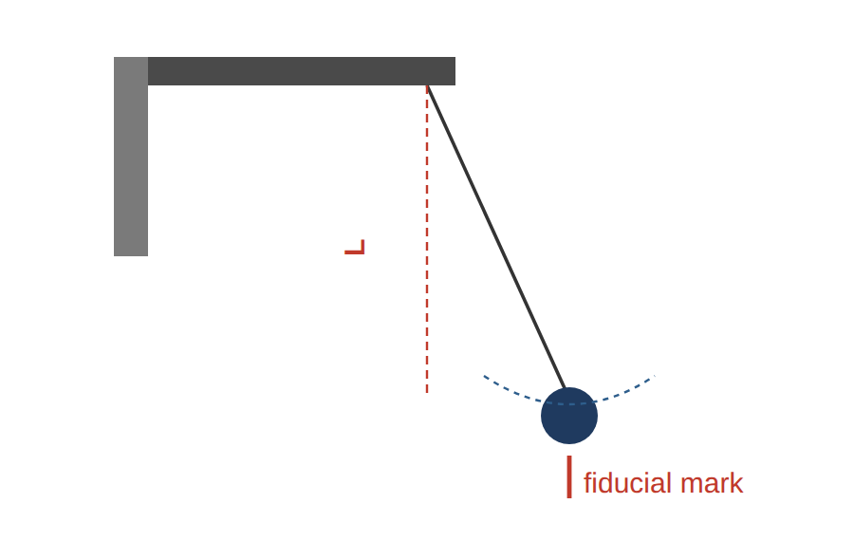
Fig. 2.1 — the pendulum. Timing is started as the bob passes the fiducial mark at the centre.
- Explain why the student times 20 oscillations rather than a single one. [2]
- On the grid (Fig. 2.2), plot a graph of T² (y-axis) against L (x-axis) and draw the best-fit line. [3]
- Determine the gradient of your line, showing your triangle clearly. [2]
- The period is related to length by T² = (4π²/g) L. Use your gradient to find a value for g. [2]
- State one reason your value of g might differ slightly from 9.81 m/s². [1]
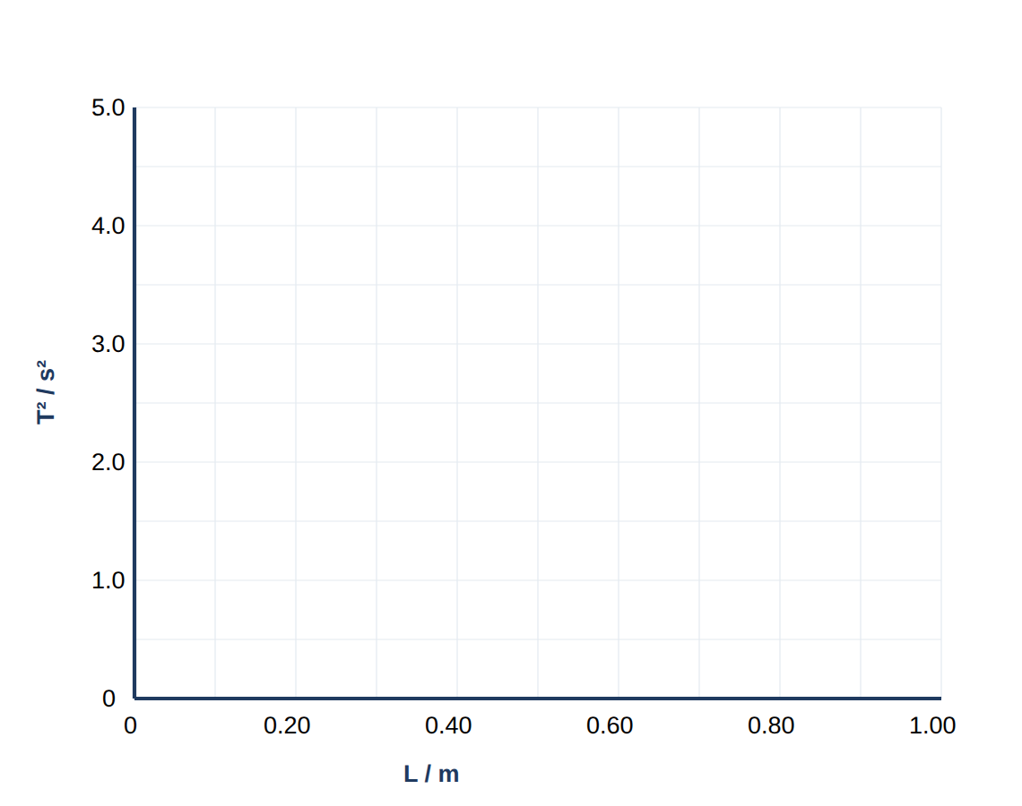
Fig. 2.2 — grid for plotting. (Each labelled square = 0.20 m on x, 1.0 s² on y.)
Teach here: this is the money question. (b) label axes with unit, points as small crosses, best-fit balanced. (c) insist the gradient triangle spans > half the line and values are read off the line. (d) rearrange g = 4π²/gradient — watch they don't invert it.

Question 3 Principle of moments | [8 marks]
MMO ACE
A uniform metre rule is balanced on a knife-edge pivot at its centre. A 100 g mass is hung at the 15.0 cm mark. A mass M is moved along the other side until the rule balances horizontally at the 80.0 cm mark.
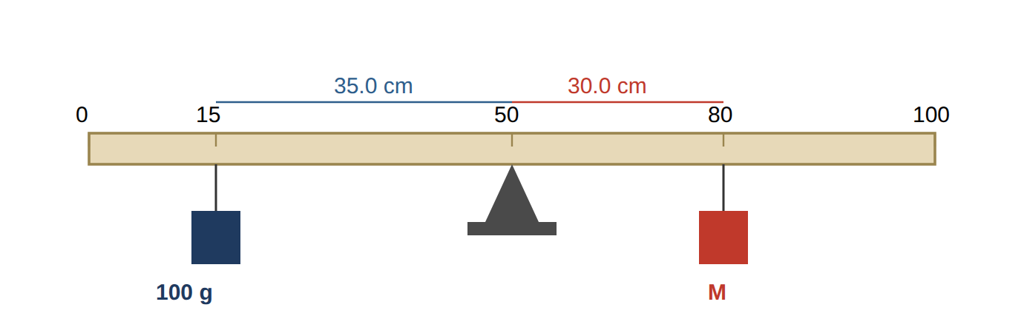
Fig. 3.1 — the balanced metre rule (drawn not to scale).
- State the principle of moments. [1]
- Calculate the perpendicular distance of each mass from the pivot. [1]
- By taking moments about the pivot, determine the value of the mass M. [3]
- The rule is uniform and pivoted at its centre. Explain why the weight of the rule does not appear in your calculation. [1]
- Suggest one precaution the student should take to obtain an accurate balance point, and explain how it helps. [2]
Teach here: moment = force × perpendicular distance, and that in a balance you can equate mass×distance on each side because g cancels. Part (d) is a favourite — centre of gravity acts at the pivot so its moment is zero.

Mock Section B
Questions 4–6. Longer, integrated experiments — the type that carries the full 20-mark Section B question.
Question 4 Resistance of a wire | [12 marks]
MMO PDO ACE
A student investigates how the resistance R of a length of nichrome wire depends on its length L. The circuit in Fig. 4.1 is used. For each length, the voltmeter reading V and ammeter reading I are recorded.
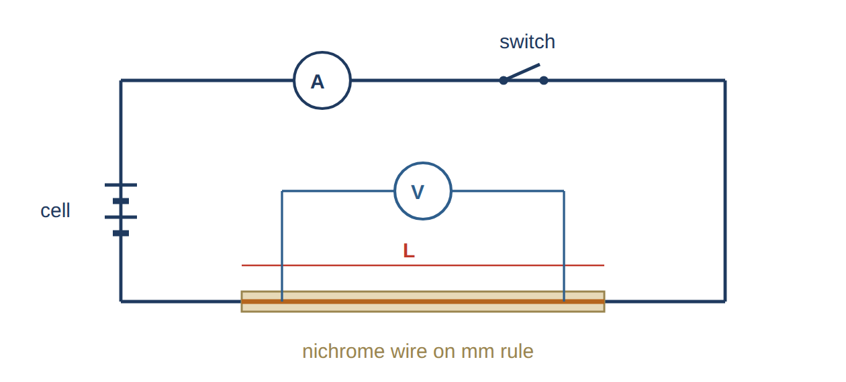
Fig. 4.1 — circuit: ammeter in series, voltmeter across the length of nichrome wire.
L / cm | V / V | I / A | R = V/I / Ω
20.0 | 0.42 | 0.60
40.0 | 0.84 | 0.60
60.0 | 1.26 | 0.60
80.0 | 1.68 | 0.60
100.0 | 2.10 | 0.60
- Copy and complete the final column of the table by calculating R for each length. [2]
- State the relationship between R and L shown by your values, and explain how the numbers support it. [2]
- Sketch the shape of the graph of R against L you would expect, labelling the axes. [2]
- The student is told to switch off the circuit between readings. Explain why, referring to the effect on the wire. [2]
- The ammeter reading stays at 0.60 A for every length. Suggest what the student must have done to keep the current constant, and name the component used. [2]
- Identify one source of error in measuring L and state how to reduce it. [2]
Teach here: R = V/I per row, then spot R ∝ L (doubling L doubles R). Part (d) heating → resistance rises → systematic error. Part (e) is subtle: a rheostat re-adjusted each time keeps I fixed.

Question 5 Refraction through a glass block | [9 marks]
MMO PDO
A student traces a ray of light passing through a rectangular glass block. She marks the incident ray with two pins (P1, P2) and the emergent ray with two more (P3, P4), then removes the block and draws the ray path shown in Fig. 5.1.
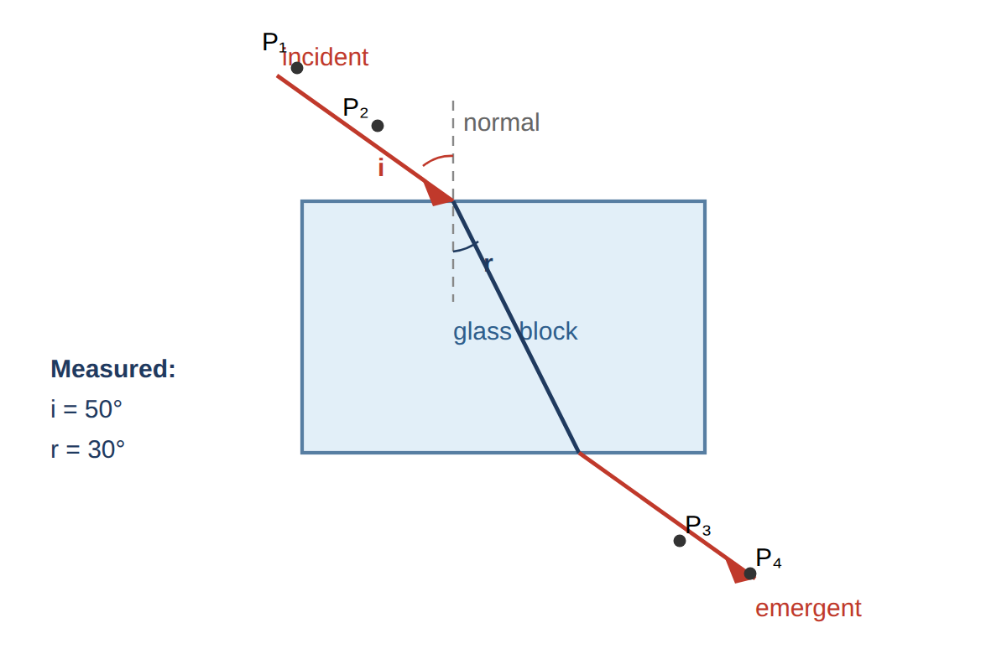
Fig. 5.1 — traced ray path. Angles measured from the normal: i = 50°, r = 30°.
- Describe how the student should position the two pins P1 and P2 so that the incident ray is accurate. [2]
- Explain why the ray bends towards the normal as it enters the glass. [2]
- Using the measured angles, calculate the refractive index of the glass. (Use sin 50° = 0.766, sin 30° = 0.500.) [2]
- State the number of significant figures appropriate for your answer and why. [1]
- Suggest two ways the student could reduce error when measuring the angles. [2]
Teach here: pins vertical and well separated (long baseline = smaller angular error). n = sin i / sin r. Emphasise measuring angles from the normal, not the surface — a very common slip.

Question 6 Cooling curve & heat loss | [10 marks]
PDO ACE
Hot water is placed in a beaker and its temperature recorded every minute as it cools. The results are plotted in Fig. 6.1.
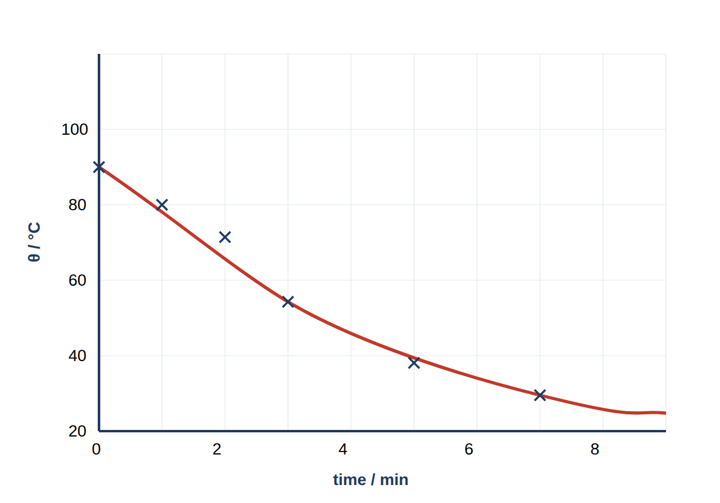
Fig. 6.1 — temperature of the cooling water against time.
- Use the graph to state the temperature of the water after 4.0 minutes. [1]
- Describe how the rate of cooling changes over the 8 minutes, and explain why in terms of temperature difference with the surroundings. [3]
- The student wants to reduce the rate of heat loss so the water stays hot longer. Suggest two changes to the apparatus and explain how each helps. [4]
- Explain why the temperature levels off rather than falling to 0 °C. [2]
Teach here: reading a curve (drop a line from t = 4). The rate = steepness of the curve, which decreases as the water approaches room temperature (smaller temperature difference → slower transfer). Levels off at room temperature.

Planning & Evaluation
Questions 7–8. Planning is worth 15% of Paper 3, and evaluation marks are scattered through every question. These two build the habits directly.
Question 7 Planning task | [8 marks]
PLANNING
A spring extends when a load is hung from it. A student wants to investigate how the extension of a spring depends on the load applied, and to find the load at which the spring stops obeying Hooke's law.
Plan an experiment to do this. Your plan should be detailed enough for another student to follow.
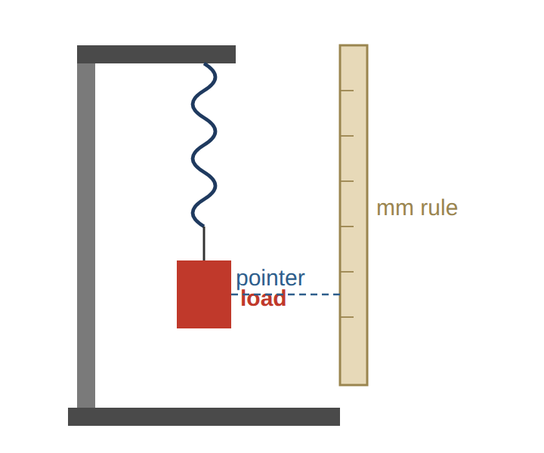
Fig. 7.1 — suggested apparatus (a guide only; the plan is yours to write).
In your plan, make sure you include:
- the independent, dependent and controlled variables; [2]
- the apparatus and a step-by-step method, including how you measure the extension; [2]
- the readings you would take and how you would use them (what you would plot); [2]
- how the graph shows where the spring stops obeying Hooke's law; [1]
- one safety precaution relevant to this experiment. [1]

Teach here: model the five-part skeleton aloud before the tutee writes. IV = load/force, DV = extension, controlled = same spring & temperature. Extension = new length − original (unstretched) length. Plot extension vs load; straight-through-origin region obeys Hooke's law, the point where it curves is the limit. Safety: masses can fall → keep feet clear / tray below / goggles.

Question 8 Errors & evaluation drill | [7 marks]
ACE
Short evaluation questions. These test the language examiners want in the “identify the error / suggest an improvement” parts.
- A student times one swing of a pendulum with a stopwatch and gets 1.4 s. Explain why this single reading is unreliable and describe a better method. [2]
- Distinguish between a random error and a systematic error, giving one example of each from a practical you have studied. [2]
- A set of calipers reads 0.03 mm when the jaws are fully closed. Name this type of error and state exactly how the student should correct every reading. [2]
- Explain why the improvement “repeat the experiment and take an average” does not help reduce a systematic error. [1]

Teach here: this is the highest-yield wrap-up. Hammer that improvements must be specific and matched to the named error. Zero error is systematic — subtracting the 0.03 mm fixes it; averaging never will because the offset is in every reading the same way.

Answer Key — Worked Marks
Mark points are shown as [1]-style tags. Accept equivalent correct wording. Award method marks even if the final number is wrong (error carried forward).
Question 1 — Density of an irregular solid [7]
(a) Eye level with the bottom of the meniscus / water surface [1]; to avoid a parallax error when reading the scale [1].
(b) V = V₂ − V₁ = 63.0 − 45.0 = 18.0 cm³ [1].
(c)
ρ = m / V = 47.25 / 18.0
= 2.625 → 2.63 g/cm³
Correct substitution [1]; answer 2.63 g/cm³ to 3 s.f. with unit [1]. (3 s.f. because the raw data is given to 3 s.f.)
(d) Air bubbles cling to the stone / it is not fully submerged, so the displaced volume reads too high [1]; tap or tilt to release bubbles and make sure the stone is completely under the water [1].

Question 2 — Simple pendulum → g [11]
(a) Timing one swing has a large percentage (reaction-time) error [1]; timing 20 and dividing by 20 spreads that fixed error over many swings, reducing the uncertainty in T [1].
(b) Axes labelled with quantity and unit, sensible scale using > half the grid [1]; all five points plotted correctly as small crosses [1]; single thin best-fit line, roughly balanced, passing near the origin [1].
(c) Using a large triangle on the line, e.g. from (0.20, 0.80) to (1.00, 4.02):
gradient = Δ(T²) / ΔL
= (4.02 − 0.80) / (1.00 − 0.20)
= 3.22 / 0.80 ≈ 4.0 s²/m
Large triangle / values read off the line [1]; gradient ≈ 4.0 s²/m (accept 3.9–4.1) [1].
(d) gradient = 4π²/g, so:
g = 4π² / gradient = 39.48 / 4.0 ≈ 9.9 m/s²
Correct rearrangement [1]; g ≈ 9.9 m/s² (accept 9.6–10.1) [1].
(e) Any one [1]: reaction-time error; amplitude too large; air resistance/draughts; length not measured to centre of bob.

Question 3 — Principle of moments [8]
(a) For a body in equilibrium, the sum of clockwise moments about a pivot equals the sum of anticlockwise moments about the same pivot [1].
(b) 100 g mass: 50.0 − 15.0 = 35.0 cm; mass M: 80.0 − 50.0 = 30.0 cm [1].
(c)
100 × 35.0 = M × 30.0
3500 = 30.0 M
M = 3500 / 30.0 = 116.7 g
Correct moment equation [1]; rearrangement [1]; M ≈ 117 g (accept 116–117) [1].
(d) The rule is uniform, so its weight acts at its centre of gravity, which is at the pivot; its perpendicular distance is zero, so its moment is zero [1].
(e) Any one precaution with reason [2]: use a knife-edge pivot so the balance point is well defined; check the rule is horizontal with a set square; take the balance point as the midpoint of the range where it just tips.

Question 4 — Resistance of a wire [12]
(a) R = V/I for each row:
20.0 cm: 0.42/0.60 = 0.70 Ω
40.0 cm: 0.84/0.60 = 1.40 Ω
60.0 cm: 1.26/0.60 = 2.10 Ω
80.0 cm: 1.68/0.60 = 2.80 Ω
100.0 cm: 2.10/0.60 = 3.50 Ω
All values correct [1]; consistent 2–3 s.f. with unit Ω [1].
(b) R is directly proportional to L (R ∝ L) [1]; e.g. when L doubles 20→40 cm, R doubles 0.70→1.40 Ω — R/L is constant [1].
(c) Straight line [1] through the origin, axes labelled R / Ω (y) against L / cm (x) [1].
(d) Current heats the wire; a hotter wire has higher resistance [1]; switching off keeps it near room temperature so R depends only on length (avoids a systematic error) [1].
(e) She adjusted the rheostat/variable resistor to bring the current back to 0.60 A [1]; component = rheostat (variable resistor) [1].
(f) Any one [2]: end of wire not at the zero mark / hard to see the contact → view square-on, use a set square; wire not straight → keep it taut.

Question 5 — Refraction through a glass block [9]
(a) Place both pins vertically (upright) [1] and as far apart as possible along the ray, so the direction is defined accurately [1].
(b) Light slows down on entering the denser glass [1]; the part of the wavefront that enters first slows first, so the ray bends towards the normal [1].
(c)
n = sin i / sin r = sin 50° / sin 30°
= 0.766 / 0.500 = 1.53
Correct formula & substitution [1]; n ≈ 1.53 [1].
(d) 3 s.f. (or 2 s.f.), because the sine values / measured angles are known to about that precision [1].
(e) Any two [2]: sharp pencil, measure from the normal; long ray lines; pins far apart; repeat for several angles and average / plot sin i vs sin r.

Question 6 — Cooling curve & heat loss [10]
(a) About 55 °C (accept 52–58 °C read at t = 4.0 min) [1].
(b) Cooling is fast at first then slows / the curve gets less steep [1]; the rate of heat loss depends on the temperature difference with the surroundings [1]; as the water cools this difference shrinks, so energy transfers more slowly [1].
(c) Any two changes, each with a reason [4]: lid → reduces evaporation/convection from the top; insulation/lagging → reduces conduction & convection from the sides; insulating mat → reduces conduction through the base; cover shiny surface → reduces radiation.
(d) Cooling stops at the temperature of the surroundings (room temperature) [1]; no temperature difference then means no net transfer of energy [1].

Question 7 — Planning task (Hooke's law) [8]
(i) Variables [2]: IV = load/force; DV = extension; controlled = same spring, same starting length, constant temperature.
(ii) Apparatus & method [2]: clamp the spring vertically; fix a rule alongside with a pointer at the lower end; record the unstretched reading; add a known mass, let it settle, record the new reading; extension = new − original; repeat in equal steps.
(iii) Readings & graph [2]: 6–8 loads over a sensible range; table of load and extension; plot extension (y) against load (x).
(iv) Interpreting the graph [1]: straight line through the origin while it obeys Hooke's law; the load where the line starts to curve is the limit of proportionality.
(v) Safety [1]: masses may fall — keep feet clear / tray or cushion below; or wear eye protection in case the spring snaps.
Award full marks only if the method is genuinely repeatable and the fair-test controls are stated.

Question 8 — Errors & evaluation drill [7]
(a) One swing is comparable to the ~0.2 s reaction time, so the percentage error is very large [1]; time many oscillations (e.g. 20) and divide, starting/stopping at a fiducial mark as the bob passes the centre [1].
(b) Random error: scatters readings both sides of the true value (e.g. reaction-time timing) — reduced by repeating and averaging [1]. Systematic error: shifts every reading the same way (e.g. zero error, heat loss) — reduced by fixing the cause [1].
(c) A zero error (systematic) [1]; subtract 0.03 mm from every reading [1].
(d) The same offset is present in every reading, so averaging keeps it — it does not cancel; only correcting the cause removes it [1].

Closing checklist to run with your tutee
Units in every column heading and final answer • consistent significant figures • graph fills > half the grid with sensible scales • gradient triangle spans > half the line • every “improvement” is specific and matched to a named error. Nail these five and the technique marks look after themselves.

Written to the SEAB Singapore–Cambridge O-Level Physics syllabus 6091 (first examined 2026). Original teaching material, not reproductions of past papers. From 2027 the O- and N-Level exams consolidate into the Singapore–Cambridge Secondary Education Certificate (SEC); confirm practical requirements against current SEAB documents for later cohorts.

