Guide

### Additional JS Files

I added these JS files to get JavaScript libraries such as Drag & Drop and Twitter widget libraries. Also I added jquery_drag_drop.js where in it there’s JavaScript code that I created so I can drag and drop the components in the website.

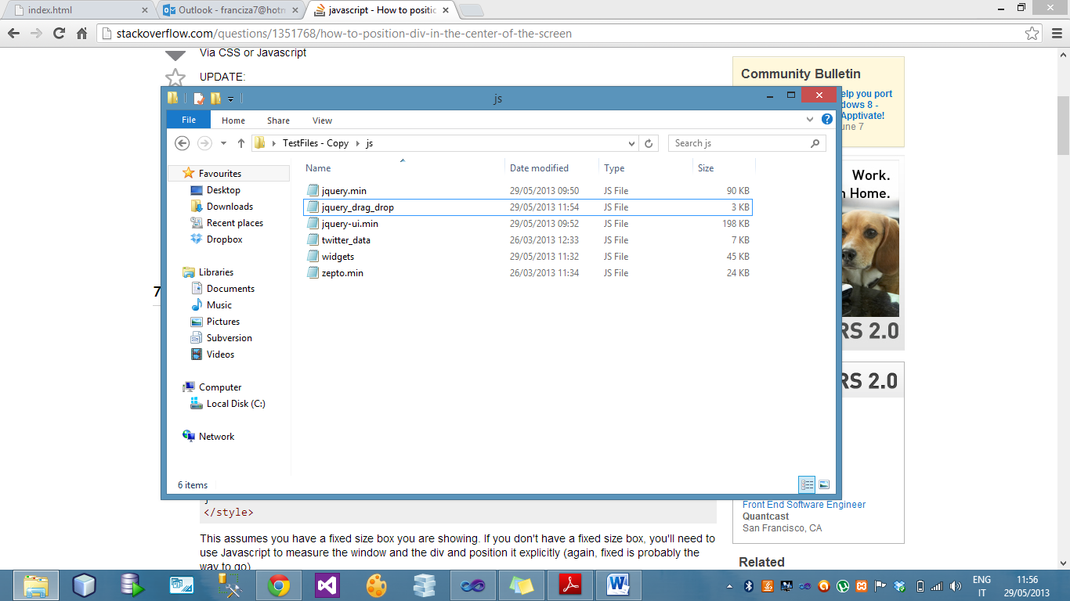

### Scrolling inside the widget window (the widget should display only 5 tweets at the same time)

In the sidebar I implemented a twitter widget which it displays 5 tweets and allow users to scroll inside the widget window.

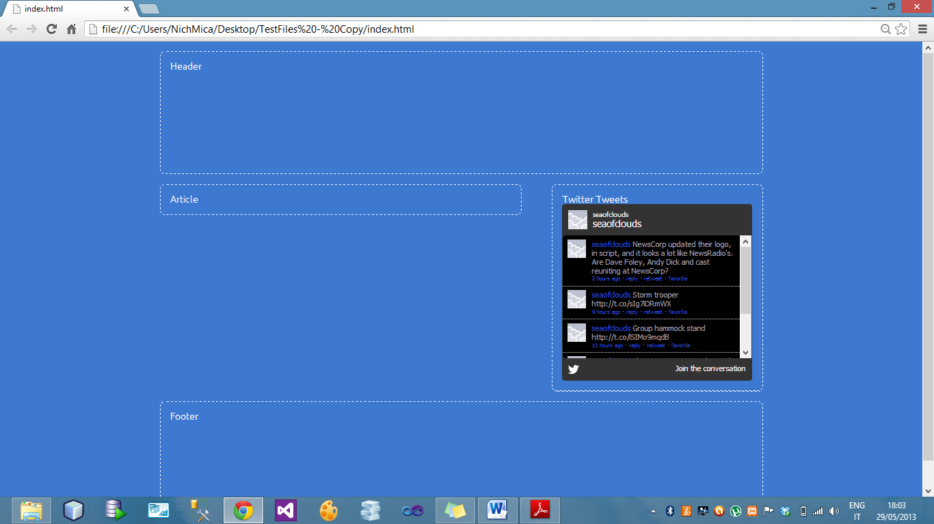

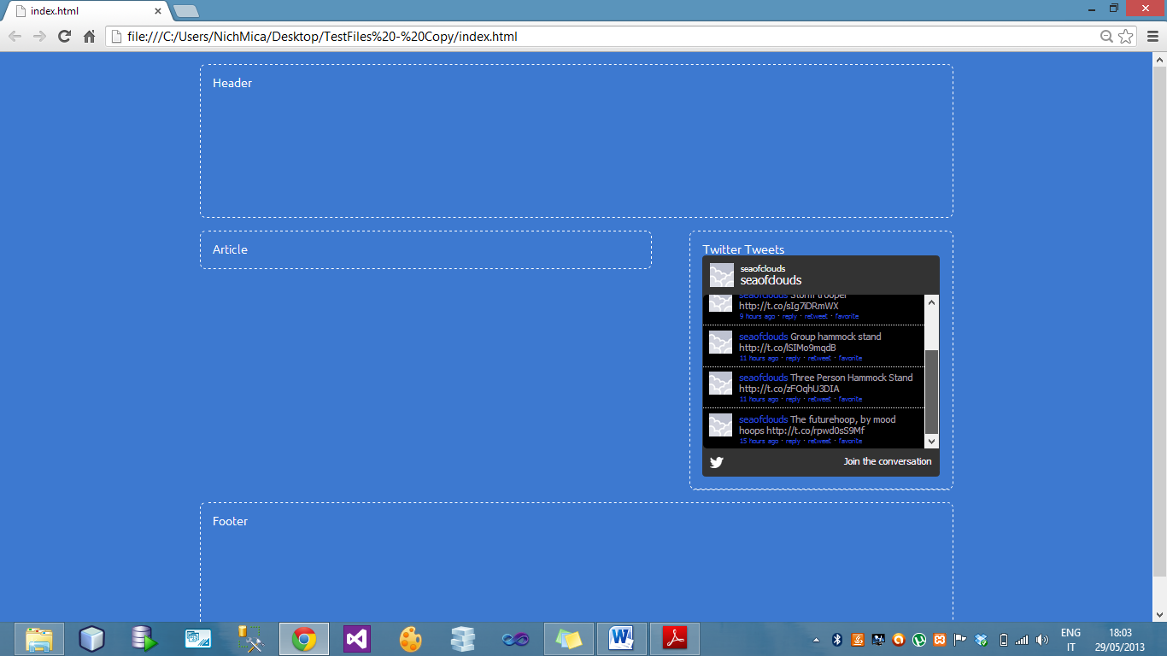

### Drag & drop (Sidebar & Article).

The sidebar or article can be dragged either to the left or right side. When the user tries to drag the sidebar / article, two black boxes will appear to indicate to which position (Left & Right) the component can be dragged and placed. Once the component is dragged and dropped, the other component will automatically move to the opposite position. This is done so the components cannot be placed on each other. Example: If the sidebar is dragged to the left side automatically the article will move to the right hand side.

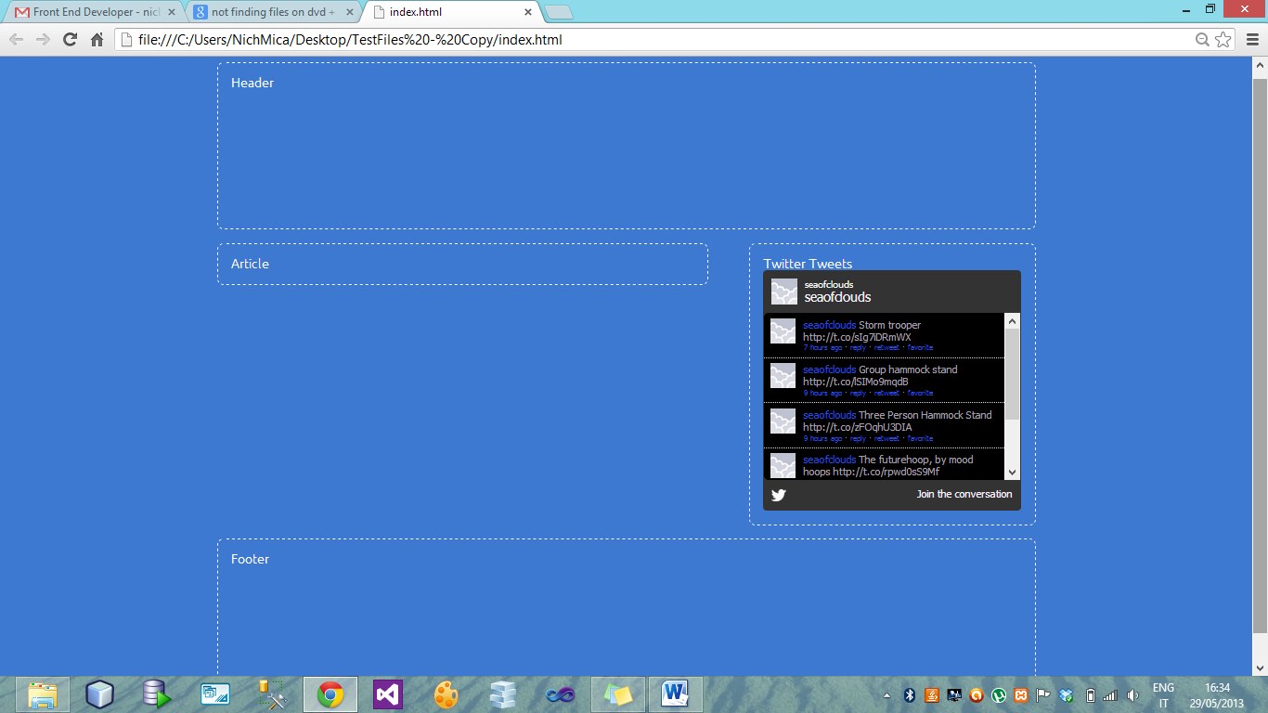

Figure 1: Current position of the sidebar and article before being dragged

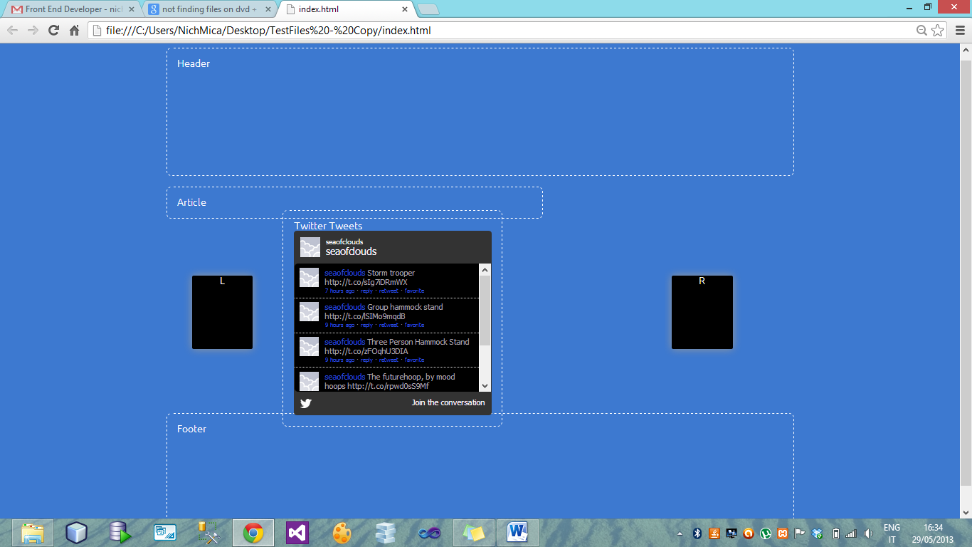

Figure 2: Sidebar is being dragged to the left hand side

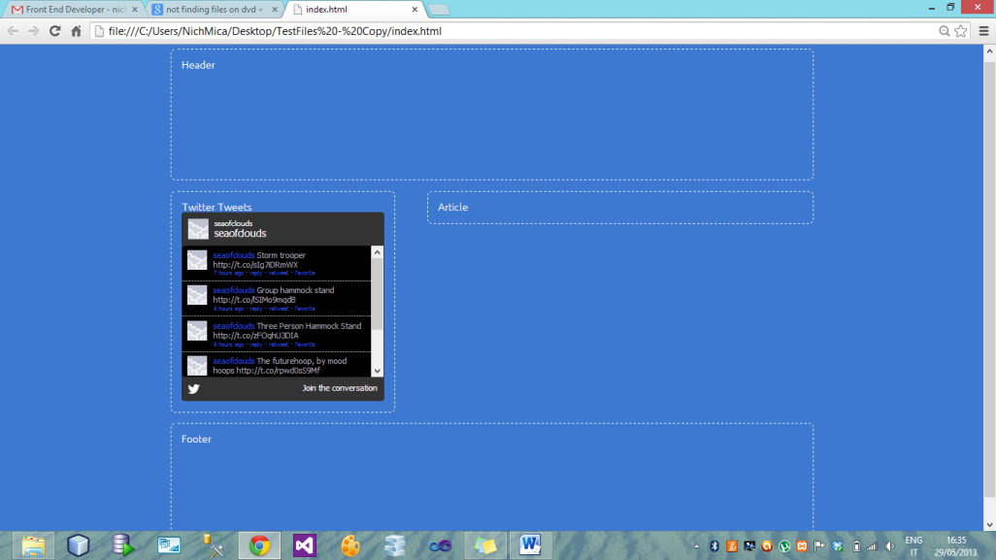

Figure 3: After the sidebar was dragged to the left hand side, the article was automatically moved to the right hand side.

### Site rendered on the following browsers:

##### Chrome 25.0.1364.172 (build number may vary)

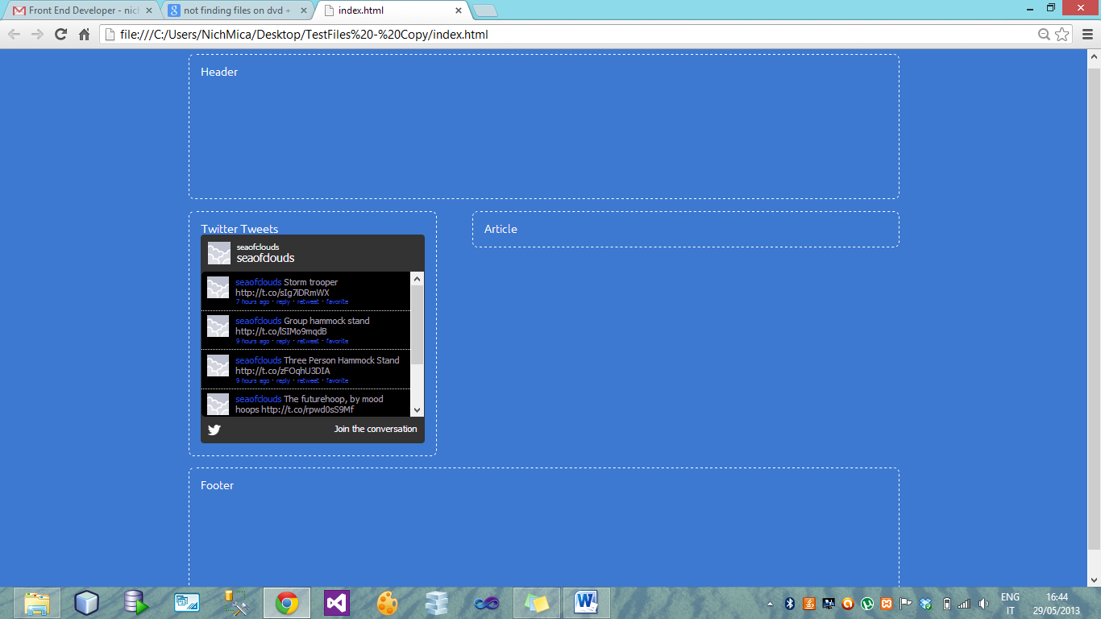

##### Internet Explorer 9

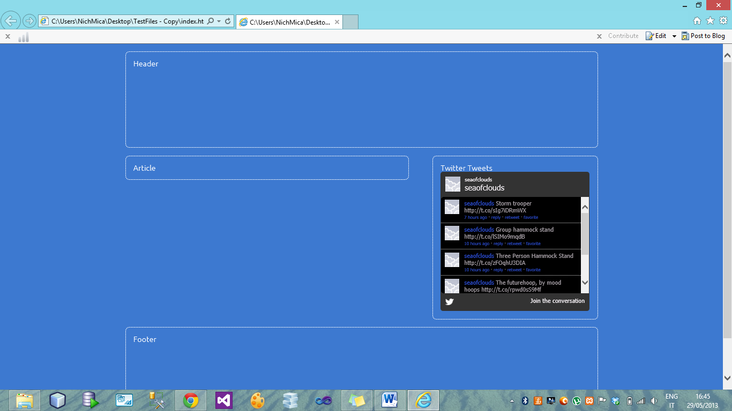

### W3C tools for testing

##### HTML

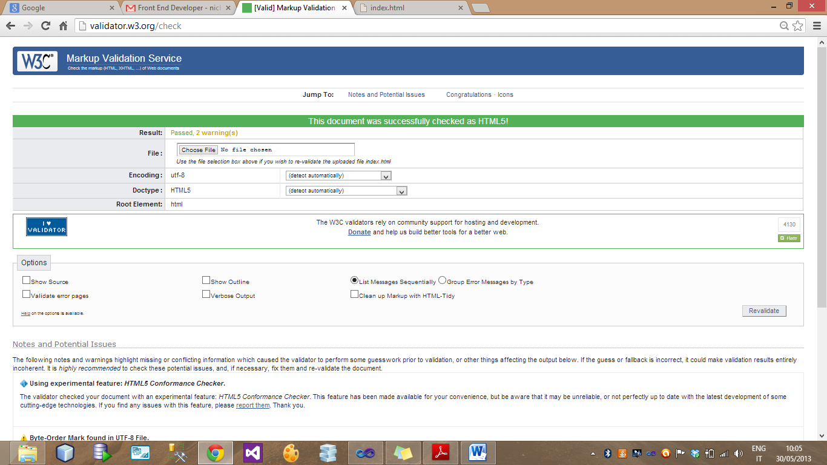

##### CSS

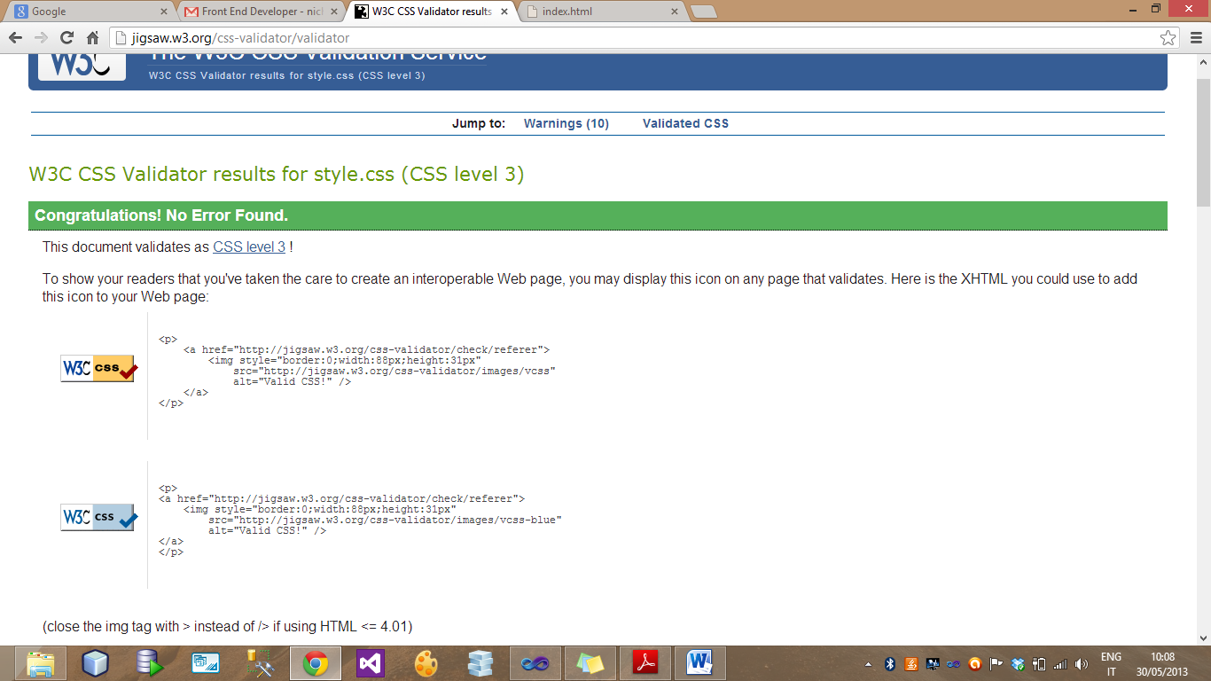

### Site must be built using a responsive approach, which means that it has to be optimized properly for at least three types of devices:

I added CSS files so when the size/resolution of the device changes, the site will be optimized properly on the device screen.

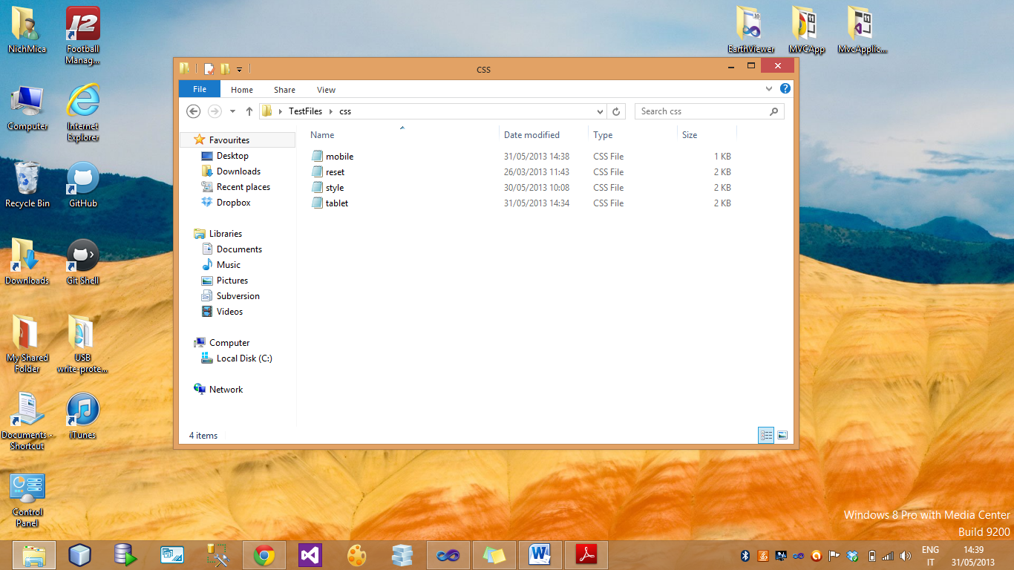

##### Desktop Screen:

The site on a desktop screen will appear like this.

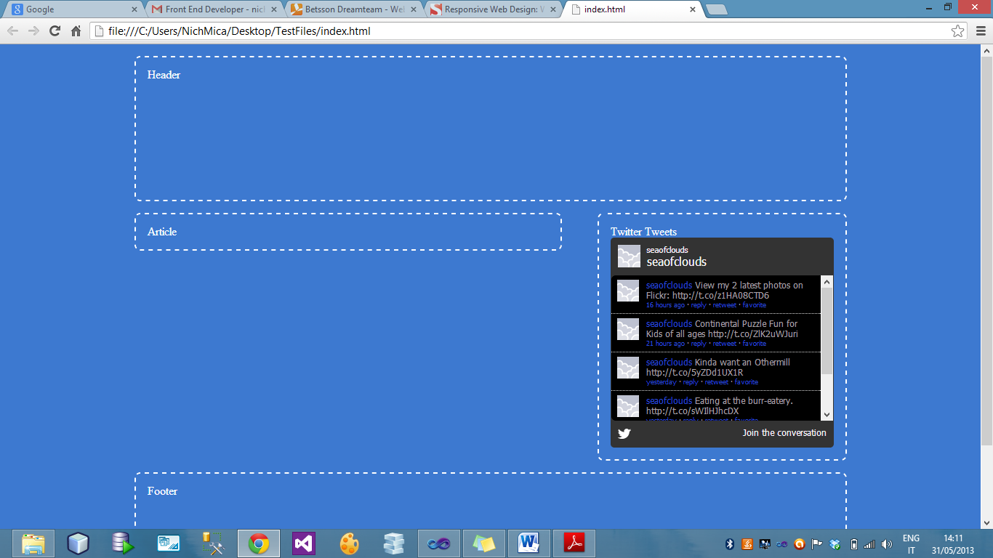

##### Mobile Screen:

The site on a mobile screen will appear like this. As you can see, when the site appear on a mobile screen I modified the CSS so the sidebar will be displayed after the article content. (Screenshots taken from 2 different mobiles).

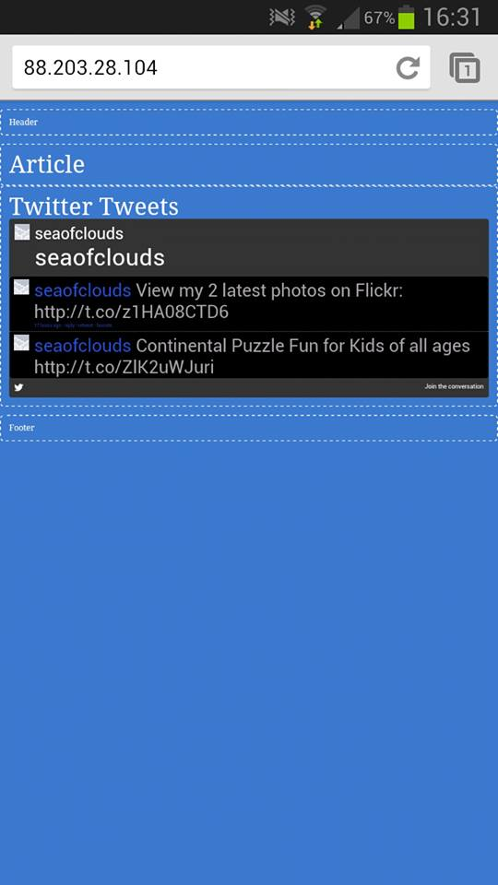 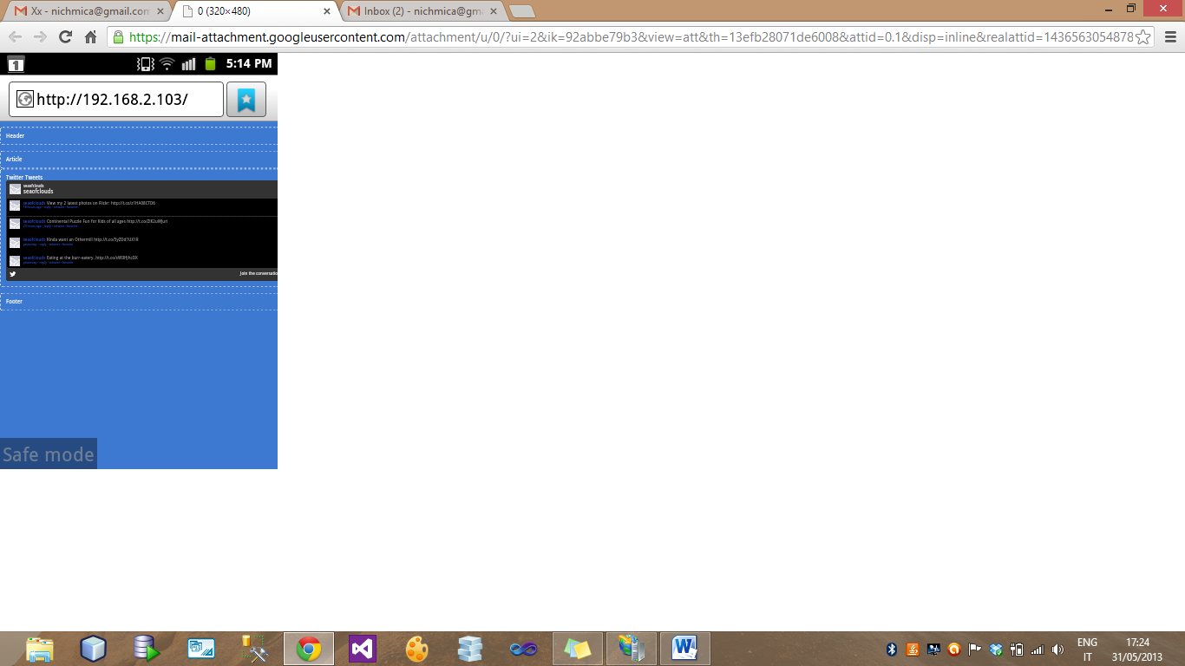

##### Tablet Screen:

I modified another CSS (tablet.css) file so when the site will appear and be optimized properly on a tablet screen. (Screenshots taken from IPad)

