**Scenario+Storyboard**

**New**

Billy is a new COSC1046 student who wants to write his first Java program, with the help of Extreme Editor Plus ™. As an Amateur, he simply enters “Hello w”, but decides to backspace and put a capital ‘w’ instead, resulting in “Hello World” being printed.

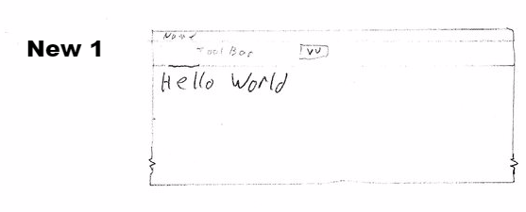

After hitting return, and expecting more than just a line printed, as a new user, he hits the “▼▼” curious as to what it does. He sees it lists his writing history.

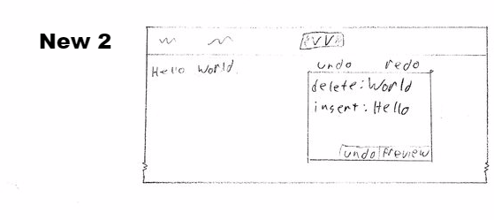

He selects the ‘World’ entry, then clicks undo:

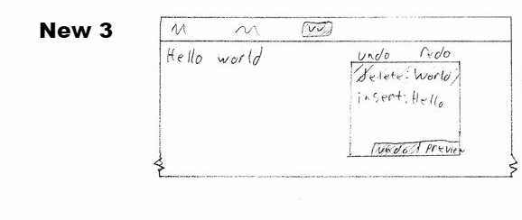

That action removes the ‘World’, then he renters it written with a lower case ‘w’.

While confused why nothing is happening in regards to the Hello World program he wishes to create, Billy is content with how Extreme Editor Plus™ functions as a text editor.

**Advanced**

Sally is an experienced Extreme Editor Plus™ programmer, and is aware of the shortcuts and features a new user may not be aware of. She is going to edit a small program she coded earlier.

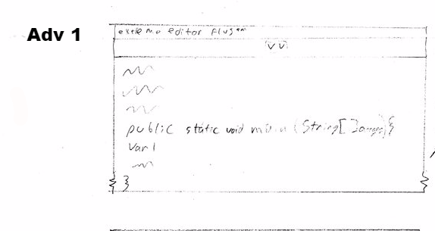

She enters a line ‘var 1’ consisting of something she wants to remove. She accidently removes both it, and the line above. Thus, she opens the undo/redo history, showing her previous actions:

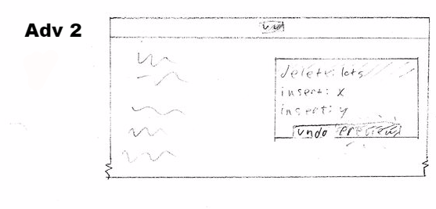

The ‘delete’ action being the most recent would contain her mistake. Just to be certain, she selects it and presses the Preview button, not wanting any uncertainty when editing this program.

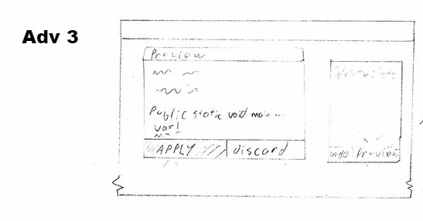

This opens the Preview pane, which appears over the normal work area, but a separate entity that can be moved or resized. As this replaces the line she mistakenly removes, she pressed the ‘Apply’ button, confirming the undo-delete action, resulting in:

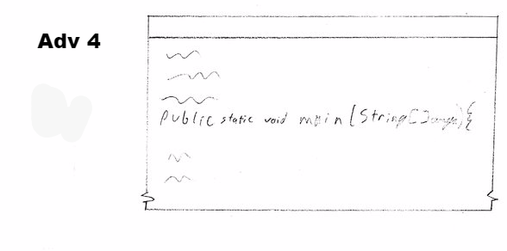

The line being replaced, and Sally removing ‘var 1’ more carefully.

This demonstrates the level of control and certainty Extreme Editor Plus™ can have, as Sally doesn’t want to mistakenly change something risky with CRTL+Z, not seeing where the change takes place. She wanted more control.