Fraud Detection, Measured in Money
A Leakage-Safe, Cost-Sensitive Study of Credit-Card Fraud Detection
with Ensemble Learning, Probability Calibration, and Explainable Diagnostics
Course: EECS 3404 — Applied Machine Learning
Institution: York University
Team: [ team member names & student numbers ]
Date: July 2026
Repository: github.com/nicholaekim/ML-project-york

Contents
Abstract 3
1. Problem Definition and Motivation 3
2. Dataset and Preprocessing 3
3. Methodology 4
4. Experiments and Results 5
5. Discussion: Limitations, Uncertainty, Drift, and Bias 9
6. Engineering Workflow and Reproducibility 9
7. Conclusion 9
References 10
Appendix A. Reproducing the Results 11

Abstract
Credit-card fraud is a rare-event problem — 492 of 284,807 transactions (0.17%) — in which the standard evaluation habits (reporting accuracy, and applying synthetic oversampling before the train/test split) silently and severely overstate performance. We build a fraud detector whose pipeline makes such data leakage structurally impossible, evaluate it in dollars saved rather than abstract scores, and run eight self-contained experiments that quantify how much the common shortcuts inflate results and which of our own conclusions are statistically real. Our best honest model (a class-weighted Random Forest with calibrated probabilities) prevents about 67% of do-nothing fraud losses. A 2⁴ factorial ablation shows a single mistake — oversampling before splitting — accounts for essentially the entire inflation (reported PR-AUC rises by 0.25 while the true score is unchanged) and ships a model whose deployed F1 is 0.07 versus a reported 0.95. A paired bootstrap shows every pairwise classification-score win among our top models is statistical noise at 95 test frauds, while our headline money result was confirmed on held-out seeds. Every figure is reproducible from raw data with one command per experiment.

1. Problem Definition and Motivation
Financial institutions must flag fraudulent card transactions in real time, under two hard constraints. First, fraud is extremely rare: in our data it occurs once in every 579 transactions. Second, the costs are asymmetric — missing a large fraud is far costlier than investigating a false alarm. Together these make the naïve machine-learning workflow actively misleading.
The rarity breaks accuracy as a metric. A model that flags nothing is 99.83% accurate and catches zero fraud, so accuracy cannot distinguish a useful model from a useless one. The rarity also invites a subtle methodological error: because positive examples are scarce, practitioners synthesise artificial fraud examples (SMOTE). Done incorrectly — before the data is split — this leaks information from the test set into training and inflates every reported number. A recent critical survey shows a trivial model with this leak can appear to beat most published methods.
This project's contribution is therefore not a novel model but a rigorously honest workflow: (i) a pipeline in which leakage cannot occur, (ii) evaluation in monetary units that reflect the real decision, and (iii) an experimental programme that measures the cost of the common mistakes and the statistical reliability of every claim — including our own.

2. Dataset and Preprocessing
We use the ULB / Worldline Credit Card Fraud Detection dataset (Kaggle: mlg-ulb/creditcardfraud): 284,807 European card transactions over two days in September 2013, of which 492 (0.172%) are fraudulent. The features are Time, V1–V28 (anonymised principal components from a PCA the data provider applied for confidentiality), Amount, and the binary Class label.

2.1 Preprocessing decisions
- Deduplication. The dataset contains 1,081 exact duplicate rows. More importantly, we found 9,144 duplicate rows in the feature space the model actually sees (V1–V28 + Amount, ignoring Time) — roughly eight times the exact-duplicate count. Ordinary drop_duplicates() therefore still leaves thousands of model-identical rows able to straddle the train/test boundary. We deduplicate on the model-visible columns before splitting.
- Excluding Time. Time is elapsed seconds within the 2-day window; used as a feature it encodes a transaction's position in that window and does not generalise (and gives away a temporal split). We exclude it from the model features but use it for the out-of-time evaluation (§4.5).
- Scaling and resampling live inside the pipeline. Amount is standardised, and any resampling is fit on the training folds only — see §3.2.
- Amount as cost. The Amount column doubles as the cost of a missed fraud in our money metric (§3.4). Notably, ~45% of frauds are ≤ $5, which reshapes what an optimal policy should even attempt.

3. Methodology

3.1 Train / validation / test protocol
We split the data before any learning step. Two split strategies are used deliberately: a stratified random split (preserving the 0.17% positive rate in each part) for the main study, and a temporal split (train on the earliest transactions, test on the latest) as a deployment-realistic robustness check. Decision thresholds and probability calibrators are fit on the validation split only; the test set is scored exactly once. All experiments repeat over five random seeds and report mean ± standard deviation.

3.2 The leakage-safe pipeline
Every learning step — the StandardScaler and the resampler — is wrapped in a single imbalanced-learn Pipeline object. Because scikit-learn re-fits that object on the training fold at every step (including inside cross-validation), the scaler and SMOTE can only ever learn from training data. Leakage is prevented by construction, not by discipline. This is the project's methodological spine, and §4.3 measures exactly what happens when it is violated.

3.3 Models and baselines
We compare five classifiers of increasing capacity: Logistic Regression (a linear baseline), Random Forest (bagging), and three gradient-boosted implementations — HistGradientBoosting, XGBoost, and LightGBM. Every model is judged against four reference baselines that any real system must beat: flag-nothing (the do-nothing bank), flag-all, an oracle that flags every fraud, and a cost-optimal oracle that flags only frauds worth more than the investigation fee.

3.4 Metrics and the cost model
Because accuracy is uninformative here, our primary statistical metric is PR-AUC (average precision), which is appropriate under extreme imbalance; we report accuracy only to demonstrate its uselessness. Our primary decision metric is monetary. Following an example-dependent cost model, each alert (true or false) costs a fixed investigation fee of $5, and each missed fraud costs its own transaction amount. We define
savings = 1 − (model cost ⁄ do-nothing cost),
so 1.0 is a perfect policy, 0 is no better than ignoring fraud, and negative values mean the alerts cost more than the fraud they prevent. Thresholds are tuned to maximise savings on validation — the model literally optimises money.

4. Experiments and Results

4.1 Money benchmark and imbalance ablation (E1–E2)
Running all five models under four imbalance strategies (class weights, SMOTE, undersampling, none) over five seeds, evaluated in dollars, produces the leaderboard below. Two findings stand out: classification quality and money are different rankings, and the simple class-weight strategy matches or beats SMOTE while undersampling hurts.
Policy / model | Savings | PR-AUC | F1 | Fraud $ missed
Cost-optimal oracle (ceiling) | 0.971 | — | — | —
class_weight / RandomForest (money winner) | 0.671 | 0.809 | 0.821 | $3,348
class_weight / LightGBM (PR-AUC winner) | 0.664 | 0.829 | 0.808 | $3,328
SMOTE / RandomForest | 0.541 | 0.810 | 0.807 | $4,347
Do nothing | 0.000 | — | — | —
Block everything | −24.47 | — | — | —
Table 1. Selected results from the 5-seed money benchmark (mean over seeds). Full table: results/tables/benchmark_summary.csv.
The best honest model prevents about 67% of do-nothing losses. The PR-AUC leader (LightGBM) is not the money leader (Random Forest), and — most tellingly — SMOTE + Random Forest is competitive on PR-AUC (0.810) yet near the bottom on savings, letting $4,347 of fraud value through versus $3,348 for the money winner (30% more). A model can rank well and still be the wrong one to deploy. Even the perfect oracle scores 0.971, not 1.0, because it correctly declines to chase sub-$5 frauds that cost more to investigate than they are worth.

4.2 Decision policies and the price of calibration (E3)
We next ask whether a smarter decision rule and honest probabilities earn more money. The decision-theoretic rule — flag a transaction when p × Amount > $5 (expected loss exceeds the fee) — needs no tuning but trusts the probabilities literally. Class-weighted Logistic Regression's raw probabilities are calibrated to an artificial balanced world and are inflated roughly 300-fold; fed into the rule they lose 3.5× the total fraud value (savings −3.56). A single post-hoc Platt-scaling step, fit on validation, repairs the same model to +0.67 — a swing of roughly $48,000 per test slice. Models that were already well calibrated (LightGBM) gain almost nothing. Calibration is worth money in direct proportion to how miscalibrated the model was.
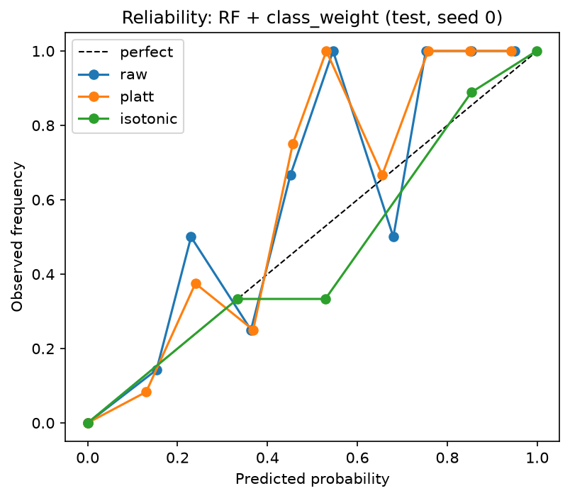
Figure 1. Reliability diagram for the showcase model on the test set: raw scores vs. Platt- and isotonic-calibrated probabilities. A well-calibrated curve tracks the diagonal.

4.3 Leakage forensics: a 2⁴ factorial ablation (E4)
Rather than a single leaky-vs-safe comparison, we make each classic mistake an independent on/off factor — SMOTE-before-split, scaling on all data, keeping duplicates, tuning the threshold on the test set — and run all sixteen combinations. Every configuration is scored twice: on its own (possibly poisoned) test set, the number a flawed notebook would publish, and on a pristine holdout carved out before any mistake could act.
Sin (turned on) | Δ reported PR-AUC | Δ true PR-AUC | Δ reported F1 | Δ true F1
SMOTE before split | +0.249 ± 0.029 | −0.000 | +0.123 | −0.713
Scaler fit on all data | +0.001 | −0.001 | +0.001 | −0.000
Keep duplicate rows | −0.003 | −0.002 | +0.000 | −0.000
Tune threshold on test | 0.000 | 0.000 | +0.005 | +0.000
Table 2. Main effect of each sin, Logistic Regression, averaged over the other factors and 5 seeds (results/tables/leakage_forensics_effects.csv).
The attribution is unambiguous. SMOTE-before-split alone accounts for essentially the entire inflation (+0.25 reported PR-AUC); every other sin is within noise of zero. And it is a poisoned test set, not a better model: the true PR-AUC moves by −0.0002. The full "Kaggle-special" pipeline reports 0.99 while its clean-holdout truth is 0.74; the honest pipeline reports 0.744 against a clean-holdout truth of 0.742 — honesty verified, not assumed. Tuning the threshold on test inflates F1 but, by construction, cannot move PR-AUC (a printed consistency check confirms exactly 0.000).
The same sin also ships a broken product. Its reported F1 is 0.95, but the identical model and threshold deployed at the real 0.17% prevalence score an F1 of 0.07 — a 13.5× overstatement — because the decision threshold was tuned in an artificial balanced world and floods false alarms in reality. The mistake therefore inflicts two distinct harms: a dishonest score and a non-functional operating point.

4.4 Are the differences real? A paired bootstrap (E5)
With only ~95 frauds in a test set, single-number differences may be luck. We quantify this with a paired bootstrap: the same test rows are resampled 1,000 times for every model at once, so sampling luck cancels and the confidence interval lands on the difference between models.
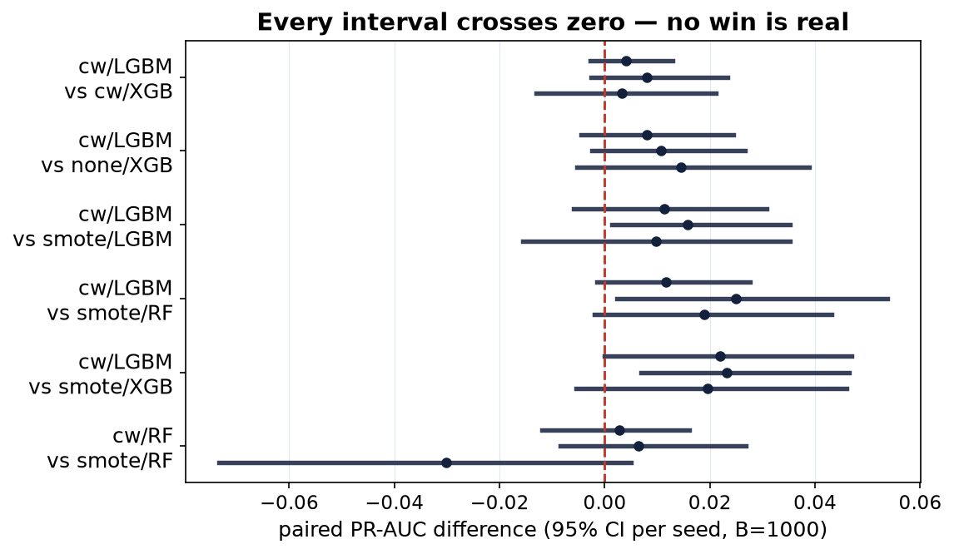
Figure 2. Paired 95% confidence intervals on PR-AUC differences (leader vs. challengers, per seed). Every interval crosses zero — no PR-AUC ranking is statistically distinguishable.
Every pairwise PR-AUC "win" among our top models is statistically indistinguishable — LightGBM's 0.005 edge over XGBoost straddles zero in every seed, and the PR-AUC leader even changes between seed sets. The single-number leaderboard is noise at this scale. We then applied the same test to our own headline money result. On the discovery seeds its interval merely touched zero, so we pre-registered the comparison and re-ran it on fresh seeds 3–4, where both intervals exclude zero (seed 3: [+0.084, +0.227]; seed 4: [+0.058, +0.167]). The money gap is therefore confirmed on held-out data — a discovery → pre-register → confirm sequence that we report exactly.

4.5 Out-of-time robustness (E6)
Training on the earliest transactions and testing on the latest — how a deployed system actually operates — reduces the best model's savings from ~0.67 to ~0.61, and reorders the leaderboard (the stratified PR-AUC leader is no longer on top). Forward-in-time prediction is measurably harder than the random split every tutorial uses. Because the dataset spans only two days, we treat this as a robustness check rather than a concept-drift study, and say so.

4.6 Interpretability and error economics (E7)
We open the model three ways. Globally, permutation importance and SHAP agree on the dominant drivers (components V14, V4, V11, V12); we are careful that, because the features are anonymised principal components, these identify influential components, not human-readable causes — a genuine interpretability ceiling of this dataset.
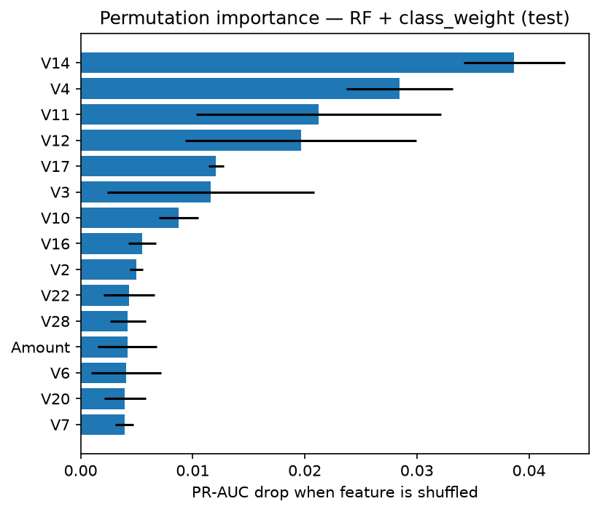
Figure 3. Permutation importance (drop in PR-AUC when each feature is shuffled) for the showcase model on the test set.
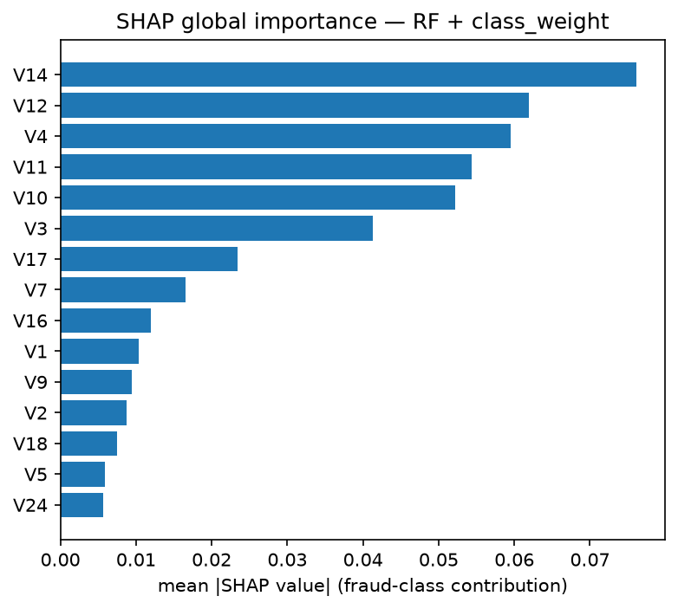
Figure 4. SHAP global importance (mean |SHAP value|) for the showcase model; it independently agrees that V14 and V12 are top drivers.
Locally, two case studies are instructive. The model's most confident false alarm was a $2.00 transaction (score 0.687) — even a correct alert there loses money, which is exactly why the per-transaction rule of §4.2 exists. Its most expensive miss, $1,097, scored 0.000: SHAP shows the strongest global fraud signals both pointed "legitimate", so it is a genuine blind spot, not a near-miss. Finally, an error-economics view by amount band shows misses are wildly unequal: nine missed frauds under $5 cost $14 in total, whereas two missed frauds over $100 cost $1,646. Error analysis for fraud must be economic, not merely counted.

4.7 Leakage-safe hyperparameter optimisation (E8)
A RandomizedSearchCV over LightGBM, run entirely inside the leakage-safe pipeline (cross-validation on the training split only), improved cross-validated average precision but did not move test-set performance beyond the bootstrap noise floor (PR-AUC 0.886 → 0.881; savings 0.783 → 0.797, both within ±0.02). With only ~280 training frauds, hyperparameter search largely polishes noise. We report this honest null result rather than cherry-picking a favourable run.

5. Discussion: Limitations, Uncertainty, Drift, and Bias
- Leakage. Addressed directly and quantified (§4.3); our pipeline prevents it by construction, and we measured the cost of violating it.
- Uncertainty. All headline numbers carry seed-to-seed standard deviations, and comparisons use paired bootstrap confidence intervals. The top savings cluster (0.671 / 0.664 / 0.656) is within noise, which is why we do not over-claim a single "best" model on PR-AUC.
- Drift. The out-of-time split (§4.5) shows performance degrades on future data. The 2-day span limits this to a robustness check, not a longitudinal drift study.
- Bias / fairness. The features are anonymised principal components with no demographic attributes, so a formal fairness analysis is impossible — we state this rather than implying a fairness guarantee.
- Cost-model assumption. The $5 fee is an assumption exposed as a single configuration constant; savings conclusions should be read relative to it, and the framework re-runs under any cost.
- External validity. A single, anonymised, 2-day European dataset is not representative of all deployment settings; the methodology, not the specific numbers, is the transferable contribution.

6. Engineering Workflow and Reproducibility
Every experiment followed a build → adversarially review → fix → verify loop, and the reviews caught real defects in our own work before they reached any result: a "clean" holdout that was contaminated in feature space (the 9,144-duplicate finding), a headline metric that was inadvertently selecting the better calibrator on test data, a misspecified Platt implementation, and a pre-registered hypothesis that was mathematically incapable of failing (reframed as a consistency check). Applying the project's own skepticism to the project is itself part of the methodology.
The repository is organised as a small library (src/: data, pipeline, models, evaluation, calibration, explainability, statistics) plus one script per experiment (experiments/). Every table and figure is regenerated by a single command; seeds are fixed and dependencies pinned, so a fresh clone reproduces our numbers exactly. Reproduction commands are listed in Appendix A.

7. Conclusion
We set out to build not merely a fraud model but an honestly evaluated one. The resulting workflow prevents data leakage by construction, evaluates in money rather than abstract scores, and demonstrates — through a factorial ablation, a paired bootstrap, and a confirmatory re-test — that one common shortcut causes almost all of the inflation seen in typical projects, that classification scores and monetary value are different rankings, that probability calibration has a measurable dollar value, and that most model "wins" at this data scale are statistical noise. Four numbers summarise the study: 0.99 vs 0.74 (the reported-versus-true gap of a leaky pipeline), ~$48,000 (the value of honest probabilities), 13.5× (how badly one sin overstates a deployed model), and 95 (the fraud count that makes every claim require an interval). The work is fully reproducible and, we hope, a useful template for evaluating rare-event classifiers honestly.

References
[1] Dal Pozzolo, A., Caelen, O., Johnson, R. A., & Bontempi, G. (2015). Calibrating probability with undersampling for unbalanced classification. IEEE Symposium Series on Computational Intelligence, 159–166.
[2] Bahnsen, A. C., Aouada, D., & Ottersten, B. (2014). Example-dependent cost-sensitive logistic regression for credit scoring. IEEE ICMLA, 263–269.
[3] Chawla, N. V., Bowyer, K. W., Hall, L. O., & Kegelmeyer, W. P. (2002). SMOTE: Synthetic Minority Over-sampling Technique. Journal of Artificial Intelligence Research, 16, 321–357.
[4] Lundberg, S. M., & Lee, S.-I. (2017). A unified approach to interpreting model predictions (SHAP). Advances in Neural Information Processing Systems, 30.
[5] Saito, T., & Rehmsmeier, M. (2015). The precision-recall plot is more informative than the ROC plot on imbalanced datasets. PLoS ONE, 10(3).
[6] Pedregosa, F., et al. (2011). Scikit-learn: Machine Learning in Python. JMLR, 12, 2825–2830.
[7] ULB Machine Learning Group. Credit Card Fraud Detection dataset. Kaggle: mlg-ulb/creditcardfraud.

Appendix A. Reproducing the Results
From the repository root, after installing requirements and placing creditcard.csv in data/raw/:
Command | What it produces
python -m experiments.run_benchmark | E1/E2 — money benchmark, imbalance ablation, leaky-vs-safe
python -m experiments.run_policy_ladder | E3 — decision policies × calibration, priced in dollars
python -m experiments.run_leakage_forensics | E4 — 2⁴ sin-by-sin ablation with clean-holdout dual evaluation
python -m experiments.run_bootstrap | E5 — paired-bootstrap significance (needs E1 score files)
python -m experiments.run_benchmark --split temporal | E6 — out-of-time robustness
python -m experiments.run_explain | E7 — SHAP, permutation importance, error economics
python -m experiments.run_tuning | E8 — leakage-safe RandomizedSearchCV
All commands write CSVs to results/tables/ and figures to results/figures/. Add --quick for a fast smoke test.

