**Airborne Contamination during Post-Fire Investigations: Hot, Warm & Cold Scenes**

1Gavin P. Horn, 1Daniel Madrzykowski, 2Summer Neumann, 3Alexander Mayer, 3Kenneth W. Fent

*1UL Firefighter Safety Research Institute; Columbia, MD*

*2UL Environment & Sustainability; Lake Forest, CA*

*3National Institute for Occupational Safety & Health; Cincinnati, OH*

**Address correspondence to**:

Gavin P. Horn

UL Firefighter Safety Research Institute

Underwriters Laboratories Inc.   
 6200 Old Dobbin Lane, Suite 150  
 Columbia, MD 21045 USA

Telephone: 847.664.6699

E-mail: [gavin.horn@ul.org](mailto:ghorn@illinois.edu)

**Acknowledgements/Funding**: This work was supported by Underwriters Laboratories, Inc. The authors thank Sameual Horner and Nelson Tirado for their hard work in data collection and support from Mark Carpenter throughout the project. Craig Weinschenk, Keith Stakes and the UL FSRI staff supporting the firefighting tactics study that produced the investigations scenes studied in this work. The findings and conclusions are those of the author(s) and do not necessarily represent the official position of the National Institute for Occupational Safety and Health, Centers for Disease Control and Prevention.

**Disclosure**: There are no conflicts of interest regarding this work.

**Abstract** (230 words)

.

**Keywords:** fire investigators, combustion products**,** occupational exposure,

**Word Count:** xxxx words

# INTRODUCTION

The fire service has witnessed growing evidence of an overall increased cancer risk (IARC. 2010; Daniels et al. 2014, 2015; Glass et al. 2014; Jalilian et al. 2019; LeMasters et al. 2006; Lee et al.,2020; Pukkala et al. 2009; Tsai et al. 2015) and studies focused on occupational exposures that may be encountered (e.g. Englesman et al, 2020; Gill & Britz-McKibbin 2020). It has been well documented that today’s structure fires can produce high levels of airborne particulate and hundreds of compounds including known, probably and possible carcinogens such as aldehydes (formaldehyde commonly noted), polycyclic aromatic hydrocarbons (PAHs – naphthalene typically reported in highest concentrations), volatile organic compounds (VOCs - benzene most commonly reported) (Austin et al. 2001a, 2001b; Jankovic et al. 1991). While much of this occupational exposure research has focused on training scenarios (Fent et al. 2019; Fernando et al. 2016; Kirk and Logan. 2015; Stec et al. 2018; Olivera??; Wingfors et a. 2018) or structural fire responses (Baxter et al. 2014; Bolstad-Johnson et al. 2000; Fent et al. 2013,2018; Hoppe-Jones et al. 2021; Keir et al 2017 & 2020; Olivera??), potential risks for post-fire scene investigators have not been characterized nearly as well.

Fire investigators’ often expect to encounter lower levels of airborne environmental contamination than structural firefighters as they are generally active in the fire building after extinguishment. Occupational exposure risks during fire responses are often characterized as a high magnitude but for a relatively short duration. Heavy insulating firefighter PPE and self-contained breathing apparatus (SCBA) are well suited for these risks and compliance with PPE usage is common given the known risks. However, due to the extended duration of overhaul and investigation (potentially several hours over multiple days), PPE usage is not as consistent. The timeframe for active fire investigation can range from immediate post suppression (before or during overhaul) to several days after fire suppression has been completed. And oftentimes, due in part to a lack of perceived risk from an active fire along with important challenges in completing documentation tasks, the use of PPE among fire investigators is not consistent, potentially increasing their susceptibility to carcinogenic exposures. The International Association of Arson Investigators (IAAI) Fire Investigator Health and Safety Best Practices guidelines recommends fire investigators monitor for carbon monoxide and hydrogen cyanide during the incident (International Association of Arson Investigators, 2020). However, many other harmful substances found during firefighting activities are likely to remain present during the fire investigation period even after active fire is suppressed (Weiss & Miller 2011; Gainey et al. 2018). For example, during overhaul – activities conducted after all active fire has been extinguished and firefighters look for hidden and/or smoldering fires- concentrations of airborne contaminants such as benzene have been found to remain elevated, and in some cases exceed short-term exposure limits (Bolstad-Johnson et al. 2000; Fent et al. 2018).

The IAAI has defined categories of fire scenes based on the post-fire extinguishment time and has recommended PPE protection for each time period based on the potential hazard that may exist (International Association of Arson Investigators, 2020).

* HOT SCENE A: A fire scene where the fire has been extinguished, but overhaul has not yet commenced or is in progress.
* HOT SCENE B: A fire scene that has been fully extinguished/overhauled for less than two hours.
* WARM SCENE: A fire scene that has been fully extinguished at least two hours but for less than 72 hours.
* COLD SCENE: A fire scene that has been fully extinguished for at least 72 hours and not generating detectable or visible dust, fumes, mists, particulates, gases, vapors or aerosols.

Surprisingly few studies have focused on the time periods, specific to fire investigators. Kinnes and Hine (1998) conducted environmental monitoring during investigations of five fires, and found formaldehyde at concentrations up to 0.18 ppm along with total and respirable dust at time-weighted average (TWA) concentrations up to 5.3 and 1.3 mg/m3. The authors suggest that excessive dust concentrations were encountered for short durations during some activities. Importantly, it was noted that several fire investigators, who did not wear respiratory protection, experienced both eye and respiratory irritation during these investigations. Recently, as part of a larger study, Sjostrom et al (2019) assessed exposure to PAHs, VOCs, and particles on nine police forensic investigators (PFIs) investigating the aftermath of five different fires in a wide range of settings (a cottage, an apartment building, an office, an antique store, and a warehouse) and various time- frames (from within 12 hours of the fire to 5 days after the fire). PFIs were found to be exposed to several hazardous compounds during their work, particularly naphthalene, benzene and total dust (means of 4.58 µg/m3, 19.3 µg/m3, 176 µg/m3 respectively). These magnitudes were substantially higher than urban background levels but well below Swedish occupational exposure limits (OELs).

In 2013, Fent et al reported results of environmental conditions during Overhaul and Investigation (approximately the time period as Hot Zone A and Hot Zone B, respectively) as part of a larger study focusing on exposures during fire suppression. PAH concentrations during overhaul were 7–280 times higher than the background concentrations, while investigation concentrations were 7–11 times higher than the background concentrations for two of the six scenarios. In general, VOC concentrations were higher during overhaul than background or investigation phases, though measurable benzene, styrene, toluene and carbon disulfide were reported during the investigation period. Particulate concentration levels remained elevated compared to background levels through the overhaul phase of each burn and during the investigation phase of one scenario. Fent et al (2013) note that measurements during overhaul and investigation may underestimate typical fire fighters exposures because the structures were relatively small and well-ventilated, which allowed heat and contaminants to dissipate quickly.

A slightly larger body of literature has reported on environmental conditions and occupational risks that may be encountered while firefighters are conducting the post-suppression overhaul process (approximate Hot Zone A environments). Bolstad-Johnson et al (2000) conducted an air monitoring study with Phoenix firefighters during the overhaul phase of 25 structure fires. The authors found measure conditions that exceeded ceiling values for acrolein, carbon monoxide, formaldehyde and glutaraldehyde at 1, 5, 22, and 5 of the 25 fires respectively, while benzene exceeded short-term exposure limit values at two fires. Importantly, the 10 minute average CO concentrations did not predict concentrations of other products of combustion, suggesting that CO should not be used as an indicator gas for other contaminants found in this atmosphere. Weiss and Miller (2011) measured airborne concentrations of several chemicals during the overhaul phase at thirty-eight fire responses in a wide range of structure. One of their primary conclusions supports the findings of Bolstad-Johnson et al (2000) in that CO levels did not predict other chemicals’ presence or concentrations at fire scenes. The authors found a natural dissipation of chemical levels over the first 45 minutes post knock down. After 1 hour, most products were no longer detectable with their instrumentation. Finally, Fent et al (2017) characterized area and personal air concentrations of combustion byproducts produced during controlled residential fires with furnishings common in 21st century single family structures. Area and personal air measurements were collected during active fire and overhaul. Sampled compounds included PAHs, VOCs, hydrogen cyanide (HCN), and particulate. Personal air concentrations of total PAHs and benzene measured from some overhaul firefighters exceeded

exposure limits.

Based on the limited studies that have been conducted, post-fire investigators are currently lacking data upon which to determine appropriate levels of personal protective equipment that should be worn during Hot A, Hot B, Warm and Cold Scene investigations. The objective of this manuscript is to characterize airborne contaminants that may be encountered while investigating a residential fire scene along with the evolution of these contaminants in the days following the fire, from within an hour after fire extinguishment to 5 days after the fire

# METHODS

## Test structure and fuel load

Two identical, purpose-built residential structures were constructed on the grounds of the Delaware County Emergency Services Training Center (ESTC) in Sharon Hill, Pennsylvania. The structures, fuel loads, and set of experiments are described in detail in a report from a related study (DHS Size Up, Search and Rescue Report). These test structures were approximately 1600 ft2 single-story, four bedroom, 2 bathroom ranch homes equipment with a heating, ventilation, and air conditioning (HVAC) system typical to the northeastern region of the United States. Figure 1 shows the structure floor plan.

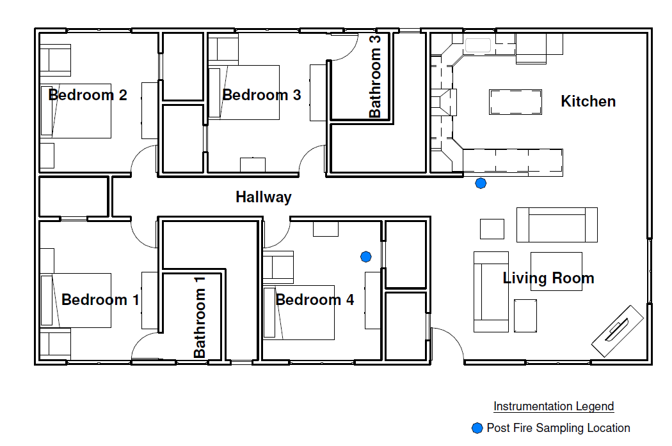

*Figure 1. Structure layout and sampling locations selected for the Bedroom and Common Room (kitchen and living room) fire scenarios.*

Prior to ignition, the structure was fully furnished to represent fuel load conditions typical to a residential structure. This included furnishing each of the four bedrooms, the two bathrooms, the kitchen, and living room.. The furnishings were measured and weighed, and where possible, the base materials used in their construction were determined and documented. Fuel arrangements for the bedroom fire scenarios and common room (open floor plan kitchen and living room) fire scenarios are shown in Figure 2.

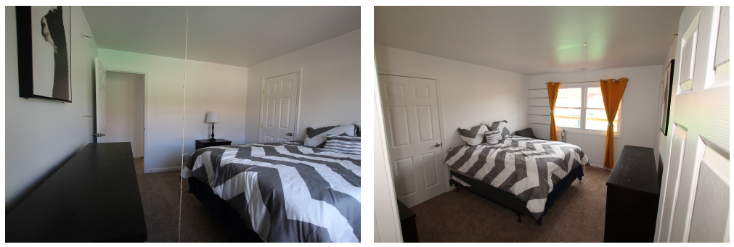

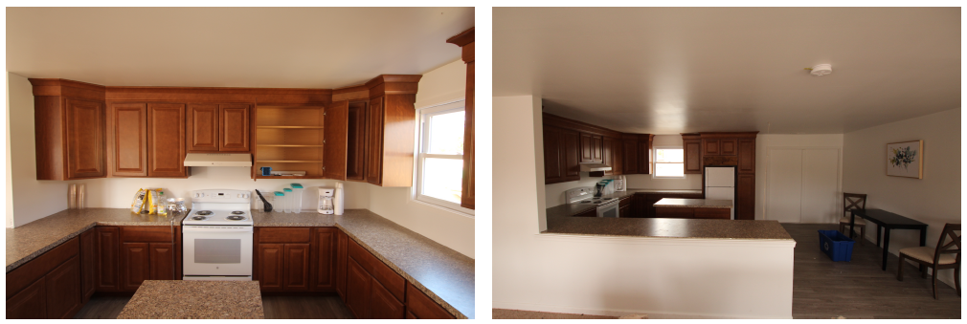

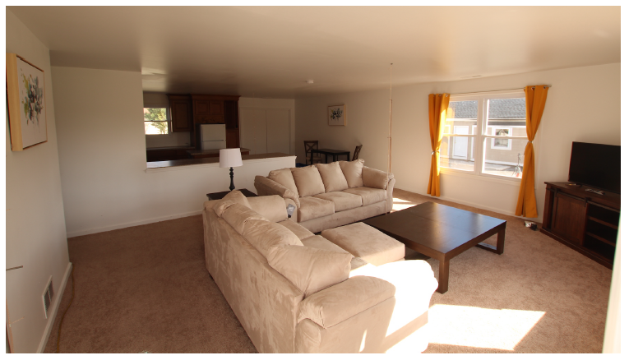

*Figure 2. Photographs of typical furnishings in the bedroom fires (top) and common room fires including kitchen (middle) and living room (bottom).*

## Area air Sampling

Table 1 provides a summary of our substrate-based and whole-gas area air sample collection and analysis

methods. The VOC method was used quantify benzene, ethyl benzene, toluene, xylenes and styrene (BTEXS) as well as naphthalene (which, based on previous publication is expected to the polycyclic aromatic hydrocarbon in the highest abundance (Bolstad-Johnson et al. 2000; Fent et al. 2018; Sjostrom et al. 2019). Total VOCs were also quantified with this method and other compounds found regularly at high concentrations are reported. Pumps calibrated before and after each session? Sampling media was located at approximately 5 feet from the floor to approximate breathing zone height. After each sampling period, all sampling media were capped and stored in a −20°C freezer prior to shipment (on ice) to the analytical laboratory.

For the area air samples, the pumps were run for 60 minutes to collect baseline samples prior to all 18 burn scenario and for Hot Scene B after overhaul was completed and CO levels returned to background for each of the 18 scenarios. During Hot Zone B timeframe, investigators were documenting the scene, collecting pictures and identifying patterns following typical fire scene investigation protocols. For eight scenarios, an additional set of VOC and Aldehyde instrumentation was intruded during the Overhaul/Hot Scene A timeframe where the pumps ran an average of 35 minute (range 30 to 41 minutes). Additionally, after four scenarios the structures were closed up (openings covered with OSB screwed to the outside of compromised door and window frames) and then removed for additional investigation activities during Warm Scene (1-day and 3-day post-fire) and Cold Scene (5-days post-fire).

Investigators conducting their tasks. Dan more detail here?

*Table 1. Area air sampling collection and analysis methods*

|  |  |  |
| --- | --- | --- |
| Compound | Sampling media | Analytical method |
| Aldehydes | XAD-2 | ASTM D5197 |
| Fiberglass | MCE? | NIOSH 7400 |
| Hydrogen Cyanide (HCN) | Soda lime; 226-210 | NIOSH 6010 or 6017? |
| Hydrogen Sulfide (H2S) | 226-01 | NIOSH 6013M |
| Mercury | 226-17-1A | NIOSH 6009 |
| Metals | MCE? | NIOSH 7300M |
| Volatile Organic Compounds (VOCs) | Charcoal tube | EPA TO-17; ASTM 6196 |
|  |  |  |
| Respirable particles | DustTrak DRX – 1 sample/sec (PM1, PM2.5, Respirable, PM10, Total) | |
| Asphyxiant gases | MultiRAE Lite – 1 sample/sec (HCN, H2S, CO) | |

## Data Analysis

Descriptive statistics and other data analyses were carried out using SPSS software. Student t-test orKruskal-Wallis test was used to test whether area air concentrations varied by timepoint (pre vs. Hot Zone B).

Because the direct-reading particle instruments took measurements every 10 sec or less, summary statistics

(i.e., median and range) for particle number, respirable mass, thoracic mass, and active surface area were

conducted on the arithmetic means calculated for each response phase.

# 3. RESULTS

## 3.1 Particulate, Fiber and Metal (Solid phase) Results

### 3.1.1 Hot Zone B Particles

Average and peak particulate concentrations for a range of mean diameters are presented in Tables 2 and 3 respectively. Prior to conducting the burn scenario, particulate level was relatively low. Respirable particle concentration was, on average, below 50 µg/m3  and transient peak values typically remained less than 150 µg/m3. Compare these value to AQI? During Hot Scene B activities, particulate concentration increased significantly for all particle sizes (*p<0.05 for all sizes – can break this down for each size: PM1- p=0.003, PM2.5-p=0.003; Respirable- p=0.004; PM10-p=0.009; Total- p=0.017*) with average Respirable concentrations increasing to over 160 µg/m3 (Red or Unhealthy) and peak values averaging nearly 3,500 µg/m3. Pre-scenario particulate were commonly higher in the bedroom than in the common room (47 vs 17 µg/m3), possibly due to the relatively closed bedroom compared to open common room with more air flow. Hot zone B particulate were generally higher in Common Room compared to Bedroom (average of 225 vs 100 µg/m3; peak of 4,750 vs 2,172 µg/m3). Anecdotally, peak particulate values appeared to occur when drywall fell or was removed from the ceiling or walls, though increases were noted during simulated investigation activities that included shoveling, moving furnishings, and K9 investigation searching.

*Table 2. Average particulate concentration (µg/m3) for submicron (PM1), less than 2.5µm (PM2.5), respirable particulate, less than 10µm (PM10), and total particulate concentration for all eighteen scenarios as well as bedroom and common room fire scenarios over a 60 minute data collection period. Data are presented as mean (SD).*

|  |  |  |  |  |  |  |
| --- | --- | --- | --- | --- | --- | --- |
|  | **Total (N=18)** | |  | | | |
|  | | ***Bedroom (N=9)*** | | ***Common Room (N=9)*** | |
| ***Pre*** | ***Hot Zone B*** | ***Pre*** | ***Hot Zone B*** | ***Pre*** | ***Hot Zone B*** |
| **PM1** | 25(21) | 153(151) | 37(24) | 90(115) | 14(9) | 217(161) |
| **PM2.5** | 27(23) | 158(153) | 40(26) | 94(117) | 15(9) | 214(174) |
| **Respirable** | **32(28)** | **163(156)** | **47(32)** | **100(122)** | **17(10)** | **225(167)** |
| **PM10** | 48(48) | 181(171) | 73(57) | 124(153) | 23(14) | 238(177) |
| **Total** | 59(67) | 211(226) | 91(83) | 172(266) | 28(25) | 249(186) |

*Table 3. Peak particulate concentration (µg/m3) for submicron (PM1), less than 2.5µm (PM2.5), respirable particulate, less than 10µm (PM10), and total particulate concentration for all eighteen scenarios as well as bedroom and common room fire scenarios. Data are presented as mean (SD).*

|  |  |  |  |  |  |  |
| --- | --- | --- | --- | --- | --- | --- |
|  | **Total (N=18)** | |  | | | |
|  | | ***Bedroom (N=9)*** | | ***Common Room (N=9)*** | |
| ***Pre*** | ***Hot Zone B*** | ***Pre*** | ***Hot Zone B*** | ***Pre*** | ***Hot Zone B*** |
| **PM1** | 124(74) | 3,302(5,820) | 127(57) | 1,969(3,601) | 120(92) | 4,635(7,418) |
| **PM2.5** | 129(78) | 3,368(5,880) | 135(63) | 2,030(3,666) | 123(95) | 4,705(7,484) |
| **Respirable** | **142(88)** | **3,461(5,931)** | **154(78)** | **2,172(3,838)** | **130(99)** | **4,750(7,503)** |
| **PM10** | 214(136) | 3,877(6,292) | 255(135) | 2,881(5,152) | 173(131) | 4,874(7,439) |
| **Total** | 396(292) | 5,164(9,166) | 485(314) | 5,179(11,12) | 306(253) | 5,149(7,307) |

### 3.1.2 Warm & Cold Zone Particles

The 60-minut average and peak respirable and total particulate concentrations during the 1-day and 3-day post-fire investigation scenarios were similar to Hot Zone B measurement though some variation occurred depending on investigation activities (Figure 3). The 5-day post experiment deviated significantly across all particle sizes as the firefighters began to vigorously remove drywall ceilings and walls to locate the structural supports of the fire compartments. Particulate concentrations increased dramatically with peak values well above 10,000 µg/m3 and in one case above 40,000 µg/m3. Total particulate levels increased more dramatically, possibly due to the difference in particulate produced by the gypsum board compared to products of combustion. Experiments 5, 6 and 11 followed similar trends, but experiment 12 was unique among this group. The fire in this scenario resulted in more damage to the compartment resulting in some drywall falling from the ceiling prior to the Hot Scene B investigation (time 0) and some additional drywall fell from the ceiling during the 3-day post-fire investigation (approximately 75 hours post fire).

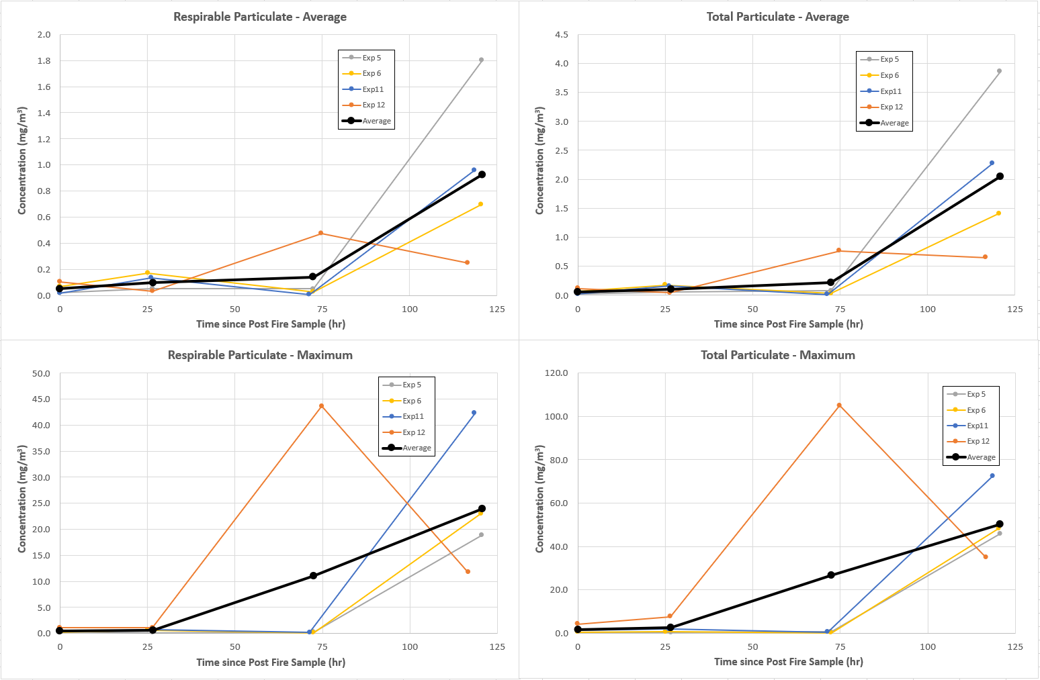

*Figure 3. Respirable (left) and total (right) 60-minute average (top) and peak (bottom) particulate concentrations (µg/m3) for four experiments including Hot Scene B (immediately post-fire sample at time = 0 hour), Warm Scene (1-day and 3-day post fire samples at approximately 24 and 72 hours) and Cold Scene (5-day post fire samples at approximately 120 hours).*

### 3.1.3 Fiber and metals results

Fiber samples were collected from the first twelve scenarios. No fibers were identifiable due to soot overloading on the initial samples. Flow rates were reduced to reduce overloading, but no reliably detectable samples were collected.

Metal samples were also collected from the first twelve scenarios to characterize arsenic, cadmium, chromium, lead and mercury. Led was detected in two post-fire samples at concentrations ranging from 0.18-0.33 µg/filter*.* No other metal compound was detected pre- or immediately post-fire.

## 3.2 Vapor Phase Results

Hydrogen sulfide and hydrogen cyanide were characterized using both time-resolved hand-held data loggers similar to those used in the fire service and sorbent based collection tubes during Hot Scene B. Hydrogen sulfide was not detected in any of the first six scenarios using either method and was discontinued thereafter. Hydrogen cyanide was only detected in two of the first twelve Hot Scene B collection sessions at values well below 1 ppm. However, the time resolved monitor identified several transient occasions where the HCN concentration was detectable. This value never exceeded 4 ppm at any time and thus would not have reached the typical fire service alarm level (4.7 ppm). Carbon monoxide levels were

## 3.2.1 Hot Scene A & B Volatile Organic Compounds

While a wide range of volatile organic compounds were detected at some point during the study, we will focus mostly on BETXS compounds, naphthalene, total VOCs and a few other compounds that appeared in relatively high concentrations in many different samples (Table 4). No important differences are noted between the bedroom and common room scenarios (Include this detail in Supplemental materials? This will compliment particulate data where this is a difference…). While BTEXS compound were identified in many of the pre-fire samples, concentrations of all compounds increased in Hot Scene A while benzene (*p<0.001*), ethyl benzene (*p=0.002*), and styrene (*p<0.001*) remained significantly elevated above pre-fire levels in the 60-minute Hot Scene B sample. Average Hot Scene A concentrations of benzene were below the most conservative exposure limit (NIOSH REL of 0.1 ppm (~321 µg/m3)), though one common room scenario did register 302 µg/m3. Naphthalene concentrations increased significantly during Hot Scene A (*p<0.001*), but returned to levels similar to pre-fire concentrations during Hot Scene B. Total VOCs also dramatically increased during Hot Scene A, but returned to values lower than pre-fire on average during the Hot Scene B time period. Much of the high pre-fire total VOC concentrations can be attributed to components of paint, thinners and adhesives (e.g Texanol, 224 Trimethyl… and Toluene) as well as freshly installed carpeting, curtains and kitchen cabinetry/countertops that appeared to be off-gassing.

*Table 4. Airborne concentration of select volatile organic compounds (µg/m3) as 60-minute time weighted averages for pre-fire and Hot Scene B and averaged over 30-41 minutes during Hot Scene A. Data are presented as mean (SD).*

|  |  |  |  |  |
| --- | --- | --- | --- | --- |
|  |  | ***Pre*** | ***Hot Scene A*** | ***Hot Scene B*** |
| ***N=18*** | ***N=8*** | ***N=18*** |
| **Benzene** | Mean (SD) | **5.0 (4.3)** | **139.1 (78.8)** | **35.8 (29.4)** |
| *% Detect* | *50%* | *100%* | *100%* |
| **Toluene** | Mean (SD) | 25.6 (34.7) | 65.8 (38.3) | 14.4 (10.0) |
| *% Detect* | *89%* | *100%* | *83%* |
| **Ethyl Benzene** | Mean (SD) | 3.2 (1.3) | 44.5 (21.0) | 6.7 (3.3) |
| *% Detect* | *22%* | *63%* | *61%* |
| **Xylene** | Mean (SD) | 11.8 (17.6) | 91.6 (109.4) | 9.1 (9.0) |
| *% Detect* | *56%* | *100%* | *61%* |
| **Styrene** | Mean (SD) | 6.0 (4.5) | 97.1 (55.1) | 42.6 (22.8) |
| *% Detect* | *78%* | *88%* | *83%* |
| **Naphthalene** | Mean (SD) | **21.4 (18.2)** | **122.8 (57.5)** | **22.1 (19.9)** |
| *% Detect* | *78%* | *100%* | *94%* |
| **Total VOCs** | Mean (SD) | 729 (511) | 4,411 (3,864) | 413 (452) |
| *% Detect* | *100%* | *100%* | *100%* |
| **Texanol Component…** | Mean (SD) | 122.6 (82.1) | 87.2 (32.0) | 11.6 (5.1) |
| *% Detect* | *89%* | *38%* | *39%* |
| **224Trimethyl…** | Mean (SD) | 134.2 (91.1) | 69.5 (63.6) | 11.2 (10.6) |
| *% Detect* | *100%* | *100%* | *56%* |
| **Acetic Acid** | Mean (SD) | 27.2 (23.4) | 233.7 (176.9) | 26.0 (30.3) |
| *% Detect* | *94%* | *88%* | *94%* |

## 3.2.2 Warm & Cold Scene Volatile Organic Compounds

The 60-minute average benzene concentrations during the 1-day, 3-day and 5-day post-fire investigation scenarios attend to decay from the relatively low levels post-fire to near non-detectable levels by the end of the experiment (Figure 4). These values remain well below the most conservative NIOSH recommended exposure limit. The 5-day trend for naphthalene concentrations were less consistent at 1-day post fire, but declined to below 10 µg/m3 by 5-days post-fire. Experiment 12 again displayed unique characteristics, particularly at 3-days post fire.

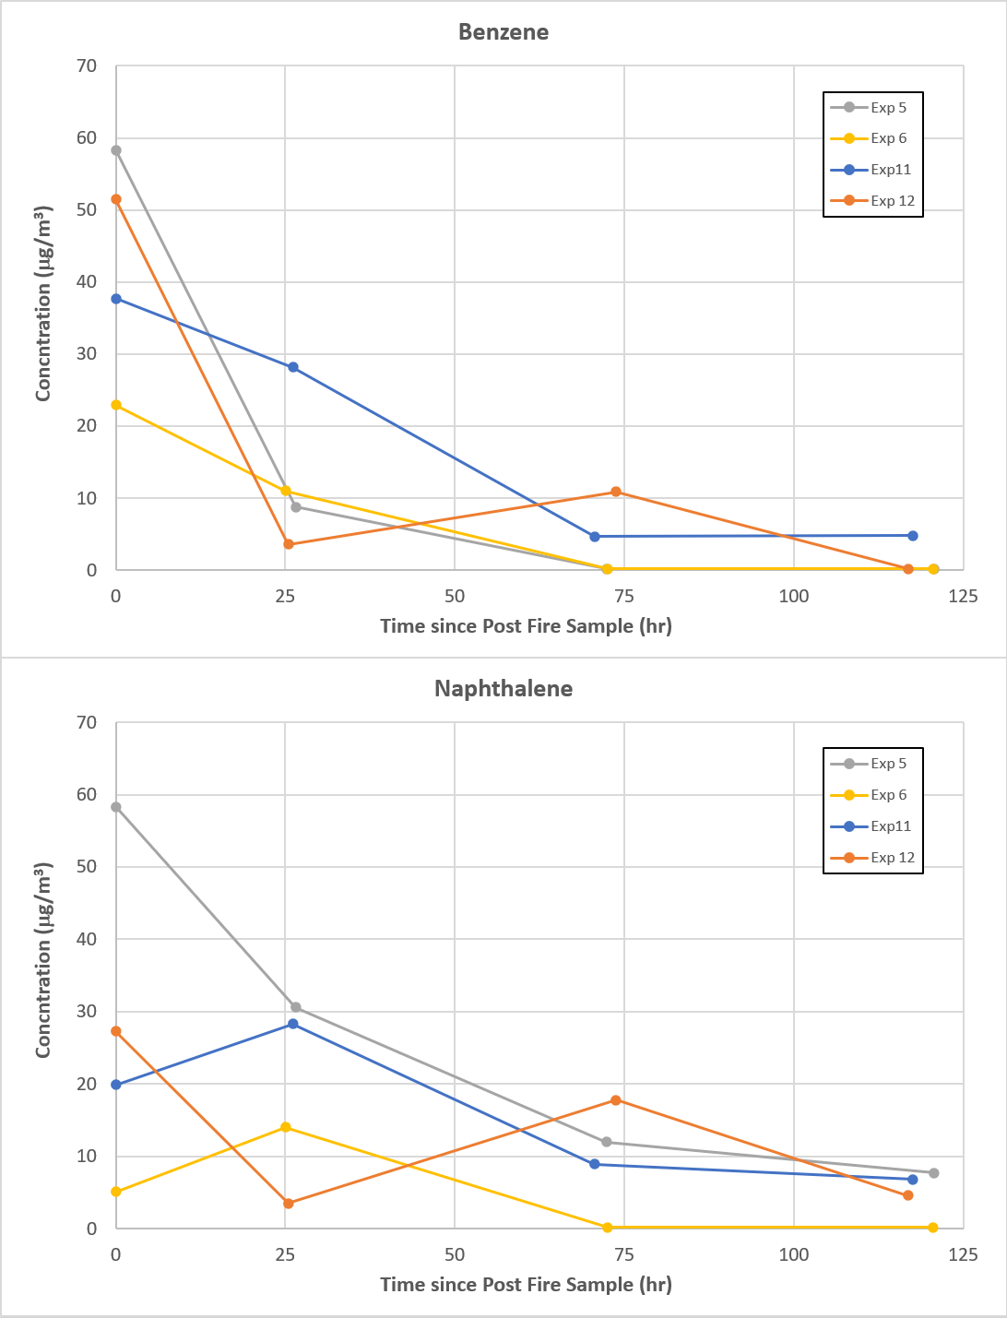

*Figure 4. Benzene (top) and naphthalene (bottom) 60-minute average concentrations (µg/m3) for four experiments including Hot Scene B (immediately post-fire sample at time = 0 hour), Warm Scene (1-day and 3-day post fire samples at approximately 24 and 72 hours) and Cold Scene (5-day post fire samples at approximately 120 hours). Could also add Styrene and Total VOCs to make a 4 plotlike Figure 3?*

## 3.2.3 Hot Scene A & B Aldehydes

Of the 12 aldehydes targeted by the DNPH/HPLC method, 11 were detected in at least one sample with acetaldehyde and formaldehyde present in the highest concentrations (Table 5). No important differences are noted between the bedroom and common room scenarios in the pre-fire measurements, but hexanal and pentanal were significantly lower in the bedroom fire scenarios compared to the common room scenarios in post-fire samples (Include this detail in Supplemental materials? This will compliment particulate data where this is a difference…). Aldehydes were again identified in many of the pre-fire samples, and concentrations of all compounds increased in Hot Scene A. Concentrations of acetaldehyde, benzaldehyde, formaldehyde and propanal increased by approximately an order of magnitude or more in Hot Scene A. However, in Hot Scene B, formaldehyde had largely returned to pre-fire levels while acetaldehyde (*p<0.001*), benzaldehyde (*p=0.002*), and propanal (*p=0.004*) remained significantly elevated above pre-fire levels. At the same time, hexanal (*p<0.001*) and pentanal (*p=0.002*) concentrations were significantly lower than pre-fire concentrations.

In all eight of the scenarios, Hot Scene A concentrations of formaldehyde concentrations were above the NIOSH Ceiling limit of 0.1 ppm (~123 µg/m3), with the maximum concentration reaching 775 µg/m3 in one common room scenario. None of the Hot Scene B concentrations exceeded this ceiling limit, though seventeen were above the most conservative NIOSH REL of 0.016 ppm (~20 µg/m3). Also of note, thirteen of the pre-fire scenarios exceeded this REL with the largest pre-fire concentrations measured in the common room, possibly due to the newly installed cabinetry and countertop in these rooms. NIOSH REL for acetaldehyde are the ‘lowest feasible concentration’, yet Hot Scene A levels reached up to 3,360 µg/m3 and were typically higher in bedroom fires than common room fires (though no statistical analysis is conducted due to the low numbers). When breaking these values down into different fire locations, the common room fires had higher formaldehyde concentrations during Hot Scene A (520±204 µg/m3 vs 321±280 µg/m3), while bedroom fires resulted in higher acetaldehyde concentrations at the same time period (1,900±980 µg/m3 vs 878±635 µg/m3),

*Table 4. Airborne concentration of select aldehydes (µg/m3) as 60-minute time weighted averages for pre-fire and Hot Scene B and averaged over 30-41 minutes during Hot Scene A. Data are presented as mean (SD).*

|  |  |  |  |  |
| --- | --- | --- | --- | --- |
|  |  | ***Pre*** | ***Hot Scene A*** | ***Hot Scene B*** |
| ***N=18*** | ***N=8*** | ***N=18*** |
| **2-Butenal** | Mean (SD) | 17.8 (---) | 101.2 (84.4) | 10.2 (5.2) |
| *% Detect* | *6%* | *75%* | *44%* |
| **Acetaldehyde** | Mean (SD) | **30.5 (19.2)** | **1,389 (940)** | **177.2 (87.0)** |
| *% Detect* | ***100%*** | ***100%*** | ***94%*** |
| **Benzaldehyde** | Mean (SD) | 5.8 (3.7) | 81.5 (46.5) | 10.1 (3.5) |
| *% Detect* | *100%* | *100%* | *100%* |
| **2,5-dimethylbenaldehyde** | Mean (SD) | ---- | ---- | ---- |
| *% Detect* | *0%* | *0%* | *0%* |
| **2- methylbenaldehyde** | Mean (SD) | ---- | 8.3 (4.8) | ---- |
| *% Detect* | *0%* | *38%* | *0%* |
| **3- and/or 4-methylbenaldehyde** | Mean (SD) | 5.9 (---) | 33.5 (16.6) | 7.4 (2.63) |
| *% Detect* | *6%* | *63%* | *28%* |
| **Butanal** | Mean (SD) | 6.6 (4.8) | 34.5 (20.8) | 9.6 (6.6) |
| *% Detect* | *72%* | *38%* | *22%* |
| **3-methylbutanal** | Mean (SD) | 4.8 (2.1) | 36.5 (26.6) | 9.6 (3.6) |
| *% Detect* | *17%* | *75%* | *50%* |
| **Formaldehyde** | Mean (SD) | **43.4 (38.5)** | **420.5 (25.6)** | **40.2 (16.8)** |
| *% Detect* | ***100%*** | ***100%*** | ***100%*** |
| **Hexanal** | Mean (SD) | 48.9 (27.2) | 58.9 (10.1) | 10.9 (6.5) |
| *% Detect* | *100%* | *100%* | *100%* |
| **Pentanal** | Mean (SD) | 19.0 (12.4) | 33.0 (15.9) | 7.4 (2.6) |
| *% Detect* | *100%* | *75%* | *67%* |
| **Propanal** | Mean (SD) | 18.1 (23.5) | 407.6 (300.5) | 38.4 (19.6) |
| *% Detect* | *83%* | *88%* | *100%* |

## 3.2.4 Warm & Cold Scene Aldehydes

The 60-minute average acetaldehyde and formaldehyde concentrations during the 1-day post-fire investigation period showed an increased concentration in three of the four scenarios prior to decaying to pre-fire levels by the end of the experiment (Figure 5). These formaldehyde concentrations exceeded the NIOSH ceiling levels at 1-day post fire, remained elevated above the immediate post-fire measurements at 3-days post fire, and were still above NIOSH REL in both bedroom scenarios (experiments 5 and 11). Concentrations were typically lower in the common room scenarios, possibly due to the proximity of the open door that was used to access the fire scenes. Experiment 12 again displayed unique characteristics, with an initial decrease in concentrations of bot acetaldehyde and formaldehyde, but a subsequent increase after the partial ceiling collapse during the 3-day post fire investigation period.

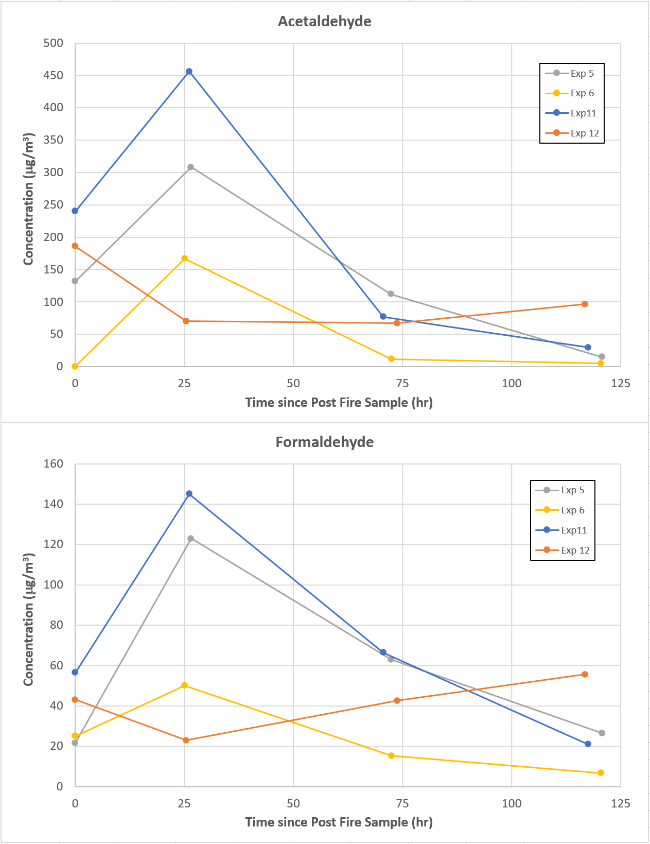

*Figure 5. Acetaldehyde (top) and formaldehyde (bottom) 60-minute average concentrations (µg/m3) for four experiments including Hot Scene B (immediately post-fire sample at time = 0 hour), Warm Scene (1-day and 3-day post fire samples at approximately 24 and 72 hours) and Cold Scene (5-day post fire samples at approximately 120 hours).*

# 4. DISCUSSION

The most important findings of this study are that 1) elevated and hazardous levels of airborne particulate may be encountered during all phases of the post-fire scene investigation depending on the activities of the fire investigator and 2) airborne formaldehyde concentrations could exceed recommended exposure limits in all phases of the investigation. This study provides the first controlled investigation scenario that allows fire scene investigation phases to be related to previously reported overhaul concentrations and extended out to 5-days after the fire.

## 4.1 Particle concentrations throughout investigation

Exposure to fireground particulate has important health implications both for exposure to possible carcinogens and increasing risk for sudden cardiac events (Baxter et al. 2010), two of the largest health and safety concerns in today’s fire service. PM2.5levels encountered during Hot Scene B scenarios averaged 94 and 214 µg/m3 for bedroom and common room fires, which correspond to air quality index (AQI) values of 171 (Unhealthy) and 264 (Very Unhealthy) https://www.airnow.gov/aqi/aqi-calculator-concentration/. The lowest average PM2.5 concentration was 17 µg/m3 (57 AQI – Moderate) while the highest concentration was 498 µg/m3 (498 AQI – Hazardous). Note, AQI indices are based on 24 hour average concentrations, while these measurements are averaged over one hour. The total particulate concentrations measured in this study (211 µg/m3 with range of 19-823 µg/m3) are comparable to the nine total dust measurements reported by Sjostrom et al (2019) (176 µg/m3 with range of 70-314 µg/m3). Likewise, Kinnes and Hine (1998) measured respirable dust concentrations ranging from undetectable (less than 100 µg/m3) to 360 µg/m3 while the total dust concentrations ranged from 200 to 1,100 µg/m3 four residential fire scenes (though one additional office scenario resulted in concentrations of 1,200 µg/m3 and 5,300 µg/m3, respectively). Finally, Fent et al (2013) reported widely varying PM10 concentrations during two largely identical simulated fire investigation scenarios (80 µg/m3 and 700 µg/m3). The current study compliments these small existing studies with a larger data set that includes a larger partitioning of particle dimensions. Might consider attempting a correlation between subjective ‘fire damage area’ or ‘fire damage ranking’ based on post-scene images compared to particulate? Additionally, the time resolved nature of these measurements allowed identification of transients in each of the investigation scenario where peak concentrations were typically one to two orders of magnitude larger than the overall mean value.

By extending particulate data collection to several days after the immediate post-fire investigation period, important changes in concentration were determined. Measurements collected during 1- and 3-days post fire followed similar investigation protocols (pictures, diagrams, K9 operations, moving furnishings as necessary to identify patterns, shoveling out debris from the scene). Similar average particulate concentrations were encountered and transient peaks were noted while shoveling and/or moving furniture, though peak magnitudes were not as high as the immediate post-fire operations other than experiment 12 when some additional ceiling collapse. Importantly, during the 5-day post-fire investigation period, investigators actively removed drywall from the compartment ceilings and walls in order to inspect structural components and building systems that may have been compromised by the fire. During these days, the average respirable and total particulate levels over the 60-minute investigation period were 925 µg/m3 and 2,048 µg/m3 with maximum levels of 23,975 µg/m3 and 50,350 µg/m3. These results highlight the need for particulate respiratory protection during all phases of the fire investigation process, particularly when drywall is being removed or handled. While this study has focused on firefighters conducting post-fire investigations, this information may be useful to inform post-fire reconstruction occupations who are likely to be pulling down smoke and fire damaged drywall as they rehab the buildings. Additionally, firefighters often train on overhaul operations in buildings that are slated for demolition, often times pulling down large amounts of walls and ceilings even in structures that did not experience a fire. The lack of fire exposure may lead the fire service to have a reduced concern for exposure and be less likely to wear SCBA during this training scenario.

## 4.2 Vapor concentrations throughout investigation

A large portion of the fire service fireground exposure studies focus on PAH and VOC contamination. For the scenarios investigated here, the concentrations of these compounds, most notably benzene and naphthalene, which are consistently reported as the highest concentrations of each class measured on the fireground, are relatively low in magnitude, particularly for Hot Scene B, Warm and Cold Scenes. The magnitude of benzene and naphthalene in Hot Scene B timepoints are slightly higher than concentrations found in the few scenarios reported by Sjostrom et al (2019) – 35.8 vs 19.3 µg/m3 and 22.1 vs 4.6 µg/m3 – but values decay to in both cases, concentrations were well below applicable exposure limits. Kinnes and Hine (1998) reported naphthalene concentrations of 30 and 36 µg/m3 in the two residential fire scenes they studied and was the only PAH consistently detected above trace or non-detected amounts. In two staged experiments, naphthalene increased to 99 and 200 µg/m3. During overhaul (similar to Hot Scene A), Fent et al (2018) report benzene concentrations of approximately 65 ppb (~200 µg/m3), which is slightly higher than 139±79 µg/m3 measured here, though the overhaul period lasted 11-19 minutes in the previous study compared to the 30-41 minute Hot Scene A period reported here which allowed more time for smoke dissipation. Bolstad-Johnson et al (2000) measured benzene in 53 of the 95 samples collected, but average values among these detectable samples was 383±425 ppb. During overhaul, Fent et al (2018) did not report any benzene concentrations over STEL, while Bolstad-Johnson et al (2000) reported 2 of 25 fires exceeded STEL, while we report no Hot Scene A samples above benzene STEL. Bolstad-Johnson et al (2000) measured naphthalene in 28 of the 88 samples collected, with average concentrations among these detectable samples of 223±101 µg/m3, which agrees well with the 123±58 µg/m3 measured here when non-detect samples are considered. Overall, the concentration of the PAH and VOC compounds most commonly reported in firefighter literature at highest concentrations are similar to those measured during Hot Scene A. This study allows continued tracking of the evolution of the fire scene airborne contaminants, showing a relatively consistent decline in concentrations to Hot Scene B, then in Warm and Cold Scene investigation. In all cases, these values remain well below applicable exposure limits.

However, aldehyde results present a different picture, with formaldehyde concentrations detected above the most protective REL and even exceeding NIOSH STEL Ceiling values. While the number of replicates is relatively low, this trend was noted in all three scenarios where the compartment ceiling remained intact after the fire. Bolstad-Johnson et al (2000) reported detectable formaldehyde in 86 of 96 samples collected with average concentrations of 0.25±0.252 ppm (307±309 µg/m3) and maximum concentrations reaching 1.18 ppm. The average sample concentration exceeds NIOSH ceiling levels similar to our results. Additionally, Bolstad-Johnson et al (2000) reported detectable acetaldehyde in 71 of 96 samples collected with average concentrations of 0.34±0.41 ppm (617±740 µg/m3) and maximum concentrations reaching 1.75 ppm. No other aldehyde in that study was reported at as high of a detection rate or magnitude, similar to the data shown here.

While the concentration of all aldehyde compounds dramatically declined from Hot Scene A to Hot Scene B, the formaldehyde levels remained above NIOSH REL levels for the bulk of the scenarios. Furthermore, concentrations of both formaldehyde and acetaldehyde were found to have slightly increase during subsequent investigation periods at 1-day and 3-days post-fire for several experiments. For both bedroom fire scenarios, these values again exceeded NIOSH STEL Ceiling values at 1-day post. These findings again highlight the need to consistently wear respiratory protection throughout the investigation period. SCBA provides the highest level of protection from aldehydes, particulate and other unknown hazards. Current guidance from (International Association of Arson Investigators, 2020) includes “*The IAAI-recommended minimum respirator assembly for all fire investigators while in the hot and warm zone of every warm and cold fire scene is a half-mask facepiece with goggles,41 or a full facepiece42, that has a P100 particulate filter with an OV/AG/FM 43,44, gas/vapor cartridge45, 46 if following U.S. descriptions OR a half-mask facepiece with eye protection, or a full facepiece, with an A3P3 combination filter if following U.K. descriptions*.” The results of this study reinforce the important of including vapor protection from formaldehyde at least through the Warm Scene investigation.

Current guidance suggests investigators use “*Multi-gas area monitoring, including VOCs, PAHs, oxygen enrichment/deficiency, carbon monoxide, and hydrogen sulfide*” (International Association of Arson Investigators, 2020). Based on the results of this study, the authors would suggest that investigators also monitor for formaldehyde.

223±101 µg/m3

* + PPE
    - Respiratory key – particulate and aldehydes
      * K9 investigators?
    - Gloves and skin protection needs?

## 4.3 Limitations

While the data presented in this study is more tightly grouped that samples collected from field studies such as Bolstad-Johnson et al (2000) and Sjostrom et al (2019), important variability remains. The fuels and compartment arrangements in each of the bedroom scenarios and common room scenarios was identical. However, important differences in suppression tactics (see Weinshenk & Stakes report) along with environmental variation (temperature, wind, humidity) had an important impact on the compartment damage from each scenario. Additionally, fire investigation activities were similar during these measurement periods, but did vary based on timing and amount of scene disturbance deemed necessary by the investigators during their observations. It is likely that other compounds may have been detected with different fuel packages and if other contaminant such as flame retardants or PFAS samples were collected. While these studies greatly expand the available data for estimating risk during post-fire scene investigation, the numbers remain relatively small, particularly with data sets focused on Warm and Cold Scenes

## . Future Work

Future studies could expand on this area air sampling study by collecting data from personal air concentrations during specific investigation activities. It is also recommended that future studies characterize the presences of other contaminants of interest including flame retardants, PFAS, etc. These compounds are not expected to be a large contributor to the overall risk during investigations, but important health concerns generated by these compounds suggest importance in characterizing. While this study lays the groundwork for understanding PPE needs for fire investigators, future work could characterize the effectiveness of different levels of PPE to protect from chemical exposure while also balancing the need to document scenes, collected evidence and do so without adverse impacts on biomechanics of movement, heat stress generation or cardiovascular strain. Finally, this work suggests the importance of studying exposure for canines used as accelerant detection animals and post-fire reconstruction workers who may not have SCBA available or have received awareness training regarding the particulate risk during drywall pulling activities.

# 5. CONCLUSIONS

The most important findings of this study are that 1) elevated and hazardous levels of airborne particulate may be encountered during all phases of the post-fire scene investigation depending on the activities of the fire investigator and 2) airborne formaldehyde concentrations could exceed recommended exposure limits in all phases of the investigation. This study provides the first controlled investigation scenario that allows fire scene investigation phases to be related to previously reported overhaul concentrations and extended out to 5-days after the fire. R

# REFERENCES

Olivera??

Baxter CS, Ross CS, Fabian T, Borgerson JL, Shawon J, Gandhi PD, Dalton JM, Lockey JE (2010) Ultrafine particle exposure during fire suppression-is it an important contributory factor for coronary heart disease in firefighters?. JOEM 52(8):791-796

* Austin CC, Wang D, Ecobichon D, Dussault G. 2001a. Characterization of volatile organic compounds in smoke at experimental fires. *J. Toxicol. Environ. Health A*. **63**(3): 191-206.
* Austin CC, Wang D, Ecobichon, D, Dussault, G. 2001b. Characterization of volatile organic compounds in smoke at municipal structural fires. *J. Toxicol. Environ. Health A*, **63**(6): 437-58 (2001).
* Baxter CS, Hoffman JD, Knipp MJ, Reponen T, Haynes E. 2014.Exposure of firefighters to particulates and polycyclic aromatic hydrocarbons*.* *J Occup Environ Hyg*. **11**(7):D85-91.
* Daniels RD, Kubale T, Yiin J. et al. 2014. Mortality and cancer incidence in a pooled cohort of US firefighters from San Francisco, Chicago and Philadelphia (1950-2009). *Occup. Environ. Med.* **71**(6): 388-97.
* Daniels RD, Bertke S, Dahm M, Yiin J, Kubale T, Hales T, et al. 2015. Exposure–response relationships for select cancer and non-cancer health outcomes in a cohort of US firefighters from San Francisco, Chicago and Philadelphia (1950–2009). *Occup. Environ. Med.* **72**(10):699-706.
* Engelsman M, Toms L-ML, Banks APW, Wang X, Mueller JF. 2020. Biomonitoring in firefighters for volatile organic compounds, semivolatile organic compounds, persistent organic pollutants, and metals: A systematic review. *Environ. Res*. **188:** 109562.
* Fent KW, Eisenberg J, Evans D, Sammons D, Robertson S, et al. 2013. *Evaluation of Dermal Exposure to Polycyclic Aromatic Hydrocarbons in Fire Fighters*. (Report #2010-0156-3196). U.S. Department of Health and Human Services. Cincinnati, OH.
* Fent KW, Evans D, Babik K, Striley C, Bertke S, et al. 2018. Airborne contaminants during controlled residential fires*.* *J. Occup. Environ. Hyg*. **15**(5):399-412.
* Fent KW, Mayer A, Bertke S, Kerber S, Smith D, et al. 2019. Understanding airborne contaminants produced by different fuel packages during training fires*.* *J Occup Environ Hyg*. **16**(8):532-543.
* Fernando S, Shaw L, Shaw D, Gallea M, VandenEnden L, et al. 2016. Evaluation of Firefighter Exposure to Wood Smoke during Training Exercises at Burn Houses*.* *Environ. Sci. Technol*. **50**(3):1536-1543.
* Gainey SJ, Horn GP, Towers AE, Oelschlager ML, Tir VL, Drnevich J, Fent KW, Kerber S, Smith D, Freund GG. 2018. Exposure to a firefighting overhaul environment without respiratory protection increases immune dysregulation and lung disease risk. *PLoS One.* **13**(8): e0201830.
* Gill B, Britz-McKibbin P. 2020. Biomonitoring of smoke exposure in firefighters: A review *Curr. Opin. Environ. Sci Health*. **15**:57-65.
* Glass D, Sim M, Pircher S, Del Monaco A, Dimitriadis C, Miosge J. 2014. *Final Report Australian Firefighters' Health Study.* January 3, 2017; Available from: <http://www.coeh.monash.org/downloads/finalreport2014.pdf>.
* Hoppe-Jones C, Griffin SC, Gulotta JJ, Wallentine DD, Moore PK, Beitel SC, Flahr LM, Zhai J, Zhou JJ, Littau SR, Dearmon-Moore D, Jung AM, Garavito F, Snyder SA, Burgess JL. 2021. Evaluation of fireground exposures using urinary PAH metabolites. *J. Expo. Sci. Environ. Epidemiol*. https://doi.org/10.1038/s41370-021-00311-x
* International Association of Arson Investigators, Inc. Health and Safety Committee. 2020. *Fire Investigator Health and Safety Best Practices*. Bowie, MD.
* International Agency for Research on Cancer (IARC). 2010. *Painting, Firefighting, and Shiftwork, in IARC Monographs on the Evaluation of Carcinogenic Risks to Humans*. Vol. 98. Lyon, France: World Health Organization.
* Jankovic J, Jones W, Burkhart J, Noonan G. 1991. Environmental study of firefighters. *Ann. Occup. Hyg.*  **35**(6): 581-602.
* Jalilian H, Ziaei M, Weiderpass E, Rueegg, CS, Khosravi Y, Kjaerheim K. 2019. Cancer incidence and mortality among firefighters. *Int. J. Cancer*, **145**:2639-2646.
* Keir JLA, Akhtar U, Matschke DMJ, Kirkham TL, Chan H, et al. 2017. Elevated Exposures to Polycyclic Aromatic Hydrocarbons and Other Organic Mutagens in Ottawa Firefighters Participating in Emergency, On-Shift Fire Suppression*.* *Environ. Sci. Technol*. **51**(21):12745-12755.
* Keir JLA, Akhtar U, Matschke DMJ, White PA, Kirkham TL, et al. 2020. Polycyclic aromatic hydrocarbon (PAH) and metal contamiation of air and surfaces exposed to combustion emmisions during emergency fire suppression: Implications for firefighters’ exposures. *Sci.* *Total Environ*. **698**: 134211.
* Kinnes GM, Hine GA. 1998. *Health hazard evaluation report: HETA-96-0171-2692, Bureau of Alcohol, Tobacco, and Firearms, Washington, DC*. (Report #HETA 96-0171-2692). U.S. Department of Health and Human Services. Cincinnati, OH.
* Kirk KM, Logan MB. 2015. Firefighting instructors' exposures to polycyclic aromatic hydrocarbons during live fire training scenarios. *J. Occup. Environ. Hyg.* **12**(4): 227-234.
* Lee DJ, Koru-Sengul T, Hernandez MN, Caban-Martinez AJ, McClure LA., Mackinnon JA, Kobetz EN. 2020) Cancer risk among career male and female Florida firefighters: Evidence from the Florida Firefighter Cancer Registry (1981-2014). *Am. J. Ind. Med*. **63**(4): 285-299.
* LeMasters, G.K.; Genaidy, A.M.; Succop, P.; Deddens, J.; Sobeih, T.; Barriera-Viruet, H.; Dunning, K.; Lockey, J. 2006. Cancer risk among firefighters: a review and meta-analysis of 32 studies. *J. Occup. Environ. Med*. **48**: 1189-1202.
* Pukkala E, Martinesen J, Lynge E, Gunnarsdottir H, Sparen P, Tryggvadottir L, et al. 2009. Occupation and cancer - follow-up of 15 million people in five Nordic countries. *Acta Oncologica.* **48**(5): 646-790.
* Sjostrom M, Julander A, Strandberg B, Lewne M, Bigert C. 2019. Airborne and dermal exposure to polycylic aromatic hydrocarbons, volatile organic compounds, and particles among firefighters and police investigators. *Ann. Work Expo. Health.* **63**(5): 533-545.
* Stec AA, Dickens K, Salden M, Hewitt F, Watts D, et al. 2018. Occupational Exposure to Polycyclic Aromatic Hydrocarbons and Elevated Cancer Incidence in Firefighters. *Sci. Rep*. **8**(1):2476.
* Tsai RJ, Luckhaupt S, Schumacher P, Cress R, Deapen D, Calvert G. 2015. Risk of cancer among firefighters in California, 1988-2007. *Am. J. Ind. Med.* **58**(7):715-29.
* Wingfors H, Nyholm J, Magnusson R, Wijkmark C. 2018. Impact of Fire Suit Ensembles on Firefighter PAH Exposures as Assessed by Skin Deposition and Urinary Biomarkers. *Ann. Work Expo. Health*. **62**(2):221-231.
* Weiss DC, Miller JT. 2011. *A study on chemicals found in the overhaul phase of structure fires using advanced portable air monitoring available for chemical speciation*. Tualatin Valley Fire & Rescue.

1. **International Agency for Research on Cancer (IARC)**. Some Non-heterocyclic Polycyclic Aromatic Hydrocarbons and Some Related Exposures, in IARC Monographs on the Evaluation of Carcinogenic Risks to Humans. (2010) Lyon, France: World Health Organization.

5. **International Agency for Research on Cancer (IARC)**. Monographs on the evaluation of the carcinogenic risks to humans: vol. 29, sup. 7, 100F benzene. (2012) Lyon, France: World Health Organization.

6.

19. **Fent, K.W., B. Alexander, J. Roberts, et al.**: Contamination of firefighter personal protective equipment and skin and the effectiveness of decontamination procedures*.* *J. Occup. Environ. Hyg.* 14(10): 801-814 (2017).

20. **Mayer, A., K. Fent, S. Bertke, G. Horn, D. Smith et al**: Firefighter hood contamination: Efficiency of laundering to remove PAHs and FRs. J Occup Environ Hyg. **16**(2): 129-140 (2019).

25**. Fent, K.W., J. Eisenberg, J. Snawder, D. Sammons, J. Pleil, and M. Stiegel:** Systemic Exposure to PAHs and Benzene in Firefighters Suppressing Controlled Structure Fires. *The Annals of Occupational Hygiene 58(7):830-845* (2014).