### MANUAL NFS SERVER

**Priority Level**: HIGH
**Estimated Time**: 20 minutes
**Required Access**:
**Risk Level**:

#### Description
Configuring a Network File Sharing Server (NFSv4) a local network.

#### Platform → RedHat

#### Prerequisites
- Server-Client Architecture
- Install Required Packages

BASIC INSTALLATION SETUP SERVER SIDE:

1. Update computer packages List and Install the nfs package:

- dnf update -y
- dnf install nfs-utils -y

2. Start the server and check the status

- systemctl start nfs-server
- systemctl status nfs-server
- systemctl enable –now nfs-server

3. Configure exports
Create and configure the directories you want to share with the clients. This is done by editing /etc/exports.d, and create a drop-in file to share:

vim /etc/exports.d/shared_directory_name and edit specifying:

- Directories to be shared, Target client & Permissions assigned

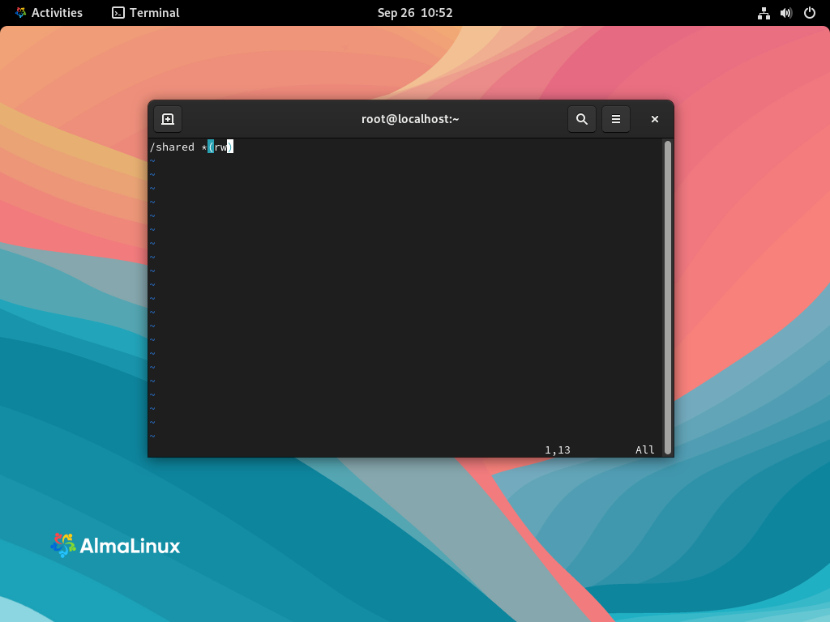

Create directories specified in the previous step:

- mkdir -pv / shared_directory_name

Add files to be shared:
cd / shared_directory_name
cp ~/Documents /shared_directory_name -r

Check and Set correct Selinux Context
ls -z /shared
Assign the public_contect_t or nfs_t type (commonly used for NFS exports)

semanage fcontext -a -t nfs_t “/shared()”
restorecon -Rv /shared

Re-initilaize the nfs services
- exportfs -r
- exportfs -v

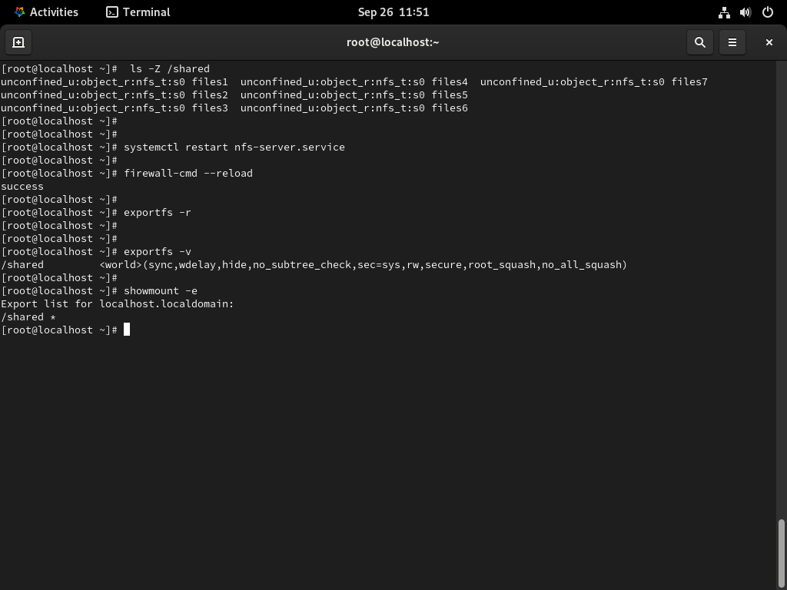

Show the mounted directories: showmount -e

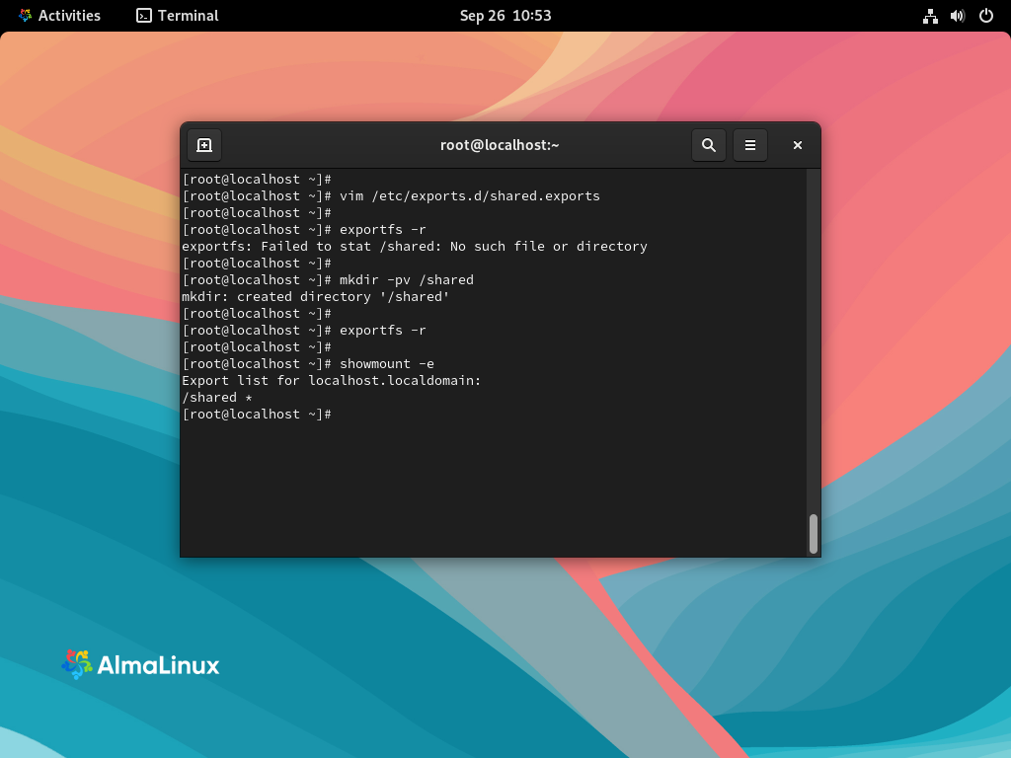

Allow firewall rules, NFS-related services and reload firewall :

firewall-cmd --permanent --add-service=nfs
firewall-cmd –reload
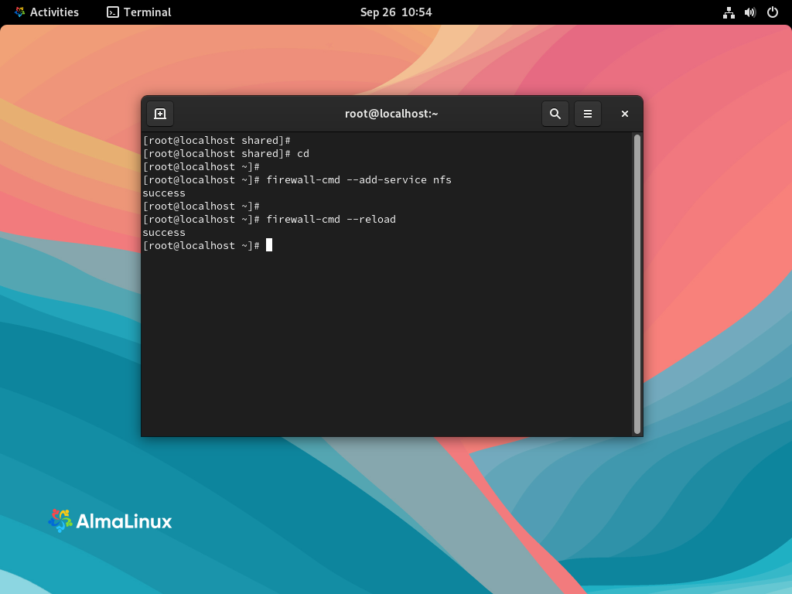

verify the firewall rules are updated:

firewall-cmd –list-all

You should see the following:
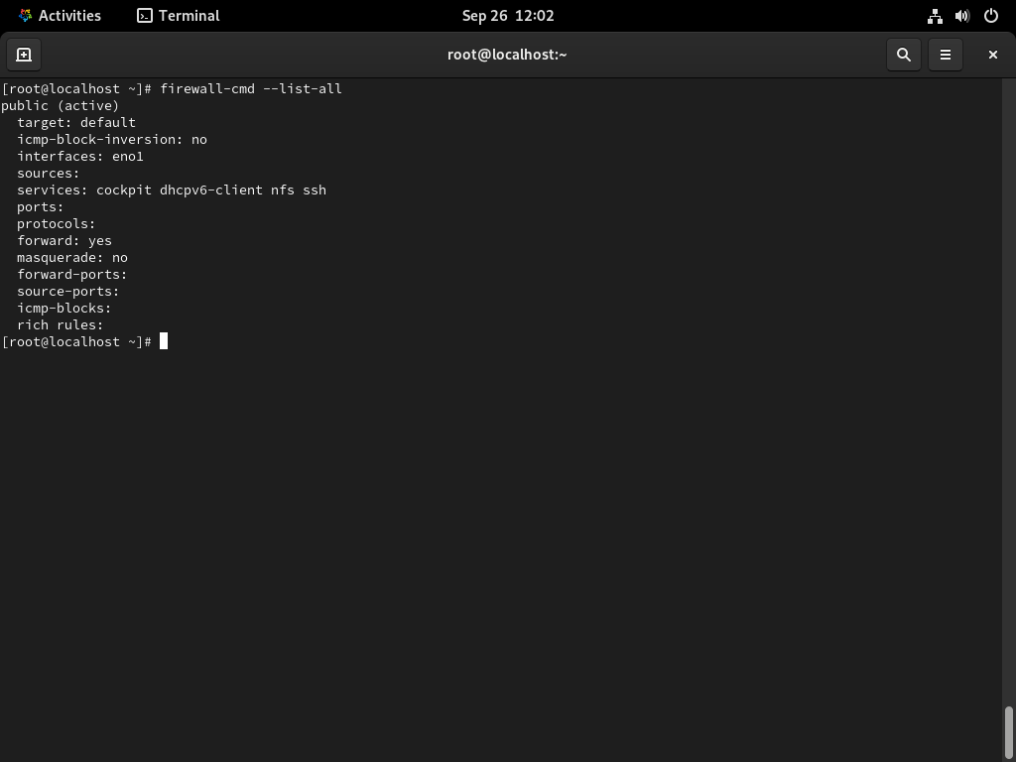

BASIC INSTALLATION SETUP CLIENT SIDE

1. Update computer packages List and Install the nfs package:

- dnf update -y
- dnf install nfs-utils -y
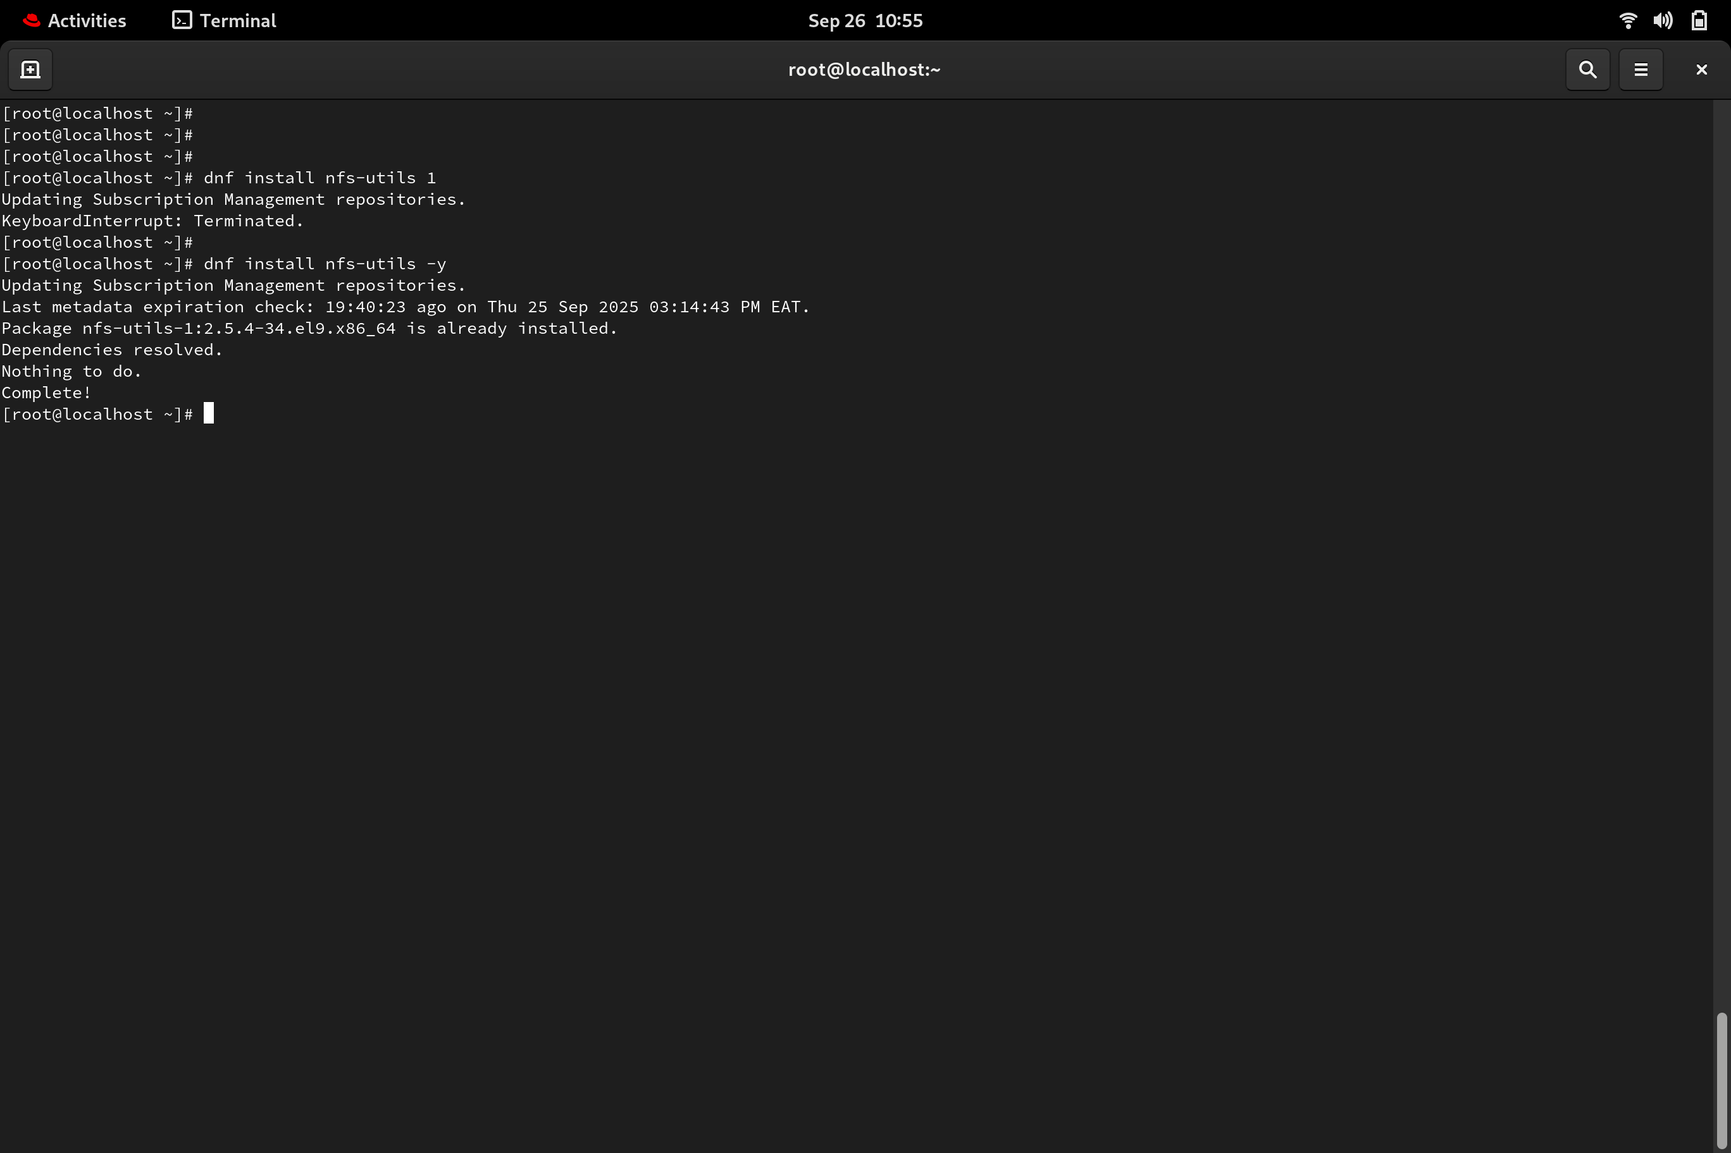

2. Create a mount point for a shared directory

- mkdir -pv /mnt/remote_share
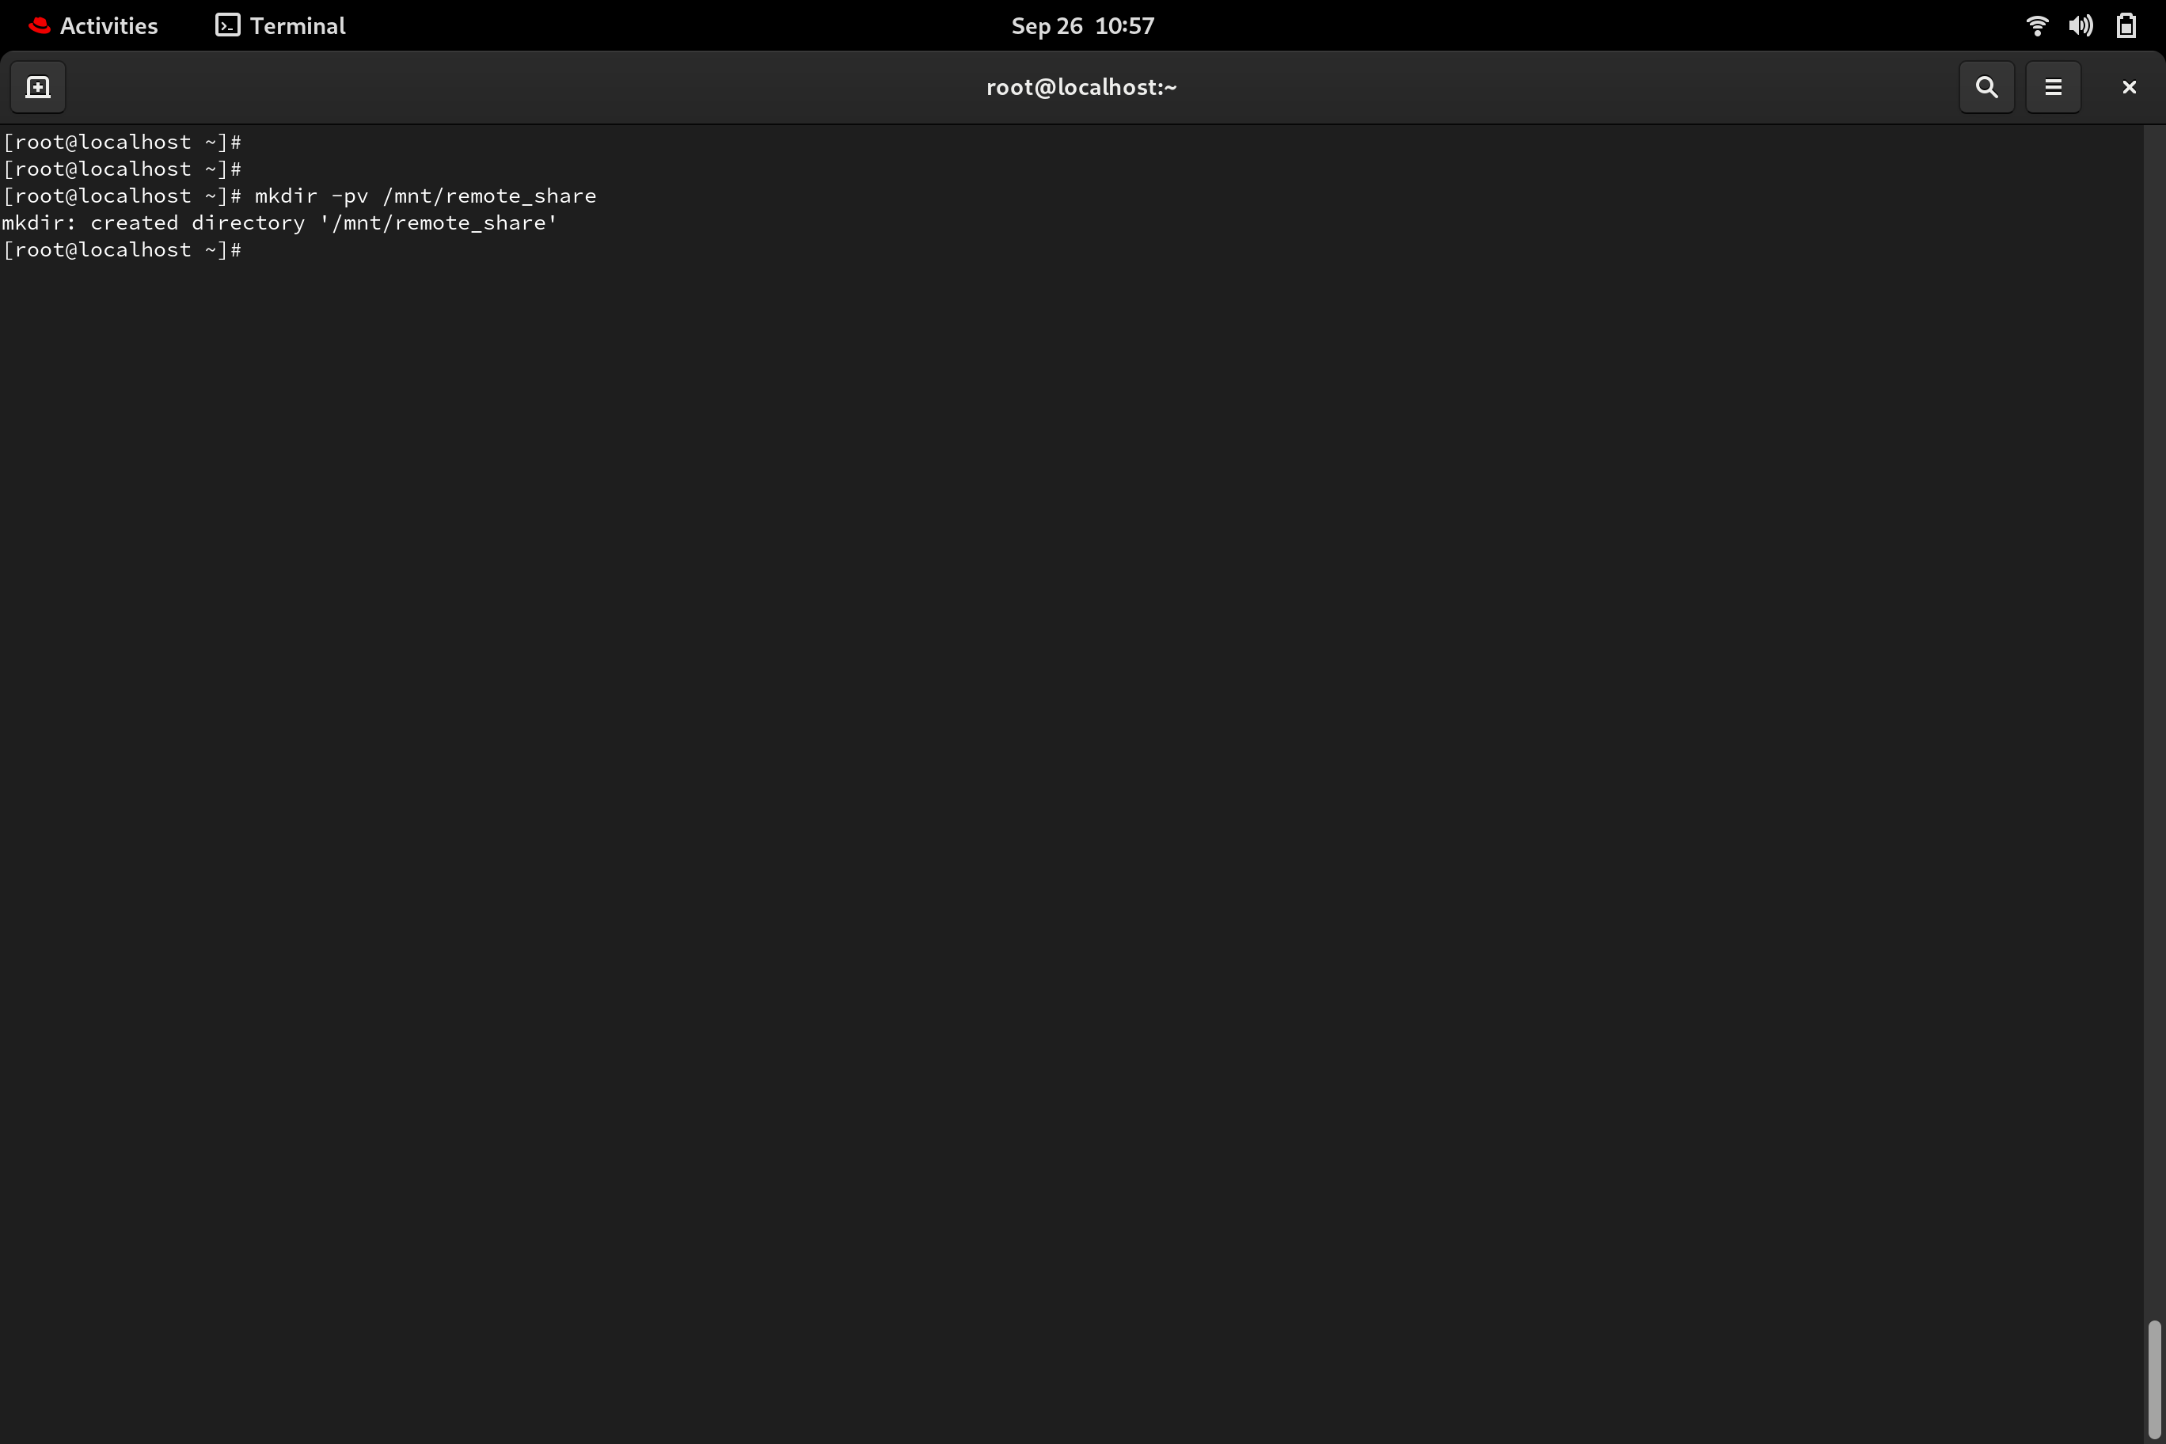

3. Mount the shared_directory using fstab file: vim /etc/fstab

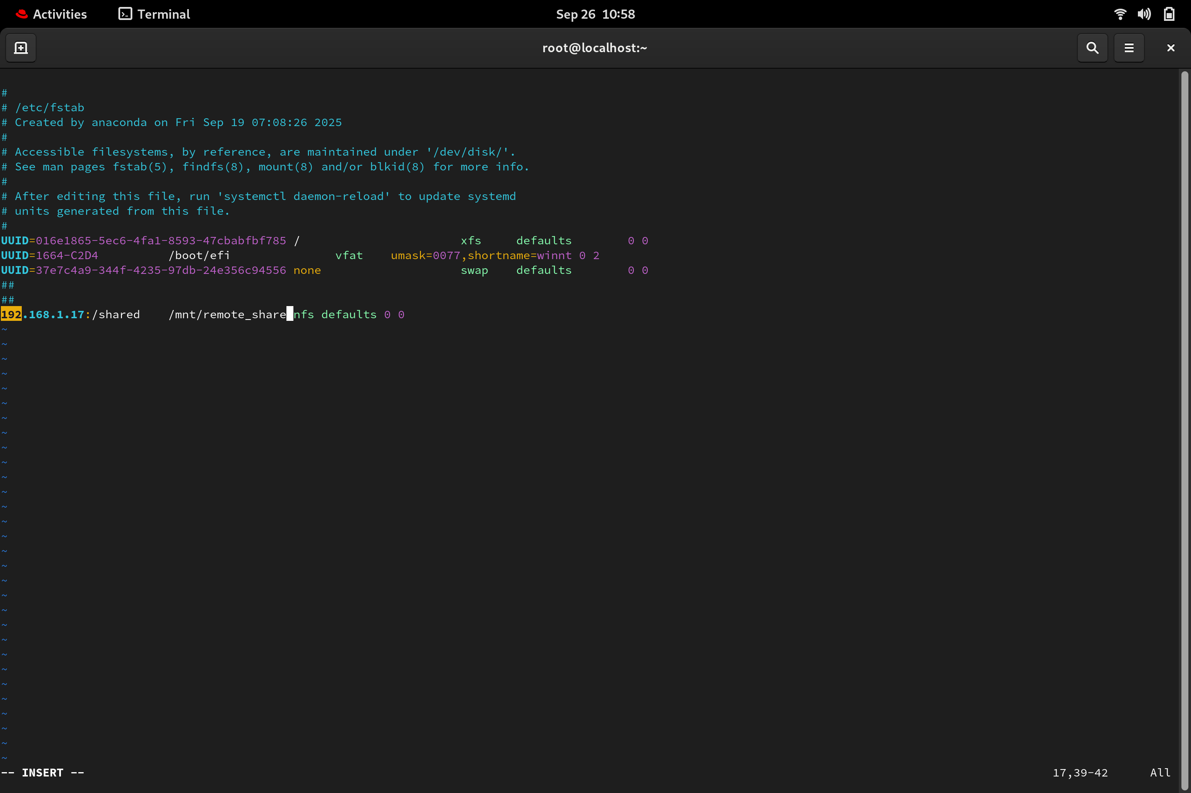

4. start the nfs service: systemctl start nfs-utils.service

5. Mount it persistently and confirm if the shared_directory is mounted.:

- mount -av
- ls /mnt/directoty_name

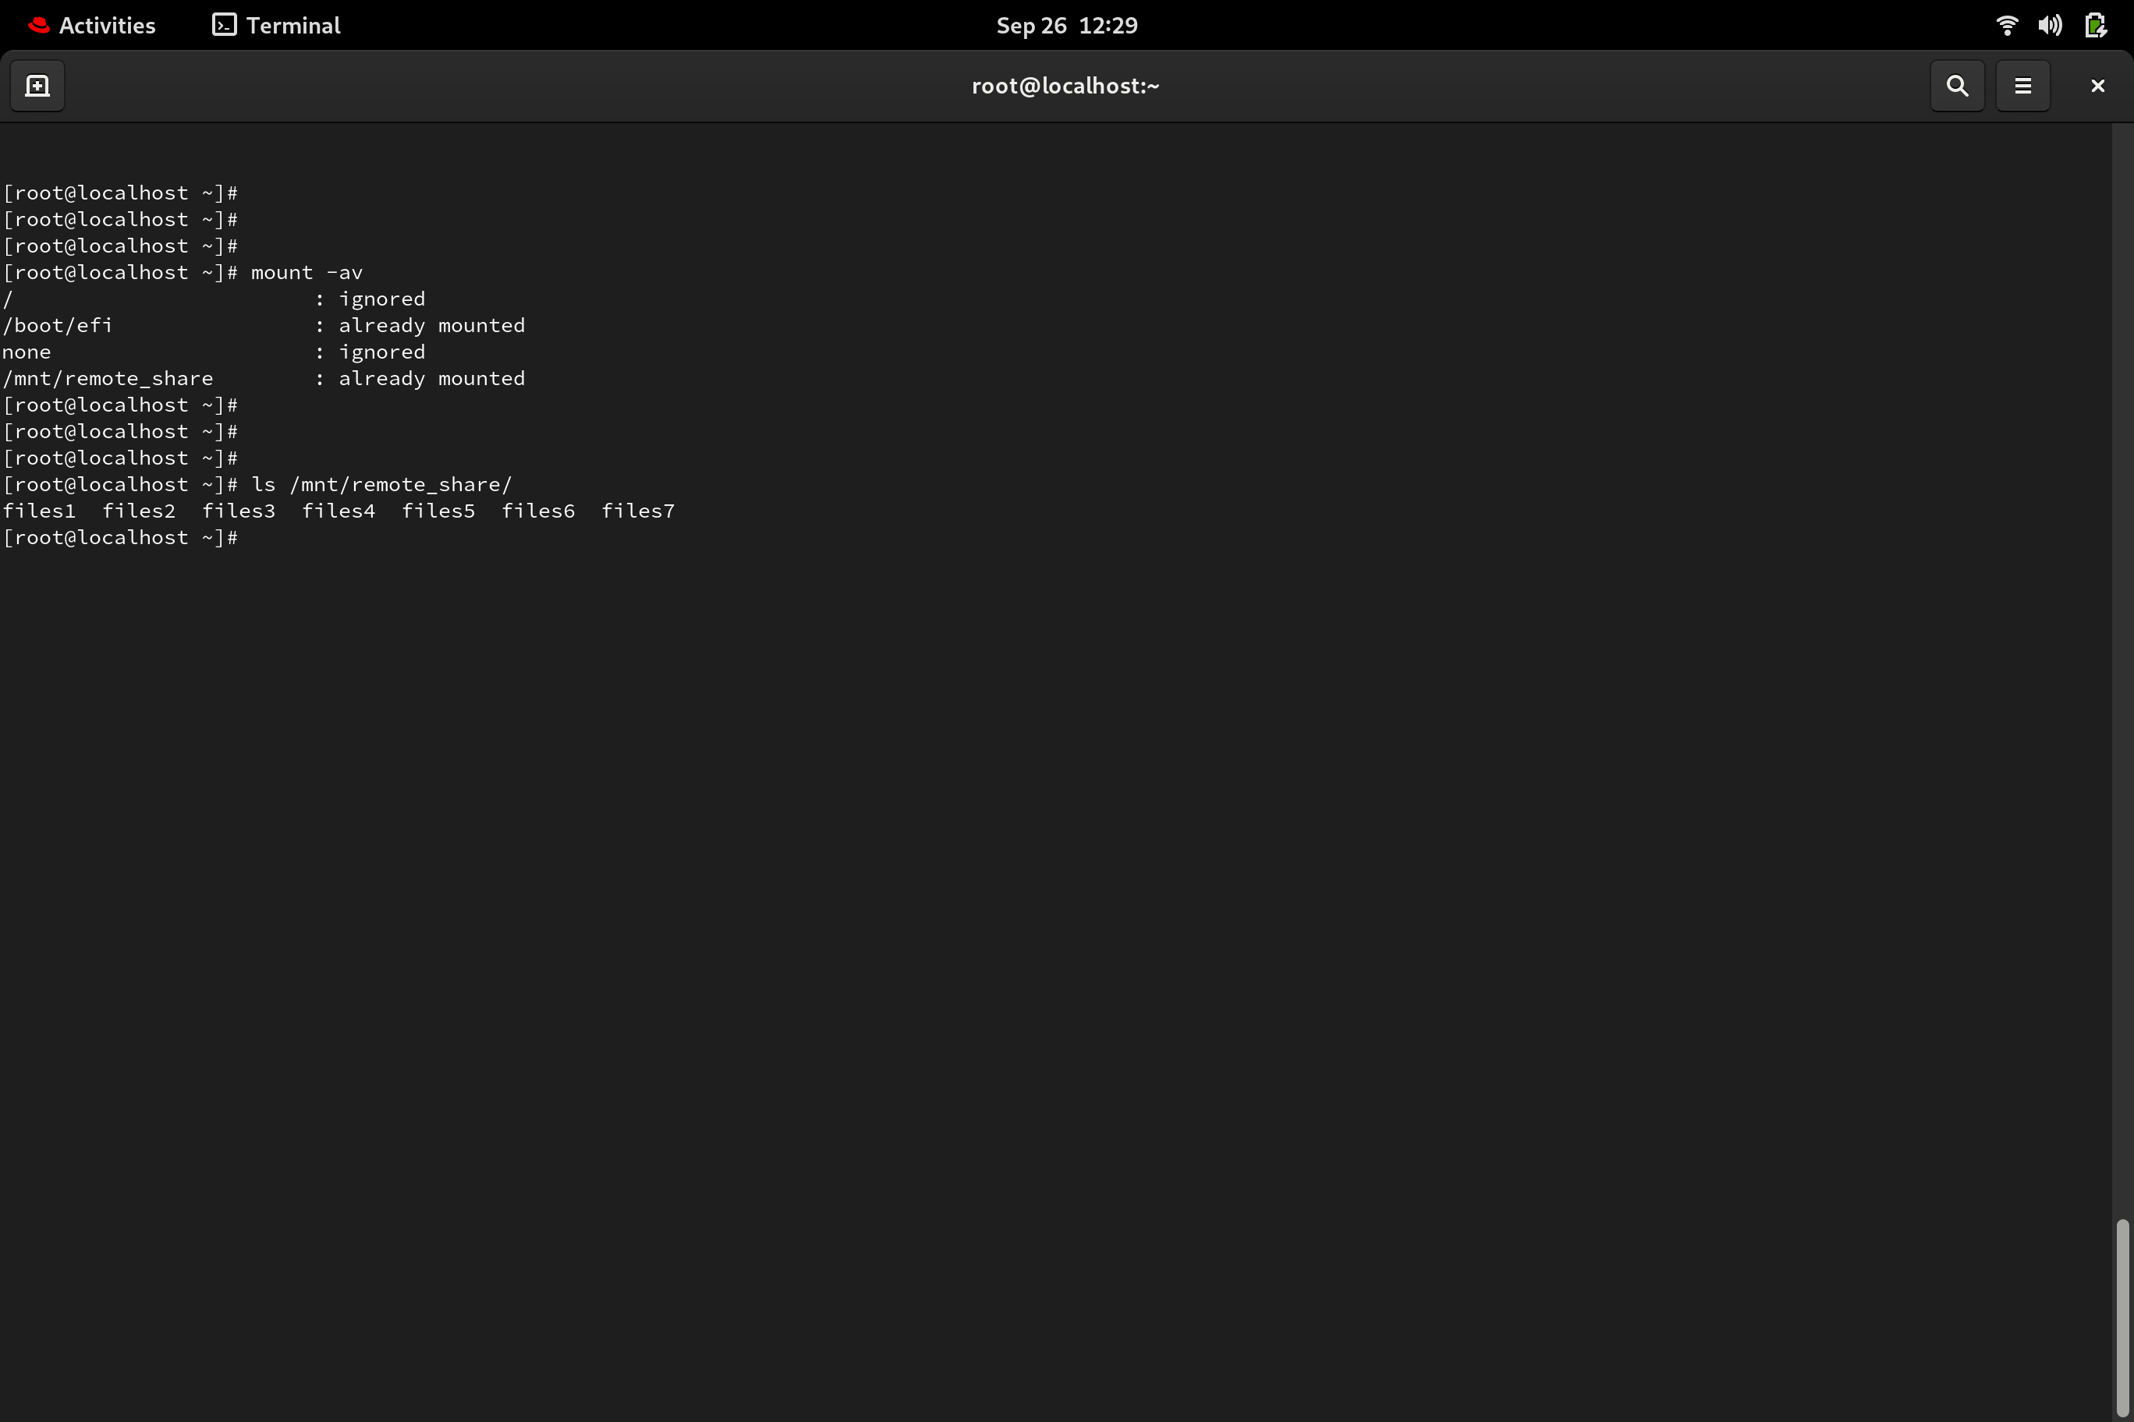

=== END

