### MANUAL SAMBA SERVER

**Priority Level**: Medium
**Estimated Time**: 20 minutes
**Required Access**:
**Risk Level**:

#### Description
Samba is an open-source application suite which provides services such as file and print to Server Message Block or Common Internet File System clients.

#### Prerequisites

Alma Linux 9.6 Server (Installed and Running)
RedHat 9.6 Client (Installed and Running)
Windows 11 Client (Installed and Running)
Internet connectivity

Procedures: on the Server

1. Check if samba is installed (and dependancies), if not Install it.

dnf install samba samba-client samba-common cups-libs

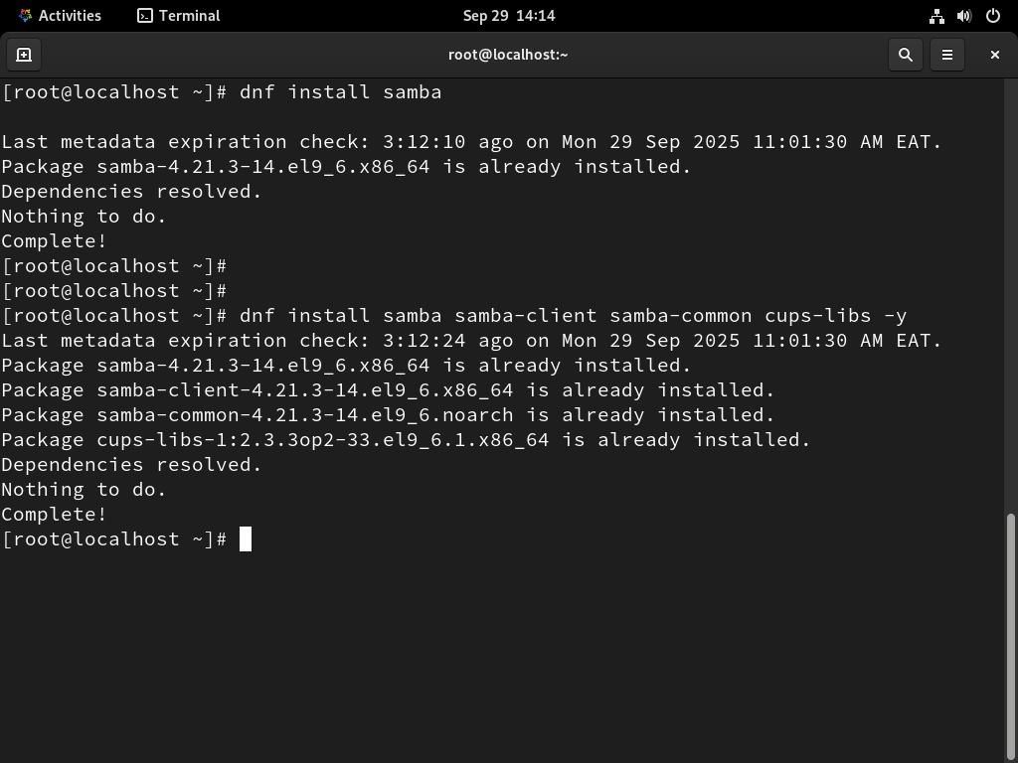

2. Create a samba shared_directory:

mkdir -pv /home/samba_share

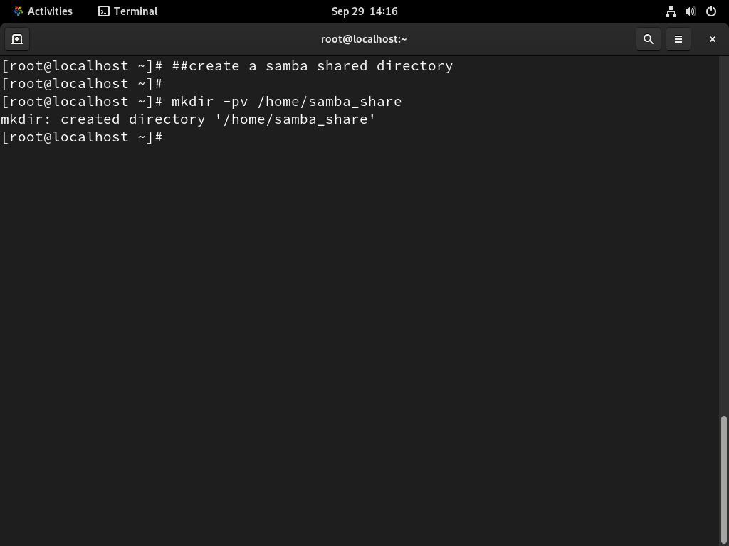

3. Create a group called “sambausers” that will share the directory using the command:

groupadd sambausers

4. Add users in the “sambausers” group created, so that they can access the samba_share directory

useradd –g sambausers Louis
useradd –g sambausers Jerry

5. Create password for the two users added to the group and verify the password when prompted

passwd Louis
passwd Jerry

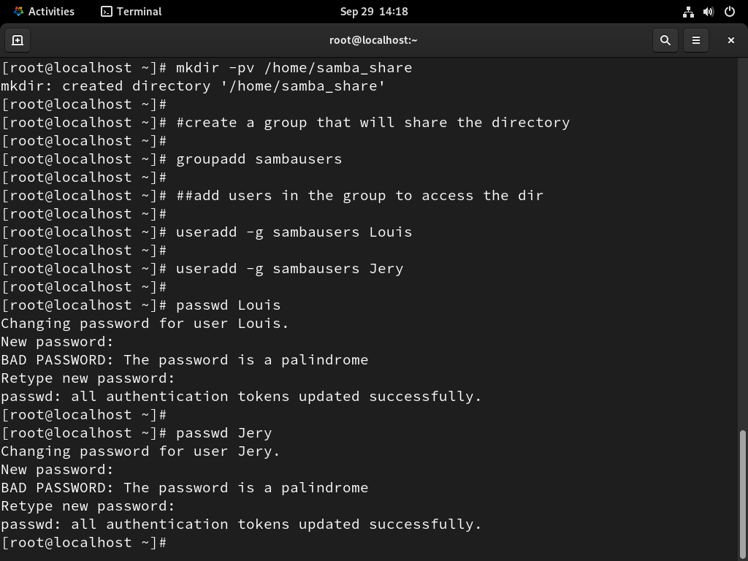

:6. Add the users (Louis and Jerry) to Samba User Account and enter smb password when ask to do so:

smbpasswd –a Louis
smbpasswd –a Jerry

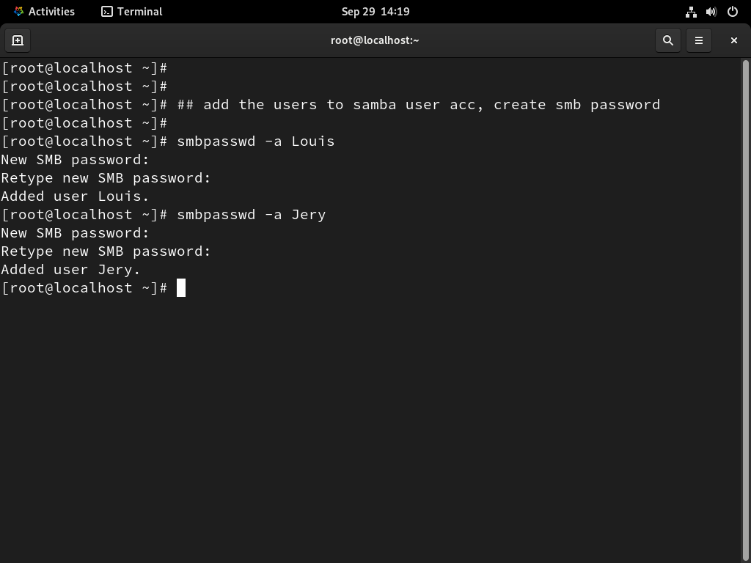

7. Configure the Samba Server Configuration file
Instruction:
1. Open the samba file using vi /etc/samba/smb.conf
2. Configure the samba global setting section in the smb.conf file to allow client machine to access the samba services

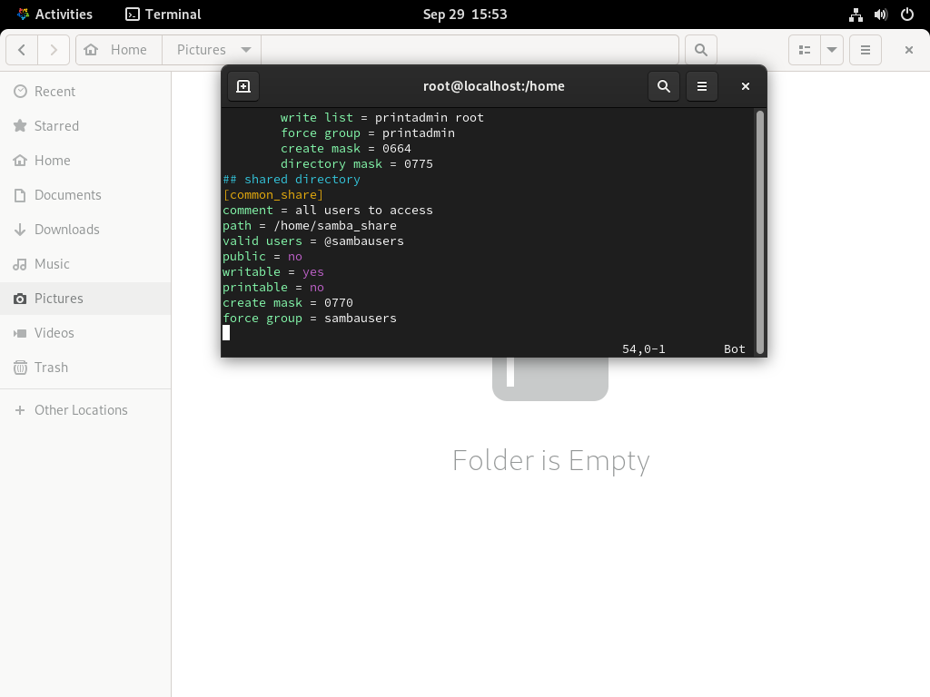

8. . Change the ownership, permissions of the shared directory and restart the samba

chown -R root.sambausers /home/samba_samba
chmod 755 /home/sambare

9. Set firewall and Selinux rules
setsebool -P samba_enable_home_dirs on
chcon -t samba_share_t /home/samba_share -R

firewal-cmd –add-service=samba –permanent
firewall-cmd –reload

