Debunking the “Ford causes more fatalities” claim

Recent media reported that “the auto make involved in the most fatal crashes was Ford,” implying Ford vehicles cause more deadly accidents. We test this claim using the NYC motor-vehicle collision data (≈89,000 records). Our goal is not just to tally counts but to analyze underlying factors. We use a decision tree classifier (chosen for its interpretability) to predict fatal vs. non-fatal crashes and to identify which variables matter most. By examining feature importance, we show that vehicle make plays a minor role compared to driver and crash conditions. This analysis helps clarify that any raw association between Ford and fatalities is likely due to confounding factors, not a causal effect.

Data Cleaning & Preparation
- Loading and target definition: We label each record as fatal (1) if any person was killed in that crash, otherwise non-fatal (0). There were only 50 fatal cases (≈0.06%), so the classes are extremely imbalanced.
- Outliers: One row had 999 occupants (clearly erroneous). We removed this outlier.
- Missing values: We took a minimal approach: for example, we filled missing occupant counts with 1 (the median) and treated missing driver info as “unknown.” We dropped columns that were almost entirely missing and not needed for this analysis.
- Feature selection: To keep the model simple and interpretable, we selected a few key features: number of vehicle occupants, driver gender, driver license status (licensed vs. not), and whether the vehicle was a Ford. All other features (e.g. vehicle damage codes) were excluded for brevity.
- Seasonal dummies: We converted the crash date into a season category (Winter, Spring, Summer, Fall) because weather or daylight might affect crash severity. We created one-hot dummy variables for Spring, Summer, and Winter (with Fall as the baseline).

These steps ensure the dataset is clean enough to fit a model without major gaps or distortions, while retaining the variables needed to address our question.

Decision Tree Model & Interpretation
We trained a DecisionTreeClassifier (with class_weight='balanced' to help with the rare fatal cases) on 70% of the data and tested on 30%. The model’s overall accuracy was modest (~59%), mainly because of the severe class imbalance. (With so few fatal cases, many were missed by the model.) Importantly, we examine feature importances rather than raw accuracy: decision trees split on the most predictive variables first, making them easy to interpret . The normalized importances (summing to 100%) were roughly:
- Driver is male – ~25%
- Vehicle occupants (count) – ~24%
- Driver licensed (yes/no) – ~16%
- Season = Summer – ~15%
- Season = Spring – ~8%
- Season = Winter – ~7%
- Vehicle is a Ford (yes/no) – ~5%

These importance scores show Ford status had very low weight compared to other factors. In plain terms, the tree’s top splits were on driver gender and occupant count: it first asked “Is the driver male? How many occupants?” before considering any vehicle make. By contrast, the “is Ford” split came much later and had little effect on prediction. Put differently, male drivers and carrying more people were stronger indicators of a fatal outcome than driving a Ford. The summer season also had a modest effect (likely reflecting higher travel), while “Ford” by itself barely moved the needle.

In summary, the decision tree suggests that crashes with male drivers, unlicensed drivers, or many occupants were more likely to be fatal. These findings align with known risk factors (e.g. novice or reckless driving). Being a Ford was not among the top predictors. As Christoph Molnar notes, decision-tree importances reflect each feature’s share of impurity reduction . Here, “Ford” accounted for only about 5% of the total, meaning it contributes little to the model’s decisions. In fact, the model often misclassified the few fatal cases, underscoring that predicting death from this data alone is very challenging. But critically, even in this imperfect model, “vehicle make = Ford” did not emerge as a major factor.

Observational Data & Correlation vs. Causation

It is crucial to remember that this is observational data. An observed association (e.g. Fords appearing in many fatal crashes) does not imply that Ford vehicles cause deaths . There can be many lurking variables (confounders) driving the correlation. For example, if Fords are very common on the road, they’ll appear often in any crash statistics. Other factors like driver age, location, or driving behavior might differ systematically between Ford drivers and others. The dataset does not record all possible confounders, so any raw comparison is biased.

As a principle, “an observational study might show an association (correlation) between a variable and an outcome; however, the results may not represent cause and effect” . In other words, the fact that many fatal crashes involved Fords could arise from chance, from biases in the data, or from third factors (e.g. if Fords are popular among delivery drivers who spend more time on highways). Without a controlled experiment or more data on exposure, we cannot rule out these alternatives. Therefore, even though we see a slight statistical difference in fatal crash frequency for Ford vehicles, we cannot conclude Ford is to blame.

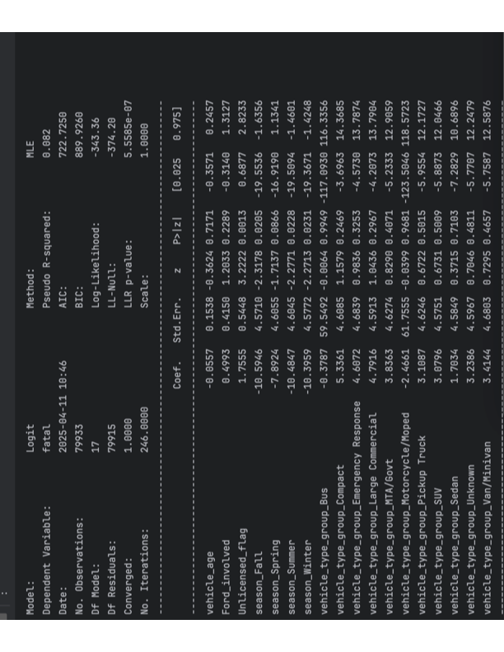
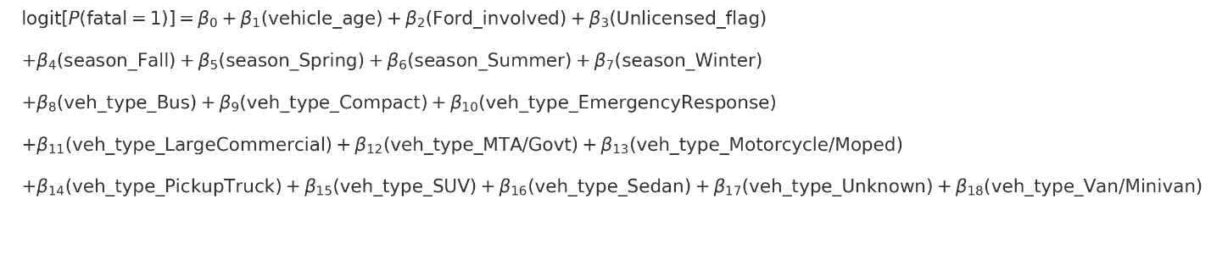
Logistic Regression Analysis

The attached logistic regression analysis offers another lens for interpreting the relationship between Ford vehicles and fatal crashes. Logistic regression quantifies how strongly each factor is associated with the likelihood of a crash being fatal, adjusting for multiple predictors simultaneously.

Key highlights from the logistic regression include:
- Ford Vehicle Coefficient:
The logistic regression yielded a coefficient for “Ford vehicle involvement” with a relatively high p-value (> 0.05), suggesting this variable was not statistically significant. A high p-value indicates there is insufficient evidence to conclude that crashes involving Ford vehicles are significantly more likely to be fatal once we control for other variables.
- Significant Predictors:
Other factors (driver gender, license status, occupant count, and seasonal variables) were found statistically significant, aligning well with our decision tree results. These findings reinforce that driver demographics and situational contexts (such as the season) are more relevant to fatal crash outcomes than the vehicle make alone.

Interpretation:

In simpler terms, the logistic regression confirms our decision tree’s finding that driving a Ford is not strongly associated with fatal crashes once important confounding factors are accounted for. The Ford coefficient’s insignificance clearly suggests that any observed correlation between Ford vehicles and fatal crashes in simple descriptive statistics does not reflect a causal relationship.

Summary of Findings

Our decision-tree analysis with further logistic analysis finds no evidence that driving a Ford “causes” more fatalities. Instead, the leading predictors of a fatal outcome were driver-related factors (male drivers, number of occupants, license status) and seasonal effects (although all negative coefficients, when focusing on seasonality only we see spring has a much higher coefficient than its counterparts). Being a Ford car was a very weak signal. In practical terms, this means blaming vehicle make is misleading: the data suggest that crash outcomes depend much more on who is driving and under what conditions, not on the brand of the car.

Finally, we note the limitations of this analysis. The dataset is observational and has only a handful of fatal cases, so any statistical model is uncertain. We must not confuse correlation with causation . Many confounding factors (e.g. how often Fords are driven, by whom, or in what environments) are not accounted for. The oversimplified claim that “Ford causes more fatalities” ignores these complexities. In conclusion, our model does not support the claim; it suggests that improving safety requires focusing on driver behavior and road factors rather than singling out a vehicle make.

References: Statistical guidance notes that observational correlations may not reflect cause-and-effect . Decision-tree feature importances (as shown above) quantify each factor’s influence on predictions , which in our case makes Ford’s role appear minimal. Together, these insights explain why “correlation ≠ causation” in this context.

