community of Flowers

Planet Pluto Games

Version 0.1.2   
March 25, 2020

“If you look the right way, you can see that the whole world is a garden.”

Frances Hodgson Burnett

“Gardens and flowers have a way of bringing people together, drawing them from their homes.”

Clare Ansberry

“I alone cannot change the world, but I can cast a stone across the waters to create many ripples.”

Mother Teresa

“We cannot seek achievement for ourselves and forget about progress and prosperity for our community... Our ambitions must be broad enough to include the aspirations and needs of others, for their sakes and for our own.”

Cesar Chavez

# Overview

## Mission Statement

?????????

## Elevator Pitch

????????

## Project Description

???????

## Genre

Buzzwords to help home in design, descriptions below each to say how they influence the game. These are listed in approximately order of importance, but may fluctuate during development to fit the vision best

* Management Simulation
  + High level the player is managing a flower shop
* Rouge-lite
  + The player will explore procedurally generated levels while gathering supplies
* Real Time strategy
  + The game will require the player to strategically use time and resources in order to optimize the outcomes in real time
* Metroidvania
  + The player will be able to gain upgrades that will allow them to unlock new areas

## Design Pillars

### Pillar 1: Non-Combat

You’re a lover not a fighter, this game is built on the idea that you will do things to influence the outcome that does not involve direct physical fighting. This is not to say that the game is promoting passive action as solutions or even non-violent action as the only solution, but that the player will not be the hands that do that. If through development of this game a situation arises where combat aught to happen, then the player flees, loses, or otherwise resolves the situation with out resorting to violence themselves.

The biggest reason for this idea is to explore the possibility space of a game that does not use fighting but still uses tension in ways to engage the player.

### Pillar 2: Everyday Politics

Politics are an everyday thing, not just something that you engage in around elections, politics are your work, your friends, your values. The goals of this game is to make the interconnectedness of this available to the player, showing how little actions can influence and drive a larger definition of politics. The characters’ morals, politics and opinions should be clear via their actions, community, workplace and more, this is not to say that characters cannot lie but that the lie must be determinable via the other factors of the character.

This is a major theme that should pervade the game through narrative and game play. A player should be able to get the outcomes they want while ignoring any and all political details because of insight with the characters, who they are and how they act, as this should inform the politics completely. Nothing is apolitical.

### Pillar 3: Community & Solidarity

A major theme in this game should be community, becoming a part of a community and then working in solidarity with them. As the greater narrative develops the player should learn about communities, become involved in them. The game should explore what happens as communities move apart, how to build communities, how individuals influence and are influenced by the community. This list is not exhaustive but represent ideas to help build and drive all parts of the game.

Community should not ignore the individuals and should have heterogeneous groups. But the groups should not be lost to individualism. This should work to avoid stereotypes while creating a group identity for each character to work with. The player should see something as they look from the outside, but they should be able to have an evolving view as they get closer to a community.

### Pillar 4: Collect & Cultivate: High Ceiling

This game should be about gathering and cultivating a collection, it should have a robust system to capture but then grown and spread this collection. Bringing together the idea of a collect-a-thon and husbandry in a meaningful and astute way. This should have interesting things to get, and ways to get them, coupled with a way to combine and grow these things to add to and develop the collection in interesting ways. This should reward mastery of the systems, with deep enough systems that the player can always grow, unstable optimization should be the goal for these systems.

At the highest levels of play collecting should provide something that cannot be cultivated, that no construction can compete with. But by the same token at the highest level, cultivation should provide a reward that cannot be collected. This dynamic will encourage mastery of both systems, as well as provide support if a player wants to focus on one aspect over another.

### Pillar 5: Ease of Entry

While leaning on the wealth of game development knowledge and leveraging this to make a better game, and while this game should not hold back to experienced gamers engaging those with the high mastery. This game should give an ease of entry for people who are not video game literate in a way that does not pander or demean those players. Giving more casual players a point of entry but allowing growing mastery to engage all types.

## Influences

A lot of things went into making this, much of that originates in a world I have been working to create for years. But this deeply comes from finding many great games, but never ones that scratched the itch this is trying to scratch

* Pokémon
  + A collect-a-thon that has meaning behind cultivating what you collect
* Animal Crossing, Stardew Valley
  + Good chill game
* Michaea
  + Someone who showed me what it means to come into a new hobby
* Colonialism
  + Kind of fucked everything up, let’s talk about that in this game
* Non-Combat game
  + Where are they
* Adam Millard, Extra Credits, Game Makers toolkit
  + YouTube, got some great stuff

# Audience

## Target Players

* In experienced players
* Optimizers
* Sim game enthusiasts
* Rouge-lite fans

## Target Platforms

The primary targets for development are the Computer and the Nintendo Switch. Initial development will be for the computer, while researching and determining the best course of action for the Switch. Once a functional demo and vertical slice have been developed, then there will be an evaluation to determine if mobile development is a responsible choice.

After research into various platforms it seems best to focus development on the computer, with the intention that there would be a port to the switch after initial launch and review of success. This is to reduce the amount of learning that needs to be done at any one time. With this in mind it will be important to create the game in such a way to make the port as smooth as possible. This means keeping code quality good, good organization, and keeping important Nintendo philosophies in mind.

Mobile development criteria

* Easily and intuitively translating to touch screen
* UI which translates to the smaller screens
* Play Loop translates to 10 – 30 min chunks

At this point there is no plans for Xbox or PS Development

## Marketing Strategy

TBD, I would like to make this a commercial game, but this is first a foremost a passion project, a moral and political statement, and trying to give voice to a variety of experience both my one, my students, and those people important to me. With keeping that in focus once this project has some momentum, I will begin to look at how to market this game so that this vision might be shared with others.

## Localization

This will be important to reach new markets, but this will probably only take place if this is a success, I will probably bring partners on to accomplish this, but I will need to do research first. This section is included to remind me of stretch goals.

# The World of Flowers

## Themes

* **Community**
* Colonialism
* Collectivism
* Individual action
* Small things mean much

## Setting

### Nomadic City

* What is the city?
  + Most likely an actually walking city
  + But maybe a caravan?
* Taking multiple stops on a cyclical rout.
  + Might be consistent stops (ex. same 4 stops)
  + Minor randomness with some consistency (i.e. every 5 stops is with trading post)

### Animalistic

* Broad Strokes
  + No humans
  + All groups are part of the animal kingdom
  + Many factions will be more of one race than another
    - This is a rough outline, there should be some that this is not true
    - Primary species should be a plurality not a majority

## Factions

### The Unaligned

These are all the people who do not belong, whose priorities are split between factions for some reason, or the people who have been cast out for one reason or another. The most notable of these will be the player character at the start of the game, though much of the story will be resolving this. The main point of these characters is to give voice and example to edge cases to people who have difficulties. This should provide challenge to, and display the problems with, tribalism and the communities. Not to undermine the systems.

### Faction 1

### Faction 2

### Faction 3

### Faction 4

### Colonizers

## Characters

### The Protagonist

* Caught between worlds, and does not intrinsically belong to a community
* The protagonists person arc should be about becoming involved in a community.

## The Flower Shop

* Needs natural light, and a way to get water (think nasuka and the valley of the wind)

## Story: Narrative

The story focuses on how the florist will subtly influence each faction to ultimately drive who will gain control of the city, they will be given the opportunity to pick one or more factions to support to which will decide the type of obstacles they will face

### Act 1: Call to adventure, Meeting the Mentor [Engage]

#### Promise:

#### Payout:

### Act 2: Tests, Allies, Enemies, the Ordeal [Explore]

#### Promise:

#### Payout:

### Act 3: Transformation [Explain]

#### Promise:

#### Payout:

### Act 4: The Final Ordeal [Extend]

#### Promise:

#### Payout:

### Act 5: Return [Evaluate]

#### Promise:

#### Payout:

# Gameplay

## Player Goals

### Micro

Players will attempt to complete deliveries by managing their flower gardens, this is broken down into smaller goals and steps that is later expanded upon in the game loop section.

* Cultivate their current crop of plants
  + Prune
  + Plant
  + Cross breed
* Expand their plant stock
  + Explore
  + Complete deliveries
* Complete deliveries
  + Select plants
  + Assemble them to achieve macro goals

### Macro

Players, using their flower selection for deliveries, will attempt to strengthen communities internally and externally, some players will go as far as to bring communities together. This will be done by determining what flowers grow support and connections with which communities. This will involve the micro goals with the added step of community investigation.

### Success and Failure

In order to best align with Pillar 5, the only way that a stock is removed is by total player usage. In explorations players may be forced to flee or be unable to advance, but at no point in the game should there be a game over screen. With this in mind it is also important to note that players can fail their macro goals, prune poorly, have plants or cross breeds die, but this should be a permanent result of their actions.

#### Saving the game

Dark souls like saving, save periodically and at good auto save points, and on exit. Players should not control saves.

## Game Loop

### Player Experience

### Micro

### Macro

## User Skills

## Core Mechanics

### Cultivating your Garden

### Delivering on your Promises

### Exploring and Gathering

## Progression Mechanics

## Items

### Philosophy:

Items need to be unique and provide a meaningful change to other items, the questions bellow should all be answered before adding an item to the game so that they may best fit with the philosophy behind the game and the items behind this. Players should have meaningful progression, as detailed above but items should in that way be meaningful and not clutter the player, there should be no need for them to clean closets.

Questions:

* Why is it an item, not a mechanic?
* When should they get it, why?
* Can it be used in multiple ways, if no why can’t it be part of something else?
* Does this represent vertical or horizontal progression?

### Game Items by use

#### Cultivation

#### Delivering

#### Exploring and Gathering

## Story: Mechanics

Story is advanced between acts by player actions, players should not feel unnecessarily rushed because of it, or held back after mastery by the story.

### Act 1: Tutorial

* Introduce the player to all the key mechanics
* Needs to include
  + More than 1 explore
  + A few orders given and delivered
  + Needs to have an election
  + Needs to have an interaction with the colonizers

### Act 2: Building

* Should be able to get all the unlocking items
* Should be comfortable with all mechanics
* Has crossbred plants
* Players should have formed goals for the game
* Major incident at the end should shape the rest of the game
  + Major incident will be based on which factions they chose to support or ignore

### Act 3: Mastery

* Players are working with changes from the major incident
* Players are driving home their goal
* Players should be mastering the mechanics during this phase
* A final turn/twist to disrupt the players plans

### Act 4: Finale

* Players work to resolve the final disruption
* High difficulty

### Act 5: New Game +

* Players can restart with increased difficulty
* Players can continue playing with the recurring systems continuing the challenge

# Level Design

## Philosophy

## The City of Flowers

## Dungeons

## Tile Sets

## Game Balance

# Art Style

## Game Graphics

### Examples/Influences

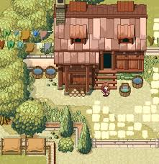 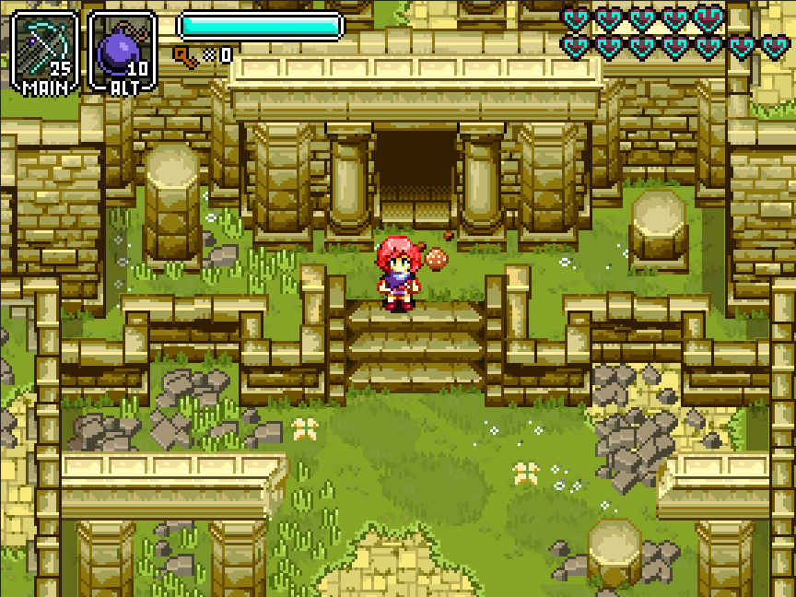

### Characters & Factions

### Tile Sets

## User Interface

### Menus

### In Town

### Exploring

## Music & Sound

# Technical Descriptions

## Development Tools

### Programing tools:

### Art Tools:

### Music & Sound Tools:

### Version Control Software:

### Game Engine:

## Code Standards

### Versioning:

Major . Minor . Patch

This system is outlined by Tom Preston-Werner, should be followed as closely as possible for full details please see the post about it, but a quick explanation is outlined below[1].

* Major: is not backwards compatible to different versions
* Minor: backwards compatible changes
* Patch: fixes to functionality

## Game Controls

### Computer Controls

### Switch Controls

### Controller Controls

# Back Burner

## New Ideas

### Romance [could return]

This was intially removed because it would undermine the community nature making it more individualistic as well as potentially move it from engaging with a community to a romance game. Even if this was well balanced would encourage players to focus on just one person instead of the whole. But this could return with the following list if it can well add to the themes and pillars   
To return:

* Play testing to make it feel valuable
* A good result of, instead of driving factor of
* NPC driven romance, they flirt and engage with player not vice versa
* Inquisition’s Scout Harding would be a good example of this.

### Play the Mentor [extra post game content]

At some point, new game+ or at an act transition you would play the mentor, helping to manage a few younger people and focusing on building relationships with communities and building up your young ones. As of now this seems to be a radical shift from the core game loop and undermine many of the game features and player progress. It was added when the game had many more modes of play that were reduced to help focus on the core themes and design pillars.

## Removed Ideas

# Document Version Notes

## Version 0

### 0.1.0:

Added core design philosophies, overall concept being more focused and streamlined

1. https://semver.org/#semantic-versioning-200