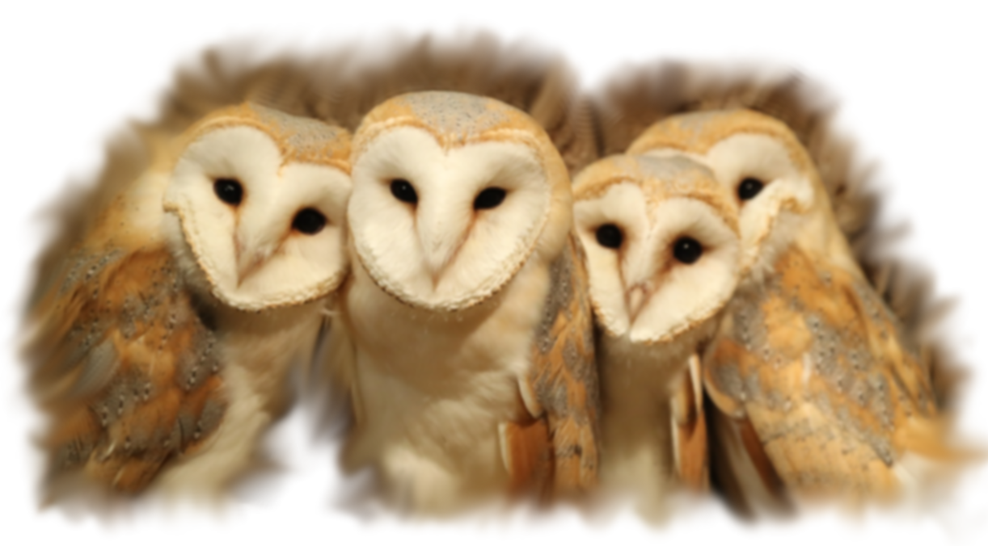Hoot! Hoooot!

Up on the mountain

The hoots echoed

Where we had home

Hoot! Hoooot!

The knowledge we had gathered

For the nestlings to be

Hoot! Hoooot!

Greatest in the land

A place of learning

Oldest in the land

A place of history

Hoot! The sky shadows

Hoot! The mountain cries

Hoot! The mountain shook