Assignment9

2017314712 김우진

A. Effect of type of interface to time of completion

1. State the Null Hypothesis and Alternative Hypothesis.

Null Hypothesis : Mean1 = Mean2 = Mean3 = Mean4

Alternative Hypothesis : Mean1 != Mean2 != Mean3 != Mean4

2. What is the statistical method to analysis the Hypothesis?

One way ANOVA

3. Select a level of significance.

.05

4. Calculate your statistics in PSPP (or other software of your choice).

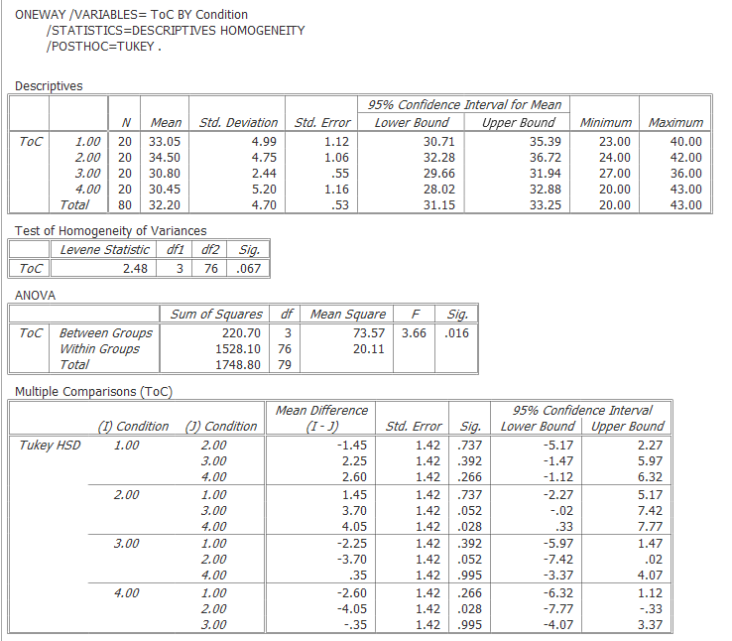

5. What conclusion can you make based on your statistical analysis?

is rejected.

Effect between Condition 1 and Condition 2 does not reaches significance (p>.05)

Effect between Condition 1 and Condition 3 does not reaches significance (p>.05)

Effect between Condition 1 and Condition 4 does not reaches significance (p>.05)

Effect between Condition 2 and Condition 3 does not reaches significance (p>.05)

Effect between Condition 2 and Condition 4 does reaches significance (p<.05)

Effect between Condition 3 and Condition 4 does not reaches significance (p>.05)

B. Effect of type of interface to error rate

1. State the Null Hypothesis and Alternative Hypothesis.

Null Hypothesis : Mean1 = Mean2 = Mean3 = Mean4

Alternative Hypothesis : Mean1 != Mean2 != Mean3 != Mean4

2. What is the statistical method to analysis the Hypothesis?

One way ANOVA

3. Select a level of significance.

.05

4. Calculate your statistics in PSPP (or other software of your choice).

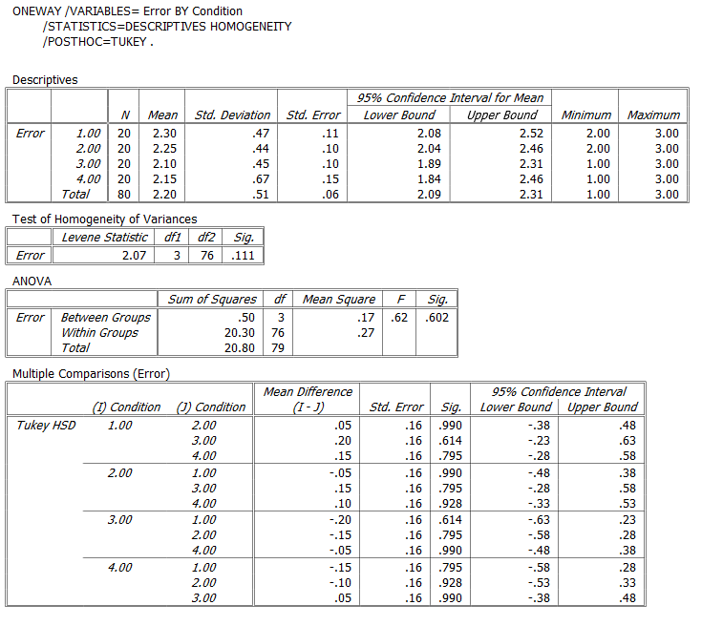

5. What conclusion can you make based on your statistical analysis?

is rejected.

Effect between Condition 1 and Condition 2 does not reaches significance (p>.05)

Effect between Condition 1 and Condition 3 does not reaches significance (p>.05)

Effect between Condition 1 and Condition 4 does not reaches significance (p>.05)

Effect between Condition 2 and Condition 3 does not reaches significance (p>.05)

Effect between Condition 2 and Condition 4 does not reaches significance (p>.05)

Effect between Condition 3 and Condition 4 does not reaches significance (p>.05)

C. Effect of type of interface to perceived mental workload

1. State the Null Hypothesis and Alternative Hypothesis.

Null Hypothesis : Mean1 = Mean2 = Mean3 = Mean4

Alternative Hypothesis : Mean1 != Mean2 != Mean3 != Mean4

2. What is the statistical method to analysis the Hypothesis?

One way ANOVA

3. Select a level of significance.

.05

4. Calculate your statistics in PSPP (or other software of your choice).

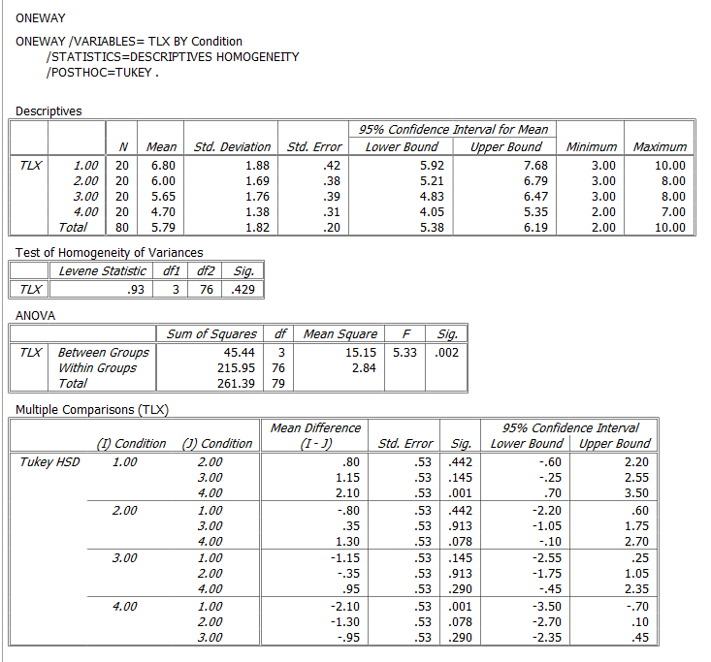

5. What conclusion can you make based on your statistical analysis?

is rejected.

Effect between Condition 1 and Condition 2 does not reaches significance (p>.05)

Effect between Condition 1 and Condition 3 does not reaches significance (p>.05)

Effect between Condition 1 and Condition 4 does reaches significance (p<.05)

Effect between Condition 2 and Condition 3 does not reaches significance (p>.05)

Effect between Condition 2 and Condition 4 does not reaches significance (p>.05)

Effect between Condition 3 and Condition 4 does not reaches significance (p>.05)

D. User’s preference of interface

1. State the Null Hypothesis and Alternative Hypothesis.

Null Hypothesis $H_{0}$: The collected data would have the same natural distribution of 20/20/20/20

Alternative Hypothesis $H_{1}$: The collected data would not have the same natural distribution of 20/20/20/20

2. What is the statistical method to analysis the Hypothesis?

Chi-Square

3. Select a level of significance.

.05

4. Calculate your statistics in PSPP (or other software of your choice).

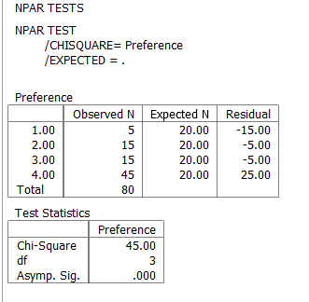

5. What conclusion can you make based on your statistical analysis?

$H_{0}$ is rejected.

People do have a significant preference.